Measuring Earth with GPS, Unit 4: Groundwater

Activity 3 Student Exercise: Analyze, Interpret, and Apply
Karen M. Kortz (Community College of Rhode Island) and Jessica J. Smay (San Jose City College)
In this activity, you will learn how to analyze and interpret scientific data after describing it. You will conclude by using that data to support a recommendation you make about an issue relevant to society. The questions guide you through the process that scientists use when they work to solve scientific questions. This particular activity uses data from GPS stations in the Sierra Nevada Mountains and the Central Valley in California to better interpret long-term water resource trends that can be interpreted by analyzing GPS position of the ground.
If you have not already done so, watch the animation titled Measuring Drought Water Loss: A GPS Network Offers A New Perspective. Your instructor may give you a separate set of questions.

Part 1: Water resources in California
In California, precipitation falls in the winter as rain in the valleys and snow in the mountains. The mountain snow melts in the spring and early summer and provides water to the valleys, by becoming part of the groundwater and by being channeled into canals that transport water around California. Farmers in valleys use water heavily in the spring and summer, and if there is no water available at the surface from canals, they pump groundwater out of the ground to use.

1. Fill out the table below summarizing the paragraph above about the balance of water in California during a year of normal rainfall.
 | 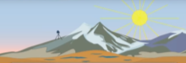  Mountains | 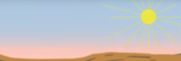  Valleys
Water added through snow and/or rain | winter spring–summer | winter spring–summer
Water subtracted by snow melt | winter spring–summer | N/A
Water subtracted by surface use or groundwater pumping | N/A | winter spring–summer

2. During a drought, when there is little rain or snow, how does the amount of water change?
 | Mountains | Valleys
Water added through snow and/or rain | decreases during drought increases during drought | decreases during drought increases during drought
Water subtracted by snow melt | decreases during drought increases during drought | N/A
Water subtracted by surface use or groundwater pumping | N/A | decreases during drought increases during drought
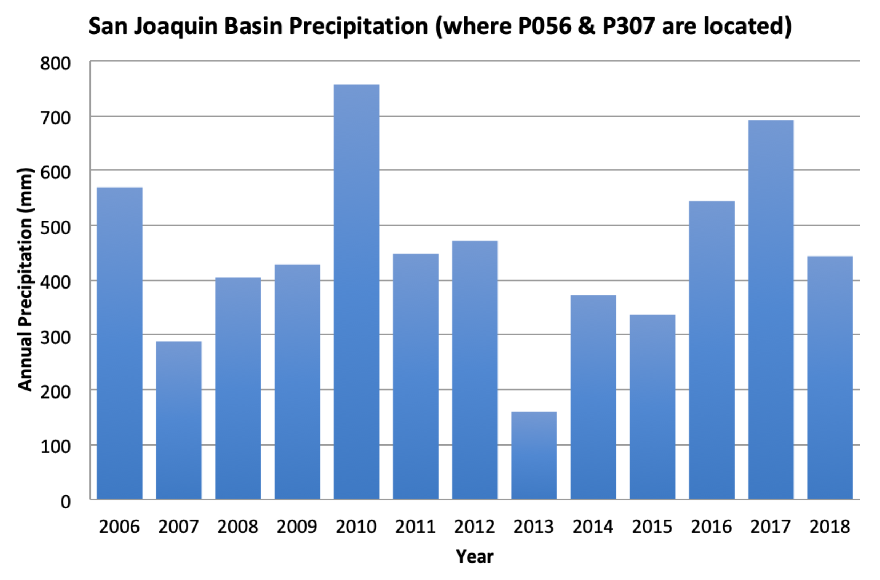
Figure 1. Annual precipitation for the San Joaquin Valley, California. Data from NOAA Data at a Glance (https://www.ncdc.noaa.gov/cag/divisional/time-series/0405/pcp/12/12/2006-2018)
3. Examine Figure 1 showing annual precipitation in the California Central Valley. Compare the sets of years to determine which sets received regular amounts of precipitation and which set was in drought because it received lower than average precipitation.

2006 to 2011 | 2012 to 2015 | 2016 to 2018
drought regular precipitation | drought regular precipitation | drought regular precipitation

Part 2: Writing hypotheses about GPS data and water resources
Geologists make hypotheses to explain how one thing affects another and why the relationship exists. They use their hypotheses to make predictions that they can then test by collecting data. You will follow this same scientific method through this activity by first making hypotheses and predictions, and then later observing and analyzing GPS data to test those predictions.
4. Based on the animation and the precipitation data, write hypotheses about the effect of drought on the mountains by filling out the table. A hypothesis includes both how you predict one variable will affect another and why you think that relationship exists.
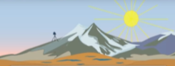
Mountains

How the range of vertical motion changes during drought | How the long-term elevation changes during drought
In mountains, if the winter snowfall decreases because of drought, the range of annual vertical movement would (circle one):  increase decrease  because… | In mountains, if the overall snowfall decreases because of drought, then the ground elevation over many years would:  rise lower  because…

5. Use your hypotheses to make a prediction: When the vertical position of the GPS station in the mountains is plotted against time in a time-series diagram, what would the trend look like over many years if the area changes from regular precipitation to drought to regular precipitation again? Circle the graph that best fits.
time
height
time
height
time
height
time
height
time
height
time
height
time
height
time
height

6. Write hypotheses about the effect of drought on the valleys by filling out the table

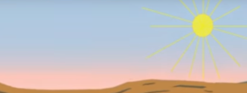
Valleys

How the range of vertical motion changes during drought | How the long-term elevation changes during drought
In valleys, if the amount of water added to the ground in the spring and summer decreased because of drought and the amount removed in the spring and summer for agriculture increases to replace lost surface water, then the range of annual vertical movement would:  increase decrease  because… | In valleys, if the overall amount of groundwater decreased, then the ground elevation over many years would:  rise lower  because…

7. Use your hypothesis to make a prediction: When the vertical position of the GPS station in the valley is plotted against time in a time-series diagram, what would the trend look like over many years if the area changes from no drought to drought? Sketch your prediction on the time-series diagram to the right.
time
height

Part 3: Observing and describing GPS data
To test your predictions, we will examine the measurements from GPS stations. Below are data from four GPS stations in California: P056, P307, P567, and P572. You will observe and describe the data by making measurements and calculating the range in annual movement and long-term elevation changes at different points in time for GPS stations in the mountains and valley. In Part 4, you will compare your collected data to your predictions to test your hypotheses.
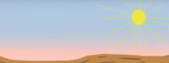
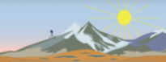
Mountains: Stations P567, P572 Valley: Stations P056, P307

Figures 1–4. Vertical GPS data from stations P056, P307, P567, and P572 in California. Larger versions of these figures are included separately.

You will describe the data for two of the GPS stations and compare your descriptions with students who described the other two stations. Your instructor will direct which stations to use.
We will divide the GPS data into the same time ranges as we did for the precipitation data: 2006–2011, 2012–2015, 2016–2018. You will describe the range in annual vertical movement and the long-term rate for each of these three time periods. Then you will compare the changes in elevation as measured by GPS to your predictions to test to see if your hypotheses are correct.

8. Read the paragraphs above. Before analyzing the graphs, summarize why you are describing the data for these GPS stations and using it to make calculations.

9. Circle the two stations you are initially describing: P567 and P056 or P572 and P307
Mountains: GPS Station P567 or P572
10. For each time period, pick a single typical year and calculate the range of vertical movement (the high point minus the low point) to determine the annual range in vertical movement in the mountains. Remember to include units.
Alt Text: a small artists rendition of a valley with a GPS station on it.
Range | Year | High point | Low point | Range of vertical movement
2006–
2011
2012–
2015
2016–
2018

11. Circle the time period with the range in vertical movement that is the lowest:
2006–2011 2012–2015 2016–2018
When you look at the graph, does the time period you circled make sense? Yes No

12. For each time period, calculate the rate of long-term elevation change. Include units.
Years | Vertical distance (difference in height from start to end) | Time (years from the start to end) | Long term rate (distance divided by time)
2006–
2011
2012–
2015
2016–
2018

13. Circle the time period with the rate of elevation change that is the highest:
2006–2011 2012–2015 2016–2018
When you look at the graph, does the time period you circled make sense? Yes No

Valley: GPS Station P056 or P307
14. For each time period, pick a single typical year and calculate the range of vertical movement (the high point minus the low point) to determine the annual range in vertical movement in the mountains. Remember to include units.
Alt Text: a small artists rendition of a valley with a GPS station on it.
Range | Year | High point | Low point | Range of vertical movement
2006–
2011
2012–
2015
2016–
2018

15. Circle the time period with the range in vertical movement that is the lowest:
2006–2011 2012–2015 2016–2018
When you look at the graph, does the time period you circled make sense? Yes No

16. For each time period, calculate the rate of long-term elevation change. Include units.
Years | Vertical distance (difference in height from start to end) | Time (years from the start to end) | Long term rate (distance divided by time)
2006–
2011
2012–
2015
2016–
2018

17. Circle the time period with the rate of elevation change that is the lowest:
2006–2011 2012–2015 2016–2018
When you look at the graph, does the time period you circled make sense? Yes No

Part 4: Analyzing GPS data to test your hypotheses
Now it is time to pull together your data from descriptions of the rainfall (Part 1), GPS motion in mountains (Part 3), and the GPS motion in valleys (Part 3). Just as geologists do, you will synthesize the data by testing your hypotheses and predictions you made with them (Part 2).

18. Test your hypotheses by applying your predictions in Part 2 to your data.
 | 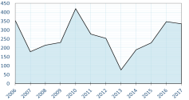 | 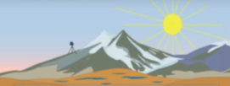  Mountains |  | 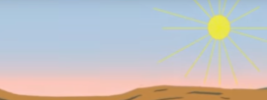  Valley
Years | Observed rainfall | Prediction from annual range | Prediction from long-term rate | Prediction from annual range | Prediction from long-term rate | Do the data agree?
2006–  2011 | Regular precipitation  drought | Regular preciptation  drought | Regular precipitation  drought | Regular precipitation  drought | Regular precipitation  drought | yes no
2012–  2015 | Regular precipitation  drought | Regular precipitation  drought | Regular precipitation  drought | Regular precipitation  drought | Regular precipitation  drought | yes no
2016–  2018 | Regular precipitation  drought | Regular precipitation  drought | Regular precipitation  drought | Regular precipitation  drought** | Regular precipitation  drought | yes no

Part 5: Interpreting data
After scientists analyze their data and test their hypotheses, they interpret what the data may mean. This interpretation often requires scientists to use judgment, creativity, and their knowledge of geologic processes.
19. During what set of years did the data from different sources disagree?
2006–2011 2012–2015 2016–2018

Some of the most interesting findings in science happen when Earth does not behave in a way that we expect it to. You likely found that the precipitation data and the data from the mountain GPS stations indicated that the drought ended while data from the valley GPS stations indicated that the drought continued past 2016. Your interpretation of your valley data may have led you to the incorrect conclusion that the drought continued, but that does not mean that your science is wrong. It means that either (a) our understanding of how the system works is incomplete or (b) the way the system behaves is changing so past behavior no longer predicts future behavior.

- Scientists think that the way the groundwater system in California valleys behaves is changing. Possible reasons for this are:
a) droughts are becoming longer and more severe because of climate change, so their repercussions last longer even after a drought is over;
b) farmers are planting crops that earn a bigger profit because of the cost to drill deeper groundwater wells; ironically, these crops tend to require more water to grow, so they require more groundwater withdrawal;
c) recent summers have been some of the hottest on record, so crops require more water and there is more evaporation of water.

20. Name one piece of data that could be collected to determine which of the three reasons is the cause of the unpredicted pattern in the valley elevation for the GPS data for 2016–2018. Explain why that data would be useful.

Part 6: Applying data interpretation to society
Scientists use their interpretations of what is happening in the world around us to learn how society may be affected and help people make informed decisions. In this part, you will apply your interpretations of your observations of the vertical movement of the GPS stations to help a person make an informed decision.

Imagine you are advising a politician who says, “Farmers need water to grow crops, and crops provide millions of dollars to the California economy. We should let the farmers take all the groundwater they need, especially during droughts. Their use of water helps us all.”

22. Do you agree or disagree? Formulate an argument to support or refute the statement. Write a letter to the politician with the purpose of supporting their statement or encouraging them to set limits on the amount of groundwater used, using GPS and other data to support your argument. You will need to explain to the politician how GPS in valleys can play a role in learning about the future of groundwater resources in California.
(question continues on next page)
Additional data that will help you with your argument are given on a separate paper.

Be sure to include the following points in your letter to receive full credit:
• You include a clear statement about whether or not you support the politician’s statement.
• You use words to describe the data supporting your argument.
• You use numerical rates (numbers plus units) of GPS station motion to support your argument. Correctly include what the rate you calculated measures.
• You use other data (non-GPS, see additional data document) to support your argument.
• You explain the link between GPS station motion and the amount of groundwater.
• You explain the link between farming and the amount of groundwater.

(Hint: You have already addressed most of these questions by answering questions in Activity 3; it may help to review your previous answers so you can synthesize them to write your letter.)

Part 7: Reflecting on your results
Scientists reflect on the decisions they make while solving a problem. They also think about how they may change their approach the next time, perhaps because they learned by doing something the hard way or perhaps because they came up with ways to simplify their approach.

23. Assumptions in science are things that you assume to be true but may not be. Scientists have to make assumptions because the world is very complicated and we do not have a limitless amount of data, instruments, or time. Describe one assumption that you made when you used data from GPS stations to make your argument about water resources in Part 5.

24. If you could have one more piece of information to support your argument in your letter to the politician, what data would you collect? Explain how you would use this information to support your argument.

Think about how you approached answering the questions in this entire activity.
25. What aspect of working with the GPS data was easiest for you?

26. What aspect of working with the GPS data was hardest for you?

27. You may be asked to describe, analyze, interpret, and apply GPS data again in this class. Make three notes to your future self of skills you developed that you can use or how you would change your approach when presented with GPS data again.

