Landslide Analysis Unit 3: Preparing a Final Susceptibility Map
Bobak Karimi (Wilkes University) and Stephen Hughes (University of Puerto Rico – Mayaguez)
For this assignment you will be working in pairs, or (ideally) groups (4-5 students max) to generate a final susceptibility map for your chosen region. Your final product will be a series of maps to be used in a unit end poster presentation.

Preparing a Final Susceptibility map
From Unit 2, the final LSI maps will need to be processed for use in this part of the lab.

Generating a Susceptibility Map
To generate a final susceptibility map, we refer to the equation:
$$S=\frac{1}{n} \sum_{i=1}^{n}{{LSI}_{i}}$$
Where S is the overall susceptibility for each pixel, LSI_{i} is the susceptibility for each factor i, and n is the total number of factors being considered. You may choose to consider 5 factors, so your n value would be 5. If you only consider 3 factors, your n value will be 3.

To generate a final map using this equation in ArcMap, follow these steps:

- Load all of your newly prepared raster files into ArcMap.
- In catalog, create a “Final_Susceptibility” file geodatabase.
- Open Raster Calculator and insert the following equation:

[(“RASTER1”) + (“RASTER2”) + (“RASTER3”)+…]/n

Where “RASTER#” refers to each individual raster name you are considering, and n is the total number of rasters considered.
- Save your output susceptibility raster in your “Final_Susceptibility.gdb” as “Susceptibility_1”.
- Repeat these steps a few times trying different combinations of LSI factors and saving each one as the next subsequent number.
- Apply a natural jenks classification scheme with 5 classes to each susceptibility model and create a map with a title, legend, north arrow, and scale bar for each. You can rename the classes as Very High, High, Moderate, Low, and Very Low ranging from highest values to lowest.

Assessing Susceptibility Maps
Follow these steps to assess each susceptibility map generated using the steps above:
- Add the XX_Landslides25.shp file to your map. XX refers to your regions specific abbreviation: AZ for Arizona, or PR for Puerto Rico.
- Use the Extract Values to Points tool (can be found using search) and extract the values of the first susceptibility model raster you are testing to XX_Landslides25.shp. Save the output in the “Final_Susceptibility.gdb” as “LandslideTest#” where # matches the susceptibility model number.
- Open an excel spreadsheet and create a table similar to what is shown in the image below. TP is True Positive, FP is False Positive, TPR is True Positive Rate, and FPR is False Positive Rate. We eventually want to plot the TPR vs. FPR.
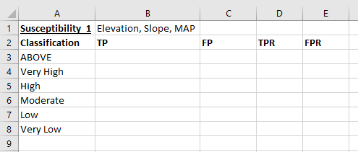

- We are going to start with the ABOVE classification, which is the “cutoff” that is beyond Very High (only has a lower bound). When the cutoff is this high, no landslides in XX_Landslides25.shp (trues) are identified as positive, meaning our True Positives (TP) are zero! Similarly, no pixels (falses) are identified as positives, so the False Positive (FP) is also zero. This means the TPR and FPR are also zero (refer to notes from the powerpoint presentation).
- Now let’s look at the cutoff that defines the Very High/High boundary. Note the cutoff value. In the example the images are based on this cutoff occurs at 291 (remember…1,000x larger than it actually is). In the attribute table of XX_Landslides25.shp use the Select by Attributes function in the upper left dropdown, and select all the points where the RASTERVALU field is greater than 291 (see image below).

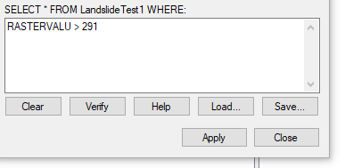
An alternate way to do the same thing is by double clicking the RASTERVALU field and arranging it ascending, then manually selecting all values above the cutoff.

Read the number of selected slides at the bottom of the attribute table and type this in as the TP. These are the landslides that the cutoff agrees are “predicted” as landslides by the model based on a specific cutoff value.

- Repeat step 5, but this time using the attribute table for the raster model itself and the VALUE field. One difference is when everything above the cutoff is selected, right-click on the COUNT field and select statistics. The sum displayed minus the TP value from step 5 is the FP value. This subtraction is necessary to separate true and false components from the model, where known landslides are always true, and pixels predicted to be landslides are false.
- Repeat steps 5/6 for every cutoff. NOTE: when you are at the Very Low cutoff, all landslides and pixels are positives. Look back at the Unit 3 powerpoint on assessing susceptibility models for reference. Your table, while differing in value, should show similar trends as in the image below.
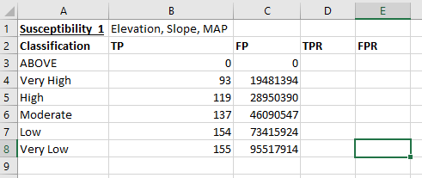

- To calculate TPR, you divide the TP by the total number of landslides (155 in the example given here). Values for TPR should only range from 0-1.
- To calculate FPR, you divide the FP by the total number of pixels in your model. This number can be found by right-clicking the COUNT field of the model when no selections have been made and looking at sum in the statistics option. FPR should only range from 0-1 (not quite reaching 1).
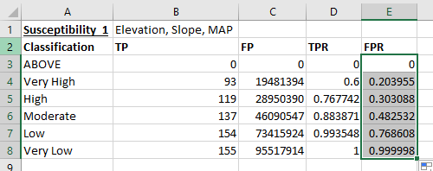

- Plot your TPR (y-axis) against your FPR (x-axis) in a table called ROC for Susceptibility_#, where # is the model number.
- Add a polynomial trendline no greater than fourth order and display the equation on the chart as in the image below.

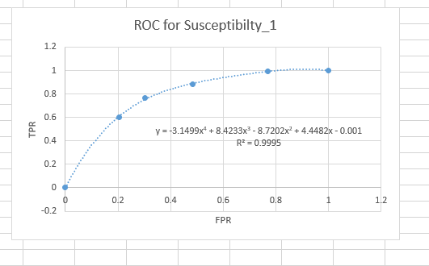

- Use an online integral calculator to calculate the area under the curve (AUC). For the examples shown here, https://www.symbolab.com/solver/definite-integral-calculator was used. If using this tool, make sure to use carrot symbols to enter in powers. See image on next page. The AUC for this example is 0.79. Write this down next to the table you created for susceptibility 1. SAVE YOUR WORK!
- Don’t forget to take notes qualitatively assessing each model as well.
- Repeat the above steps for each individual model.

