GETSI Landscape and Environmental Change Unit 1: Recognition and Quantification of Mass Wasting Features Student Exercise
Stephen Hughes (University of Puerto Rico – Mayagüez) and Bobak Karimi (Wilkes University)

Recognition and quantification of mass wasting features.
Use the data sets provided by your instructor.
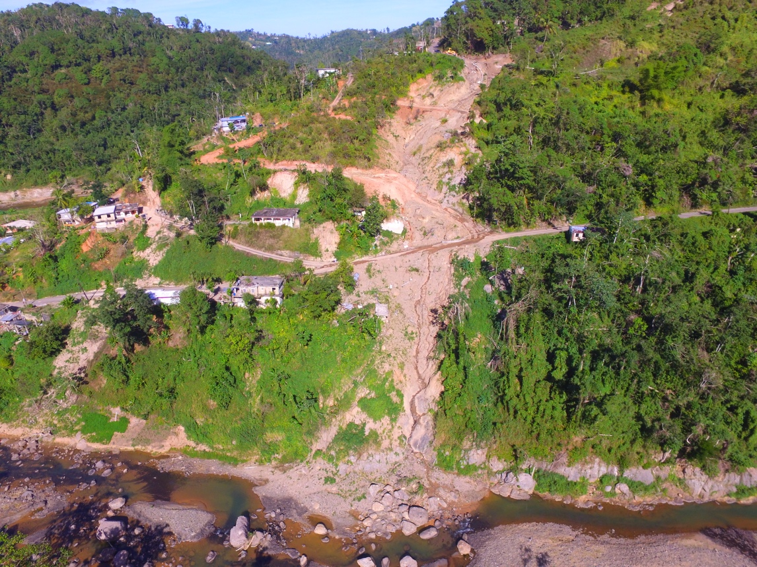
Figure 1. Drone photo from January 10, 2018 of a large slope failure site on PR-4131 road in the municipality of Lares, Puerto Rico caused by Hurricane María in September of 2017. Photo by Stephen Hughes. Location is at (18.250390, -66.884194).

- The data items can be opened in ESRI ArcMap or QGIS. First, the terrestrial laser scanner (TLS) data must be aligned to real world coordinates. This can be carried out in the program CloudCompare. For Windows, download and install the program from http://www.danielgm.net/cc/release/. For Mac, download and install the program from https://asmaloney.com/software/. The version referenced in this document is v2.10alpha on a Windows machine. The other versions should be similar, however if you are using the Mac version 2.11.1 please see the note at the end of this document that details data conversions that may be necessary with this version of CloudCompare.

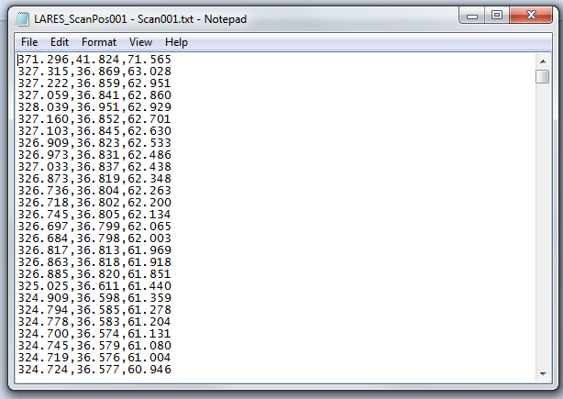
2) In CloudCompare, Open (File > Open) the TLS data file (pr-4131-tls.txt). You will need to specify the file type to include (ascii .txt). This is a comma separated text file with no headers. The scan position was at the following coordinates: (18.247895, -66.882817). This position is across the river from the large slope failure. The units in the scan file are in meters from the scan position. The first column is x, the second column is y, and the third column is z. Figure 2 shows image of file format to the right. There are 15,267,905 points in this dataset. Accept the default import settings when opening the file in CloudCompare, a progress box will appear (Figure 3).
Figure 2. Image of the post data file, showing the x, y, and z coordinates.

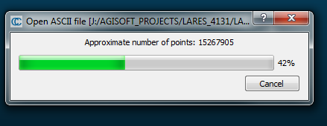
Figure 3. Image of the points from .txt file loading into CloudCompare

3) After the file successfully opens in CloudCompare, we need to ‘clean’ the stray points that may have been caused by water reflection or other anomalous returns. We can also remove points that are far away from the target feature and not needed for the analysis. The best way to do this for this dataset is to view the data in “front view.” This can be done using the small cube on the far left of the program window (Figure 4). If at anytime you “lose” your data and cannot find it, use the magnifying glass tool that is just above the cube icons; this will center your data. In order to navigate around the scene, left-click-and-drag allows you to rotate the scene. Right-click-and-drag allows you to move the center of view. Make sure you click your data layer to highlight it (you will also see a yellow box appear around your data points). Next click the “scissors” tool at the top of the program window. Choose the polygonal selection option and draw a polygon around the points that you would like to keep by left clicking (Figure 4). Close the polygon by right clicking. Choose “Segment In” to keep just the points within the segment area. Then select the Green Check “Confirm Segmentation”.
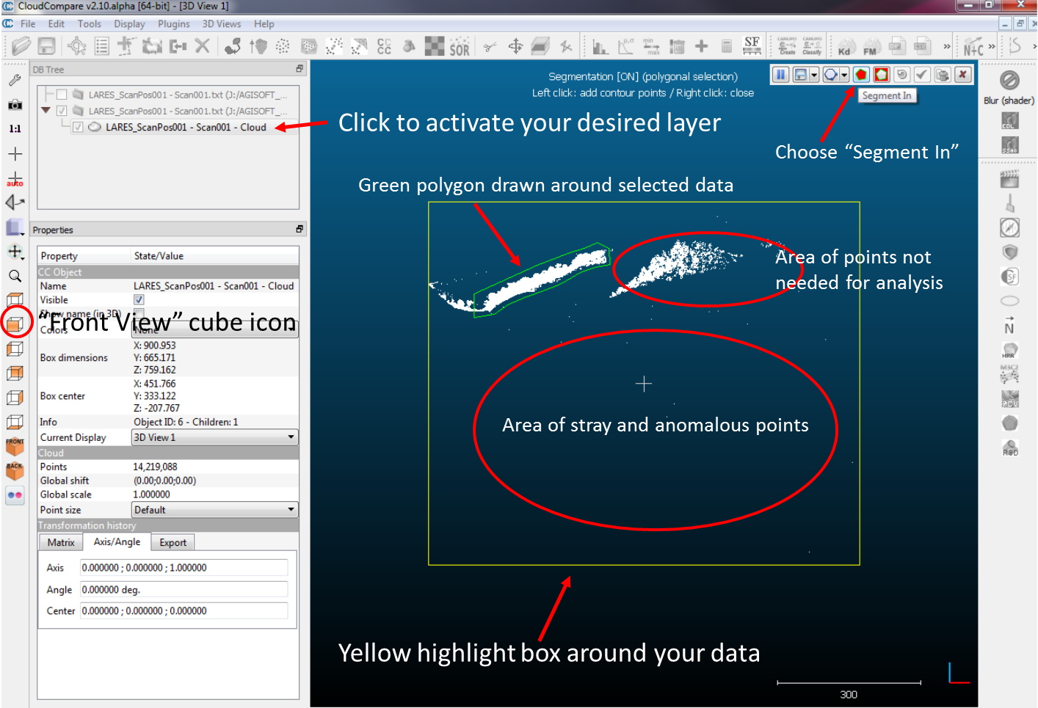
Figure 4. Image of the CloudCompare user interface, the Front View cube icon and an example of green polygon drawn around data that will be used in this exercise.

Make sure the segment is activated in the DB Tree window on the left side of the screen. Then select Edit > Colors > Height Ramp > OK. Notice detail which includes power lines. See Figure 6 for a view of the white inset box.

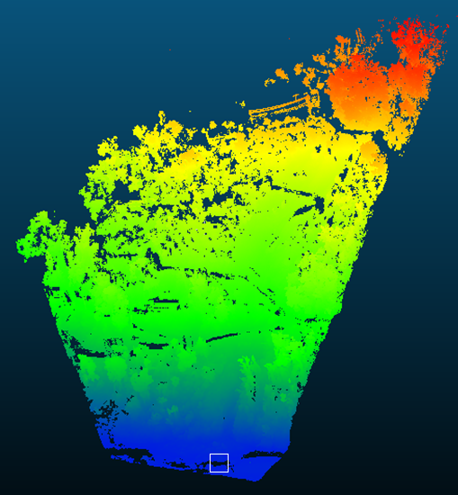
Figure 5. TLS point cloud after using “scissors” tool and applying a height ramp color scheme in CloudCompare.

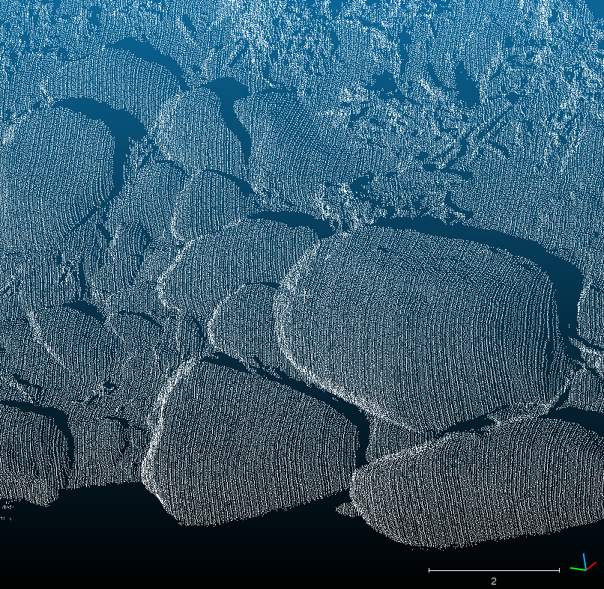
Figure 6. TLS point cloud image of boulders in the toe of the Lares PR-4131 landslide caused by Hurricane María. No data represents areas with no laser return either in the “shadow” of the boulders or where standing water is present in the lower area of the image. The same boulders can also be seen in the photograph on page one of this document.

4) Now that your TLS data is clipped to the proper extent, add in the pre-event USGS LiDAR .las point cloud file in the same workspace in CloudCompare (pr_lares_usgs_lidar_premaria_las). Accept all the default import settings. Notice that the two datasets do not appear in the same location. This is because the post-event TLS dataset does not include any projection information, and the USGS pre-event LiDAR data is projected. It is simple xyz data. The number of points in the USGS Lidar dataset is 27,722,404.
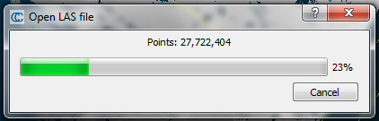
Figure 7. Image of the points from .las file loading into CloudCompare

5) In CloudCompare, give the USGS dataset elevation coloration using EditColorsHeight Ramp. The study area is only one small part of the dataset, so use the “scissors” tool again like you did in Step 3 above to segment only the area of interest (Figure 8). This will create a new layer in your DB Tree (list of layers) and will help the program run faster.

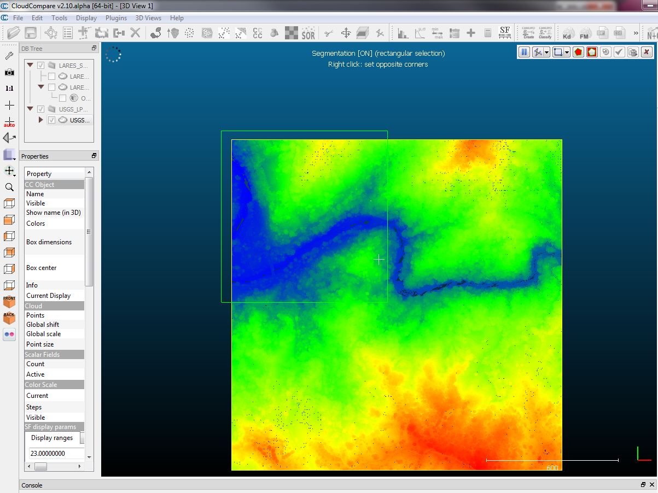
Figure 8. Image of the CloudCompare user interface, and the pre-landslide dataset. Green box shows the selection polygon drawn over the area of interest.
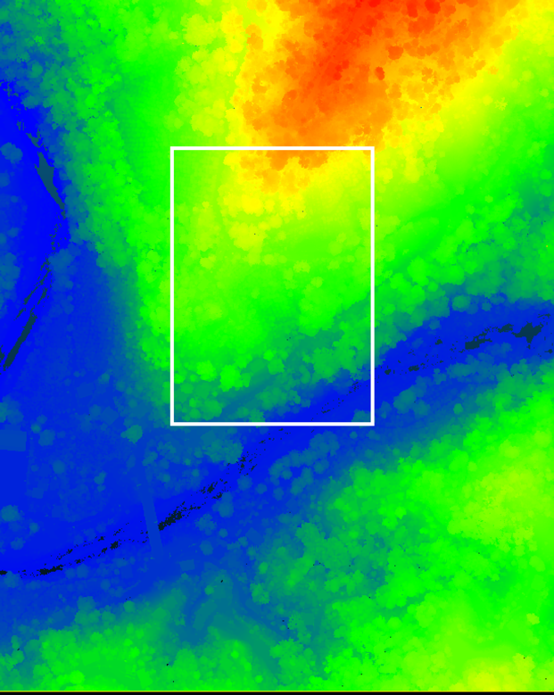
Figure 9. Image of the pre-event point cloud. The relative location of the post-event point cloud is within the white box.
6) Now it is necessary to align the two datasets in CloudCompare. We know that the pre-landslide USGS Lidar point cloud is correctly projected in the NAD83(2011) / Puerto Rico and Virgin Is. projection that has 1 meter units. So we will align our un-projected TLS cloud to the correctly projected USGS dataset. To do this, use CTRL (or “option” + “command” on Mac) to select both of your “clipped” dataset layers in the DB Tree Window and click the align symbol on the top toolbar. The align tool symbol looks like a red polygon with an arrow to a green polygon (Figure 10).
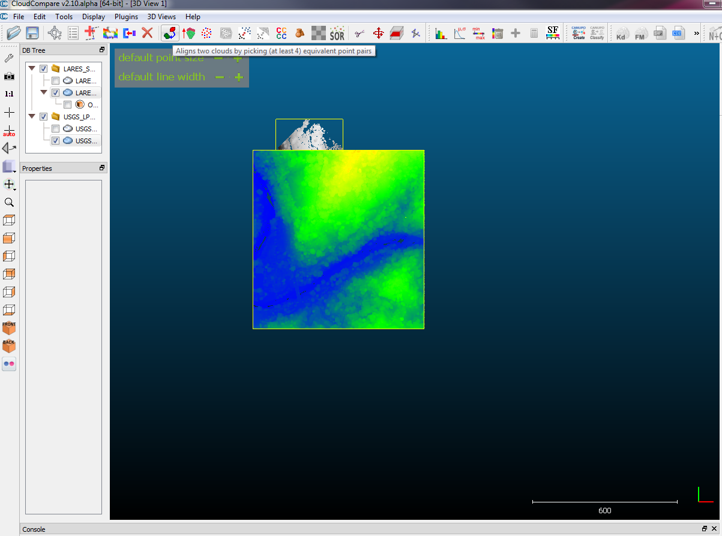
Figure 10. Image of the CloudCompare user interface, with both datasets selected.
It is imperative that you have the USGS layer (pre-event) listed as the “Reference” layer. This is the layer that does not move. The ‘Aligned” layer will be the layer to move, select the post-event TLS dataset as the ‘aligned’ data. A new dialogue box will appear, checking/unchecking either the “show aligned cloud” or “show reference cloud” allows you to toggle between the two (Figure 11).
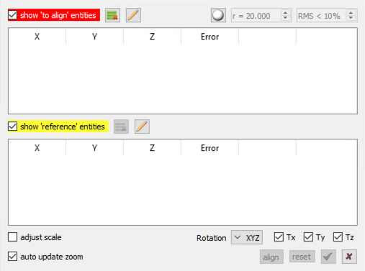
Figure 11. The align with equivalent point pairs tool. Toggle between two datasets by selected/deselecting “show reference/aligned cloud”.
Now is the tedious part. You must zoom in on each layer to select points to “match.” These must be points that have not moved between the two survey periods and should be spread across the dataset and not arranged in a straight line. In this case, there are several houses that make for good targets. It is useful to use the corners of the roofs of the houses as the matching points. See the 4 images below for an example of these points. The first two images (Figure 12) show one structure in the pre-event point cloud, the second two images (Figure 13) show the same structure in the post-event point cloud. At least 3 points should be chosen to perform the align function.
First, uncheck “show aligned cloud” so you only see the reference data (Figure 11). Left click on 3 (or more) features, they will be labeled in the order that you click them (R0, R1, R2…), remember this order for selection on the second dataset. Uncheck “show reference cloud” and check “show aligned cloud”, you should now see the aligned cloud. Left click on the same features in the same order as before, they will be labeled (A0, A1, A2, …). Now select align in the dialogue box (Figure 11), the aligned dataset will move to the reference dataset. When satisfied with the result, click the green check mark. A new box will appear with the transformation matrix that was applied to the aligned dataset, click OK.

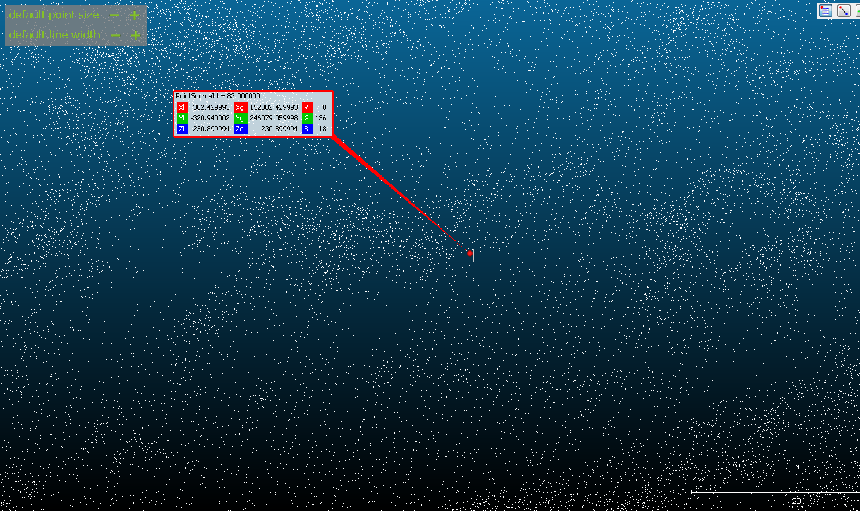
Figure 12. Images of the pre-event point cloud. The top image shows a structure near the landslide event and the bottom image zooms in on this structure and shows the placement of a reference point on the corner of the structure’s roof.
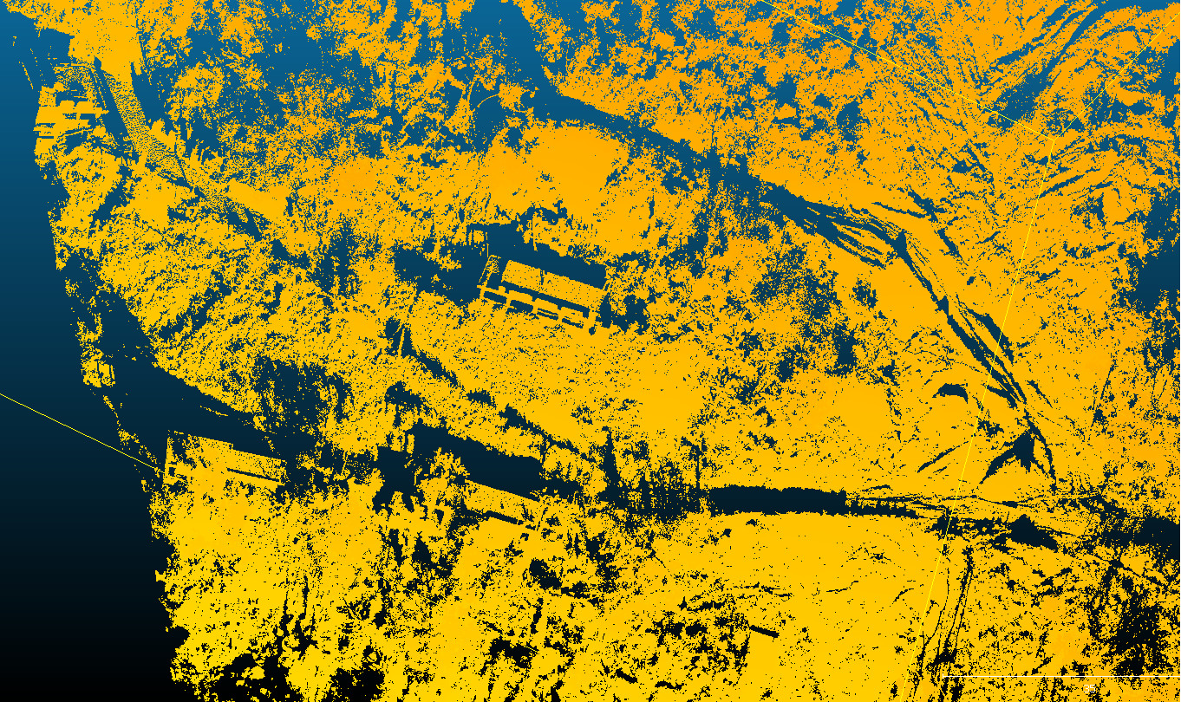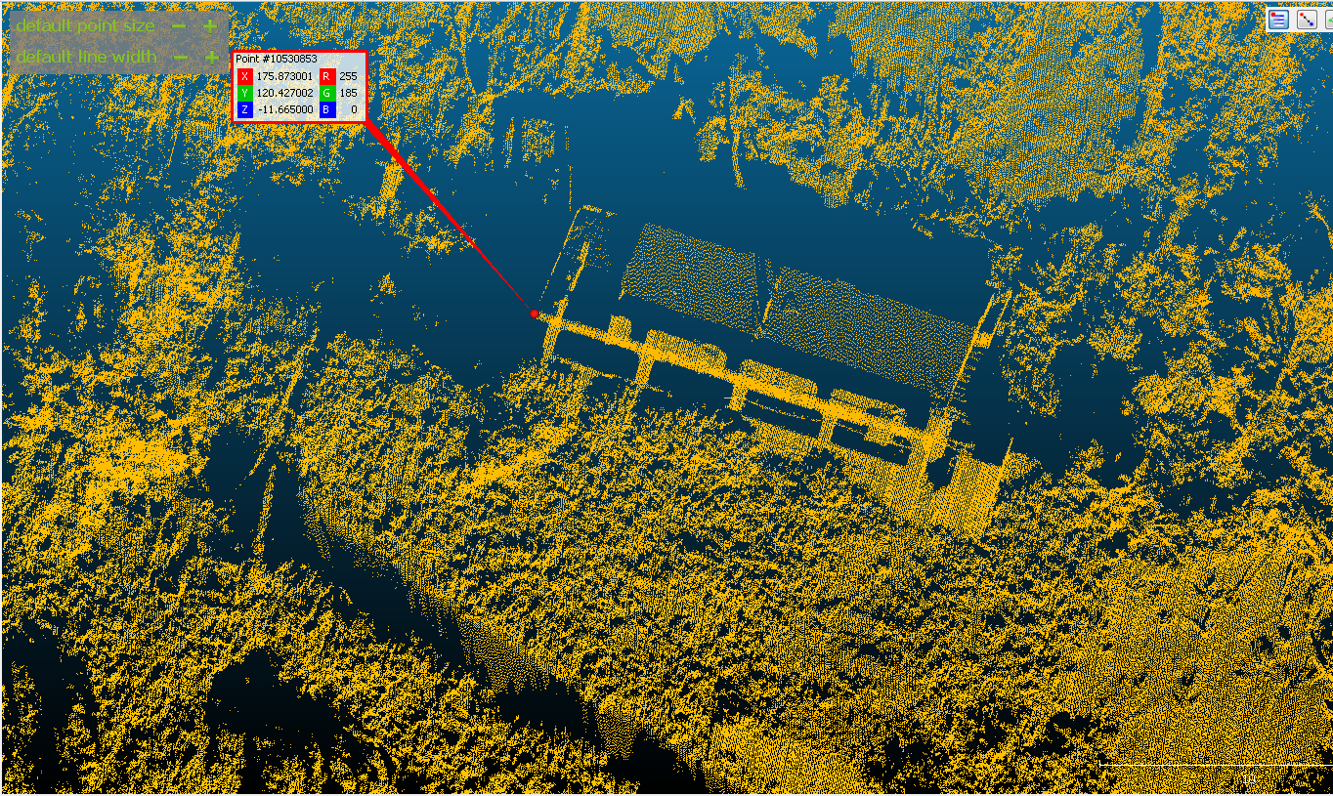
Figure 13. Images of the post-event point cloud. The top image shows the same structure from Figure 12 near the landslide event and the bottom image zooms in on this structure and shows the placement of a reference point on the same corner of the structure’s roof from Figure 12.
Once you have done the alignment, now you should choose the same two layers and carry out the “fine registration.” This tool is directly to the right of the align tool. Once again, make sure to have the USGS pre-event layer as the “Reference” layer. For this exercise, you should accept the default settings in this tool unless otherwise instructed.
7) Now you should save both of the layers. To save, click the layer in the DB Tree box and then FileSave. Save the files each as a LAS file. This is what you will import into ArcMap or other GIS software.

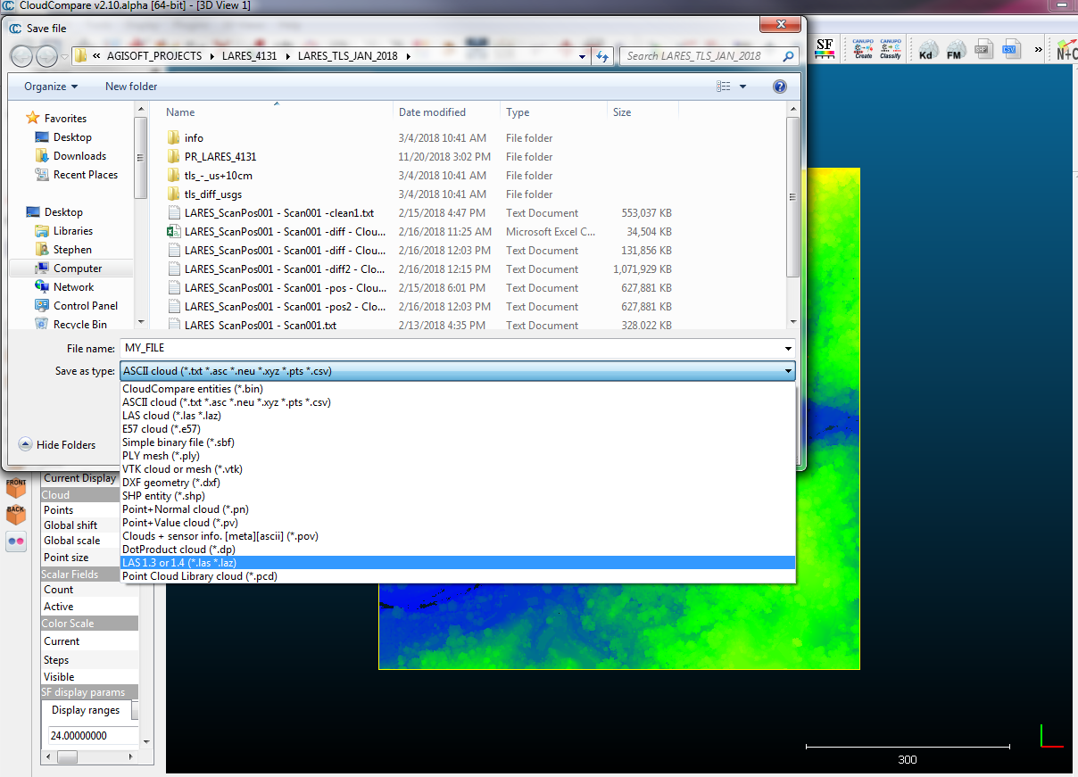

8) In ArcMap, use the “Create LAS Dataset” tool to add each of your files to a new .lasd dataset. Open each LASD file in ArcMap. If they are not aligned horizontally, then you should return to the CloudCompare steps above.
9) Now use the LAS Dataset to Raster tool to convert your LAS data to a raster format. VERY IMPORTANT: for Cell Assignment Type, choose MINIMUM. This is a quick and dirty way to approximate the ground points in each cell. Set the sampling value to 1. This will make the output raster have a horizontal resolution of 1 meter (because the projection units are in meters). Do this process for the LASD made from USGS data and the LASD made from the TLS data.
10) Add the FEMA imagery tile into the ArcMap workspace. Use the imagery and the “Draw” toolbar to trace a polygon around the large failure site. Make sure to include the scarp and toe areas. Convert that polygon into a shapefile using the “Convert Graphics to Features” option on the Draw toolbar.
11) For the two rasters, use the “Extract By Mask” tool to cut the raster based upon the area of the polygon you created. A new raster file will be created for each.
12) Use the “Raster Calculator” tool to difference the two new raster files. It is suggested to subtract the USGS raster (2016) from the TLS raster (2018) so that in the output raster, negative values indicate loss and positive values indicate accumulation.
13) Now prepare a professional set of images in ArcMap to illustrate the change that occurred at the site. The figures should include standard map items and include data overlain on basemaps.

OPTIONAL:
14) Do the same alignment and change detection using the point cloud generated from the provided photogrammetry dataset.

Questions:
- Using the measure tool in ArcMap, what is the length in meters of the failure from head scarp to toe?
- How many structures were affected by the failure?
- Using Google Maps (or similar) what is the change in driving time from the PR-4131 bridge over the Rio Blanco (18.247480, -66.885440) to the city of Lares if PR-4131 is blocked at the landslide headscarp?
- What is the volume change in the overall landslide scar area?
- What is the volume change in the toe area of the landslide? How did the Rio Blanco adjust to the landslide toe development.
- What is the volume change in the area within the PR-4131 switchback?
- Are there any differences between the SfM model generated and the TLS model generated? (if both approaches were carried out) Knowing that the two datasets were collected at the same time, how can these be explained?
- Explore https://storms.ngs.noaa.gov/storms/maria/index.html and locate at least one other landslide in the vicinity of the one studied here. How is it different or similar?
- During Hurricane María, over 40,000 similar slope failures occurred across Puerto Rico, especially in the rugged interior of the island. What are some sediment sinks for the volume of material that was liberated from the hillslopes during that event? What are the potential implications of such a large volume flux on the local environment and local residents?
- How can the forecasted increase in extreme tropical rainfall precipitation events in the next century affect the landscape and built environment in a place like Puerto Rico?
- What kind of measures should be implemented to prepare for future extreme rainfall events and the landslides that could be generated by them?
- Given your understanding of rainfall induced slope failures, how do you envision the landscape response in your local community from a hypothetical extreme precipitation event?
- In addition to slope failures, what other effects might occur in your local community from an extreme precipitation event?
- What is are the benefits and downsides of using either TLS or SfM data at any given site?

Known issues with CloudCompare on macOS (2.11.1) and how to fix them
The version of CloudCompare on macOS is not able to load LAS v1.4 files and the pre-event USGS data used in this exercise is LAS v1.4. For this reason, it is necessary to downgrade from v1.4 to v1.2 if you are attempting to do this exercise on macOS. If you see the message below when you try to load the pre-event data you will need to convert the file.
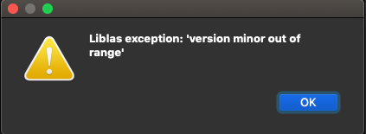
You will need three tools/packages installed on your macOS: 1) Homebrew, 2) Wine, 3) LASTools. For more information see: https://rapidlasso.com/2014/10/04/using-lastools-on-mac-os-x-with-wine/
- First, if you do not already have it installed you will need to install Homebrew. Homebrew is an open source software package that helps install software on macOS To do this, open a Terminal window and copy and paste the following:
/bin/bash -c "$(curl -fsSL https://raw.githubusercontent.com/Homebrew/install/HEAD/install.sh)"
For more detailed instructions see the Homebrew website: https://brew.sh/
- Next you will need to install Wine, which is a free software that allows users to run Windows applications without a copy of Microsoft Windows. To install wine, copy and paste the following in your Terminal window:
brew install wine

For more detailed instructions see the Wine website: https://wiki.winehq.org/MacOS

- Next you will need to download LAStools from this website: http://lastools.org/

Put the folder in a directory on your system but avoid directories with spaces/symbols. Navigate to this LAStools folder and unzip it:

unzip LAStools.zip

Navigate to the bin folder:
cd LAStools/bin

Now type the following command to convert the original pre-event LAS file from v1.4 to v1.2 (replace the path and file names to match your directory structure):

wine las2las -i pathtoyourfile/USGS_LPC_PR_PuertoRico_2016_LAS_2017.las -set_version 1.2 -o pathtoyourfileoutput/name_the_new_file_v1_2.las

The new file will now be LAS v1.2 and will be able to load into CloudCompare on macOS.

