Ice Mass & Sea Level Change Unit 5: Tide Gauge Exercise
Becca Walker and Leigh Stearns
In Units 3 and 4, you explored how changes in the Greenland Ice Sheet contribute to sea level rise. We use the term “eustatic” when referring to global changes in sea level relative to a fixed point, such as the center of the Earth.
However, individual coastlines undergo their own vertical changes due to tectonic activity, erosion, and coastal subsidence. “Relative sea level changes” refer to changes in sea level relative to a point on land that is also changing. So far, we’ve been looking at eustatic sea level changes, but in this unit, we will be focusing on relative changes in specific areas.

Part 1:
Navigate to the NOAA Tides and Currents sea level trend viewer at the URL below and answer the following questions. http://tidesandcurrents.noaa.gov/sltrends/sltrends.html

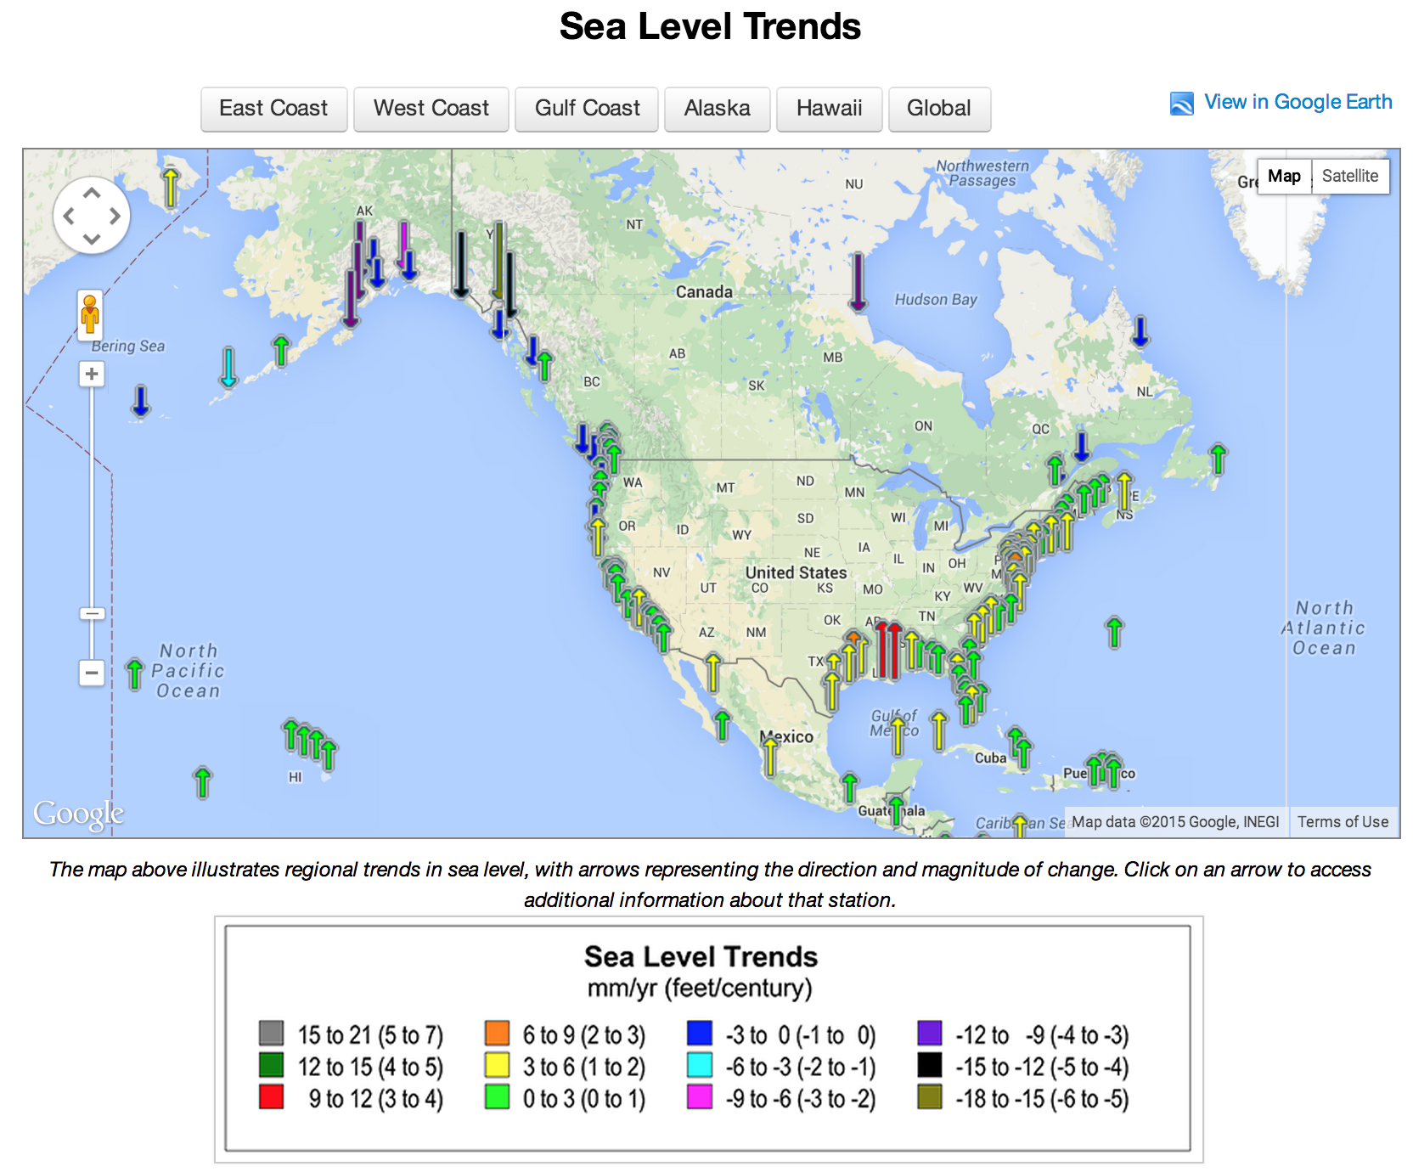
Figure 1: Homepage for NOAA Tides and Currents sea level trend viewer.

You should see a map showing parts of North America and Central America. Take a look at the legend below the map, which illustrates sea level trends listed in millimeters per year and, in parentheses, feet per century. Every arrow on the map represents a different station along the coast that collects sea level data. The sea level trend measurement for each station can be viewed by clicking on the appropriate arrow.

(1) Find a region on the map that has relatively uniform sea level trends sea level trends are relatively uniform.
(a) Where is this region?

(b) How did you decide that the sea level trends in this area are relatively uniform?

(c) Make an estimate of the average sea level trend in this area. Express your answer in mm/year and make sure that your answer includes whether the sea level trend is positive (rising) or negative (dropping).

(d) Why do you think that sea level trends are similar throughout this region?

(2) Find a region on the map where neighboring sea level trends are very different.
(a) Where is this region?

(b) How did you decide that the sea level trends in this area are very different?

(c) Make an estimate of the range of sea level trends in this area. Express your answer in mm/year and make sure that your answer includes whether the sea level trends are positive (rising), negative (dropping), or both.

(d) Why do you think that sea level trends are so different in this region?

(3) Do you think policy makers are most concerned about projections of relative sea level changes, eustatic sea level changes, or both? Explain your answer.

(4) If there is anything about these questions or the data that is confusing or unclear, please explain in the space below.

