Ice Mass & Sea Level Change Unit 5: Southern California vignettes

Becca Walker and Leigh Stearns

# Part 1: Background

With current sea levels, California’s coastline is already susceptible to flooding and coastal erosion, but what will the consequences be in the event of future sea level rise? Different climate models have predicted varying amounts of sea level rise that California’s coastline will experience by 2100, but these predictions range from about 40 cm-1.4 m of sea level rise by 2100. In this section, you’ll read about 4 ways that Southern California (defined here as Los Angeles County, Orange County, and San Diego County—see Figure 1) could be impacted in the next century by sea level rise.

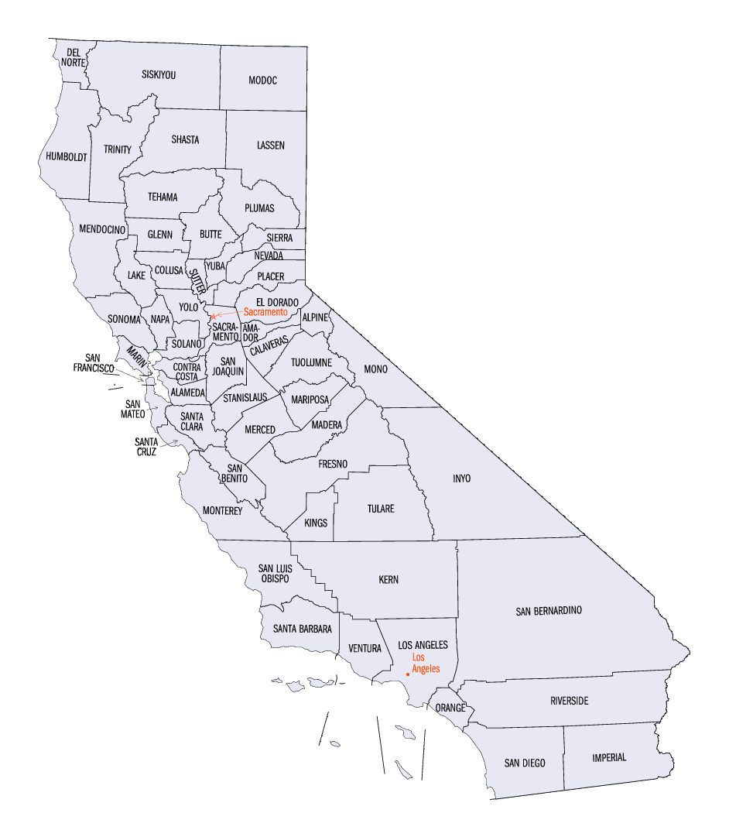

**Figure 1**. Map illustrating the counties in California. http://quickfacts.census.gov/qfd/maps/california\_map.html.

## A couple of notes before you get started:

1) Keep in mind that when scientists and stakeholders consider potential impacts of sea level rise, they often consider a particular area’s susceptibility to a **100-year flood** event and how sea level rise could increase the probability of a 100-year flood in the area. A 100-year flood means a flood event that has a 1% change of occurring in any given year.

2) Your work with sea level change so far has been mostly related to changes in ice mass and its influence on sea level. There are many additional factors that scientists and stakeholders must take into consideration when thinking about future sea level changes in a particular area, including, but not limited to, sea level variability from El Nino events; the shape of the coastline in a particular area; changes in ocean circulation patterns; and coastal subsidence (sinking) due to the extraction of fluids from the subsurface (groundwater and petroleum).

# Part 2: Vignettes

## Issue #1: Any port in the storm

A **port** (Figure 2) is an area adjacent to a body of water that has the infrastructure to allow ships to load and unload freight. Some ports are located inland on natural or human-made rivers or canals, while other ports are located in coastal areas on the shores of bays, seas, gulfs, or oceans.

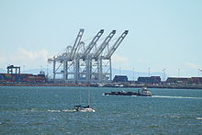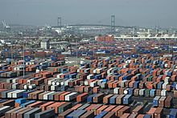

**Figure 2**: Port of Long Beach, Los Angeles, CA. (Right) A south looking view of the Port of Long Beach. (Left) Port of Long Beach, Container terminal. https://en.wikipedia.org/wiki/Port\_of\_Long\_Beach

The American Association of Port Authorities (AAPA) estimates that United States ports are responsible for $3.95 trillion in international trading per year and 13.3 million jobs. Ports allow, for example, food grown in the Midwest to be eaten in Europe and Asia and automobiles manufactured in Michigan to be sold overseas. In addition to importing goods from other countries and exporting products made in the United States to other countries, ports are also important for domestic trading—in fact, the AAPA estimates that 1 billion tons of domestic goods are transported every year within the United States. As the global economy continues to grow and more countries undergo industrialization, United States ports are becoming even busier. The US Department of Transportation projects that from 2001 to 2020, the total freight traveling through United States ports will increase by more than 50%. In short, ports have a tremendous impact on the United States (and global) economy, as well as our daily lives.

As such, disruption of ports due to environmental problems is catastrophic. For example, the 1989 Loma Prieta earthquake in the San Francisco area damaged the Port of Oakland and interfered with port operations for 18 months, costing the United States $1-$2 billion/day (California Climate Change Center, 2009.) Regardless of whether or not one lives in a community with a port, port damage will significantly impact one’s life. Despite global dependence on ports, a 2011 study by the International Association of Ports and Harbors (IAPH) found that although most port design standards consider historic flood and storm events, approximately 50% of ports do not consider future impacts of climate change in their design standards.

**Table 1:** This table lists the top 10 United States ports in total trade, including imports, exports, and domestic trading.1 Sea level rise in Southern California will have significant impacts on the Port of Long Beach and the Port of Los Angeles, both on the United States top 10 list.

|  |  |  |  |
| --- | --- | --- | --- |
| **Rank** | **Port name, city, state** | **Total cargo in 2009 (tons)** | **Coastal or inland?** |
| 1 | Port of South Louisiana, New Orleans, LA | 212,580,811 | Inland (Mississippi River) |
| 2 | Port of Houston, Houston, TX | 211,340,972 | Inland (Houston Ship Channel) |
| 3 | Port Authority of New York/New Jersey, Newark, NJ | 144.689,593 | Coastal and inland |
| 4 | Port of Long Beach, Long Beach, CA | 72,500,221 | Coastal (Pacific Ocean) |
| 5 | Port of Corpus Christi, Corpus Christi, TX | 68,239,958 | Coastal (Gulf of Mexico via Corpus Christi Bay) |
| 6 | Port of New Orleans, New Orleans, LA | 68,126,087 | Inland (Mississippi River) |
| 7 | Port of Beaumont, Beaumont, TX | 67,715,469 | Inland (Sabine-Neches Ship Channel) |
| 8 | Port of Huntington—Tristate, Huntington, WV | 59,171,545 | Inland (Ohio, Scioto, Big Sandy, and Kanawha Rivers) |
| 9 | Port of Los Angeles, Los Angeles, CA | 58,406,060 | Coastal (Pacific Ocean) |
| 10 | Port of Hampton Roads, VA | 58,369,087 | Coastal (Chesapeake Bay) |

12009 data, American Association of Port Authorities

## Issue #2: Power and wastewater treatment plants

A 1.4 meter sea level rise will put 30 power plants and 28 wastewater treatment plants in California in jeopardy of damage—of these, 10 power plants and 1 wastewater treatment plant are in Southern California (Figure 3, Figure 4). Destruction of power and wastewater treatment plants has major environmental implications and will also likely lead to increases in utility costs for residents. Perhaps more problematic is the number of hazardous waste sites in Southern California that could be vulnerable to flooding if sea levels continue to increase. Currently, Los Angeles, Orange, and San Diego Counties have 13, 4, and 0, respectively, hazardous waste sites in 100-year flood zones. With a 1.4 m sea level rise, these numbers rise to 26, 16, and 13. Stakeholders must consider the environmental impacts of hazardous waste site inundation, whether or not to relocate the sites, and if so, where the new sites will be constructed and who will bear the financial responsibility.

Fig23_Powerplants_Inundation_SoCal.pdfFig24_WWTP_CA.pdf

**Figure 4**: Wastewater treatment plants vulnerable to a 100-year coastal flood with a 1.4 meter sea level rise. From Pacific Institute Thematic Maps series.

**Figure 3**: Southern California power plants vulnerable to a 100-year coastal flood with a 1.4 meter sea level rise. From Pacific Institute Thematic Maps series.

## Issue #3: Roads and railroads

Analysis of the roads and railroads in Southern California indicates that a 1.4 meter sea level rise will put over 700 miles of roads and 30 miles of railways at risk of destruction. The implications for transportation of goods, especially agricultural products, and road traffic patterns could be crippling. Raising the level of coastal roadways and railways to prevent them from flooding during storms or over longer timescales as sea levels rise is an option being considered by stakeholders. Another possible choice is the relocation of roads and railways, but these projects come at financial and time costs and will likely result in the displacement of residential and commercial structures located where the future road will be constructed, as well as the possibility of destruction of rare plant and animal habitats to make space for the road.

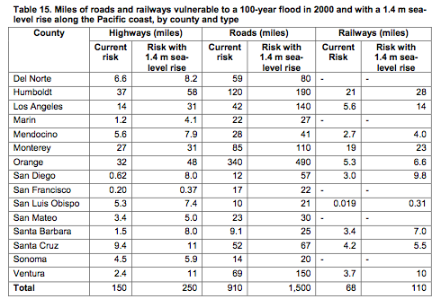

**Table 2**: data from California Climate Change Center.

## Issue #4: Land loss

There are several sea level rise-related factors that could result in a loss of land in Southern California coastal areas. Approximately 72% of California’s coastline is erosional in nature, meaning that more Earth material is removed from the coast (primarily as a result of wave action) than is deposited on the coast. In contrast, only 28% of the California coast consists of depositional features such as coastal sand dunes, bays, wetlands, and lagoons in which sediment is added to the coastline (source: Sea Level Rise California). As sea level rises, erosion rates increase.

Assuming a 1.4-meter sea level rise, increased erosion, inundation of the coast, and coastal subsidence are predicted to result in the loss of 21 square miles of land in Southern California by 2100. Because the Southern California coast is densely populated, this land loss will result in the displacement of approximately 14,000 people from land that will be underwater, $100 billion in property replacement, and almost 500,000 residents at increased risk of flooding because of the new location of the coastline.

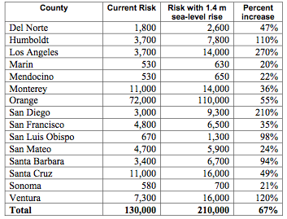

With a 1.4 meter sea level increase, $17 billion in building replacement costs would be necessary in Orange County; $3.8 billion for Los Angeles County, and $2 billion for San Diego County. Most of these buildings are residential, roughly 20% are commercial buildings, and a small percentage of buildings at risk are industrial, government, education, and religious buildings. In preparation for these land loss-associated challenges to residents, infrastructure, and the economy, stakeholders must consider how to respond to the possibility of coastal land loss within the next century. One option involves the construction of **structural measures**, defensive structures designed to protect the coast from erosion and flooding. Some examples of structural measures include:

**Table 3:** California population at risk of a 100-year flood along the Pacific Coast by county. Data from California Climate Change Center.

* importing fill (sediment) into a coastal area, essentially creating artificial land, and building **bulkheads** to keep the fill in its desired location;
* constructing **artificial sand dunes** or **seawalls** to protect the coast from erosion by storm waves;
* building **revetments** along the coast to protect the coast from erosion by “normal” (i.e., not associated with a storm) waves;
* constructing dikes and levees for flood control in coastal areas where rivers are present.

Structural measures come at a high cost. In areas where no structural measures exist, cost estimates for Southern California are $5300 per linear foot for seawall construction and $3800 per linear foot for levee construction. Who should be responsible for shouldering these costs and whether or not structural measures should be pursued in Southern California are highly controversial issues.

**Nonstructural measures** are another strategy employed to prepare for loss of coastal land. Nonstructural measures in response to sea level rise include:

* disassembling current coastal fortification structures (for example, dismantling an existing seawall);
* stopping ongoing maintenance on coastal fortification structure, thereby allowing them to erode and disappear;
* abandoning land and/or infrastructure that is in an area at risk of destruction from sea level rise;
* prohibiting additional residential, commercial, or conservation-related development in areas that are at risk of destruction from sea level rise.

