Ice Mass & Sea Level Change Unit 2: Temperature - A Global Trendsetter

Becca Walker and Leigh Stearns

*Global air temperatures are calculated using satellite observations, ground-based weather stations, and a lot of statistical corrections to merge the two and account for the fact that weather stations are not uniformly distributed across the globe. In this activity, students will calculate temperature and sea level trends and use their calculations to project temperature and sea level data points for the year 2100.*

# Part 1: Air Temperature Anomalies

The graph that you were given (or created yourself) shows global air temperature anomalies from 1880 to present. **Anomalies** are the difference between a reference temperature (or sometimes a long-term average) and the temperature that is recorded for a particular year. Essentially, an anomaly is the difference from what is “expected” given the reference temperature. Time series graphs showing temperature anomalies are sometimes more useful than graphs showing only temperature because the anomaly graphs allow trends and patterns to be recognized more easily.

(1) A positive temperature anomaly indicates (circle the correct answer):  
(a) warmer air temperatures than expected (b) cooler air temperatures than expected  
(c) the same air temperatures as expected

(2) A negative temperature anomaly indicates (circle the correct answer):  
 (a) warmer air temperatures than expected  
 (b) cooler air temperatures than expected  
 (c) the same air temperatures as expected

(3) An air temperature anomaly of zero indicates (circle the correct answer):  
 (a) warmer air temperatures than expected  
 (b) cooler air temperatures than expected  
 (c) the same air temperatures as expected

**Figure 1 is a global temperature anomaly graph. The graph uses a reference period between 1951 and 1980, which was considered a period of stable climate. Answer the questions below based on the global air temperature anomaly graph:

**Figure 1**: Global temperature anomaly graph from <https://data.giss.nasa.gov/gistemp/graphs_v4/>.

(4) During which time period were temperatures cooler than expected?

(5) During which time period were temperatures warmer than expected?

(6) During which time period were temperatures at the expected level? Why?

(7) How much warmer are global temperatures today than in 1980?

# Part 2: Air Temperature and Sea Level

Look over Figure 2 (measured air temperature anomalies from 1992–2021) and Figure 3 (measured sea level rise from 1992–2020), and answer the following questions.

**Figure 2**: Global air temperature anomaly data, for 1992–2021. Data are available [*http://data.giss.nasa.gov/gistemp/*](http://data.giss.nasa.gov/gistemp/) .



**Figure 3**: Global sea level change, for 1992–2020. Data are available at [*http://sealevel.colorado.edu*](http://sealevel.colorado.edu).

(8) How are the air temperature trend and sea level rise trend similar?

(9) How are the air temperature trend and sea level rise trend different?

(10) Explain what might account for these similarities and differences.

(11) How many degrees did average air temperature change between 1992 and 1998?

(12) How much did sea level change between 1992 and 1998?

(13) Assume that the relationship between air temperature and sea level rise is linear. Based on the trend that you identified in the previous question (for 1992–1998), what is the relationship between air temperature increase and sea level rise?

A temperature rise of 1**°**C causes a ___________ mm rise in sea level.

# Part 3: Air Temperature and Sea Level Projections

Policy makers need estimates of how sea level and air temperatures will change in the future. Below are graphs that show these predictions, based on a number of different climate models and ranges for how energy-efficient our world will be in the next 100 years. Please look at Figure 4 below and carefully read the caption to understand what the graph is showing.

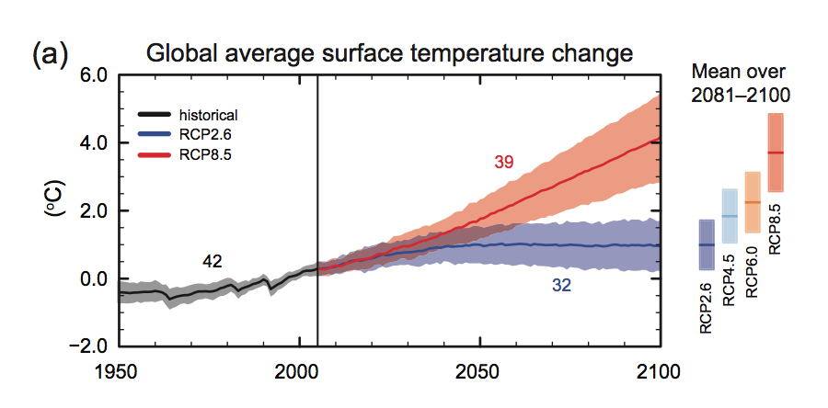

**Figure 4**: The Intergovernmental Panel on Climate Change (IPCC) estimate for air temperature change by 2100. The black line and grey shading show observational records (like those in Part 1) based on existing air temperature data. The red line (top line) shows air temperature predictions based on a scenario in which no improvements in energy efficiency or population control occur. The blue line (bottom line) shows the best-case scenario in which significant improvements in energy efficiency and population control occur. The shading represents the errors associated with the observations and predictions.

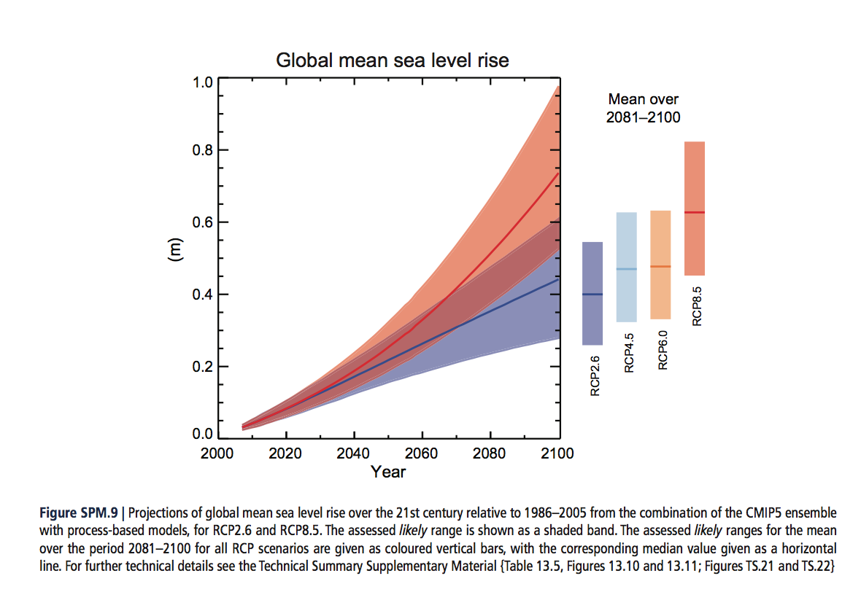

**Figure 5**: The IPCC estimate for global mean sea level rise by 2100. The red line (top line) shows predictions based on the worst-case scenario (same as for the predicted air temperature graph), whereas the blue line (bottom line) shows the best-case scenario. The shading represents the errors associated with the observations and predictions.

(14) Describe how the predicted trends in Figures 4 and 5 are similar.

(15) Describe how the predicted trends in Figures 4 and 5 are different.

(16) Look at the worst-case scenarios (red lines, ignoring the shading) for Figures 4 and 5 again. On each plot, draw a linear (straight-line) trend from the beginning of the red line to the year 2100. According to the linear trend line that you just plotted on the graph:

What is the total predicted temperature change from 2000–2100?

What is the total predicted sea level change from 2000–2100?

(a) An increase in air temperature of 1**°**C would cause a ______ m rise in global sea level.  
  
(b) An increase in air temperature of 2**°**C would cause a _______ m rise in global sea level.  
  
(c) An increase in air temperature of 4**°**C would cause a _______ m rise in global sea level.

(17) How does your estimate (in question 16) compare with what you calculated in question 12?