Ice Mass & Sea Level Change Unit 4: Additional Calculations
Becca Walker and Leigh Stearns
Instructors may have students calculate the amount of water that Helheim Glacier contributes to global sea level instead of simply giving them the solution. The calculation involves basic equations for area, volume, and unit conversions. They will need a calculator for exact results or can make rough estimates of the values.

Part 1: How much water does Helheim Glacier contribute to global sea level?
In this exercise, you will calculate the amount of water that Helheim Glacier contributed to global sea level between 2003 and 2011. First, you will calculate the volume loss, then you will determine how much sea level rises once that liquid flux is spread across the global ocean.

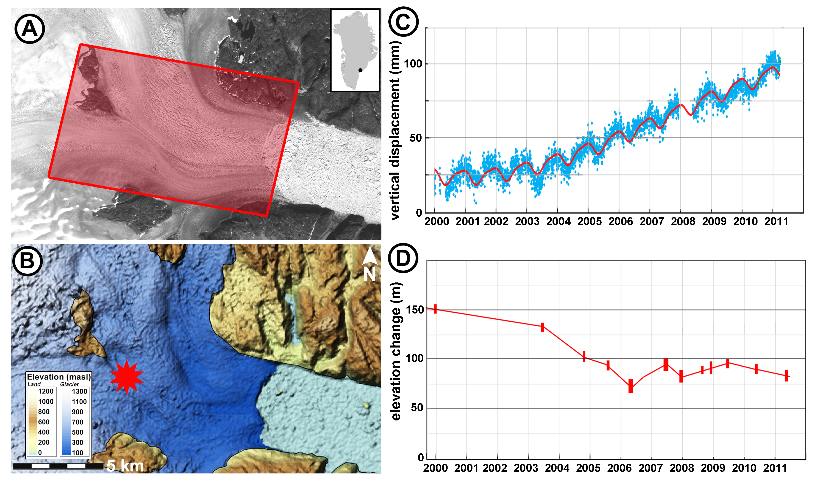
Figure 1: A. Landsat image of Helheim Glacier. The red box illustrates the region where students will calculate the volume change. B. Surface topography of Helheim Glacier. The red star shows the location of the elevation time series in panel D (Stearns and Hamilton, 2007). C. GPS time series showing vertical change since 2000 (Bevis et al., 2012). D. Time series of elevation from 2000 to 2011, (Csatho et al., 2014).

First, we will calculate how much ice is added to the oceans. For simplicity, let us assume that all the thinning on Helheim takes place uniformly over the box in Figure A. We will also assume that the ice in the red box is thinning at the same rate as what is observed at the star in Figure B (and shown in a time series in Figure D).

- The red box in Figure A is 6 km x 60 km. The box area is ___________.

- From Figure D, what was the elevation change from 2003 to 2011? __________.

- What is the volume of ice lost in the red box from 2003 to 2011? ____________.

- The answer (#3) gives the volume of ice added to the oceans. Do we need to convert ice volume to water volume or are they the same?
Same Not same

(If you are unsure about your answer, watch this YouTube video: https://www.youtube.com/watch?v=aOCqHRpQh88)

- The oceans have an area of roughly 361 million km2. Calculate how much sea level the volume you calculated above (#3) added to the oceans between 2003 and 2011. ______________.

- Calculate the sea level contribution per year. _______________.

- Look at Figure D again. The calculated rate of sea level rise is the average from 2003 to 2011. During what time period did most of this change take place? _________________.

- What is the maximum rate of sea level rate of contribution (divide your answer in #5 by the time you estimated in #7)? _______________.

References
Bevis, Michael, John Wahr, Shfaqat A. Khan, Finn Bo Madsen, Abel Brown, Michael Willis, Eric Kendrick, Per Knudsen, Jason E. Box, Tonie van Dam, Dana J. Caccamise II, Bjorn Johns, Thomas Nylen, Robin Abbott, Seth White, Jeremy Miner, Rene Forsberg, Hao Zhou, Jian Wang, Terry Wilson, David Bromwich, and Olivier Francis. 2012. Bedrock displacements in Greenland manifest ice mass variations, climate cycles and climate change. PNAS 2012 109 (30) 11944-11948, 2012, doi:10.1073/pnas.1204664109
Csatho, Beata M., Anton F. Schenk, Cornelis J. van der Veen, Gregory Babonis, Kyle Duncan, Soroush Rezvanbehbahani, Michiel R. van den Broeke, Sebastian B. Simonsen, Sudhagar Nagarajan, and Jan H. van Angelen. 2014. Laser altimetry reveals complex pattern of Greenland Ice Sheet dynamics. PNAS 2014 111 (52) 18478-18483, doi:10.1073/pnas.1411680112
Stearns, Leigh, and Gordon S. Hamilton. 2007. Rapid volume loss from two East Greenland outlet glaciers quantified using repeat stereo satellite imagery. Geophysical Research Letters. Vol. 34, L05503, doi:10.1029/2006GL028982.

PNAS (Proceedings of the National Academy of Science) allows reuse of published figures for non-commercial and educational uses. (http://www.pnas.org/site/aboutpnas/authorfaq.xhtml). Geophysical Research Letters allows reuse of a single figure from an article for non-commercial and education uses.

