Ice Mass & Sea Level Change Unit 1: Bangladesh sea level change vignettes
Becca Walker and Leigh Stearns
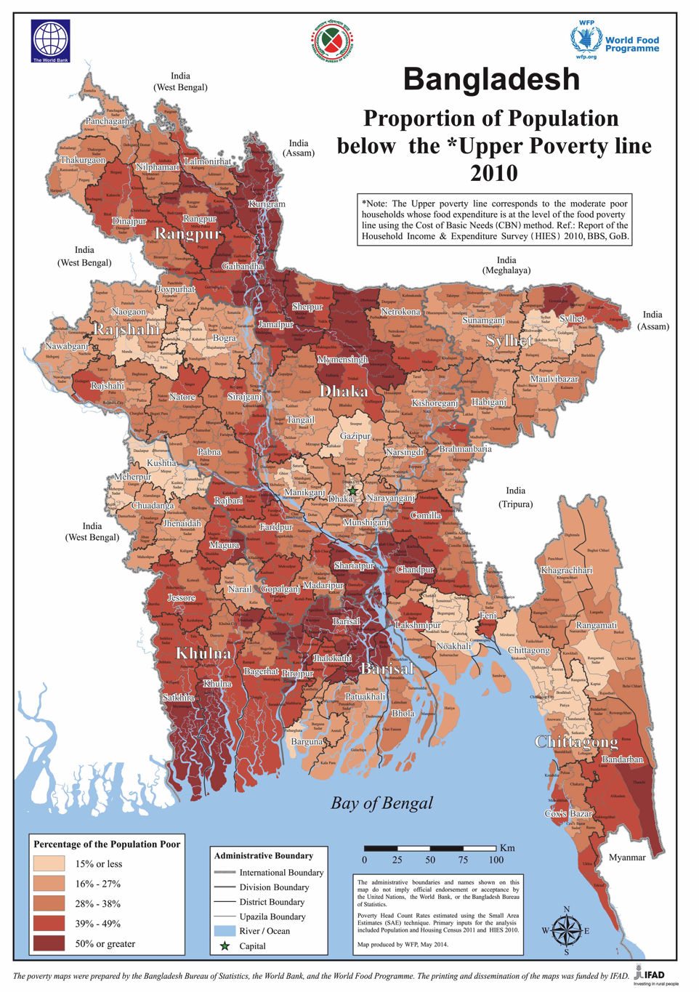
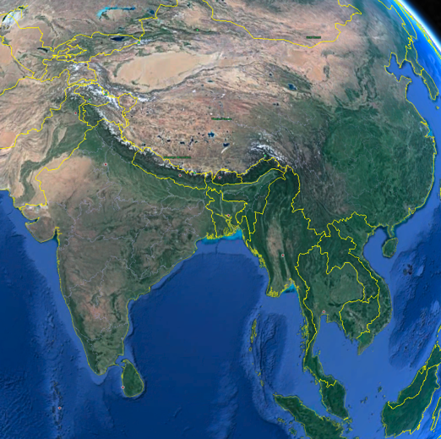
Sea level rise is already impacting Bangladesh in many ways. Bangladesh is a low-lying, coastal nation that is particularly vulnerable to sea level rise given its 710 km long coast, high population density, and pervasive poverty (Figure 1). The United Nations estimates that approximately 35.1 million people live in Bangladesh's coastal zone, over half of whom are considered "absolute poor". Roughly 1/3 of the population lives on less than $1 per day (Powers, 2012). With respect to population, Bangladesh has 3 of the 20 top cities in the world at risk of coastal flooding by the 2070s (Nicholls et al., 2007). Land erosion, salinity intrusion, and loss in biodiversity have already been observed and threats to the well being of Bangladesh's economy, political system, infrastructure, and residents will expand as sea level continues to rise. Below, read about some of the anticipated impacts of sea level rise on this coastal country.
Figure 1. Maps of Bangladesh depicting the overall location in Asia and the proportion of population below poverty. Left image: Google Earth
Right image: http://www.worldbank.org/en/news/press-release/2014/08/27/latest-bangladesh-poverty-maps-launched (World Bank has released under creative commons license)

1: Increased damage from cyclone storm surges
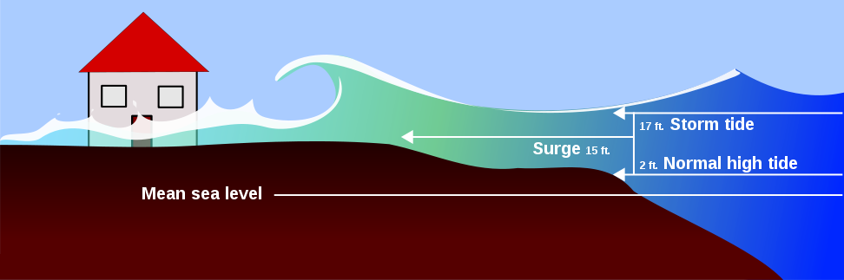
Cyclones and storm surges threaten coastal communities worldwide. A storm surge is the difference between the water level under the influence of a disturbance (storm tide) and the normal level that would have been reached in the absence of the meteorological disturbance. The World Health Organization reports that the number of cyclones has increased more than threefold from 1970 to 2006. The strength and number of major cyclones may be increasing because of higher sea surface temperatures associated with global warming. Tropical cyclones and storm surges are particularly severe in the Bay of Bengal region.
Bangladesh is especially vulnerable to cyclones because of its location at the triangular shaped head of the Bay of Bengal, the sea-level geography of its coastal area, its high population density and the lack of coastal protection systems. During the pre-monsoon (April–May) or post-monsoon (October–November) seasons, cyclones frequently hit the coastal regions of Bangladesh. About 40% of the total global storm surges are recorded in Bangladesh, and the deadliest cyclones in the past 50 years, in terms of deaths and casualties, are those that have struck Bangladesh. In addition to the immediate death and suffering caused by such disasters, cyclones also have direct and indirect impacts on general public health, livelihoods, infrastructure, the economy and sociocultural foundations. They can affect access to food and drinking water, and increase the transmission risks of infectious diseases.
Figure 2. A storm surge is a rise above the normal water level along a shore resulting from strong onshore winds and / or reduced atmospheric pressure. Storm surges accompany a tropical cyclone as it comes ashore. They may also be formed by intense low-pressure systems in non-tropical areas. https://en.wikipedia.org/wiki/Storm_surge.

2: Saltwater incursion
Because most of the surface water (lakes, rivers, and streams) in Bangladesh are too polluted for consumption, the vast majority of drinking water comes from extracting groundwater from the subsurface via wells. When sea level rises in a coastal area, a phenomenon called saltwater incursion (sometimes referred to as saltwater intrusion) occurs.
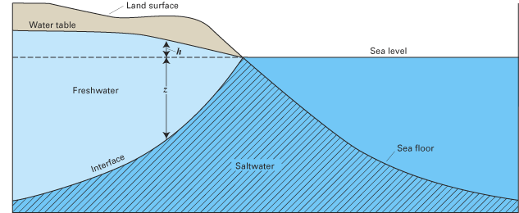
Figure 3. Under natural conditions, the seaward movement of freshwater prevents saltwater from encroaching coastal aquifers, and the interface between freshwater and saltwater is maintained near the coast or far below land surface. Seawater intrusion is the movement of seawater into fresh water aquifers due to natural processes or human activities. Seawater intrusion is caused by decreases in groundwater levels or by rises in seawater levels. https://en.wikipedia.org/wiki/Saltwater_intrusion

Generally, subsurface freshwater near the coast moves toward the ocean and helps to maintain a barrier (see the zone of dispersion in the left diagram) or transition zone between the seawater and freshwater. As sea levels rise, saltwater begins to intrude into the freshwater aquifer (see right diagram).
Saltwater incursion has many negative impacts. The intrusion of saltwater into an aquifer renders the water supply undrinkable. Recent groundwater hydrology research in Bangladesh revealed that in many of the 19 coastal areas studied, saltwater has intruded into the freshwater aquifers, rendering the groundwater unsuitable for drinking. Irrigation of farmland also becomes more challenging when freshwater supplies are contaminated by saltwater because the majority of crops cultivated on land do not thrive when irrigated with saline water. Saltwater incursion negatively influences soil productivity as well. Interestingly, saltwater incursion has allowed for expansion in Indian Tiger Shrimp farming in Bangladesh. Indian Tiger Shrimp survive in salt water, so as salt water intrudes into freshwater reserves near the coast, farmers are able to expand their shrimp farming operations.

3: Loss of land
Because most of Bangladesh lies at a low elevation, a 1-meter rise in sea level will cause Bangladesh to lose over 17% of its land area due to flooding. This means that approximately 18 million people will need to find new homes because their homes will be underwater! For comparison, consider that the entire state of Florida has a population of roughly 19.5 million people. There are environmental factors in addition to flooding that contribute to land area loss in Bangladesh. As sea levels increase and seawater begins to interact differently with river systems, the morphology (shapes) and erosion patterns of rivers change. Increased erosion by rivers results in the loss of habitable and arable (farmable) land. Bangladesh contains a large coastal wetland area called a mangrove forest (similar to the Florida Everglades) that is the world's largest remaining habitat for the endangered Bengal tigers. As sea level continues to rise, space for the Bengal tiger and other organisms that inhabit the mangrove forest will decrease and likely lead to extinction of species. Mangrove forests also play an important role in the preservation of land because they take the brunt of force from storm waves and cyclone storm surges. If the mangrove forests in Bangladesh are eliminated due to sea level rise, rates of coastal erosion will increase dramatically. Scarcity of freshwater for drinking and irrigation of crops means that increased removal of groundwater from the subsurface is necessary. As groundwater is removed from the subsurface, a process called subsidence occurs and causes the elevation of the land surface to decrease. Subsided areas are more prone to flooding and erosion, further decreasing the land area of Bangladesh.

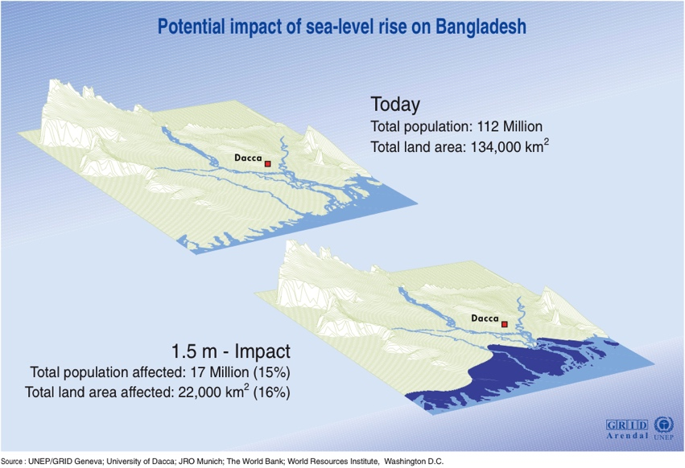
4: Agricultural problems
Figure 4. Potential impact of sea level rise on Bangladesh. UNEP/GRID-Arendal Maps and Graphics Library. 2000. UNEP/GRID-Arendal. 30 Jan 2010.
Sea level rise in Bangladesh is devastating to the cultivation of crops and livestock for a variety of reasons. The staple crops grown in Bangladesh are rice and wheat. Farmers in a particular area must consider the vulnerability of the area to flooding based on its elevation and proximity to a river or the coast, to determine which types of crops to plant and when to plant them. Irregular fluctuations in sea level flood farmland, thereby reducing the amount of arable (farmable) land available and making planting schedules less predictable. Soil degrades when it is flooded by seawater, and crops are less likely to flourish. Saltwater contamination of freshwater that is needed to water crops results in a further decrease in crop yields. When crop yields are down, there is not only less food for humans to consume, there is less food available to feed livestock. Food scarcity and malnutrition are increasingly problematic in Bangladesh as crop yields suffer due to sea level changes.

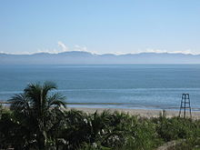
5: Negative impacts on tourism
Figure 5. Beautiful beaches and resorts may be impacted by sea level rise and flooding. https://en.wikipedia.org/wiki/Bangladesh
The World Travel and Tourism Council (WTTC) estimated that the tourism industry in Bangladesh generated nearly 3 million jobs in 2012 (almost 4% of the country's total employment). Projections show continued growth in tourism for the next two decades. However, sea level rise may seriously impede this tourism growth. Tourists visit Bangladesh for the sandy beaches, resorts and water activities. As sea level rises, the beaches will become inundated, resorts flooded, and infrastructure threatened by storm surges. Major infrastructure changes will need to take place in order to keep making Bangladesh a valuable tourism location.

6: Public health challenges
Public health has improved dramatically in Bangladesh in the past three decades. Nevertheless, Bangladesh faces major health challenges. The national population is projected to grow to between 200 to 225 million over the next four decades. Public health problems are linked to sea level rise in two ways. First, the inundation of land increases the risk of cholera. High-salinity zones are a breeding ground for cholera. Second, sea level rise increases the frequency and magnitude of floods that occur. During flooding, infrastructure becomes overwhelmed and sewage routinely mixes with floodwater, which causes diseases to spread rapidly.
Increased stress on the fresh water zone by saline seawater will decrease fresh water availability in the coastal zone (IPCC, 2001a). The unavailability of fresh water will force people to drink contaminated water leading to cholera, diarrhea and other water born diseases. Again, increased salinity in the coastal zone will decrease food production in the area, causing malnutrition for the coastal people. Sea level rise will accelerate water born diseases and malnutrition in the coastal area. However, the degree of probability of cholera and the depth of malnutrition is a matter of further research (Sarwar, 2005).

7: Threats to fisheries
The coastal and marine water of Bangladesh are some of the world's richest ecosystems with high biological diversity and productivity. There are 630 fish species, 24 shrimp species, 50 crab species, and 300 mollusk species. The extensive mangrove forests in Bangladesh are a sensitive transitional area between salt and freshwater and support at least 120 species of commercially important fish. Fisheries supply the main source of protein (60-80%) for the people of Bangladesh, and are therefore an important component of their health.
Fisheries are a major part of the Bangladesh economy, accounting for nearly 30% of the country's GDP. Bangladesh is ideally suited for fish production, having one of the highest man-water ratios in the world, at 20 persons per hectare of water area. Not only is there a large coastal area, but Bangladesh is the delta of three major river systems: the Ganges, Brahmaputra and Meghana.
The largest threat to most fisheries in Bangladesh remains over-fishing and depletion of resources. However, economists also worry that changes in salinity in the river deltas and within the mangrove forests will adversely impact the fishing industry in Bangladesh.

8: Negative impacts on the salt industry
Bangladesh is one of the largest salt producing countries in the world. Salt is produced by collecting seawater in a reservoir and allowed to evaporate. Salt crystals are transferred to salt mills where the salt is washed, crushed and packaged. For obvious reasons, both the reservoirs and salt mills are located very close to the coastline. A 1-meter rise in sea level would inundate all the salt fields and damage the mills. Salt farmers can't move to higher elevations because of the physical properties of the soil that underlies higher elevation sites. Approximately 20 million people are directly or indirectly employed by the salt industry in Bangladesh.

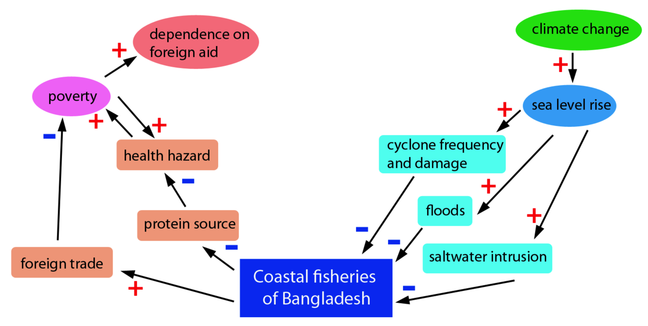
9: National security threats
Sea level rise will ultimately threaten the security of people in Bangladesh. Security, here, is defined as a secure condition or feeling (as opposed to military threat). When food, clothing, housing, health and education are threatened, the basic needs of a society are threatened. The table below shows the link between these needs and sea level rise.
Table 1: The impact of sea level rise on Bangladesh security (modified from Sarwar, 2005).

References
Nicholls et al., 2007, Coastal Systems and Low-Lying Areas, IPCC Assessment Report.
Powers, A, 2012, Sea-Level Rise and Its Impact on Vulnerable States: Four Examples, 73 La. L. Rev. 151. Available at http://digitalcommons.pace.edu/lawfaculty/866/.
 2005, Impacts of Sea Level Rise on the Coastal Zone of Bangladesh, Lund University (M.S. Thesis), Sweden. November 2005.

