Agisoft Quick Guide
1) Open Agisoft
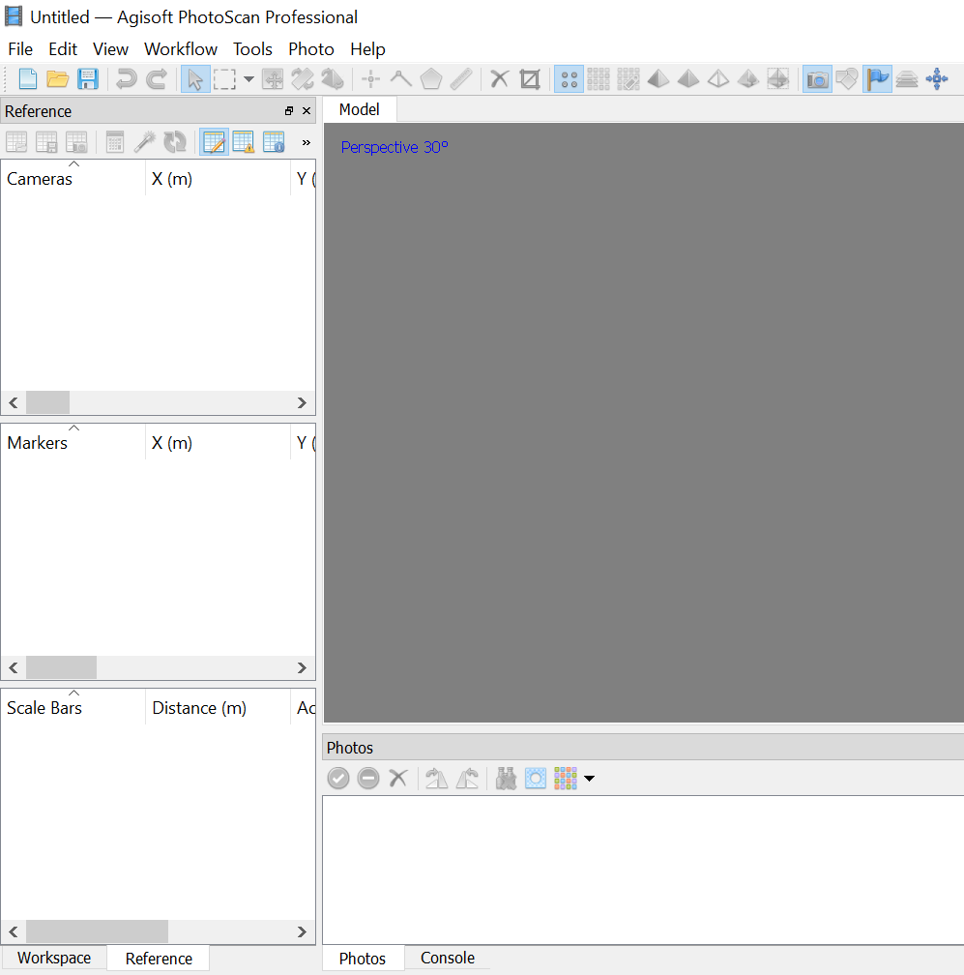
2) Add photos
Workflow>>>Add Photos
3) Align Photos
Workflow>>>Align Photos
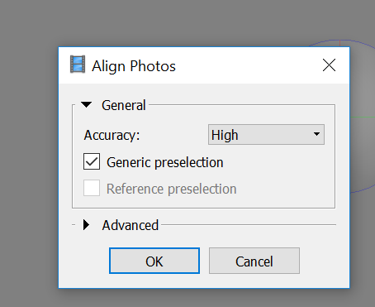

Photos are aligned
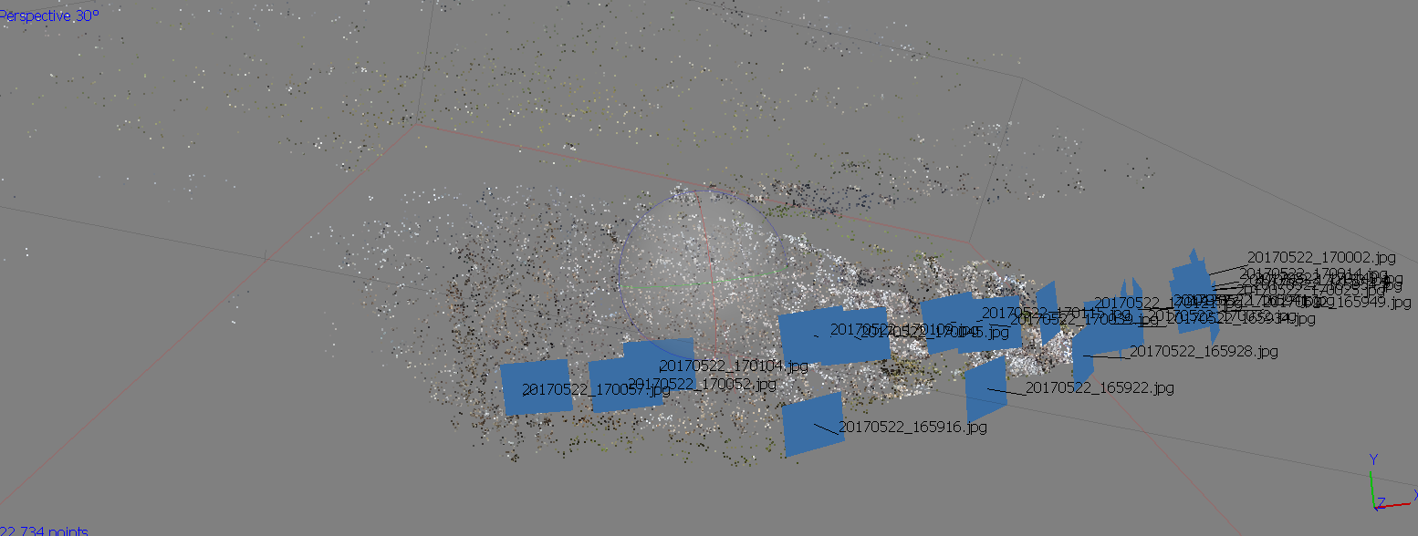

4) Build dense cloud
Workflow>>>Build Dense Cloud
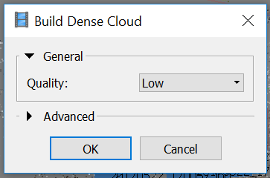
5) View dense cloud
View>>>Dense Cloud
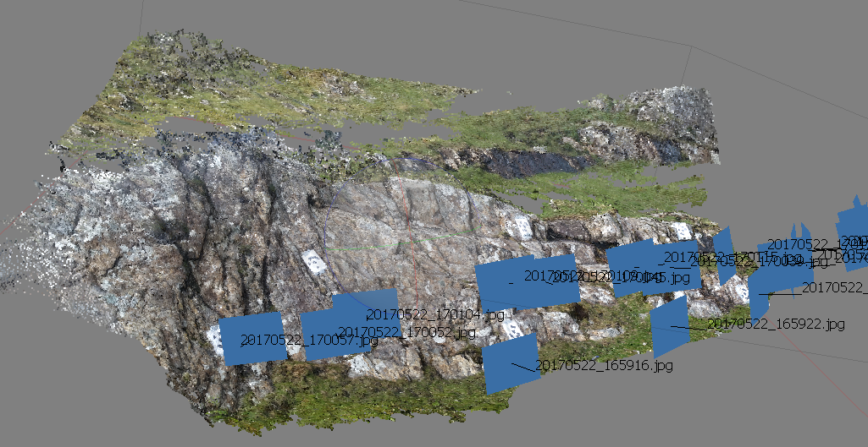

6) Import the coordinates of the targets (in Reference mode)
Import
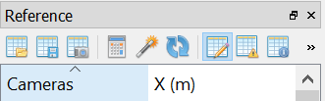
The target coordinates should be in .txt format as shown below
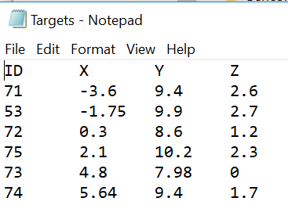
7) Assign coordinates for the targets in each coordinates. Make sure all photos in the ‘References’ pane are unchecked.
Click on each photo. A new window showing the photo will appear.
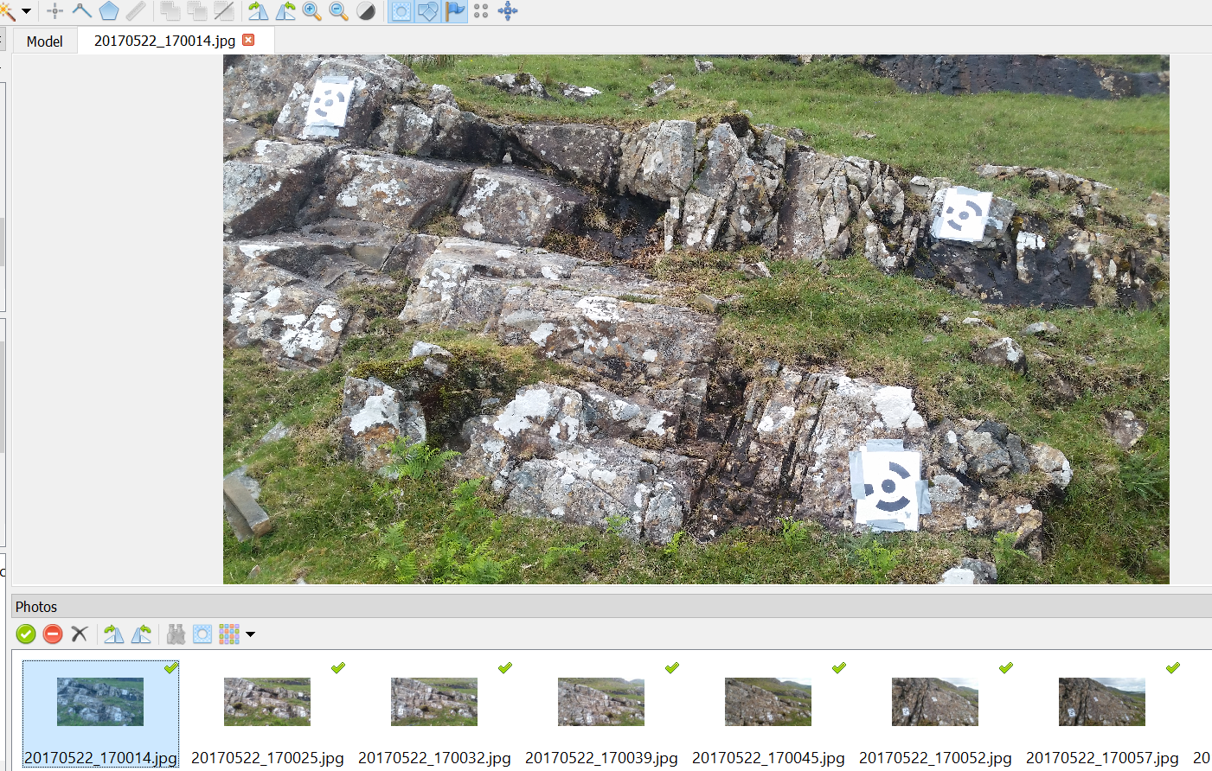
Assign coordinates by right clicking on each target>>>Place Marker and choose a corresponding targets that were imported above.
After all targets are assigned in all photos, click the refresh button to complete the georeferencing process
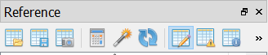
8) Export point cloud.
File>>>Export Points

