DipAnalyst Quick Guide
1) Open DipAnalyst
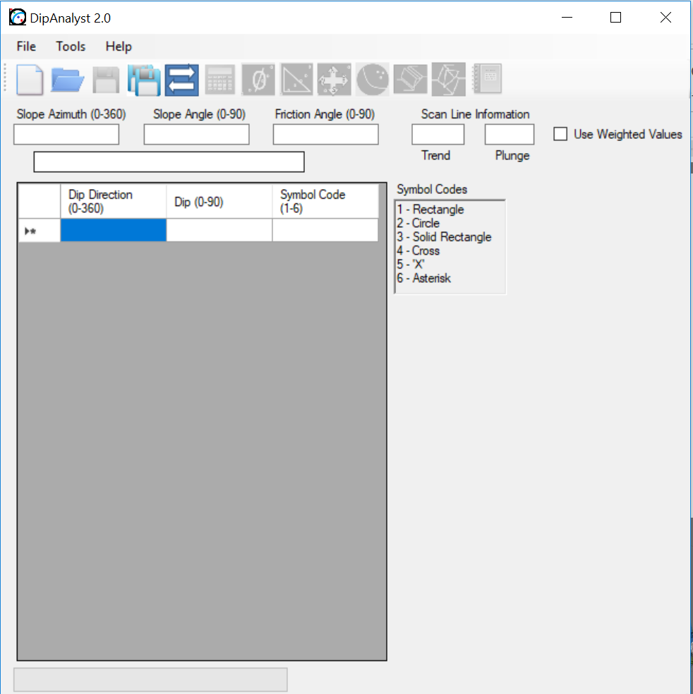
2) Prepare data.
Enter data (dip direction, dip, symbol code) in Excel and save it as .csv.
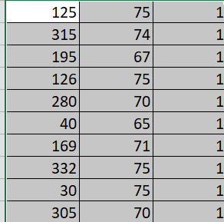
3) Enter slope azimuth, slope angle, and friction angle
4) Click the refresh button
5) Click the stereonet button.
6) Click the Dip Vectors, Great Circle, Friction Circle to evaluate plane and toppling failure.
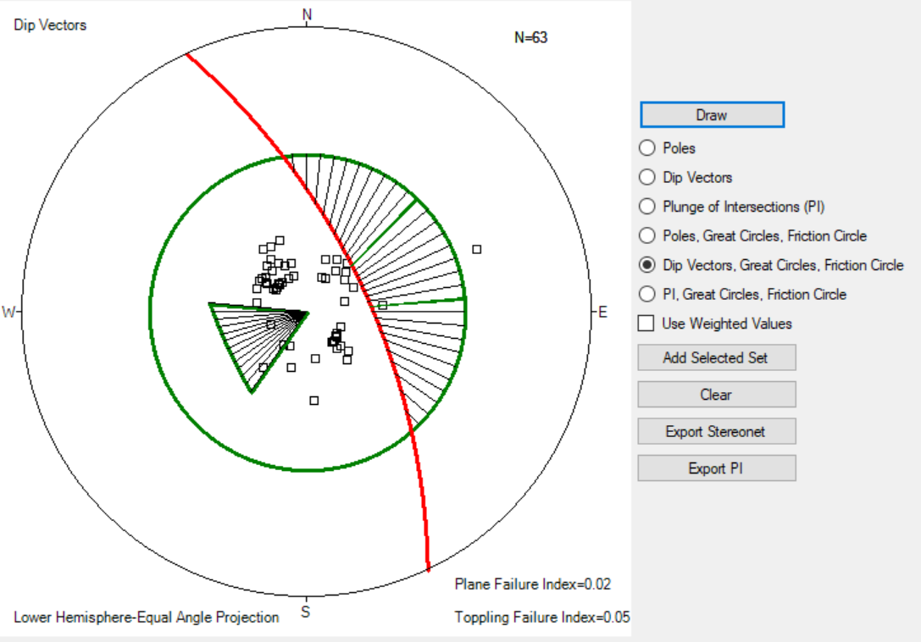
7) Click the PI, Great Circle, and Friction Circle to evaluate wedge failure.
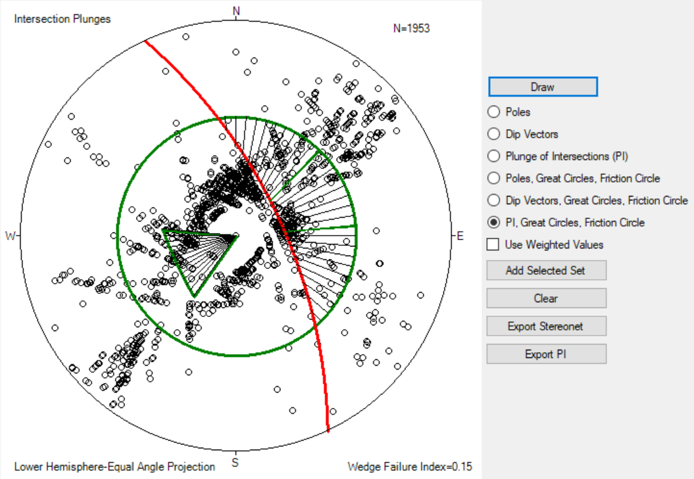

8) Export stereonet or capture a screen shot.

