Split FX Quick Guide
1) Open thegeoreferenced point cloud data (.txt) in Split-FX
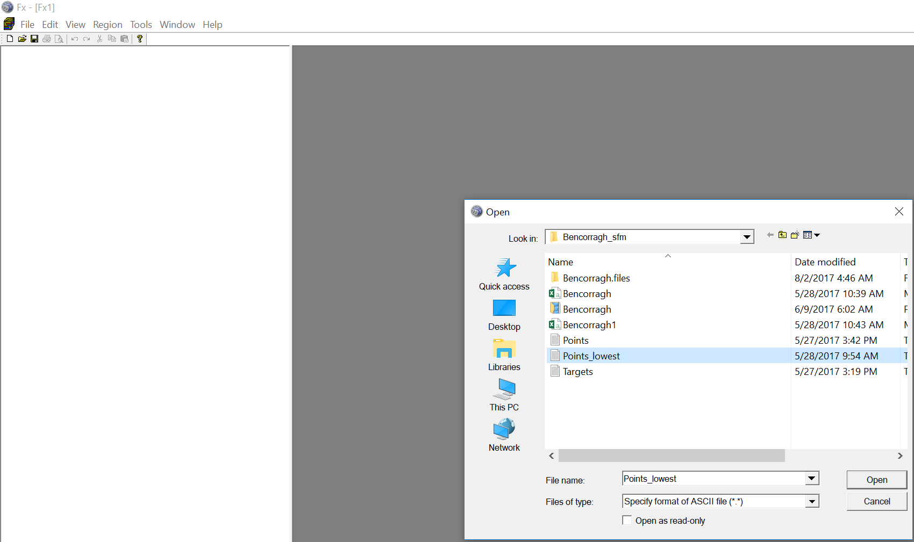
2) Assign column values (x, y, z, red, green, blue)
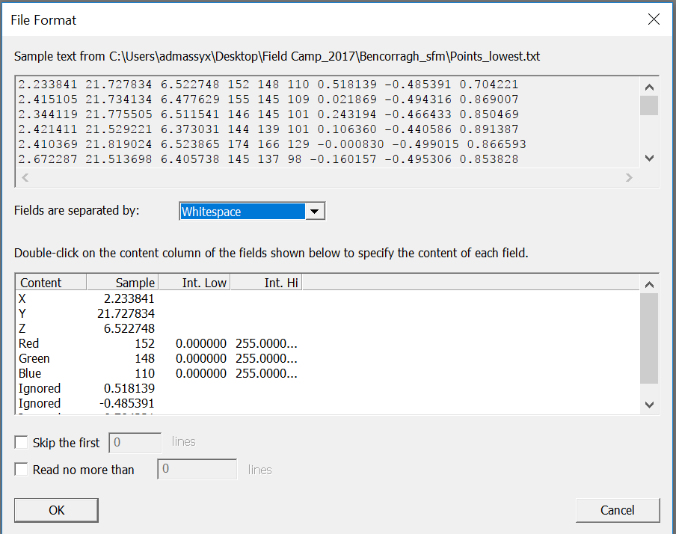
3) Point cloud will open
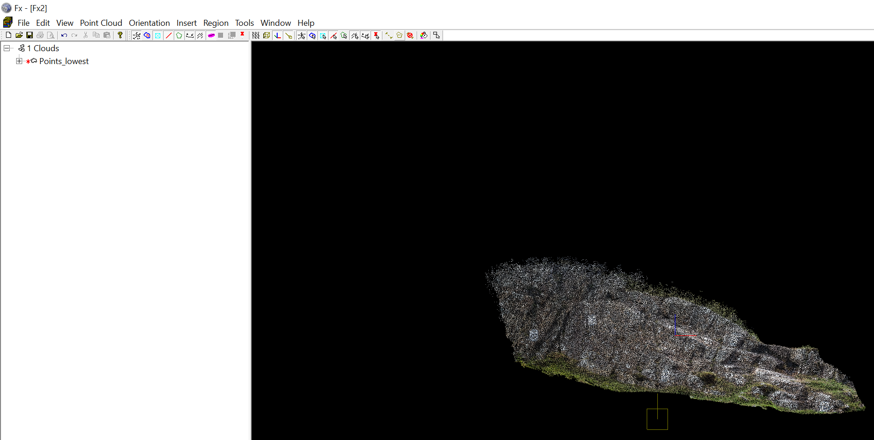

4) Orient the scan on the screen in such a way that most discontinuity surfaces are visible. Once that is achieved, register the scanner orientation. Changing the scanner orientations will affect the accuracy of the mesh.
Orientation>>> Scanner Orientation>>> Modify scanner orientation to match the current view orientation
5) Build mesh
Point Cloud>>>Create Mesh
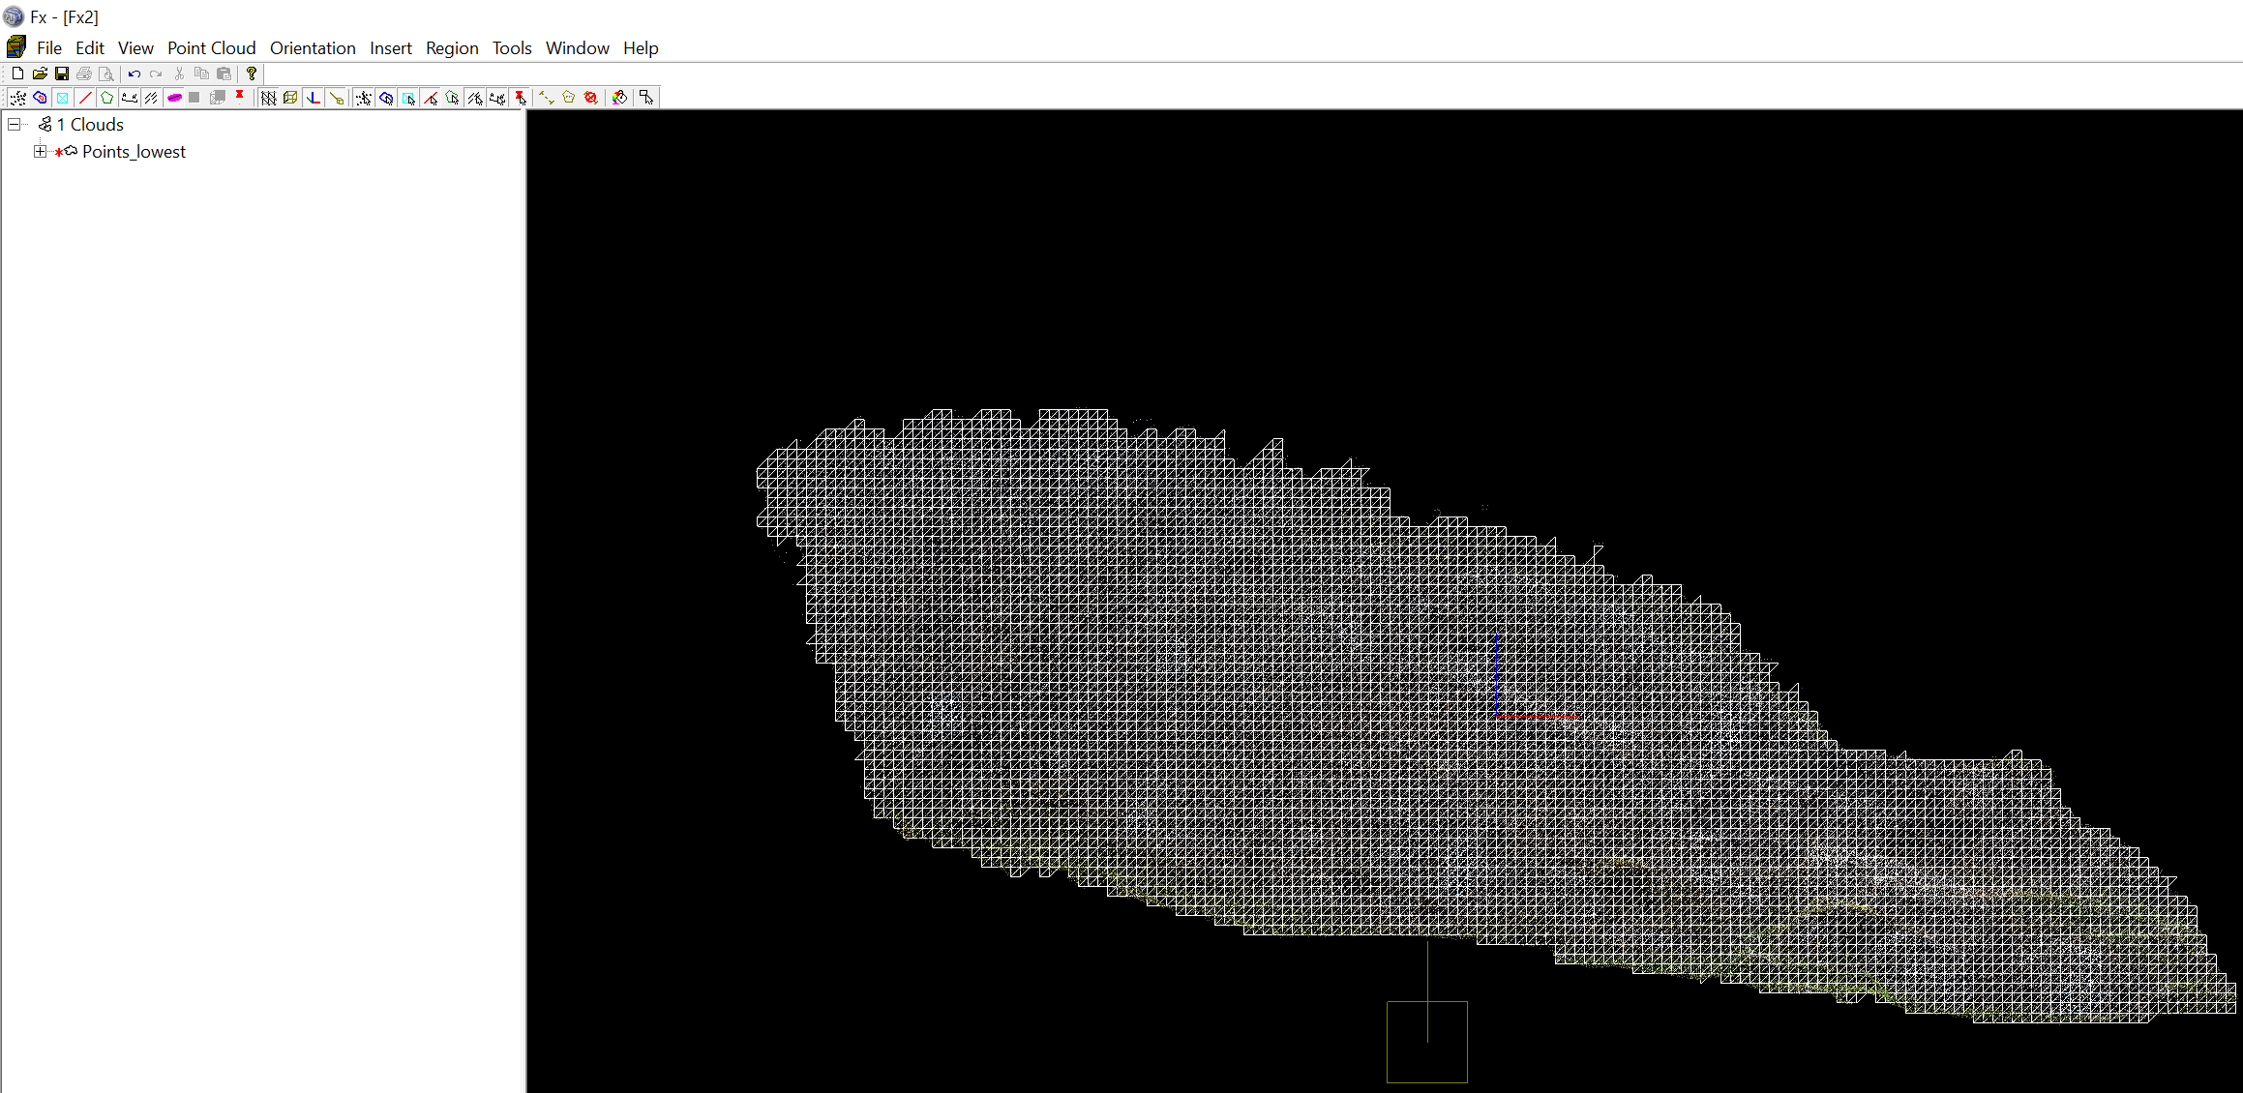
6) Find flat surfaces (patches) automatically
Point Cloud>>>Find Patches
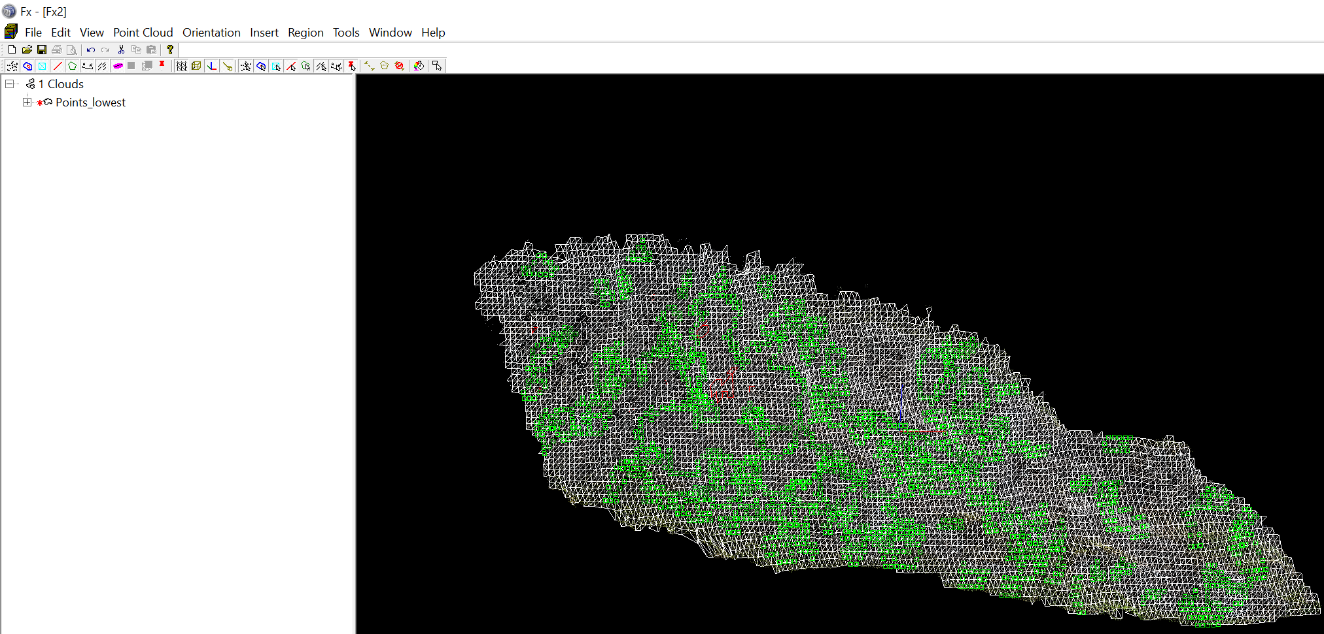
7) Manually outline patches or insert Traces along fracture traces
Insert>>>Trace
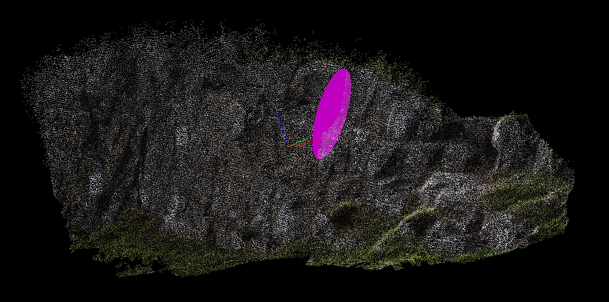
8) Export discontinuity data (dip direction, dip)
Export>>>Cloud Data>>>Exported Items (Patches)>>>Format String (Dip Direction and Plunge)
