Structure from Motion Guide for Instructors and Investigators
Katherine Shervais (UNAVCO)
This guide is intended as a resource for using Structure from Motion in teaching and research applications. It does not detail the algorithms or mathematical background of the methodology but rather how to use it in practice. This guide overlaps in content with the provided SfM manuals for students but includes more information about platform selection and other technical aspects necessary for an instructor or investigator to know. (All images not otherwise credited were created by the author.)

Table of Contents
1. Introduction……………………………………………………………………..………………2
2. Platforms 3
Lift 6
Examples of possible platforms 7
3. Camera choices 12
4. Software 13
Commercial software 13
Open source software 14
5. Ground Control Points (Targets) 16
6. Field Workflow (and field prep) 17
Before leaving for the field 17
At the field site 17
7. Agisoft MetaShape Pro 18
Based on personal experience 20
8. Photo acquisition considerations 21
9. References for the guide 24

Introduction
Structure from Motion or SfM is a photogrammetric method for creating three-dimensional models of a feature or topography from overlapping two-dimensional photographs taken from many locations and orientations to reconstruct the photographed scene. This technology has existed in various forms since 1979 (Ullman, 1979), but applications were uncommon until the early 2000s (Snavely et al., 2008). The applications of SfM are wide-ranging, from many sub-fields of geoscience (geomorphology, tectonics, structural geology, geodesy, mining) to archaeology, architecture, and agriculture. In addition to ortho-rectified imagery, SfM produces a dense point cloud data set that is similar in many ways to that produced by airborne or terrestrial LiDAR (Figure 1).
Figure 1. Comparison of SfM to airborne and terrestrial LiDAR methods. Source: Johnson et al., (2014); considered fair use by GSA Publications http://www.geosociety.org/pubs/copyrt.htm
The advantages of SfM are its lower cost relative to LiDAR, as well as its ease of use. The only equipment required is a camera. A computer and software are needed for data processing. Additionally, an aerial platform like a balloon or drone can also be useful for topographic mapping applications. A major limitation is the processing time for software to align the images to generate a model, which ranges from ten minutes for a few photographs to days for hundreds to thousands of photographs. Because SfM relies on optical imagery, it is not able to generate the “bare earth” topographic products that are typical derivatives of LiDAR-based technologies—thus, SfM is usually best suited to areas with limited vegetation.

2. Platforms
Depending on the application and survey objective, a camera can be mounted in numerous configurations to capture imagery for SfM processing (Figure 2). This section provides an introduction to various platforms that can be used to acquire imagery (Table 1).
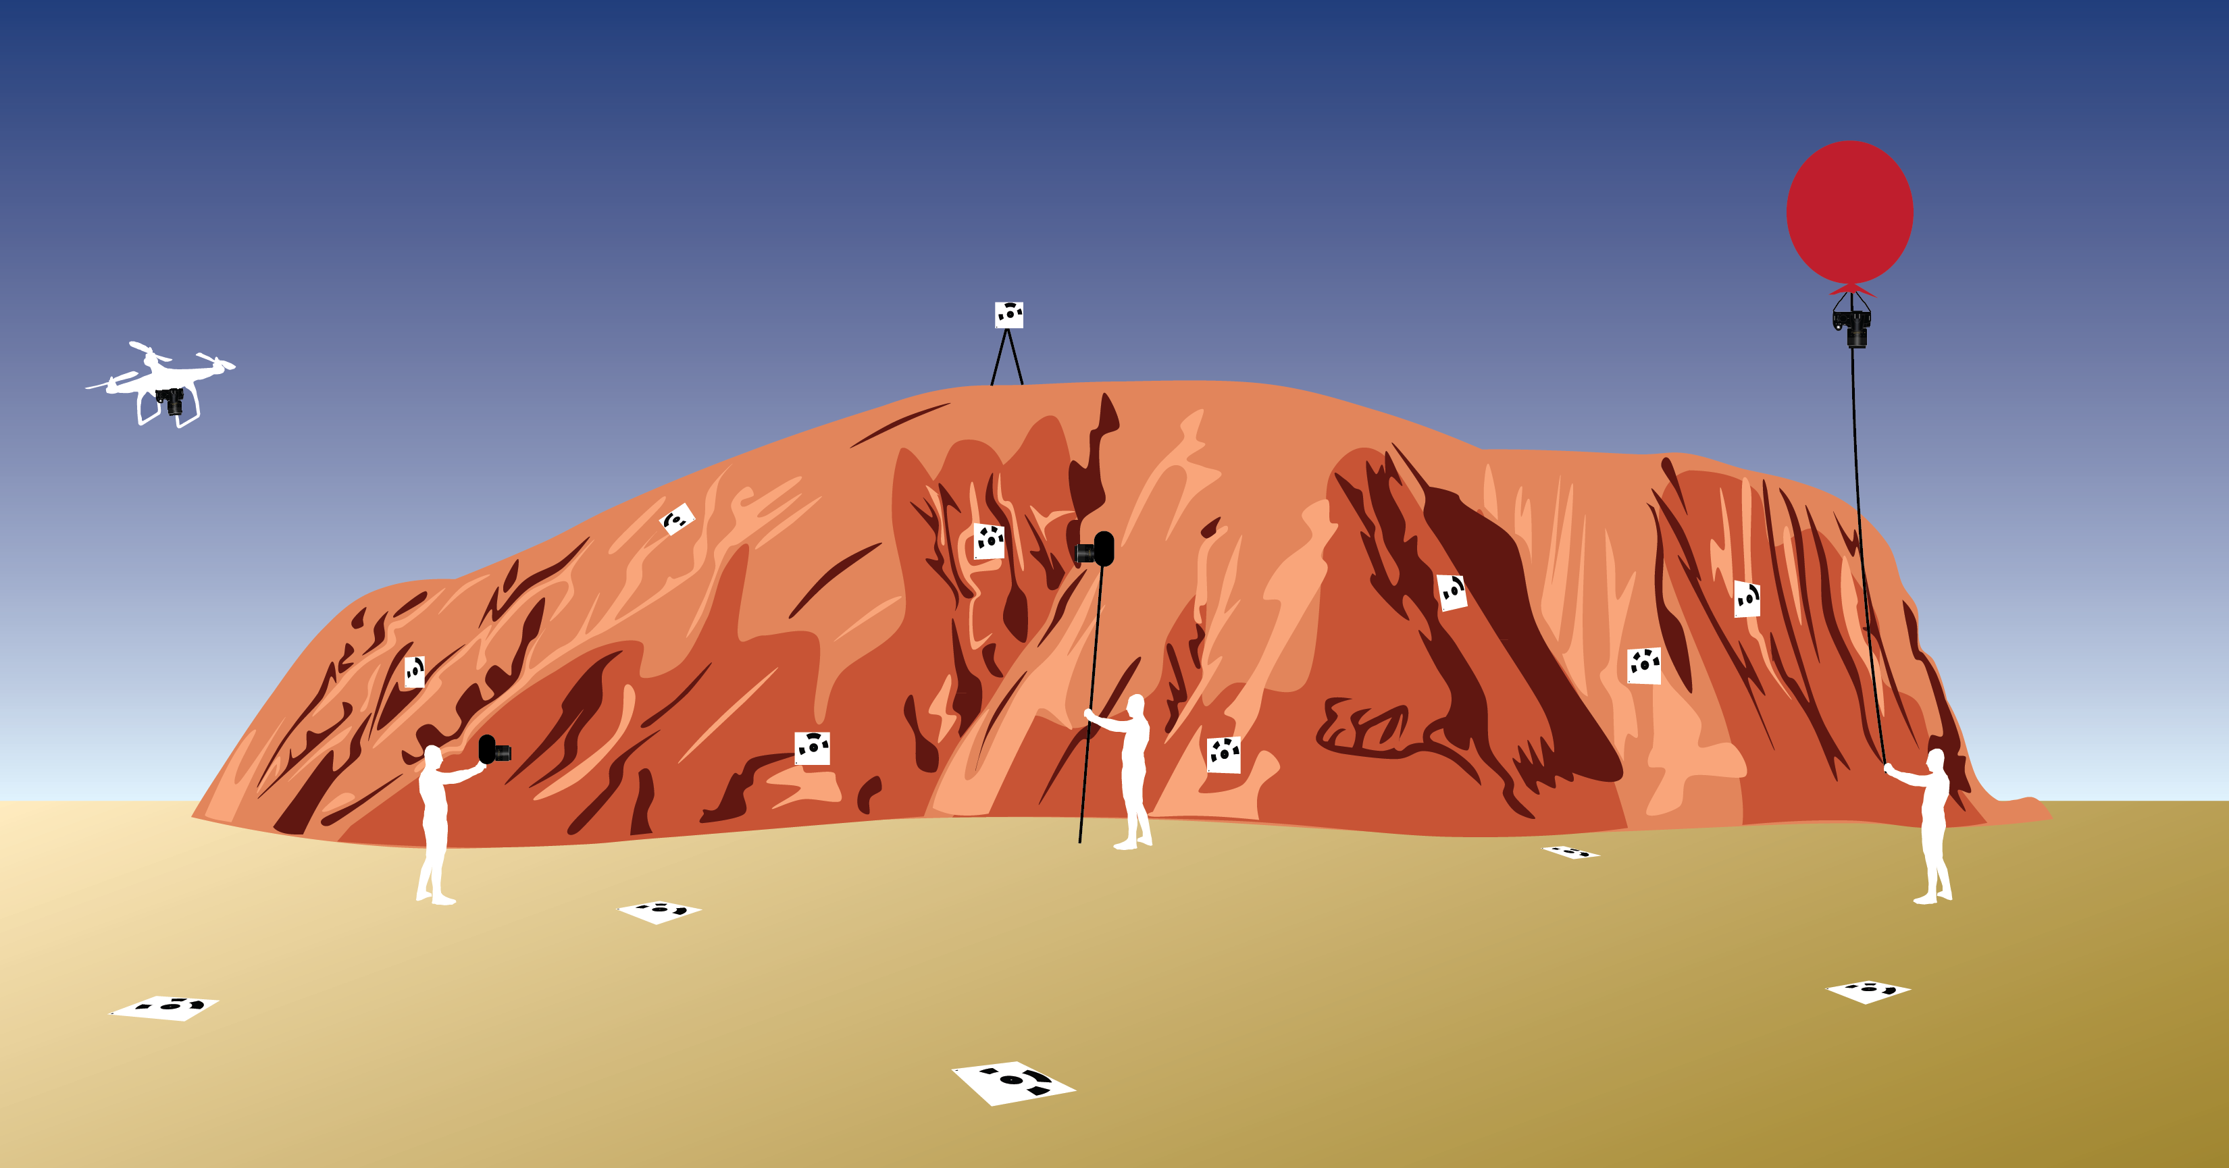
Figure 2. Various platforms for Structure from Motion (from left to right): UAS (uncrewed aerial system), handheld camera, pole, balloon. The white squares with black patterns are targets to georeference the survey.
Some things to consider:
- Many of the platform descriptions include a reference to a picavet: picavets are simply a camera mount designed to keep a camera vertical, even if the line the camera is suspended on is not. Picavets are available to purchase, but there are guides on the Internet for those who wish to build their own.
- These platforms are highly customizable. The limiting factor is typically weight, but if one has a kite or balloon with enough lift, the system could include a remote control camera mount to change the orientation of the photos during the survey. Other additions include a radio controller to regulate when photographs are taken if your camera does not have a time-lapse, and a GPS tagger on the camera to georeference photographs if the camera does not have an internal GPS. UASs (uncrewed aerial systems) can now be purchased with GNSS receivers, expediting the process of aligning photographs in the software.
- To conduct an Internet search for the equipment related to one of these platforms, try searching for “<platform> aerial photography” (ex. kite aerial photograph). This should yield platform-specific equipment designed to accommodate a camera.

Table 1. Cost, advantages, and disadvantages of common SfM platforms.
Platform | Cost | Advantages | Disadvantages
Person (hand-held) | $0 | Cost, good for detail work (characterize specific, small-scale features), potentially more efficient for outcrop scale work | Limited applications; not useful for areas larger than 100–200 square meters
Pole (Figure 3) | ~$50–250, depending on pole height. Can purchase kits online, but building your own is often more economical. | Cost, ease of setup and use, good for certain kinds of features (slope underneath an overhang, for example) | Must build mount for camera, limitation for maximum pole height, inefficient in comparison to UAS
Balloon (Figure 4,5) | ~$300–5000. Building your own system is inexpensive, but systems on the market can cost much more because they may have video systems to show what the camera is viewing. A weather balloon is ~$100, the picavet mount is ~$50, kite line ~$20, and helium ~$180, for an appropriately sized tank | Cost (unless you purchase a commercial version), simplicity, camera orientation (can shoot straight down, unlike many pole setups), height. Balloons are a good option for topographic mapping applications. Tether line line removes legal complications associated with UASs | Easier with two people rather than one, affected by the wind, requires picavet mount (build or purchase), requires helium (a limited resource)
Kite  (Figure 6) | Cost depends on the weight of the camera mount system. Kites can be used with v. lightweight cameras and cost around $50; kites made for aerial photography can cost $100–400. For both options, you will need to purchase or build a picavet for $50. | Cost, height, camera orientation (can shoot straight down, unlike many pole setups), similar range to a balloon but no helium! Well suited to topographic mapping applications. Tether line removes legal complications associated with UASs | Dependent on weather, must build/purchase picavet for camera, kite line can get in the way of photographs, kite must be large/have good “lift”
UAS – motorized glider, multi-rotor copter (quad-, hexa- or octa-)  (Figure 7) | Cost is highly variable; a motorized glider is around $200–300 + cost of picavet; quadcopters can range from $400–$5000 or more depending on their capabilities. | Height, camera position may be controlled and survey flightlines can be pre-planned and automated, GNSS integration for efficiency | Cost, requires a skilled operator, length of survey depends on the charge of the battery, may require light camera setup. Potentially dangerous if improperly operated. Legal landscape for use of UASs can be complex; users should consult institutional rules and/or legal counsel before operation.

Lift
Kite lift is more difficult to determine in a simple chart, as it is highly dependent on the kite and the wind at any given time.
Balloon lift is simpler because it is dependent on the helium (Table 2). Use this chart (minus the weight of the balloon) to determine the size of balloon needed to lift your camera setup.

Table 2. Balloon size relationship with lift in pounds or grams. Source: University of Hawaii, Manoa, Department of Chemistry (http://www.chem.hawaii.edu/uham/lift.html)
Diameter (ft) | Diameter (m) | Volume (liters) | Lift (grams) | Lift (lbs)
1 | 0.3048 | 14.8 | 15.2 | 0.03
2 | 0.6096 | 118.6 | 121.7 | 0.27
3 | 0.9144 | 400.3 | 410.9 | 0.91
4 | 1.2192 | 949.0 | 973.9 | 2.15
5 | 1.524 | 1853.4 | 1902.2 | 4.19
6 | 1.8288 | 3202.8 | 3287.0 | 7.25
7 | 2.1336 | 5085.9 | 5219.7 | 11.51
8 | 2.4384 | 7591.7 | 7791.5 | 17.18
9 | 2.7432 | 10809.3 | 11094 | 24.46
10 | 3.048 | 14827.6 | 15218 | 33.55
11 | 3.353 | 19735.5 | 20255 | 44.65
12 | 3.6576 | 25622.1 | 26296 | 57.97
13 | 3.9624 | 32576.2 | 33433 | 73.71
14 | 4.2672 | 40686.9 | 41757 | 92.06
15 | 4.572 | 50043.1 | 51360 | 112.23
16 | 4.8768 | 60733.8 | 62332 | 137.42
17 | 5.1816 | 72847.9 | 74765 | 164.83
18 | 5.4864 | 86474.4 | 88750 | 195.66
19 | 5.7912 | 101702.3 | 104378 | 230.12
20 | 6.096 | 118620.6 | 121741 | 268.4
21 | 6.4008 | 137318.2 | 140931 | 310.7
22 | 6.7056 | 157884.0 | 162038 | 357.24
23 | 7.0104 | 180407.1 | 185154 | 408.2
24 | 7.3152 | 204976.4 | 210369 | 463.79

Examples of possible platforms
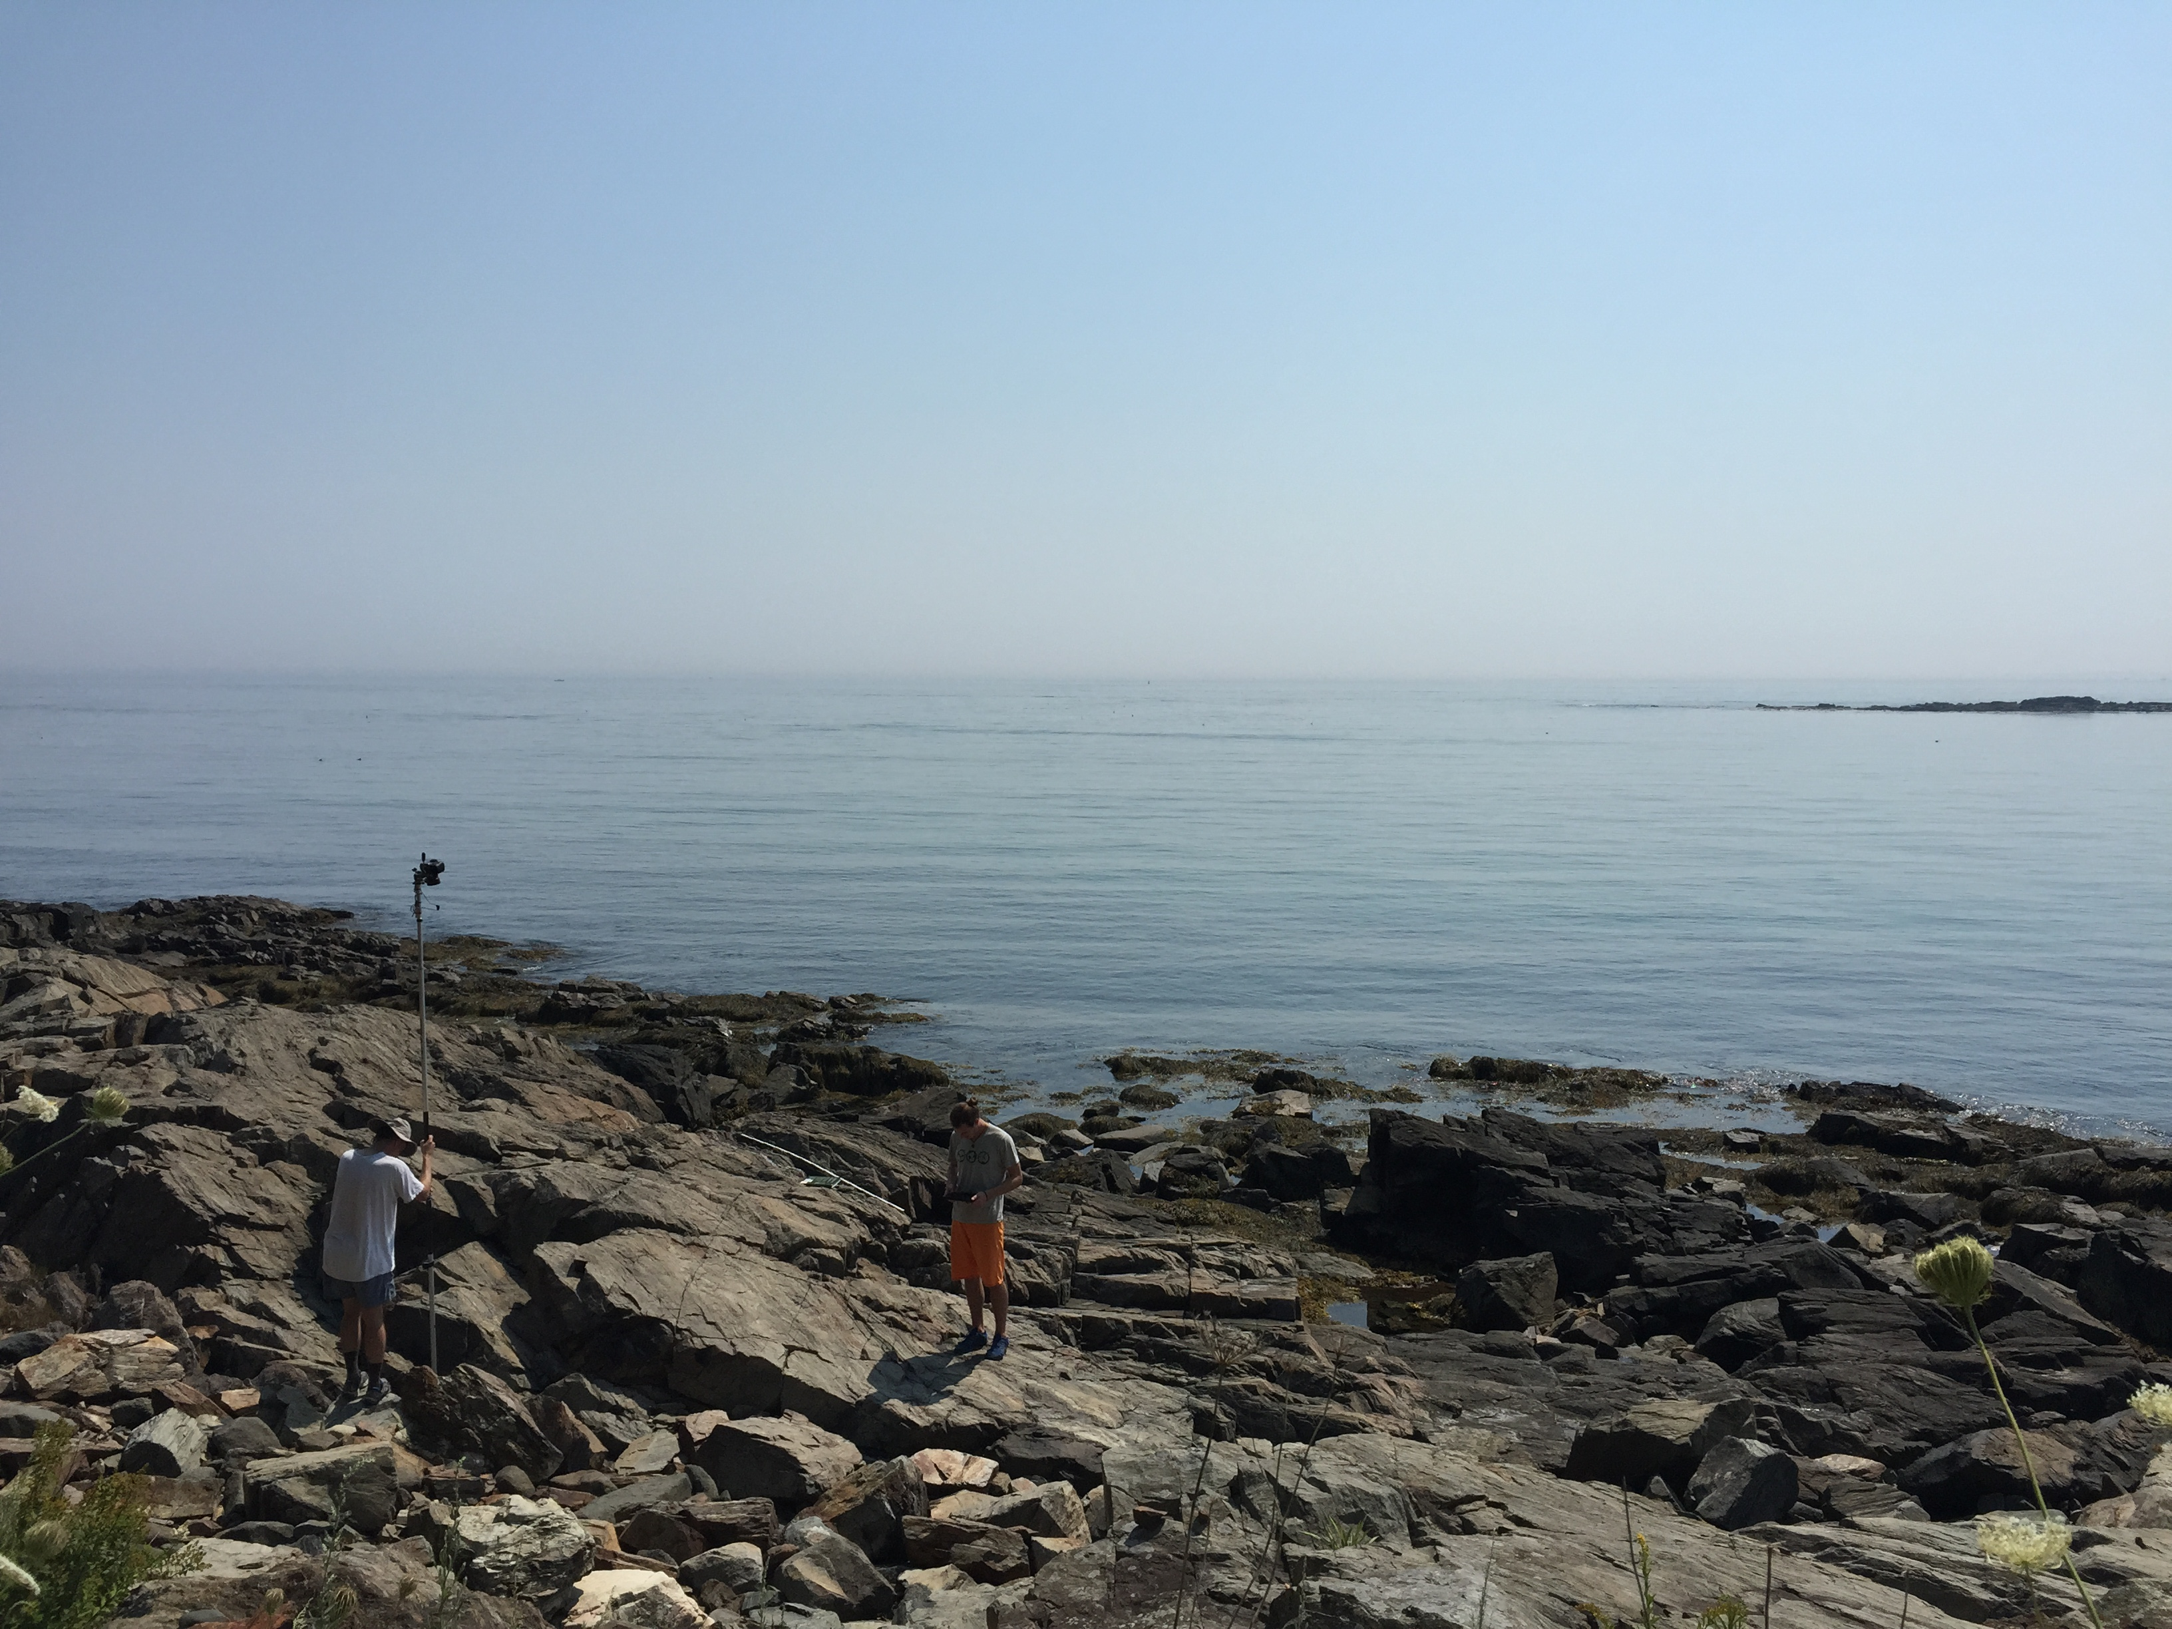
Figure 3. Pole aerial photography (PAP) platform. This platform requires a long, telescopic pole to elevate your camera for the purpose of shooting down on your subject. The camera will need to take photographs at certain intervals and can be accomplished through time lapse, continuous, or remote-controlled shooting. These researchers are photographing a series of small, melt-bearing strike slip faults within the nearly horizontal outcrops. Photo: Katherine Shervais.

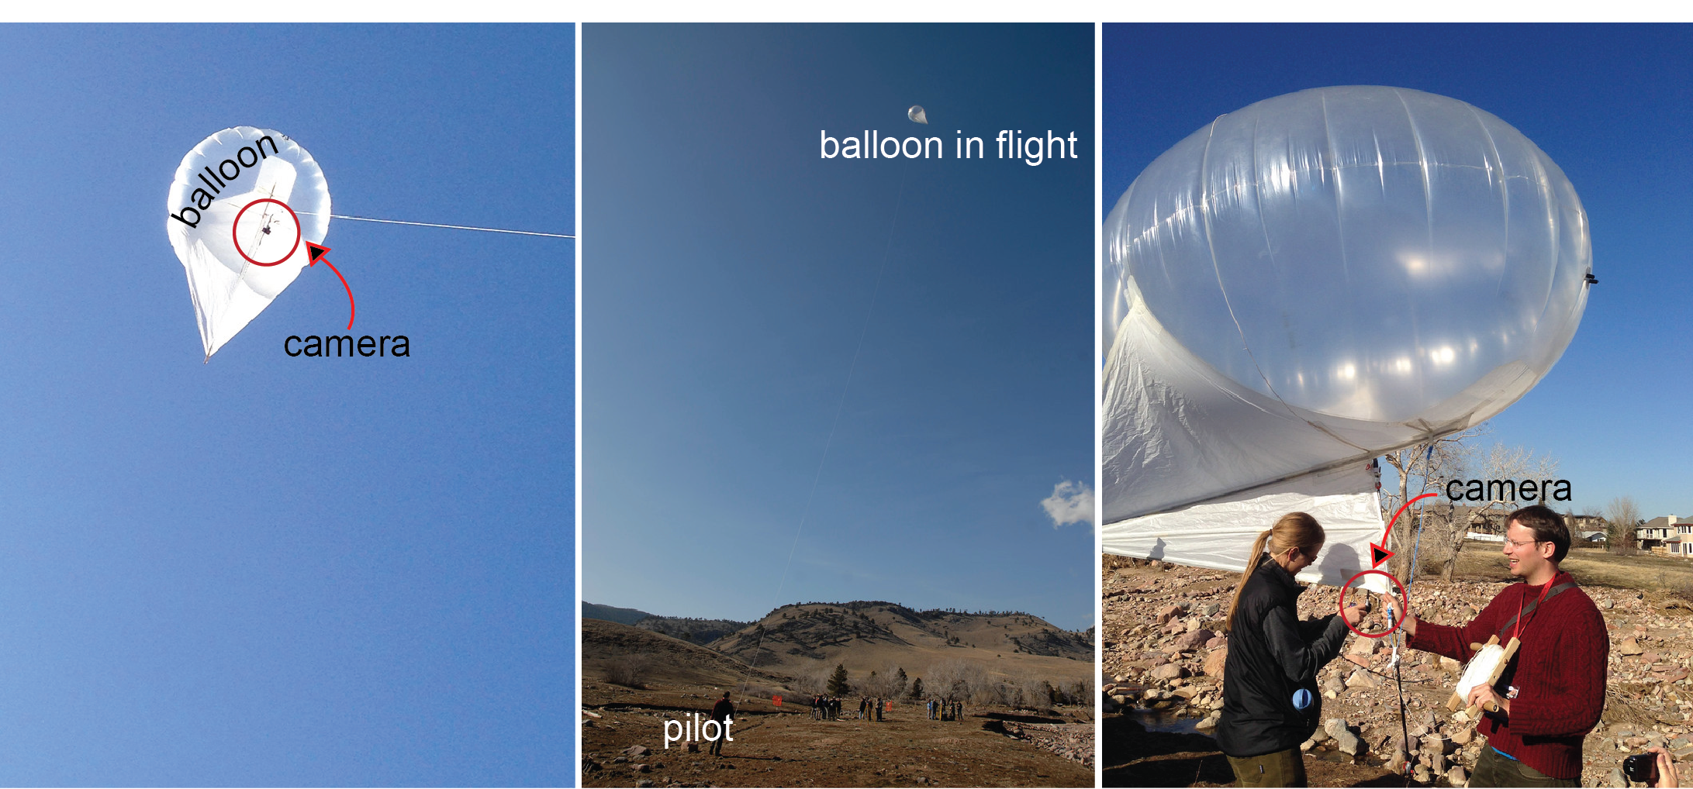
Figure 4. Balloon platform. The photo on the left shows the position of the camera while the balloon is in flight. The center photo shows the position of the balloon relative to the pilot while in flight; the photo on the right shows the more detail of the camera setup. Because of the picavet setup, the camera is oriented directly at the ground. See Figure 5 for a schematic of how this works. Photos: 2014 UNAVCO Science Workshop, Beth Bartel and Linda Rowan.

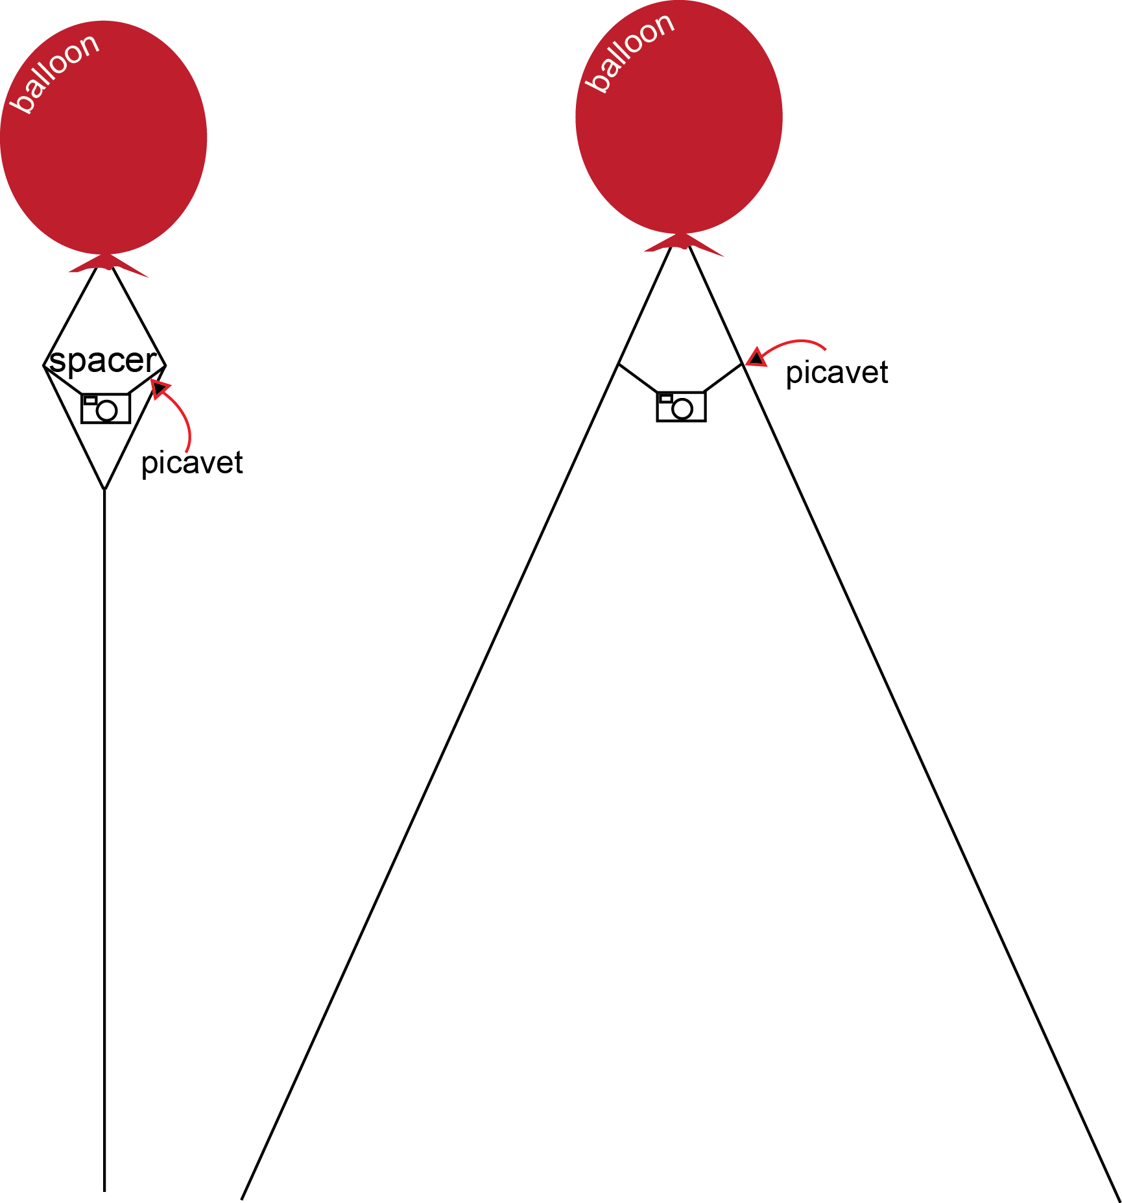
Figure 5. Demonstration of picavet system using a balloon platform. The left schematic demonstrates an ideal setup with one operator, while the right schematic demonstrates an ideal setup with two operators. You may set the orientation of the camera using the picavet; some also come with a remote control “servo” or rotator system so you can change the camera orientation while in the air.
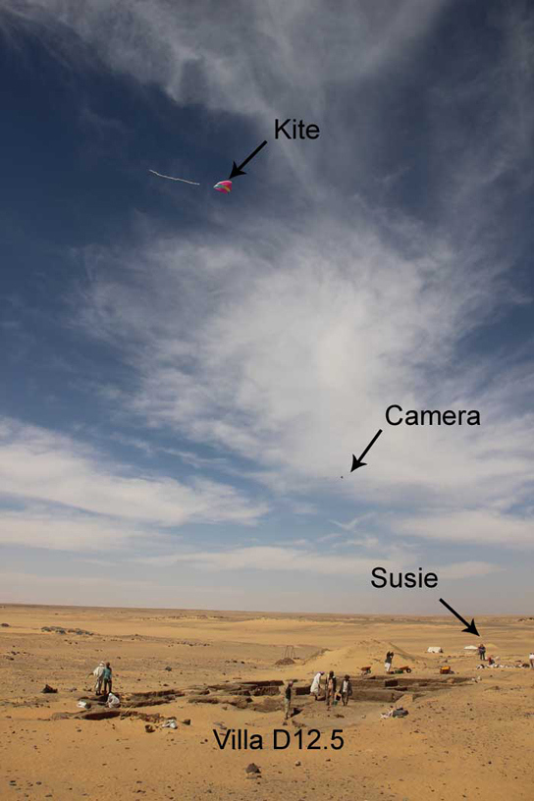
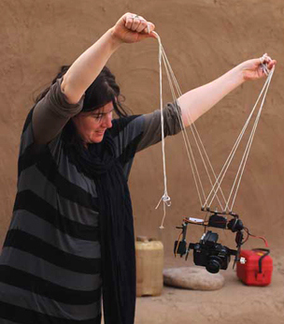
Figure 6. Above is a picavet setup for a kite—note this is basically the same as the setup for the balloon. However, this system is remote controlled with the camera mounted on a gimbal so the pilot can change the orientation of the camera while the kite is in flight. To the right is the location of the pilot (Susie) relative to the camera and the kite while in flight photographing Villa D12.5, the study area of interest. Source: Neal Spencer, British Museum.

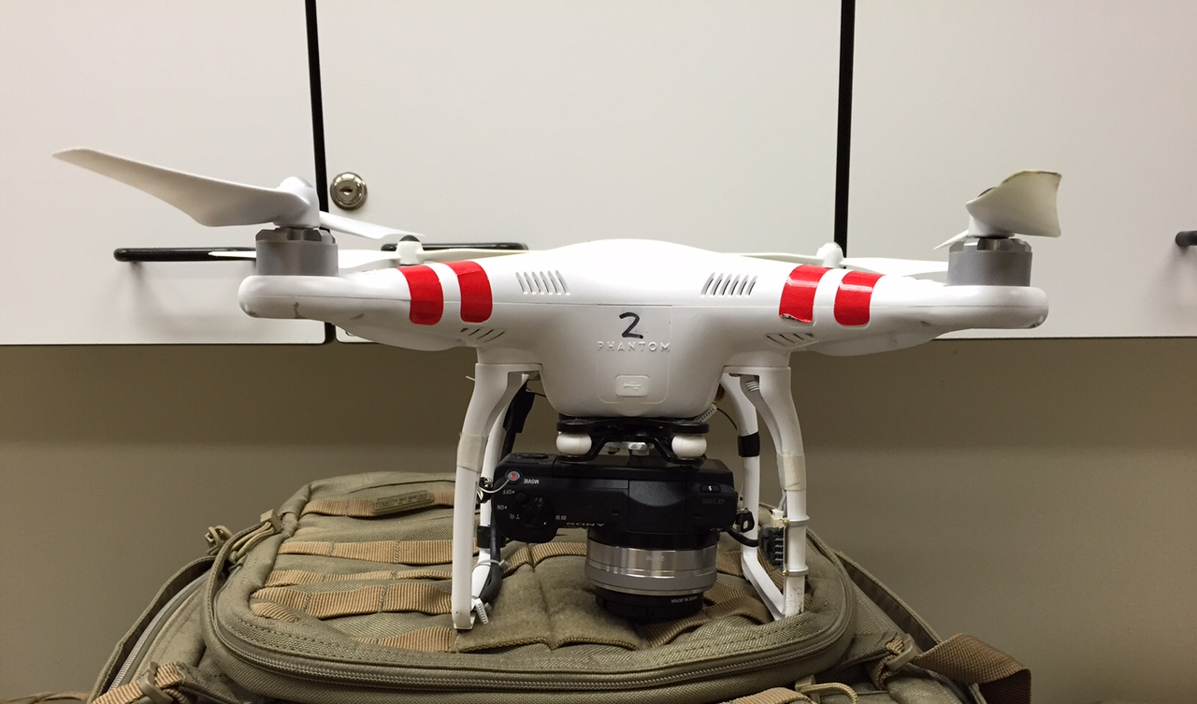
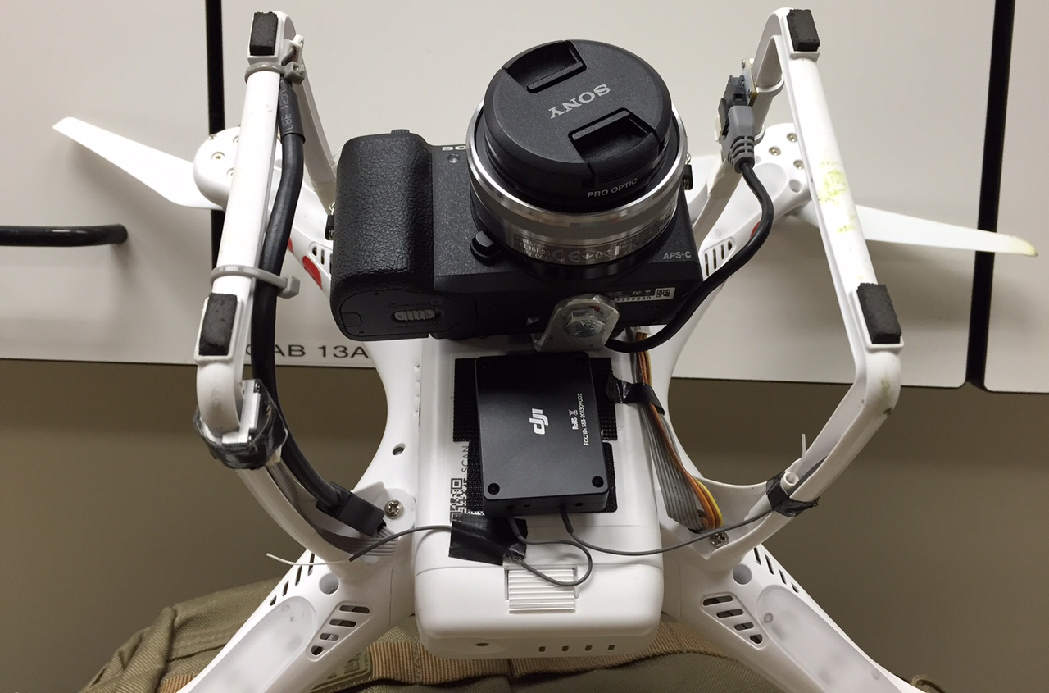
Figure 7. Examples of a UAS camera mount. Photos of a DJI Phantom with Sony camera, taken by Mike Bunds.

3. Camera choices
Rather than recommend a specific camera, compiled here is a list of general guidelines to follow when picking a camera. This list was synthesized from Johnson et al. (2014), http://www.paulillsley.com/airphoto/systems/Phantom/ (accessed July 1, 2015), Raugust and Olsen (2013), http://adv-geo-research.blogspot.com/2013/10/cameras-for-sfm.html (accessed February 18, 2016) and personal communication with Kendra Johnson (Colorado School of Mines).
- Consider the weight your platform is capable of carrying. A large balloon may be able to carry a heavier camera setup than a kite, for example.
- Opinions about the usefulness of DSLR versus point-and-shoot cameras vary. Most recommend using a DSLR (digital single-lens reflex) or a point-and-shoot that has faster ISO levels than average.
- GPS: built in GPS tagger saves weight and simplifies the photo stitching process in some modeling software. It also produces more accurate georeferenced point clouds. If the camera you select does not have GPS, it is best to buy a GPS tagger in addition to help the data processing.
- Shooting: the camera will need to take photographs at certain intervals. This can be accomplished one of three ways but cameras with time-lapse or the ability to modify the camera to take time-lapse photographs are recommended.
  - Time-lapse: the camera has the capability to take photographs at specific time intervals
  - Continuous shooting: similar to time-lapse but the camera button needs to be pushed (this is simple—use a rubber band!)
  - Remote controlled shooting: this option is the most complex, as systems may rely on radio, so you will need to limit the height of the camera.
- Resolution: some recommend staying at or above 12 megapixels, but the need for this has been debated. Cameras should be above 5 megapixels.
- Picture format:
  - RAW image files are most useful, so selecting a camera that is capable of this is a good idea. These can be converted to TIFFs after returning from the field.
  - Do not use JPEGs because they introduce unnecessary noise.
- If you would like the option of using a First Person View setup to view a live video feed of the camera sees, make sure the camera has a live video-out option.
- Manual exposure and focus: this ensures the images have a similar exposure. Manual focus helps the camera record images even if the autofocus is not working perfectly.
- Avoid ultra-wide lenses such as those found on the GoPro! If using a GoPro, make sure that either:
  - the software program used for the SfM model generation has an option to select a different camera lens type (Agisoft MetaShape Pro can, for example, in the Camera Calibration menu), or
  - the photos have been processed through a program that corrects for lens distortion (again, Agisoft has a program called “Lens” that does this; many camera companies [like Canon] have their own program to do this).
- Turn off “shake reduction.”
- Video: Only use a video camera if you know it will work with your SfM software. Not all SfM algorithms work well with images recorded from video because of differences in how the shutter functions. The other issue with video is that video stills are quite low resolution in comparison to photographs, so the resultant model will not be as high resolution.
- Where is the camera going? Waterproof or dustproof cameras may be needed in some field environments to ensure functionality.
Extras: bring extra batteries and memory cards for every camera.

4. Software
All SfM software completes one of more of the steps in the workflow figure shown below (Figure 8; Table 3).

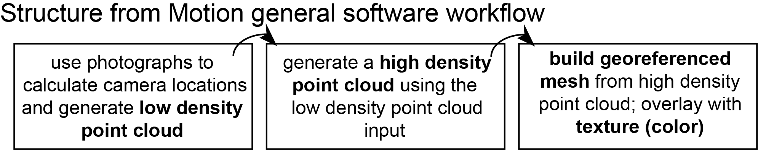
Figure 8. Generalized workflow for SfM software after data has been collected
SfM software typically falls into one of two categories: (1) commercially available software, for which the workflow is more streamlined but the software is a “black box” and (2) open source software, for which the workflow is more complex (several programs may need to be used in sequence, some may not have a graphical user interface [GUI]).

Commercial software
Prices are current as of March 2016.
The primary commercial software used for research in geoscience and archaeology is Agisoft MetaShape. This software is available in Professional ($3499, $549 academic) and Standard ($179, $59 academic) editions. The Professional Edition is best for geologic SfM purposes, as it allows the use of ground control points, measurements, DEM (rather than just point cloud) export, and georeferenced orthomosaic export. Agisoft is a “black-box” but uses the SIFT algorithm used in the open source software (Verhoeven, 2011).
Pix4Dmapper is available for purchase or to rent. This program is $350 for a month-long rental, $3500 for a year, and $4990 for one time purchase (two-computer license). More analysis and data processing can be done in this program rather than exporting the point cloud or DEM to another program such Cloud Compare or ArcGIS.
Another commercial program is PhotoModeler Scanner, which is the PhotoModeler program optimized for UAS mapping. This program is $2495 and does not seem to have an education license. This program has been used less frequently for research applications, so has less peer-reviewed documentation about its capabilities.
Free web-based programs exist, like Microsoft Photosynth. Photosynth builds a sparse point cloud, but the point cloud is not linked to physical coordinates.

Open source software
Many open source software programs exist for SfM or portions of the SfM workflow. These programs range from GUIs to programs run from the command line to programs run through MATLAB (note that MATLAB requires its own, fairly expensive license: $2150, $500 for academic, $49–99 for student edition). An incomplete list is in this Wikipedia article: https://en.wikipedia.org/wiki/Structure_from_motion, which is one of the few sites to aggregate this kind of list.
Papers by Westoby et al. (2012), James and Robson (2012), Fonstad et al. (2013), and Green et al. (2014), go through different workflows using existing open source software. Green (2012) is a master’s thesis that outlines the workflow for one method of using open source software and will be a good resource for anyone who prefers the open source option.
Table 3. Comparison of multiple software platforms, both open source and commercial, for Structure from Motion applications. Compiled from Green et al., 2014 and Johnson et al., 2014, as well as websites for the specific platform.
Software | Commercial or open source? | Low  density  PC | High density PC | Georeference; mesh and texture | Notes and/or extra capabilities
Agisoft MetaShape Pro | Commercial |  |  |  | Primary commercial software used in geoscience and archaeology.
Bundler | Open source |  |  |  | Creates output file of camera locations and low density point cloud; can be input into PMVS2 using “Bundle2PMVS2” script
CloudCompare | Open source |  |  |  | Use for georeferencing output from CMVS + PMVS2
CMVS + PMVS2 | Open source |  |  |  | If easier to run from a GUI, use VisualSFM (GUI using same algorithms)

Software | Commercial or open source? | Low  density  PC | High density PC | Georeference; mesh and texture | Notes and/or extra capabilities
JAG3D | Open source |  |  |  | Add ground control points and apply transformation matrix to georeference; works with MeshLab output
MATLAB | Commercial |  |  |  | Add ground control points and apply transformation matrix to georeference. Also can build mesh.
MeshLab | Open source |  |  |  | Creates and textures meshes; can remove outlier points
PhotoModeler Scanner | Commercial |  |  |  | PhotoModeler software optimized for UAS collection methods
Photosynth + SynthExport | Commercial (free for non-commercial use / open source |  |  |  | Fast, but only produces a relatively low resolution model. SynthExport is needed to export the model.
Pix4Dmapper | Commercial |  |  |  | Specifically for UAS collected data
Points2Grid | Open source |  |  |  | Grid aligned point cloud to DEM
SFMToolkit3 | Open source |  |  |  | Uses SIFT algorithm to identify keypoints between photos
VisualSFM | Open source |  |  |  | GUI for CMVS +PMVS2
123D Catch | Open source |  |  |  | Low resolution textured 3D

5. Ground Control Points (Targets)
Ground control points (GCPs) will need to be recorded in the field to link the generated model to the global coordinate system. Ground control points can be recorded on specific points of distinctive features or of targets that are photographed in the field. These points can then be georeferenced after model generation. Survey the targets using a global position system (GPS).
Examples of ground control points:
- Recognizable natural features
- Simple Frisbee with an X
- Coded targets printed from Agisoft (Tools—Markers—Print Markers) on cardstock or other materials.
- Jacob’s staff or scale bar
- Agisoft coded markers at either end of a scale bar (formal or informal)
Targets should be easily recognizable in photographs, distinct from the surrounding material, be viewable in multiple photographs, not obstruct the feature of interest, and have one specific point that can be used as a differential GPS survey point. The targets must not move over the course of the survey or they will be unusable as GCPs.
Georeferencing falls into two categories: rigorous and less rigorous. In a rigorous survey, you will use GPS to survey clear targets and then integrate these known points into the model. In a less rigorous survey, you may use a georeferenced ALS point cloud to extract the location of recognizable features or use scale bars/Jacob’s staffs to scale the model. Rigorous surveys are required to be comparable to TLS and are necessary for any kind of change detection application.
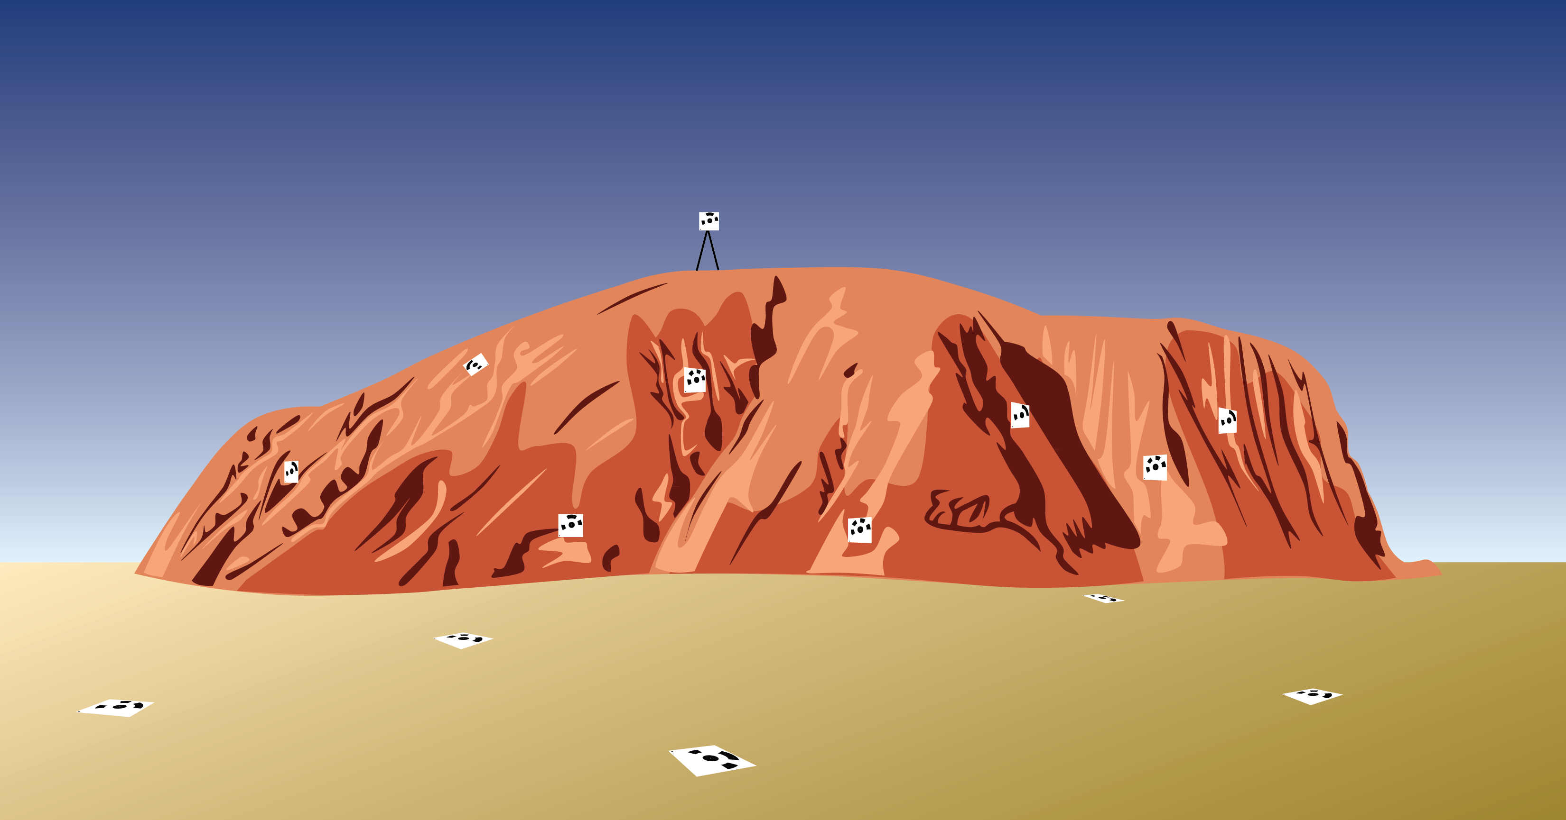
Figure 9. Suggested target placement for a survey of the ground and of the outcrop. Targets should be variable in their horizontal and vertical locations, so they do not appear to be bunched up or in a line.
Recognizable natural features may be used as targets with or without a GPS. If an ALS survey of the location exists (or a TLS survey) and you can assume little change has occurred, the recognizable features can be selected within the ALS point cloud and the location used as the GCP location in the SfM point cloud. These also may be used as targets for a GPS if the resolution of the model is high enough to recognize a specific part of the natural feature used as a survey point.
A Frisbee with an X can be used as a target; survey the centerpoint of the X.
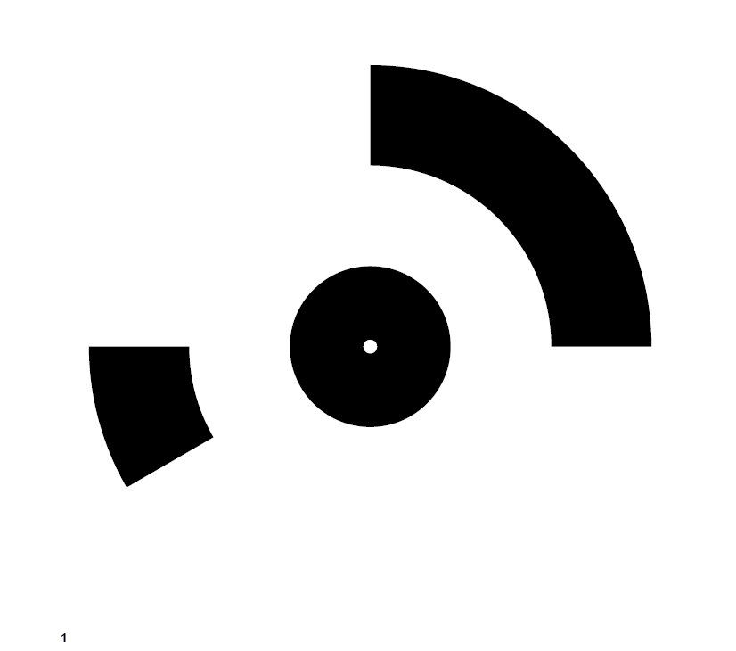
Agisoft recommends using its provided coded targets as they can be automatically recognized by the software and input into the model; however, the auto recognition is often not successful, so expect some manual input of target locations into Agisoft (Figure 10).
If a high-precision GPS system is unavailable to use, targets may still be used. Measure between specific targets and record the distances; these can be input into Agisoft MetaShape Pro to roughly scale the model. More measurements of distance will increase the accuracy of the model.
Scale bars may also be used in the model to scale it. Scatter scale bars of an appropriate size for the scale of the survey around the survey area without obstructing the feature of interest. Scale bars need to have some sort of texture or color; SfM algorithms have difficulty with items that are glittering, flat, or a homogeneous texture/color (as distinct features are used to link the images for model generation). One way to avoid this is to place the coded targets from Agisoft on the scale bars to add complexity. Follow the link: (http://www.agisoft.com/pdf/tips_and_tricks/CHI_Calibrated_Scale_Bar_Placement_and_Processing.pdf) for an example of scale bars with coded targets.
Figure 10. Example of an Agisoft coded target.
Another thing to consider with target choice is that SfM software has a difficult time recognizing featureless objects; the keypoints are features that are identifiable because they have a distinct texture. Using a completely flat piece of cardboard that is only one color, for example, may result in a distorted and therefore unusable target. The scale of the targets should match the scale of the survey; do not use small targets if surveying a large area, as the size of the target may be smaller than the model resolution and therefore unusable.
Targets should not be placed in a linear fashion or bunched up, but should be as evenly dispersed as possible around the survey area—both horizontally and vertically, if possible (Figure 9). For a paleoseismic trench survey, twelve targets has been shown to be the ideal number (no significant decreases in error above this number).

6. Field Workflow (and Field Prep)
Based on personal experience and Johnson et al. (2014).

Before leaving for the field
- Decide on a platform that works best for the data you would like to collect. In selecting a platform, be sure to consider your need for power (to charge batteries) or refill helium (if using a balloon).
- Select a camera. Remember to use the section above to guide your choice, and ensure that the camera has GPS tagging or can integrate GPS tagging.
- Select what your targets will be. Make sure they will be visible given the terrain you are surveying and make sense with what you are interested in—if you are mapping the terrain, a flat target (Frisbee, etc.) makes more sense, but if you are photographing an outcrop, a target that attaches to a tripod or a target that attaches to the outcrop makes more sense. Also make sure you have enough targets; Reitman et al. (2015) found twelve targets used as ground control points was an ideal number for a paleoseismic trench survey (more targets did not significantly decrease model error).
- Have a minimum of two SD cards for your camera that will hold a large number of photos and a way to back up the data. Also have an extra battery (or three).
- Test your survey setup prior to fieldwork. If using time-lapse or a remote control for the system, ensure these work, as they are key to capturing photographs.
- Field supply list: platform, camera, camera mount, extra charging supplies, extra SD cards, targets, and GPS (to survey in the targets).

At the field site
- Make a plan:
  - What is the furthest extent you would like dense photographs of?
  - Where should the targets go to not obstruct features of interest?
  - Is everything of interest visible? If you are mapping an outcrop, you may want to clean it beforehand. SfM algorithms do not work with glittering or homogenous surfaces, so make sure these surfaces are either not included or have been modified in some way to be more algorithm friendly.
  - If using a UAS, how much flight time do you have and how should that influence your survey design?
  - What time of day will give you the best lighting to photograph this area? Does that place a limitation on the time you have available and, as a result, the area to survey?
- Set up and survey the targets as ground control points. Ensure that the targets WILL NOT MOVE; if they change position, they are unusable.
- Take photographs. Remember the important parts of taking SfM photos: overlap and changing position. Do not stand and take photographs in a circle around yourself, for example. Move the camera locations for best results. If using an aerial platform, set a time (5–10 s) that makes sense with the speed you are moving the platform and the number of photographs you would like to take / the spacing of those photographs.
  - Go to section 8 for more information on photo acquisition strategies.
- At the end of the field day (especially if surveying the same location again, or if you have extra days to fix problems) generate an initial model to ensure the photographs you took captured the feature you are interested in (see next section).

7. Agisoft MetaShape Pro
One consideration with Agisoft is the hardware used. Below are the recommendations from Agisoft as of March 1, 2016 (Table 4).
Table 4. Hardware recommendations from Agisoft for optimal use of MetaShape Pro. Source: http://www.agisoft.com/downloads/system-requirements/
 | Basic configuration  Up to 32 GB RAM | Advanced configuration  Up to 64 GB RAM | Extreme configuration  More than 64 GB RAM
CPU | Quad-core Intel Core i7 CPU, Socket LGA 1155 (Sandy Bridge, Ivy Bridge or Haswell) | Six-core Intel Core i& CPU, Socket LGA 2011-v3 or 2011 (Haswell-E, Ivy Bridge-E or Sandy Bridge-E) | For processing of extremely large data sets a dual socket Intel Xeon Workstation can be used.
Motherboard | Any LGA 1155 model with 4 DDR3 slots and at least 1 PCI Express x16 slot | Any LGA 2011-v3 or 2011 model with 8 DDR4 or DDR3 slots and at least 1 PCI Express x16 slot
RAM | DDR3-1600, 4 x 4 GB (16 GB total) or 4 x 8 GB (32 GB total) | DDR4-2133 or DDR3-1600, 8x 4 GB (32 GB total) or 8 x 8 GB (64 GB total)
GPU | Nvidia GeForce GTX 980 or GeForce GTX 1080 (optional) | Nvidia GeForce GTX 780 Ti, GeForce GTX 980 or GeForce GTX TITAN X

Table 5. Memory consumption for differing operations with various numbers of photos for Agisoft MetaShape Pro (photo resolution 12 megapixels).
Aligning photos | 100 photos | 200 photos | 500 photos | 1000 photos | 2000 photos | 5000 photos | 10000 photos
 | 500 MB | 1 GB | 2.5 GB | 5 GB | 10 GB | 25 GB | 50 GB
Building model – height field
Lowest quality | 25 MB | 50 MB | 125 MB | 250 MB | 500 MB | 1.25 GB | 2.5 GB
Low quality | 100 MB | 200 MB | 500 MB | 1 GB | 2 GB | 5 GB | 10 GB
Medium quality | 400 MB | 800 MB | 2 GB | 4 GB | 8 GB | 20 GB | 40 GB
High quality | 1.6 GB | 3.2 GB | 8 GB | 16 GB | 32 GB | 80 GB | 160 GB
Ultra-high quality | 6.4 GB | 12.8 GB | 32 GB | 64 GB | 128 GB | 320 GB | 640 GB

Building model – arbitrary | 20–50 photos | 100 photos | 200 photos | 500 photos
Lowest quality | 100–300 MB | 150–450 MB | 300 MB–1 GB | 1–3 GB
Low quality | 500 MB–1.5 GB | 750 MB–2.2 GB | 1.5–4.5 GB | 4–12 GB
Medium quality | 2–6 GB | 3–9 GB | 6–18 GB | 15–45 GB
High quality | 8–24 GB | 12–36 GB | 24–72 GB | 60–180 GB
Ultra-high quality | 32–96 GB | 48–144 GB | 96–288 GB | 240–720 GB

Decimating model (millions of faces) | 1 | 5 | 10 | 20 | 50 | 100 | 200 | 500
Memory consumption | 128 MB | 640 MB | 1.3 GB | 2.5 GB | 6.2 GB | 12.5 GB | 25 GB | 63 GB

For a comparison of differing CPU/GPU’s: http://www.anandtech.com/show/7648/gigabyte-brix-pro/3

Based on personal experience
Although many SfM software packages exist, this is my preferred workflow for working in Agisoft MetaShape Pro. If you would rather use open source software, see James and Robson, (2012), Westoby et al. (2012), Fonstad et al. (2013), and Green et al. (2014). I would also suggest looking into the blog http://archaeologysfm.blogspot.co.uk/, in which Susie Green (of Green et al., 2014) includes additional details on the open source workflow, as well as a link to her master’s thesis on the topic.
Workflow for Agisoft:
- Take a cursory glance through your photographs to ensure that none are obviously blurry. This will help with the texture overlay later and get rid of errors in the generated point cloud.
- Agisoft has a function called Estimate Image Quality that will assess image quality automatically. Use images with a quality rating of 0.6 or higher.
- Load photos, as well as associated GPS information (known as “camera position”). The details of how to do this are in the Agisoft document here: http://www.agisoft.com/index.php?id=31 and are detailed in the SfM Data Processing and Exploration Manual.
- For the Align Photos and Dense Cloud steps in Agisoft, you have the option to set the “quality.” If you select “high,” the photos will not be downsampled.
- Go to Align Photos. Keep accuracy at “high”—this helps with later steps. As you will have camera locations from GPS, selecting “high” does not take significantly longer. Choose “reference” for the pair preselection option as you have camera locations. Hit “OK.”
- Now add Ground Control Points. This process is detailed in the SfM Data Processing and Exploration Manual.
- Go to the Workflow menu and select “Batch Process.” This way you can set the model up to run without having to constantly check whether a step has finished.
- Now add the next step: dense cloud. Use high quality to prevent downsampling. The other setting is “depth filtering.” If you would like to include small details, use “mild” to avoid filtering these out as outliers. If small details are unimportant, use “aggressive” and for all other situations use “moderate.”
- If there are time constraints or this is a test model to check the photos, build mesh and THEN build dense cloud (swap steps 7 and 8). If using this option, source data from the sparse cloud. Choose the “medium” or “high” option for polygon count. Hit “OK.”
- Build the mesh. Surface type should be “height field” if a planar surface and “arbitrary” if something like a building.
- The last step is adding texture. Select “arbitrary” if working on something like a building; “adaptive orthophoto” if there is a flat portion and a vertical portion; “orthophoto” if it is flat, “spherical” if it is spherical. Blend a mosaic for slightly higher quality texture. Blending should be modified based on your results, but mosaic works best for a quick model. Hit “OK.”
- Run the batch process. Processing speed is dependent on your hardware and number of photos; processing significantly slows above ~250 photos.
- Break the model into chunks and perform the above steps to each chunk if working with a large number of photos (500 or more). Then it is possible to merge the chunks after all the processing has occurred, significantly speeding up the process.

8. Photo Acquisition Considerations
Based on personal experience and Raugust and Olsen (2013).
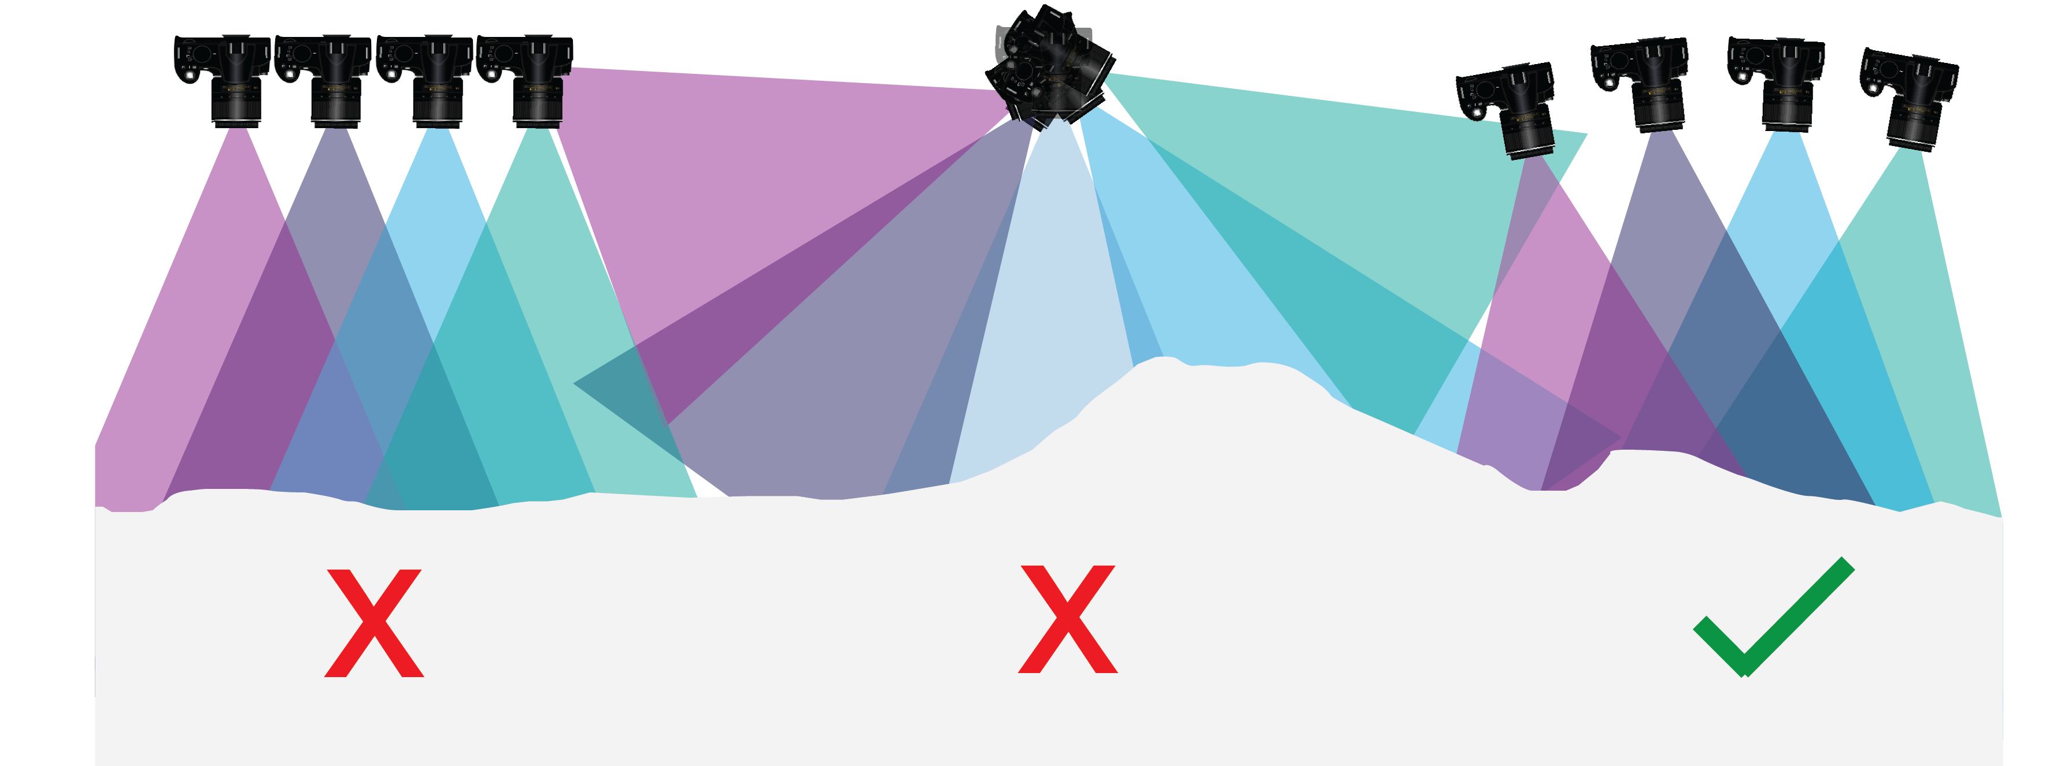
Figure 11. Do not take photos in a planar or divergent fashion (left and center). Take photos in a convergent fashion.
- Photos should be taken in a convergent fashion (Figure 11). James and Robson (2014) have shown photographs taken in a divergent or planar orientation distort the model.
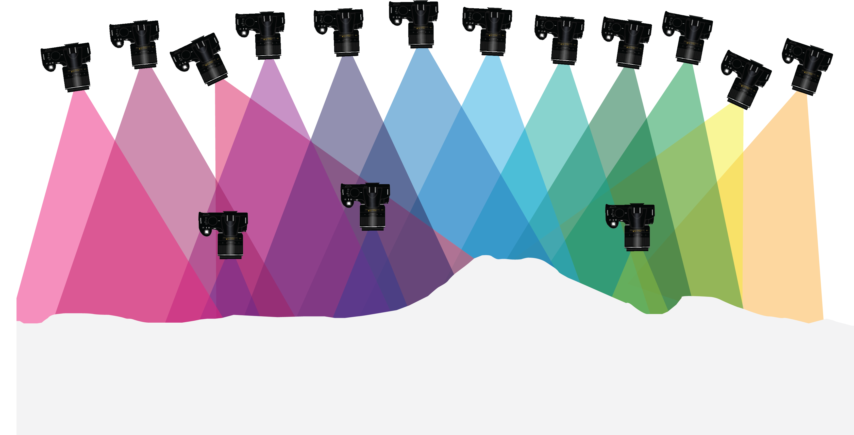
Figure 12. Take photos converging on the feature, at multiple distances and angles.
- When in the field, consider taking photographs at multiple distances and angles (Figure 12). If using a balloon or UAS, collect a flight path at a single height and then either increase or decrease the height depending on whether you would like more surrounding context or more detail
- Always photograph a larger region than you anticipate needing. The edges of the area you are surveying will have a lower photo density, so ensure that these are not areas that apply to your research.
- OVERLAP IS KEY. Overlap your images as much as possible. Different software programs have different guidelines, but it is essential all portions of the area of interest are covered by multiple photographs. Less than 70% overlap will affect the interpreted scene, while more than 90% overlap may significantly increase processing time.
- When considering overlap, keep in mind the goals of your project. Do you want decimeter resolution? Centimeter resolution? If you are interested in lower resolution models, high overlap percentages are unnecessary.
- Lighting the photos well is important. If it is too dark, features (especially texture) do not stand out, but if is too bright, these features are washed out. Ideally, if working on smaller-scale features, take photographs when the feature is in shadow or lower lighting but the sun is still out. This usually corresponds to late afternoon or early morning light.
- Georeferencing targets rather than geologic features is best. If necessary, use parts of the outcrop as ground control points, but some features may be less visible in the model and georeferencing is essential for scale.
- Surface texture is essential. If there is little variation on the surface, SfM is difficult. Problematic materials: glass, mirror, very smooth dirt, painted surfaces, surfaces that do not vary in color or texture (i.e., a box), many other man-made materials, snow. PRACTICE photographing a similar feature beforehand to ensure that the texture will be represented.
- Break areas into blocks if there are a large number of photographs (greater than 250) and processing is extremely slow. This is a way to speed up processing time, and with georeferenced data, all blocks can be tied together later.
- To work with data while in the field, make lower resolution models that require less processing time and computer power to check that the model covers all of your area of interest. In addition, if using Agisoft MetaShape Pro, generating the mesh prior to generating the dense point cloud (after the photos are aligned) will be a quicker way to stitch the photographs together. This method is less reliable—sometimes models generated are just black blobs rather than textured accurate representations—but is useful in a field setting when you are prepping for the next day of work.

9. References for the guide
Fonstad, M.A., Dietrich, J.T., Courville, B.C., Jensen, J.L., and Carbonneau, P.E., (2013) Topographic Structure from Motion: A New Development in Photogrammetric Measurement: Earth Surface Processes and Landforms, 38, 421–430, doi: 10.1002/esp.3366
Green, S., (2012) Structure from Motion as a Tool for Archaeology, MSc thesis, University College London, 128 p.
Green, S., Bevan, A., and Shapland, M., (2014) A Comparative Assessment of Structure from Motion Methods for Archaeological Research: Journal for Archaeological Science, 46, 173–181, doi: 10.1016/j.jas.2014.02.030
James, M.R., and Robson, S., (2014) Mitigating Systematic Error in Topographic Models Derived from UAV and Ground-based Image Networks: Earth Surface Processes and Landforms, 39, 1413–1420, doi: 10.1002/esp.3609
James, M.R., and Robson, S., (2012) Straightforward Reconstruction of 3D Surfaces and Topography with a Camera: Accuracy and Geoscience application: Journal of Geophysical Research, 117, F03017, doi: 10.1029/2011JF002289
Johnson, K., Nissen, E., Saripalli, S., Arrowsmith, J.R., McGarey, P., Scharer, K., Williams, P., and Blisniuk, K., (2014) Rapid Mapping of Ultrafine Fault Zone Topography with Structure from Motion: Geosphere, 10 (5), 969–986, doi: 10.11130/GES01017.1
Raugust, J.D., and Olsen, M.J., (2013) Emerging Technology: Structure from Motion: LiDAR Magazine, 3 (6), 5 p.
Reitman, N.G., Bennett, S.E.K., Gold, R.D., Briggs, R.W., and DuRoss, C.B., (2015) High-Resolution Trench Photomosaics from Image-based Modeling: Workflow and Error Analysis: Bulletin of the Seismological Society of America, 105, 2354–2366, doi: 10.1785/0120150041
Snavely, N., Seitz, S.N., and Szeliski, R., (2008) Modeling the World from Internet Photo Collections: International Journal of Computer Vision, 80, 189–210, doi: 10.1007/ss112263-007-0107-3
Ullman, S., (1979) The Interpretation of Structure from Motion: Proceedings of the Royal Society of London B, 203, 405–426, doi: 10.1098/rspb.1979.0006
Verhoeven, G., (2011) Taking Computer Vision Aloft—Archaeological Three-Dimensional Reconstructions from Aerial Photographs with MetaShape: Archaeological Prospection, 18, 67–73, doi: 10.1002/arp.399
Westoby, M.J., Brasington, J., Glasser, N.F., Hambrey, M.J., and Reynolds, J.M., (2012) Structure from Motion Photogrammetry: A Low-Cost, Effective Tool for Geoscience Applications: Geomorphology, 179, 300–314, doi:10.1016/j.geomorph.2012.08.021

