Structure from Motion (SfM) Photogrammetry Field Methods Manual for Students
Written by Katherine Shervais (UNAVCO)

Introduction to SfM for Field Education
The purpose of the Analyzing High Resolution Topography module is to introduce students to new technologies that are becoming widespread in geologic field investigations. Students will learn to design surveys and apply analysis of high resolution topographic data to a variety of geoscience questions. This manual is focused on Structure from Motion (SfM) photogrammetry. This method of data collection, first used in the geosciences in 2012, has already been applied to a wide variety of geological problems; the low overhead, ease of data collection, and the data resolution make this technique applicable to investigations of a variety of geological processes. In some cases, SfM is valid alternative for traditional photogrammetric methods and terrestrial laser scanning (TLS) and airborne laser scanning (ALS). (All images not otherwise credited were created by the author.)

Introduction
Structure from Motion, or SfM, is a remote sensing technique that uses multiple photographs of an object or feature to create a three-dimensional set of points corresponding to the surface of the feature (each with X, Y, Z coordinates) called a point cloud with associated RGB coloration. After georeferencing the point cloud with ground control points taken with a GPS unit defining the position of recognizable features, the data can be converted to a digital elevation model (DEM) to analyze for scientific research. SfM is a tool that is quickly becoming popular in the geosciences for topographic mapping, as well as temporal and spatial geomorphic and tectonic studies of earthquakes, volcanoes, landslides, fluvial geomorphology, glacier mass balance, and snow depth measurements. SfM is also used in biomass investigations in forestry, habitat analysis in biology, and numerous engineering applications.

Basics of the Structure for Motion methodology
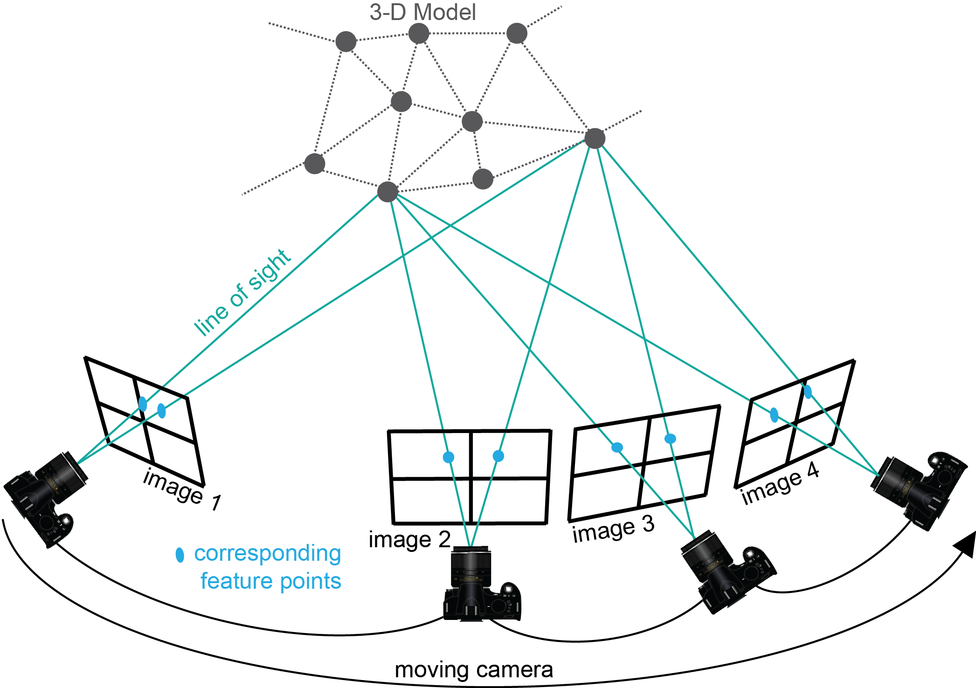

Figure 1. Schematic of Structure from Motion (SfM) method. Photographs are taken at a variety of orientations; the matched features in multiple photographs are used to estimate relative camera position, which is then extrapolated to create a point cloud, or 3D model, of the scene. (Figure modified from Chris Sweeney, UCSB).
This manual will focus on the survey, or photo collection, process (Figure 1). However, it is also important to understand the basics of the model generation process to design an optimal survey. Multiple photos of a feature from a variety of perspectives are taken and input to SfM software. After photographs are taken, the “structure” (e.g., topography) of the scene is constructed from the “motion” of the camera. The software identifies features present in multiple photographs, called keypoint descriptors (hereafter referred to as keypoints) using an algorithm called SIFT (Scale-Invariant Feature Transform) (Figure 2).

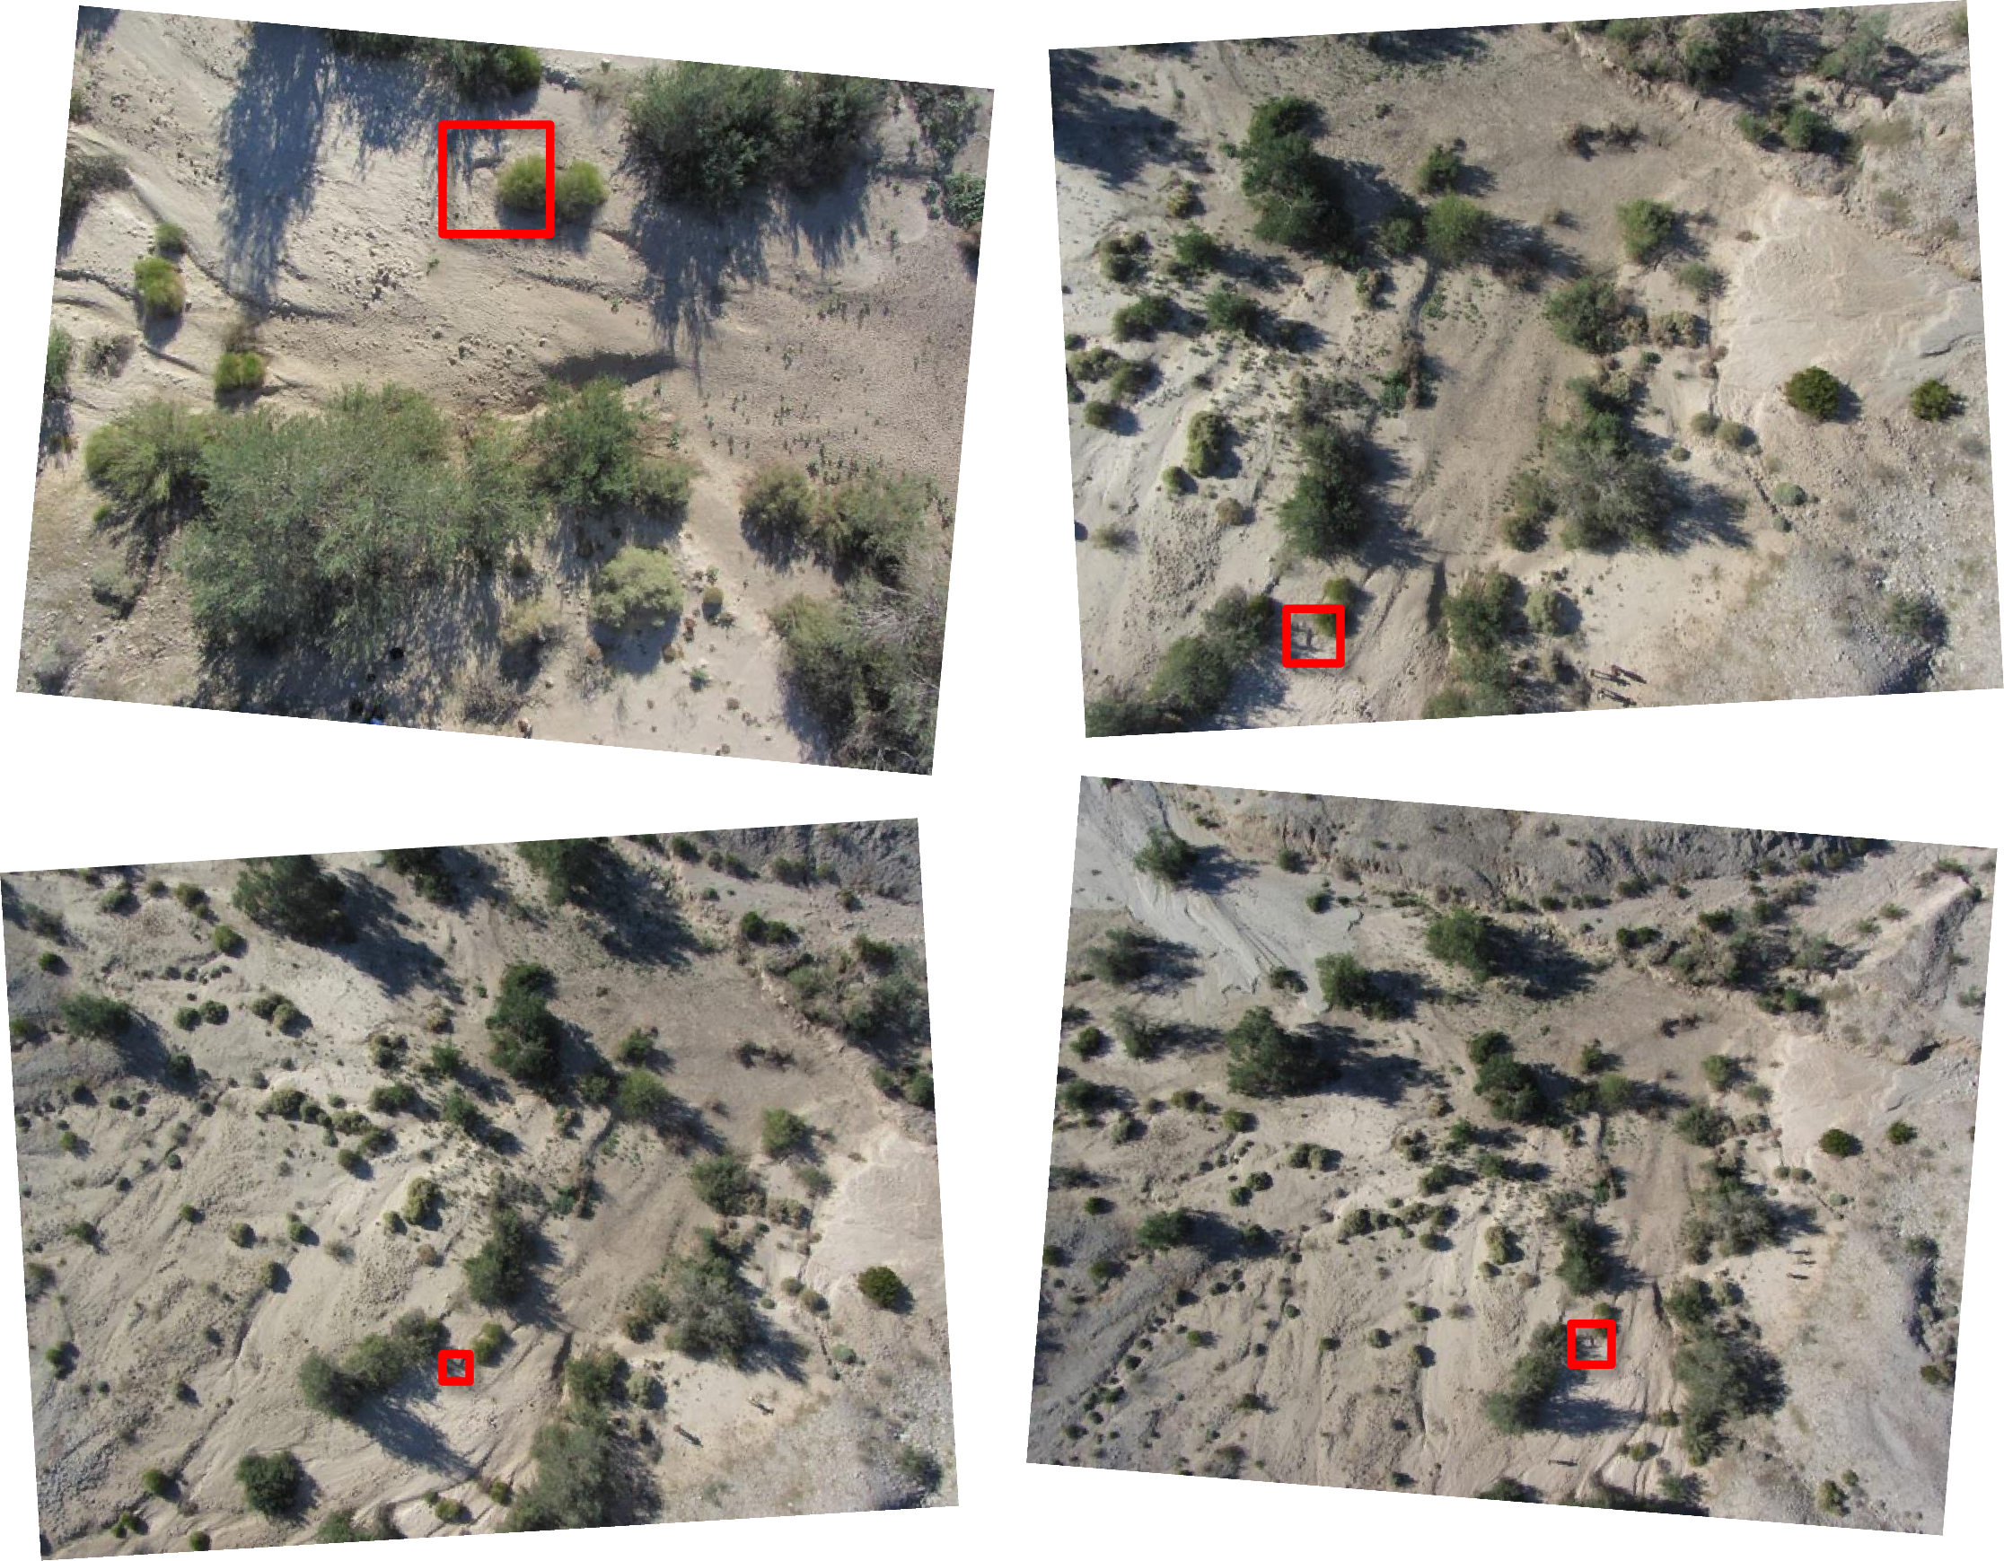

Fig. 2: SIFT (Scale-Invariant Feature Transform) is an algorithm that identifies keypoint descriptors found in multiple images regardless of their scale as shown above. The same bush is highlighted in each photograph and is able to be matched despite the size variations (Ed Nissen, CO School of Mines).
Keypoints are used to calculate the relative locations of the cameras to create a sparse “low-density” point cloud. A high-density point cloud is then generated based on the locations of the sparse points and the locations of the camera (Figure 3). Ground control points, or the GPS locations of recognizable features within the model, can now be added to georeference the point cloud so it can later be transformed into a digital elevation model (DEM). Ground control points are also crucial to generating a more accurate topographic model.

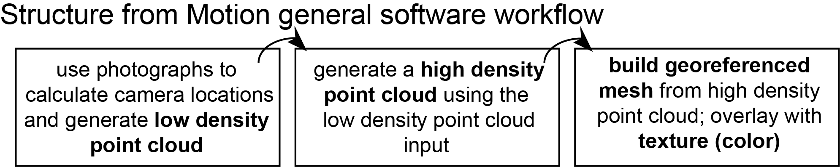
Figure 3. General workflow for any Structure from Motion software. This process is explained in more detail in the SfM Data Processing and Exploration Manual.

Comparisons to other geodetic imaging techniques

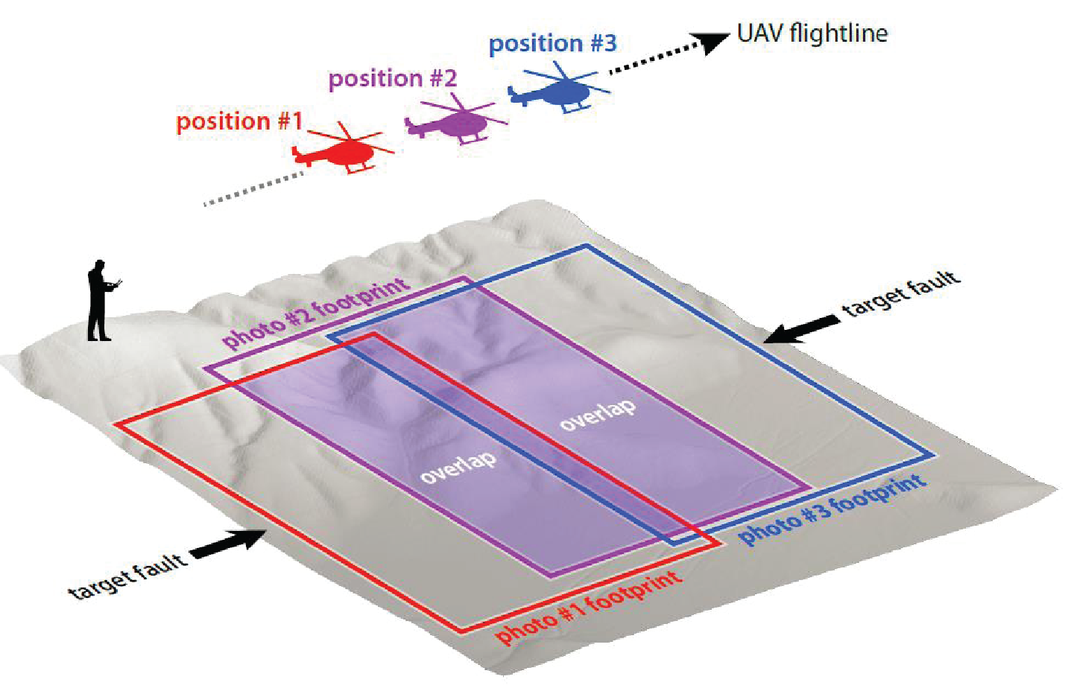

Figure 4. Top: Comparison of SfM to airborne LiDAR and terrestrial LiDAR; figure from Johnson et al., 2014 (considered fair use by GSA Publications http://www.geosociety.org/pubs/copyrt.htm); Bottom: Example of traditional photogrammetry methodology. UAV is unmanned aerial vehicle (Ed Nissen).
TLS and ALS are expensive, require technology-specific expertise, a lot of equipment (TLS), and may not be appropriate for medium-sized project areas (1–5 sq kilometers) and/or frequent resurveys of a site. The advantage to SfM is that it does not require expensive equipment, can be done by anyone with the correct tools, and uses a variety of collection platforms and so is adaptable to many environments (Figure 4). Traditional photogrammetric techniques require a highly specific and complex photography process, while SfM requires only overlap between photographs. Ground control points are required to combine the photographs into a model in traditional photogrammetry, while they are optional in using SfM and may be added later if derived from other means.

SfM Survey Design
An effective Structure from Motion survey has several components. Because the applications of this methodology are so variable, the platform used to collect photos and the survey duration depends entirely on the type of feature studied. Keep in mind that the course instructor may have already made camera and platform choices for this activity.
When designing a survey, remember to consider the time constraints on data collection, the feature of interest, and the accessibility of the field site. These factors will significantly influence the survey design.

Choosing a platform
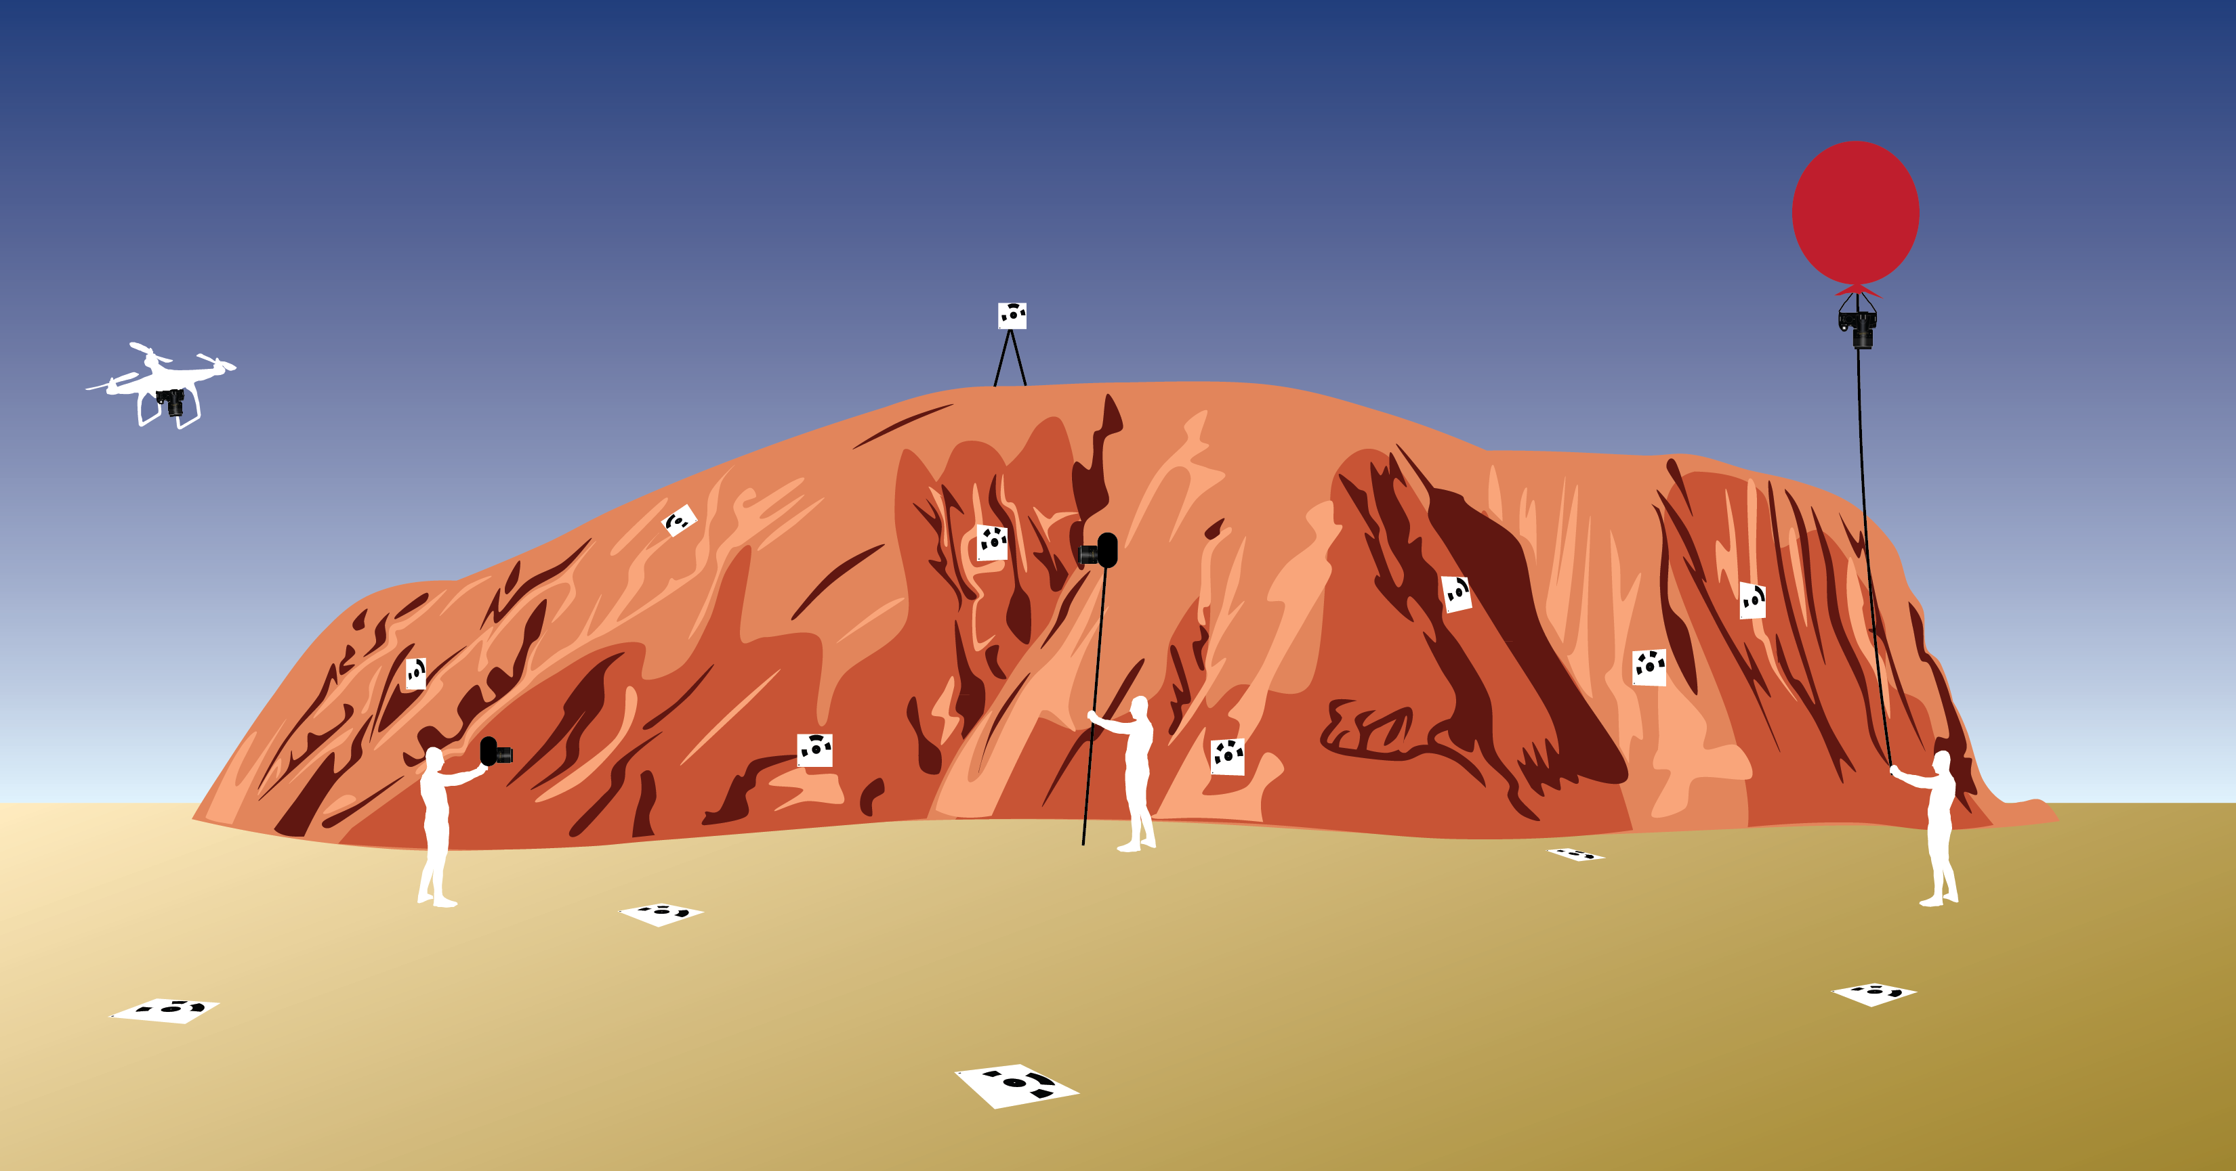
Figure 5. Examples of different SfM platforms to survey outcrops or topography; the white squares are targets, which will be explained in the “Designing the survey” section. A UAS is shown to the far left; this may be used to photograph the outcrop or the topography depending on the angle of the camera. A man is photographing the outcrop with a handheld camera in the left-center, and photographing the outcrop with a pole in the center. On the right, a balloon is used to photograph the topography.
Available platforms for SfM photo collection include handheld cameras, poles, kites, balloons, and unmanned aerial systems (UASs) (Figure 5). Platform choice should be determined based on the feature surveyed. Outcrops exposed orthogonal to the ground, such as roadcuts or quarry faces, may be best surveyed by handheld cameras. Outcrop-scale features parallel to the ground may be surveyed by handheld cameras or pole-mounted cameras. If trying to characterize a large-scale feature such as the topography of a region, choose an aerial platform. This platform choice should be made synchronously with camera choice, as the platform must be able to support the camera weight.
Another component of platform choice is the number of cameras or the number of operators. If many people are collecting data at the same time, many handheld cameras may be the most efficient choice.

Choosing a camera
The key component of the survey is clear photography of the feature of interest. This can be achieved with a variety of cameras, ranging from video cameras (stills) to low-grade consumer cameras to digital SLR (single-lens reflex) cameras. Images produced from a camera with greater than 12 megapixels may need to be downsized, depending on the computing capacity of the computer running the model.
Cameras with a time-lapse option (taking photos every x number of seconds) is necessary when using most aerial platforms, unless a remote is installed to manually control the time between photos.
Using a camera with a built-in GPS tagger reduces the amount of time needed to process the photos and is recommended.

Power and memory
The camera and potentially the platform require batteries. Ensure that there is a power source to charge batteries if surveying on multiple days. A plentiful supply of batteries should be available. Available power will affect the length of your survey if using a UAS; average flight time per battery is approximately twenty minutes but varies widely by system. Multiple memory cards should be available for the camera; the number depends on the number of photos needed for the survey.

Designing the survey
The overall goal of the survey is to obtain clear, sharp photographs that overlap in the area contained in the image. Considerations prior to survey design:
Studies have shown that the geometry of the survey path affects the SfM model that results from the photographs. The best survey design is to try to create camera views that converge upon the feature of interest (Figure 6). If photos are taken exactly in parallel, the model will suffer radial distortion in the center that could introduce error into change detection or any other quantitative analysis (Figure 6). Divergent camera locations, where the camera stays in one location but rotates, are also not ideal for the SfM process because differing camera locations are essential for the software to work properly (Figure 6). This is also true in 3D, so the camera location needs to move up and down as well as side-to-side as demonstrated in Figure 6.
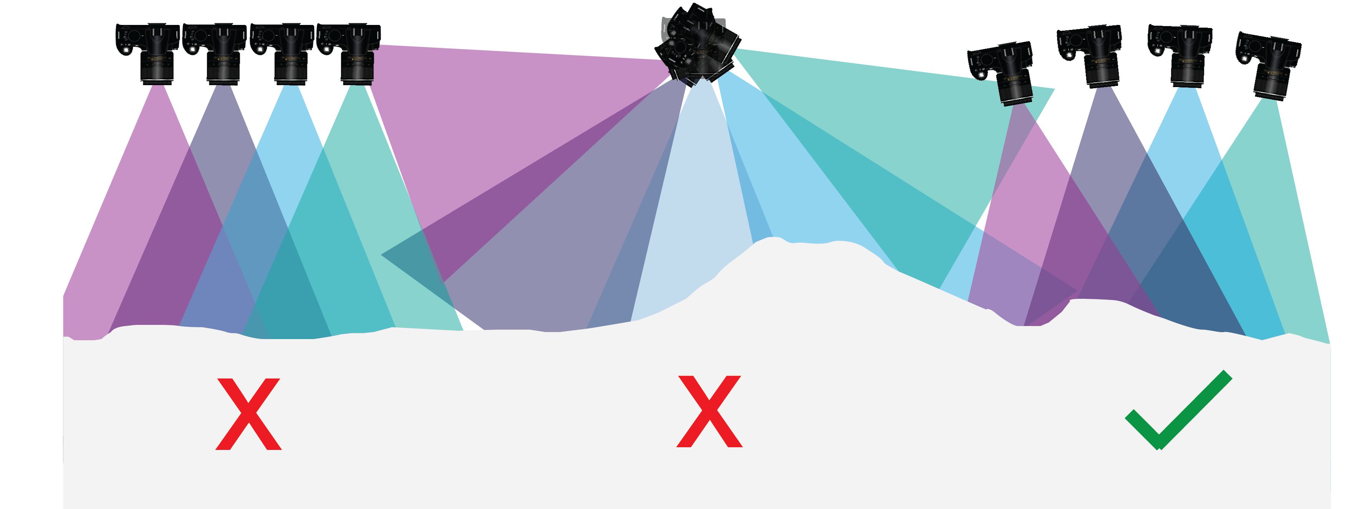
Figure 6. The left and center views show how you should not take photographs. Taking all photos in parallel or from only one position will distort the survey. If possible, take photos converging on the scene of interest such as shown in the right-hand view.
Step 1: Choose the photo collection path.
This depends on the platform used. If using a handheld camera or a pole, design a survey path to incorporate the best views of the feature of interest while progressing by foot. If using an aerial platform controlled via line (i.e., kites and balloons), design the survey path to be accessible for the operator on foot. UASs should take photographs at multiple angles, to reduce the number of exactly parallel photos as to not distort the final product. Think of these questions:
- What is the furthest extent you would like dense photographs of?
- How many photographs will you need to survey in the area of interest? There is a trade-off between model resolution (lots of photos = greater resolution) and model processing time (lots of photos = greater processing time).
- Is everything of interest visible? If you are mapping an outcrop, you may want to clean it beforehand. SfM algorithms do not work with glittering (i.e., a mirror) or homogeneous (i.e., a white cardboard box) surfaces, so make sure these surfaces are either not included or have been modified in some way to be more algorithm-friendly.
- If using a UAS, how much flight time do you have and how should that influence your survey design?

Step 2 (optional): Set up targets
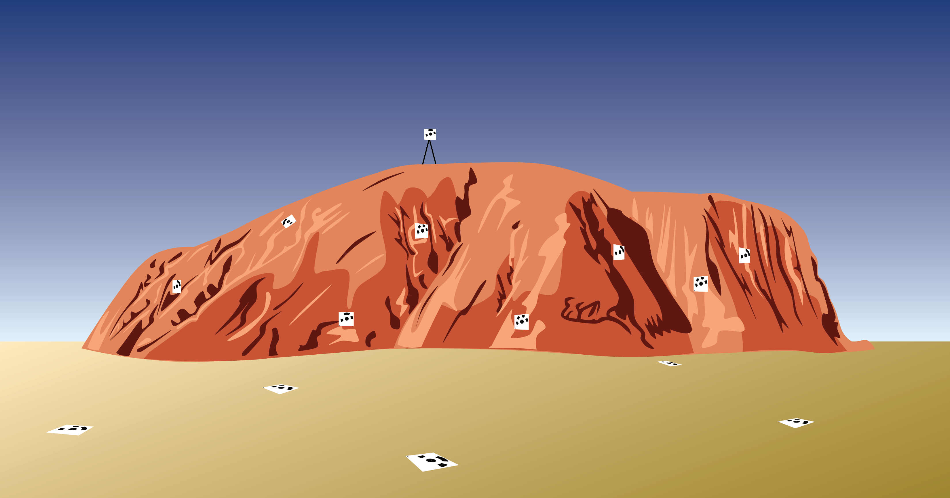
Figure 7. The white squares with black patterns represent the coded targets. Targets should be oriented based on the feature of interest. If the feature of interest is the topography, the targets should be flat on the ground to be captured by the camera as shown in the foreground. If the feature of interest is orthogonal to the ground, place targets at a matching orientation as shown in the outcrop in the background. For all, place targets at different elevations and triangulate, so the targets are not in a straight line.
If the model is intended to become a DEM, it is essential to set up a series of targets to use as reference points, also known as ground control points (GCP) (Figure 7). These targets should be easily recognizable in photographs, distinct from the surrounding material, viewable in multiple photographs, not obstruct the feature of interest, and have one specific point that can be used as a differential GPS survey point. The targets must not move over the course of the survey or they will be unusable as GCPs.
Another thing to consider with target choice is that SfM software has a difficult time recognizing featureless objects; the keypoints are features that are identifiable because they have a distinct texture. Using a completely flat piece of cardboard that is only one color, for example, may result in a distorted and therefore unusable target. The scale of the targets should match the scale of the survey; do not use small targets if surveying a large area, as the size of the target may be smaller than the model resolution and therefore unusable. For a paleoseismic trench survey, twelve targets has been shown to be ideal (there are no significant decreases in error above this number). Examples of targets include using recognizable natural features, simple Frisbees with an X on them, Agisoft coded targets, Jacob’s staffs, scale bars, or Agisoft coded markers at either end of a scale bar.
Targets should not be placed in a linear fashion or bunched up, but should be as evenly dispersed as possible around the survey area—both horizontally and vertically, if possible. Twelve targets is the minimum needed to ensure the greatest accuracy.
Use GPS to survey the targets. Record the survey point and an identifier for the target, as it is essential to link each target to the correct survey point to georeference the data. For example, if you use a pieces of cardboard with a pattern printed on them, number each one and then label the GPS point at that target number.
If using the program Agisoft Photoscan Pro, you may use their preconstructed coded targets as GCPs. Go to Tools—Markers—Print Markers. Choose a size that makes sense given the scale of your project (i.e., do not print extremely small markers if surveying a large area). Do not modify the marker in any way; do not write on it, cut it into shapes that are not essentially square, bend it, or make any other modifications. Choose a random selection of the markers printed; decide an appropriate number based on your project. Record what type of marker you used to input into the program later.
Step 2 alternative: Set up scale bars
If GPS is not available, a cheaper and less time-consuming alternative is to set up scale bars around the study area. Distribute the scale bars evenly around the area without obstructing the feature of interest. Scale bars may be a simple ruler or yardstick; you may also make them yourself out of blocks of wood or other material. Try to use the same principles of target placement with the scale bars suggested for the targets. Use scale bars that are an appropriate size for the scale of the survey; the bars should not dominate the survey but should also be visible. One issue with scale bars is that they may become distorted by the model-building process and therefore not show up with their true shape/length. Agisoft has difficulty recreating features with little color or texture variation as well, so scale bars with a more complex color/texture pattern are more likely to be accurately recreated. You may create small coded targets to attach to the scale bar to help with model generation. See the Agisoft tutorial (http://www.agisoft.com/pdf/tips_and_tricks/CHI_Calibrated_Scale_Bar_Placement_and_Processing.pdf) for an example of scale bars with coded targets.

Photograph collection
To minimize risk of model failure, it is essential to follow the below tips on camera settings and photo collection.
Some camera settings tips:
- Set the camera to take RAW images; if this is not available, choose an image output option that is not JPEG, as the compression used in this format introduces unnecessary noise.
- Use manual exposure and focus so the photos have similar exposure; consistency in the settings is better for calculation of camera location.
- Set the ISO to the lowest level to reduce noise.
- If using the time-lapse setting to take photographs with an aerial platform, adjust to your preferred settings and turn on prior to launching the platform.
- If using a remote control to take photographs with a pole or aerial platform, take test photographs prior to starting the photo collection process to confirm that the remote system is functional.
- Do not use the zoom! Instead move towards or away from the feature; using the zoom will make the software calculations of camera location more difficult. This will result in a less accurate model.
Some photo collection tips:
- Photos should have overlap of 60–80%.
- Take photos in a convergent fashion (like Figure 8 below).
- Take photos at a few angles, not just one orientation, to reduce distortion in the model.
- Think of what time of day will give you the best lighting to photograph the area. Does that place a limitation on the time you have available and, as a result, the area to survey?
  - As a general rule, morning and afternoon are the best times of day to photograph; because the light is low, photographs will not be too bright (obscuring features) and may be able to show an area entirely in shadow (preventing large variations in brightness in the photos used in the model).
  - If this is not possible, try to make sure the photographs are taken at the same level of brightness, so features appear the same in every photograph.
- Minimize the number of moving objects in the images; people and animals should stay out of the line of sight of the camera. If using a platform controlled by a line like a kite or balloon, the line will show up in different locations in the images. However, the software will recognize that these are not a part of the scene so you should not be concerned about the line location.

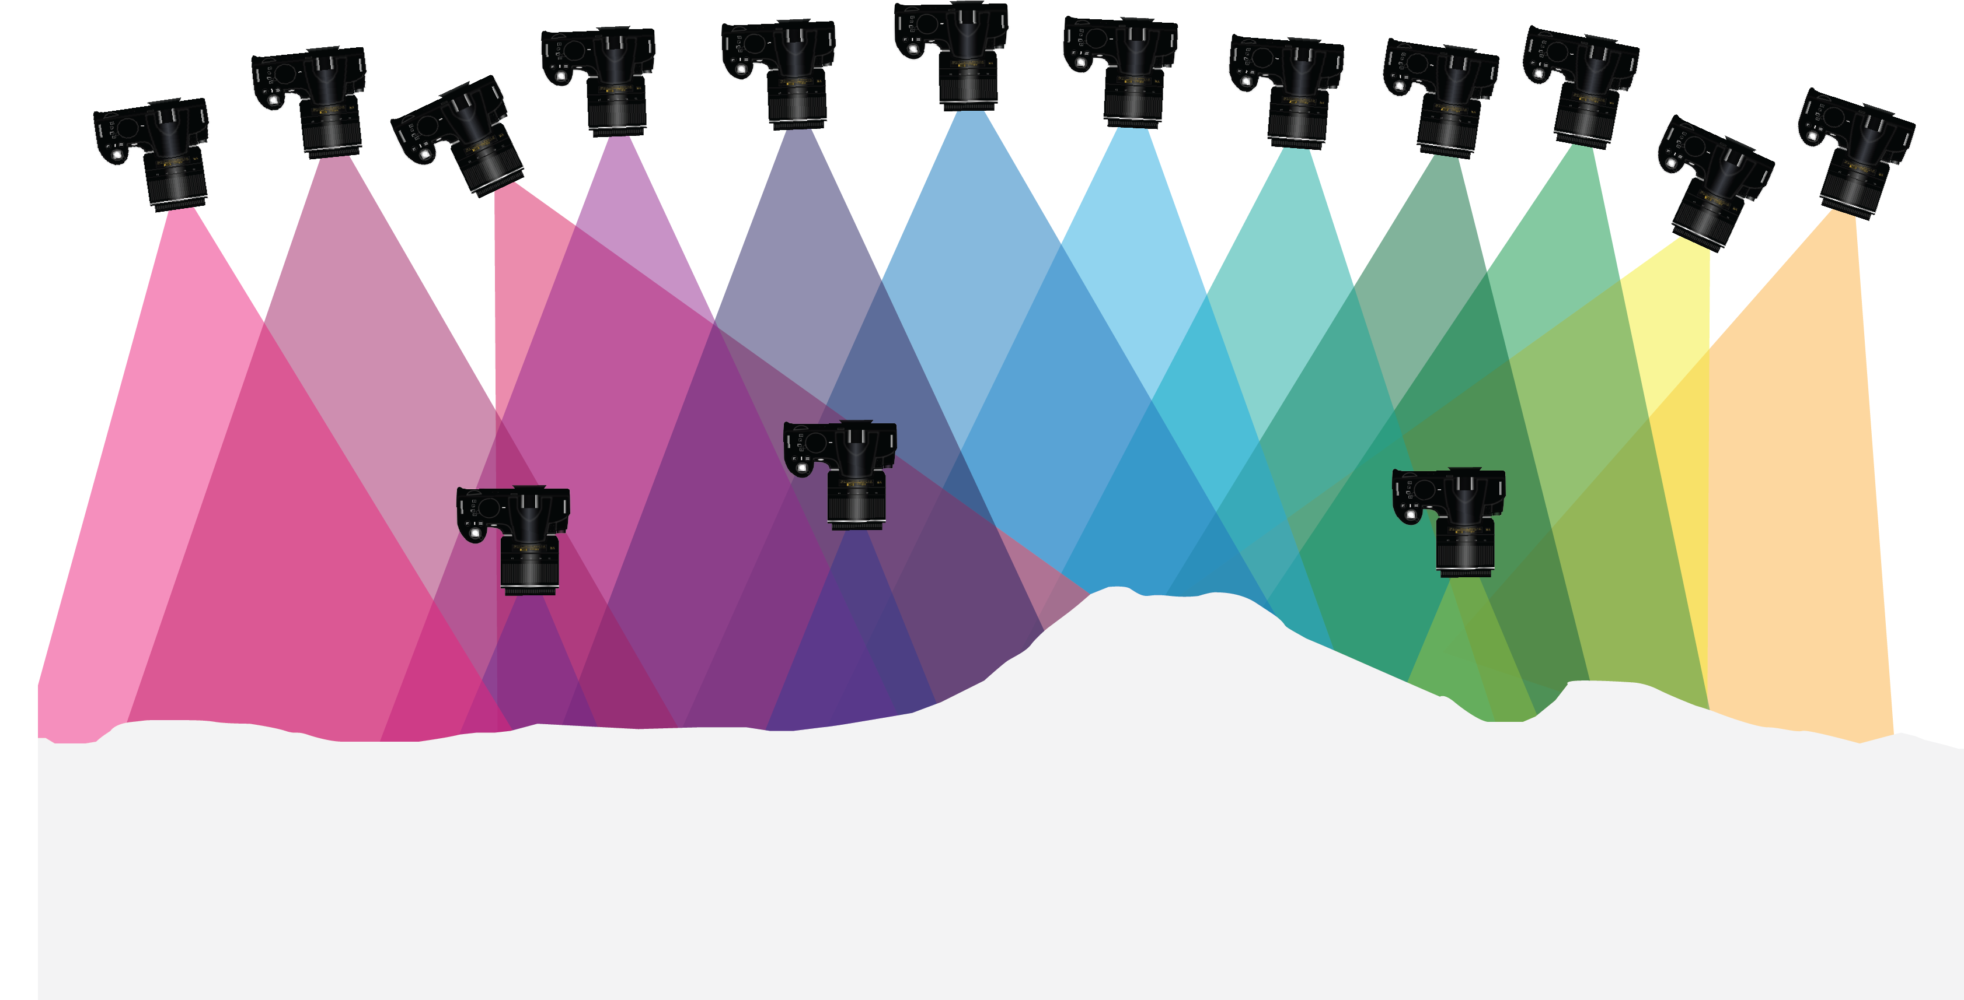
Figure 8. The ideal photo collection method includes taking photographs in a convergent fashion, using multiple angles, not varying the angles by more than 25°, and taking photos both close to and far away from the feature to introduce detail into the model (if needed).

