Kinematic GPS/GNSS Methods Manual
Ian Lauer, Idaho State University (laueian@isu.edu)
This document is intended as a practical guide to field methods for kinematic positioning systems. It does not cover positioning computation or theory, but is focused on field-based use of kinematic survey systems. This guide is intended for both instructors and students in its current form and includes asides of technical or theoretical material targeted toward advanced users.
Table of Contents
1. Introduction to Kinematic GPS/GNSS 2
1.1 Real-Time Kinematic (RTK) Survey 2
1.2 Post-Processed Kinematic (PPK) Survey 3
2. Equipment 4
2.1 Antennas 4
2.2 Receivers 5
2.3 Radios 5
2.4 Power and Batteries 5
2.5 Data Management, Storage, and Initial Settings 6
2.6 Tripods, Benchmarking, and Distance Measurement 7
3. Field Workflow: General 8
3.1 Site Analysis 8
3.2 Preparation and Logistics 8
4. RTK/PPK Field Setup 9
4.1 Base Station Preparation 9
4.2 Base Station Field Setup 10
4.3 Rover Setup and Preparation 11
4.4 Rover Field Setup 11
4.5 Conducting a Survey 12
4.6 Base Station: Finalize Survey 12
5. Data Processing 13
5.1. Data Downloading and Backup 13
5.2. Data Formats 13
5.3 Data Processing 14
5.4. Data Archiving and Data Access 16

Note: Although the term GPS (Global Positioning System) is more commonly used in everyday language, it officially refers only to the USA’s constellation of satellites. GNSS (Global Navigation Satellite System) is a universal term that refers to all satellite navigation systems including those from the USA (GPS), Russia (GLONASS), European Union (Galileo), China (BeiDou), and others. In this module, we use the term GNSS to refer generically to the use of one or more satellite constellations to determine position.

1. Introduction to Kinematic GPS/GNSS
Kinematic GNSS surveys are used to rapidly collect large numbers of high-precision survey positions, which are post-processed against a static base station. The system is composed of a base station, a rover, and potentially a radio system. The base station may be a combination of a temporary local base station or a permanently installed GNSS station, such as a Network of the Americas (NOTA; https://www.unavco.org/instrumentation/networks/status/all) or Continuously Operating Reference Station (CORS; https://geodesy.noaa.gov/CORS/) site, which is located close to the study area. A rover is an antenna and receiver combination, which can be mounted to a range pole or backpack and is carried to each site for measurements.
The basis of the kinematic system is a mobile rover, which takes initial positions, and a base station, which allows for corrections of the rover’s position. The rover is carried to each measurement site and is stabilized during a short occupation, typically 5–30 seconds, to acquire an initial position. The rover’s position is processed against the static base station’s position to remove several types of error including integer ambiguity and atmospheric delays. This results in a high-precision position for the rover on the order of several centimeters. This correction may take place either during post-processing or in real time if the rover receives correction information via radio or cellular connection. Whether processed after or during the survey, these methods produce the same results.

1.1 Real-Time Kinematic (RTK) Survey
Real-time kinematic surveys take advantage of constant radio communication between a static base station and the roving antenna to provide signal correction for increased positioning accuracy of the rover in the field (Figure 1). The real-time correction has the advantage of processing and viewing corrected, centimeter-accuracy measurements in real time while in the field. Additionally, RTK allows positions to be located within a georeferenced coordinate system and enables real-time measures of angles, distances, area, and navigation while in the field. However, to obtain these advantages the base station must either be established over a known position such as a previously installed benchmark or monument or run for a sufficiently long time to be corrected using independent software (e.g., OPUS [Online Positioning User Service]). RTK systems also provide an enhanced level of quality assurance that equipment is functional and positions are approximately correct before leaving the field area, potentially preventing loss of time. With post-processed systems (discussed in the next section), you must wait to see your corrected results.
An RTK setup consists of the base and rover antennas, receivers, a controller, and the addition of a radio at both the base and rover for positional corrections (Figure 1 and Figure 5). The base station is typically set up over a monument or other position with a known coordinate. This can be assigned to a local coordinate system, but reduces many of the system’s advantages. The base antenna receives positioning code from satellites and delivers it to the base receiver for processing. The base receiver then saves the base antenna’s position and communicates the carrier code correction and base position to the roving antenna and receiver unit via radio. The rover receiver combines the base station data and a GNSS positioning signal from satellites. The receiver compares the variations and noise in the base station’s code with its own, which allows it to eliminate several sources of error including atmospheric and tropospheric delays, integer ambiguity guesses, and clock errors. The correction of these errors increases the accuracy of the rover’s position from tens of centimeters to 1–2 cm precision. Although RTK systems have many advantages, they require significantly more equipment in the form of two radios, batteries, and supporting equipment.
Figure 1. An example of a Real-Time Kinematic (RTK) base station (left) and rover (right). Many options are available for rover mounts including poles, bipods, and backpacks (shown). A PPK setup is essentially the same, minus the radio link. (Source: Steve Lundblad and Benjamin Crosby)

1.2 Post-Processed Kinematic (PPK) Survey
Post-processed kinematic survey benefit from lower equipment and technical logistics, but with positions equally precise as RTK setups and do not require a known base station. Instead PPK requires downloading and then processing signals on a computer connected to the Internet in order to calculate and apply the correction. Post-processing is advantageous whenever terrain or logistics limit the ability to carry additional equipment to the field, when it is not necessary to have corrected data immediately, or when a monument or benchmark is unavailable. Most topographic and geologic surveys do not need real-time processing unless they involve engineering-style work where distances or other geometries need to be calculated in the field. PPK equipment consists of a base station and rover, each with an antenna and receiver. The rover additionally has a controller for data collection and inputs. PPK surveys collect continuous, static signals at the base station and short, 5–30 second occupation signals with the rover. The data is then downloaded and backed up after fieldwork and processed against other continuously operating stations. This can be done in Trimble Business Center, in the case of Trimble hardware, or other proprietary and free software as necessitated by equipment. The base station data must be processed in RINEX and corrected against other static, permanent stations in the region in order to correct for its position and then apply baseline corrections to the rover’s data. At the time of writing, Emlid systems, so appealing for their lower cost, do not have an easy workflow for PPK. One can utilize the open source RTKLIB (http://www.rtklib.com/) software to apply PPK corrections but it takes some time to learn to use it effectively.
Scan Type | Advantages | Disadvantages
RTK | Real-time corrected positions in a known coordinate plane. Able to navigate to and compute geometries of data points in the field | Significantly increased equipment cost and logistics. Must have radio connection between base and rover. Must set up base on a known position to utilize advantages
PPK | Reduced logistics, cost, and complications. Sufficient for most non-engineering surveys | Corrected data is typically not available until processed. Necessary to set up base at benchmark or fix its location later
RTX | Base station not required, centimeter-level positions in real time, no base station is required, available in remote locations. | Can take 5-30 minutes to initialize RTX correction service, adding the RTX option to Trimble receiver introduces more cost

2. Equipment
Various types and combinations of antennas, receivers, and controllers are available in the modern market and are constantly evolving. For the most part, it is easiest to work with antennas and receivers from the same manufacturer unless other compatibility is specifically mentioned, although the data is completely interchangeable once retrieved and processed. Generally, UNAVCO-supported education projects receive Emlid brand units. However, because processing software and workflow is manufacturer dependent, instructions provided here are manufacturer independent. The general workflow should apply to most manufactures, but see manufacturer literature or the UNAVCO Knowledge Base (http://kb.unavco.org/kb/) for specific instructions. Emlid-specific guides are available in the GETSI GPS/GNSS Equipment page (https://serc.carleton.edu/getsi/teaching_materials/high-precision/equipment.html#emlid)

2.1 Antennas
Antennas are the physical equipment that receives the carrier frequency and positioning code from the satellites and transmits it to the receiver for processing (Figure 2). Antennas may consist of just an antenna or include one or more signal-modifying or blocking apparatus, which are aimed at reducing or enhancing multipath signals and atmospheric distortion. Some modern antennas, such as the Emlid ReachRS2 (Figure 2, left), have a combined antenna and receiver unit in one package, sometimes referred to as a smart antenna.
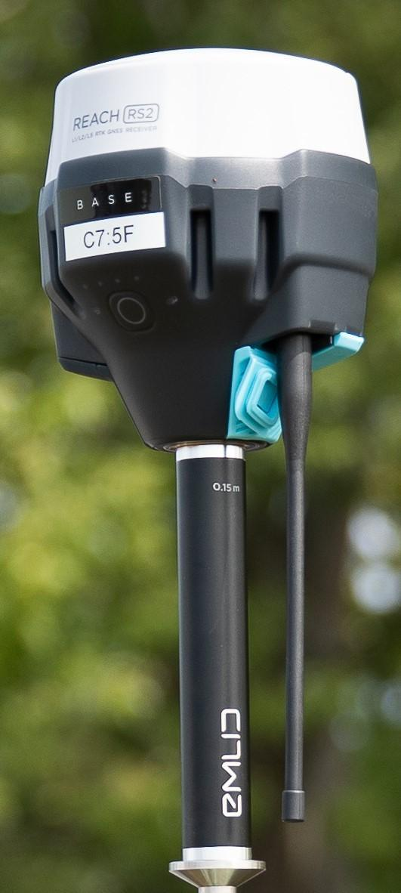
Figure 2: (Left) Emlid Reach RS2 antenna/receiver combination (Photo: Andy Moore). It contains a LoRa radio and is designed to be self-contained. (Right) Trimble Zephyr geodetic antenna mounted on a tribrach and connected to an external receiver via a port on the bottom of the saucer. (Photo: Ian Lauer)

2.2 Receivers
Receivers are the central processing units of the GNSS system (Figure 3). They connect the various other hardware including antennas, radios, and often power. They receive signals from the antenna and compare the satellite and receiver time codes to calculate distance between them. This time differential is fed into a complex code for determining position based on at least four satellite signals. Positional data may be stored in various formats, most of which are proprietary for each manufacturer. The receiver is responsible for sending the position data to the controller computer for user viewing and for taking user input and executing the commands. On an RTK setup the receiver will also connect to and receive or transmit carrier phase correction data from base station to rover. Certain models, such as the Emlid Reach RS2 and Septentrio Altus APS3 are a receiver and antenna combination, allowing for the use of a cell phone, laptop, or tablet for configuration and data access.

2.3 Radios
Radios are only used on RTK setups where a correction signal is needed for real-time processing. The radios typically use a high-frequency band near 0.5–1.5Mhz. They receive carrier phase signals from the base station receiver and transmit them to the radio and receiver on the rover unit for use in correcting and increasing precision in the rover’s position calculation.

2.4 Power and Batteries
Receivers, antennas, and controllers use both internal and external batteries for power. Average running time for batteries depends on manufacturer design but typically last 4–10 hours for internal setups, with external setups limited only by ability to transport larger batteries to the site (Table 1). Battery technology will depend on environmental conditions. Gel cell and LiPo batteries have the advantage of being environmentally stable and spill proof. Battery estimates need to be made based on equipment. A simple formula for estimating battery consumption is
Total Amperage (Volt*Watts) * Total Operational Time (hours) = Battery Capacity (Amp/Hrs)
Capacity should be overestimated to account for logistical oversight or complications, keeping in mind that battery capacity ages over time and with use. Power can also be supplemented by many means including solar, wind, or other power sources as demanded by the site.
Table 1: UNAVCO Campaign GPS GNSS Handbook, Receiver Power Consumption
Receiver | Power draw (approximate)* | Lifetime w/ a 12 V, 18 Ah battery*
Trimble NetRS | 3.5 W | 2.25 days
Trimble 5700 or R7 | 3–4 W | 2–2.5 days
Topcon GB1000 | 4 W | 1.9 days
Septentrio APS3G | 4 W | ~1.5–2 days
Emlid Reach RS2 | 7.5 W | 16 hours as 3.5G rover, 22 hours logging with 6.3 Ah internal battery
*For information on power options available from and testing performed by UNAVCO, see http://kb.unavco.org/kb/category/gnss-and-related-equipment/power/93/.

2.5 Data Management, Storage, and Initial Settings
Data management is a small but critical step in the survey design. It is ineffective to have a well-designed survey only to find out you have run out of storage space, lost the data, or collected improper occupation lengths for the precision needed. Each unit has a unique set of capabilities and limitations (Table 2). Consider the following:
- File length – do you want the receiver to bin the data into files of a fixed time window?
- Sample rate – how often do you want the receiver to collect data? The base station (fast static and kinematic surveys) must collect data at least as often as the rover(s). A kinematic rover will typically collect 1 sample/second for a total occupation at each site of 5–15 seconds.
- Elevation cutoff angle – data coming from low-elevation satellites is often noisy because of the atmosphere; below what elevation do you want the receiver to discard, rather than store, the data? Note that this data can also be discarded during processing. A typical value is 5–10°
- Storage Capacity - There must be enough free memory in the receiver for the desired survey. Whereas memory is an issue with older receivers, the later generation receivers have large amounts of data storage. File size is dependent on manufacturer file formatting. Note the Topcon collects half as much data at a 30-second sample rate (versus 15-second on Trimble) but produces a larger file. Upgraded storage space is relatively cheap and easy to acquire.

Table 2: Typical parameters for different survey styles (file lengths, sample rates, and elevation cutoffs)
Survey style | File length | Sample rate | Occupation time | Elevation cutoff angle
Continuous | 24 hr | 30 seconds | Continuous | 10 degrees
Static | 2+ hr | 30 seconds | 2+ hours | 10 degrees
Rapid Static | none | 15 seconds | 5+ minutes | 10 degrees
Kinematic | none | 1–15 seconds | 5+ seconds | 10 degrees

2.6 Tripods, Benchmarking, and Distance Measurement
Details on this equipment can be found in the GETSI GPS/GNSS Antenna Mounts Guide. Basic equipment could include a bipod, tripod, or spike mount for static or rapid-static surveys. For repeatable surveys, some kind of permanent benchmark or monument will need to be located or established such as a NGS survey marker, pin, or threaded rod mounted in an appropriately stable surface. A collapsing measuring stick, engineer’s tape, or other measuring device appropriate for your setup is necessary for metadata collection, especially for establishing antenna height. See the GETSI GPS/GNSS Antenna Mounts Guide for more information.

3. Field Workflow: General

3.1 Site Analysis
Initial site analysis is integral to good survey design and subsequent successful data collection. Anticipating and compensating for good sky coverage, line of sight, and multi-pathing issues as described in Unit 1 will significantly increase your success. The largest inhibitors to good surveys are overhead or high standing structures such as trees, buildings, canyon walls, etc., which limit sky view, obstruct signals, and create multi-path signal error. Strategies for overcoming these obstructions include placing base stations away from the study area in a position that best limits obstructions to the sky. A base station ideally may be placed within several kilometers of the area to be measured, although baseline distances up to 10 km may still yield high-accuracy, high-precision measurements for PPK surveys. RTK surveys must maintain radio contact for real-time corrections to work and are typically limited to baselines of several km with good to moderate line of sight. In areas where complicated topography obstructs communication with the base station, two or more base stations may be operated to provide saturation of baselines throughout the area.
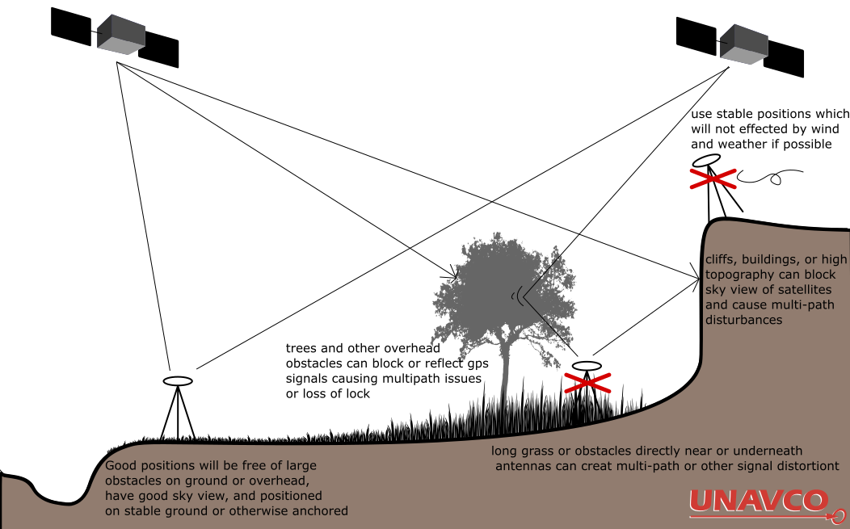

3.2 Preparation and Logistics
- Calculate power needs for equipment. Charge and test batteries.
- Locate memory devices (typically SD cards) and verify sufficient storage is available.
- If unfamiliar with equipment, do a complete test setup and verify connectivity between equipment before leaving for the field or be prepared to troubleshoot later
- Do reconnaissance of the field area. Topographic maps, Google Earth Imagery, or a pre-trip to the area can significantly improve success on your field day.
- With reconnaissance knowledge, plan the base sites, data points, and paths to navigate the field site. A good plan will reduce time spent in the field later. Anticipate the number of points to be collected and time associated with the plan.
- Pack all equipment using a checklist.
- Note: It is necessary to know which type of kinematic system (RTK or PPK) you will use before continuing. Workflow processes diverge depending on whether processing is done in real time or after in a lab. RTK is highly recommended for Emlid systems.
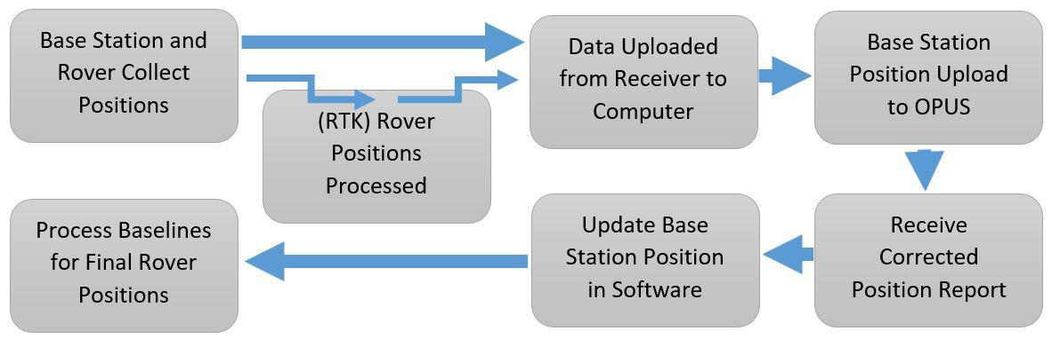

4. RTK/PPK Field Setup
This section outlines the general steps in a PPK and RTK survey. Steps that are RTK specific are marked (RTK). This outline was developed based on Trimble hardware, but should translate to other manufacturers. See manufacturer manuals for alternative instructions and additional information in the UNAVCO Knowledge Base (http://kb.unavco.org/kb/), specifically UNAVCO Resources: Campaign and Kinematic GPS/GNSS (http://kb.unavco.org/kb/article/unavco-resources-campaign-and-kinematic-gps-gnss-390.html).

4.1 Base Station Preparation
Base stations need to be programmed with a specified sampling rate, measurement length, and (RTK) radio communication protocol and baud rate. Typically, this is preprogrammed by UNAVCO or the user in the office prior to deployment. Setting the configuration file to load on power-up is common. Changes can be made in the field with a controller or a laptop with the necessary software. Additionally, starting parameters for the survey, including the known or assumed positions of the benchmark or monument, will need to be entered before data collection.
General Pre-field Workflow:
- Connect the receiver to a controller or computer and power up.
- Connect to the receiver through a program (ex. Trimble Configuration Tool) or controller.
- Download the current configuration and back up for posterity.
- Set the antenna model and (RTK) radio type as necessary. If using an external RTK radio, establish the Baud rate and communication protocol. This must match with rover radio.
- Set the elevation mask and output reference and coordinate system.
- Set the configuration file to load on power-up or boot and transmit the file to the receiver.
- Reboot the receiver, then connect and download the configuration file to verify settings were saved.
- Connect the GNSS antenna (and controller, if used) to the receiver. Verify connectivity either in the controller or using indicator lights/screen on the receiver. (RTK) Test connection with the rover radio when complete.
- Once verified, remove all cables, install protective caps, and pack equipment.

4.2 Base Station Field Setup
- Locate the benchmark, monument, or landmark to be measured. Alternatively, establish a new monument, using best practices in UNAVCO Resources: GNSS Station Monumentation (http://kb.unavco.org/kb/article/unavco-resources-gnss-station-monumentation-104.html) and recording a monument log (http://kb.unavco.org/kb/article/campaign-monument-log-sheet-62.html).
- Set up the tripod, spike mount, or another mount on top of the benchmark. See the GETSI GPS/GNSS Antenna Mounts Guide or for the “UNAVCO” method of leveling tripods and spike mounts, see the UNAVCO GNSS Antenna Mounts (http://kb.unavco.org/kb/category/gnss-and-related-equipment/gnss-antenna-mounts/23/).
- Center tripod or spike mount over the benchmark and level the antenna mount
- Anchor legs so they will not move throughout the survey.
- Attach antenna to the top of the mounting system.
- Attach antenna to the tripod or other antenna mount (http://kb.unavco.org/kb/article/unavco-resources-gnss-antenna-mounts-394.html) and hang the receiver and radio on one of the legs if available or in a protective case if necessary or convenient.
- Connect all appropriate cables. The GNSS and (RTK) radio antenna will connect to the receiver, with the battery being connected last. This will avoid errors in receivers not detecting ancillary equipment.
- Measure and record slant height or antenna height to phase center as appropriate. To measure slant height, place measuring stick or tape on center of benchmark and measure to the outer edge of the antenna where phase center is located (as found in manuals). Measure in at least three locations around antenna. Measurements should be equal if the tripod is level, +/- 0.5cm. If not, re-level system before recording data. Do not move the tripod after leveling is completed or while data is being collected. Doing so will affect the precision of positioning.
- Record general site observations, location, times, and configurations in a field book (ex. http://kb.unavco.org/kb/article/logsheets-and-field-notes-72.html).
- Power up receiver and verify connection to antenna and radio.
- Some receivers automatically begin logging on power up, others require a prompt. If necessary, start data collection.

4.3 Rover Setup and Preparation
Generally, the rover receiver will need to be pre-programmed much like the base station. In some cases, the setup will be entirely done through the controller, in which case this may be done in the field. It is still wise to verify connectivity with a base station prior to fieldwork.
- Connect the receiver to a controller or computer and power up.
- Connect to the receiver through a program (ex. Trimble Configuration Tool) or controller.
- Download the current configuration and back up for posterity.
- Set the antenna model and (RTK) radio type as necessary. If using an external radio antenna, establish the Baud rate and communication protocol. This must match with the base station radio.
- Set the elevation mask and output reference and coordinate system.
- Set the configuration file to load on power-up or boot and transmit the file to the receiver.
- Reboot the receiver, then connect and download the configuration file to verify settings were saved.
- Connect the GNSS antenna (and controller if used) to the receiver. Verify connectivity either in the controller or using indicator lights/screen on the receiver.
- (RTK) Test connection with the base station radio when complete.
- Once verified, remove all cables, install protective caps, and pack equipment.

4.4 Rover Field Setup
- Attach antenna, receiver, and controller to monopod, bipod, or alternative mounting setup
- Connect antenna, radio, and receiver cables. Install batteries and power up.
- Measure and record antenna phase center height for software setup
- With the controller, set and verify the occupation time, sampling rate, antenna height, elevation mask, and (RTK) radio communication protocols.
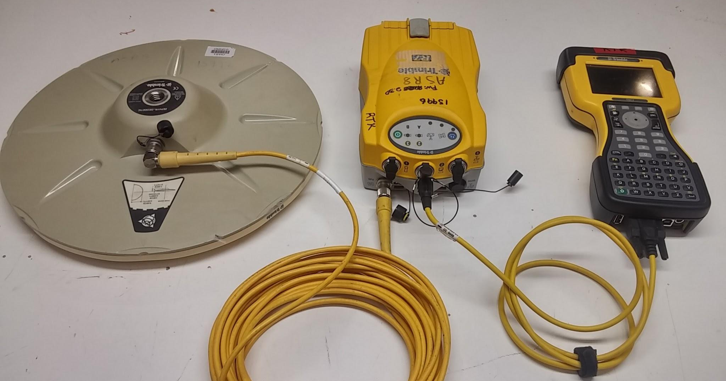
Figure 6. An example of the main components on a PPK or RTK rover. Trimble Zephyr antenna, R7 receiver, and controller. The RTK set up would also include a radio antenna attached to the R7. (Source: Ian Lauer)

4.5 Conducting a Survey
Once the base station and rover are functional, it is time to begin surveying! Before starting, review and optimize your plan of attack. It may be beneficial to take a quick measurement within a known distance of the base in order to provide QA later. On the controller, begin a new project or job (this term varies with manufacturer). Verify the survey settings are correct, satellites signals are available, and (RTK) radio communications are working. In general, 4+ satellites are required to obtain a position. You must maintain satellite communication for 5–10 minutes to receive an initialization fix before proceeding. If you lose initialization during the survey, stop, and begin survey again at this step. It will not harm previous measurements that were taken.
To collect a data point:
- Move to the location you wish to measure. Check for potential obstructions or multi-path inducing objects in the immediate vicinity.
- Name the point on the controller. Verify satellite availability and reasonable PDOP. A PDOP of less than 5 and ideally less than 2–3 is required for precise measurements.
- Place the range pole’s tip directly on the surface to be measured or in the dimple if a monument is present.
- Level the pole using the manual bubble level or electronic level on controller. Bracing your body in a tripod stance with feet shoulder width and ranger pole braced in front is a stable position. If using a bipod, do not leave it alone. You must watch it to prevent falls.
- Begin collecting data. Maintain a steady, level orientation for the antenna for the duration of the occupation time.
- After point is collected, move to the next location.
- Continue steps 1–6 until complete. You can pause a survey if there is need for a break. If so, make sure to initialize the antenna’s position before continuing the survey.
- It is advisable to reoccupy the starting point (the location next to the base station) for QA.
- When complete, stop the survey. Check to verify the data file is complete and of appropriate size. Some will allow you to check individual positions.
- Once verified, you may power down the receiver and controller.
- Before disassembling, measure the antenna’s height again and record on your data sheet. There should not be a change in height. If so, you must be aware of this when processing results.
- Disassemble and pack the unit using the checklist.

4.6 Base Station: Finalize Survey
Disassembly of the base station is the last step. The station must record its location for the entire duration of the survey in order to correct the rover’s baseline. Two hours of data or more is best.
- Stop data collection on the receiver or controller.
- Verify there is a saved file with the correct date, time, and duration of your survey.
- Before moving anything on the base station, check the slant height of the antenna and record it in your field book. It should not have moved.
- Verify that the tripod is still level and centered over the benchmark or landmark. If not, record this with any observations or measurements as to how it moved.
- If a field laptop is available, remove the memory card from both rover and base station receivers and back up data files to an external device for redundancy.
- Pack all equipment using the checklist.

5. Data Processing

5.1. Data Downloading and Backup
(Adapted from the UNAVCO GPS/GNSS Survey Guide)
Data collected with geodetic GNSS receivers must be downloaded as soon after data collection as possible to free up receiver memory (if needed) and to back up the data. As a field precaution, a duplicate copy of the data should be made as soon as it is downloaded from the receiver. Data are typically downloaded to a laptop computer. To download a receiver, manufacturer-specific download software and procedures are usually required.
Downloading instructions depend on the equipment (receiver and/or survey controller) being used; see http://kb.unavco.org/kb/category/gnss-and-related-equipment/2/.
Considerable expense goes into collecting geodetic quality GNSS data, and the data should always be backed up as soon as possible to safeguard against loss, destruction, or corrupted media. While the particular data backup strategy may vary with logistics and personal preferences, there should always be three independent copies of all GNSS data until it is confirmed that the data have been safeguarded in a data archive such as UNAVCO’s. Options for data storage prior to final archiving include DVDs, PC memory cards, USB drives, computer hard drives, and the GNSS receiver memory. Before deleting any files from a GNSS receiver, make sure they are adequately backed up elsewhere! A good practice is to keep copies of the data in separate locations and with different people.

5.2. Data Formats
GNSS receivers generally collect and store the raw GNSS data in a proprietary format, which may need to be translated into a different format for data processing or data sharing. Later generation Trimble GNSS receivers (5700, R7, NetRS) collect data in .T01 files, a format that must be translated to be read into Trimble’s processing software, Trimble Geomatics Office (TGO). These data are automatically translated to .DAT files, a Trimble format that can be read by TGO, when downloaded via the Trimble Data Transfer Utility. The Topcon GB-1000 collects data in a .tps file.
RINEX (Receiver Independent Exchange Format) is the ubiquitously accepted data format for raw GNSS data. Reference site data is generally provided in RINEX. RINEX is read by most processing software, including Trimble Geomatics Office and Topcon Tools, and also more sophisticated processing software such as Bernese, GAMIT, and GIPSY. Almost any raw high-precision GNSS data can be converted to RINEX using TEQC. TEQC (pronounced “tek”) is a simple yet powerful and unified approach to solving many pre-processing problems with GNSS, GLONASS, and SBAS data. The three main functions from which TECQ gets its name—translation, editing, and quality check—can be performed altogether, in pairs, or separately. You can download TECQ for free at: https://www.unavco.org/software/data-processing/teqc/teqc.html.
While most raw data are stored as binary files, RINEX is in an ascii format and can therefore be viewed in a text editor. An example of a RINEX file is given below (Figure 7) and illustrates the information contained in raw GNSS data files.

5.3 Data Processing
GNSS data collected for high-precision applications (excluding data collected using RTK methods) must be post-processed to provide millimeter- to meter-level precision. Typically, the post-processing involves differential processing relative to a fixed base location. For certain survey types, such as stop-and-go kinematic, it is essential to process the data while still in the field as a data quality check. This allows for a re-survey if there are problems with the data.
Post-processing the data accomplishes several things. First, there are numerous error sources in GNSS positioning, the most significant of which are:
- Receiver and satellite clock errors,
- delay of the GNSS signal through the Earth’s atmosphere (most significantly, the ionosphere and the troposphere),
- use of imprecise satellite orbits, and
- multi-path (multiple signal arrivals resulting from the signal bouncing off nearby objects or the ground).
Many of these errors can be greatly minimized or eliminated in post-processing by using data from at least two receivers with at least four satellites in common.

Data Processing Workflow:
- Import data from receivers and open base station and rover positions into your hardware-specific processing program (ex. Trimble Business Center for Trimble receivers). Set the antenna heights, equipment models, etc. during importing if this was not done in the field. Double-check these values.
- Export the data for your base station as a RINEX file. Can be done in TEQC (https://www.unavco.org/software/data-processing/teqc/teqc.html) or a proprietary software.
- Upload the RINEX file for your base stations through an appropriate precision processing program (such as OPUS for surveys in the U.S.) You will receive a file with the corrected base position from OPUS.
- Correct your base and rover positions in your hardware-specific processing software (i.e. Trimble Business Center or RTKLIB). Detailed tutorials for Trimble Business Center and RTKLIB can be accessed at https://geospatial.trimble.com/trimble-business-center-tutorials and https://docs.emlid.com/reachm2/common/tutorials/gps-post-processing/ respectively.
- Enter the corrected base station coordinates. Skip this step if you are processing in the field for a quality assurance check (not as precise, but okay for QA).
- Create baselines from base station to rover positions. Visually inspect reasonable distances and spatial relationships from rover to base station.
- Process baselines to correct for sources of error and receive new positions.
- Transform and project data if necessary.
- Export your data in the appropriate format for further analysis and processing.

Different processing programs can serve different surveying needs. The following summarizes some of the options.
To obtain a position to within several cm of a static point where a very accurate position is not needed, several online services are available:
- OPUS – http://www.ngs.noaa.gov/OPUS/
- A data file of at least two hours is recommended. Data files may be uploaded directly to site. It sometimes improves processing if you wait 1–2 days before processing.
- CSRS-PPP – https://webapp.geod.nrcan.gc.ca/geod/tools-outils/ppp.php
- Canadian Spatial Reference System – Precise Point Positioning (CSRS-PPP) is a flexible service that offers both static and kinematic data processing. Access to the database is free but requires a username and password. Data files may be uploaded directly to the site.
- AusPos - https://www.ga.gov.au/scientific-topics/positioning-navigation/geodesy/auspos
- Australia. Data files may be uploaded directly to the site.
- APPS - https://apps.gdgps.net/
- A JPL service that replaces AutoGIPSY. Data files may be uploaded directly to the site.
For cm-level static or kinematic surveys with short (ideally < 10 km) baselines, commercially available software (e.g., Trimble Geomatics Office [TGO], Topcon Tools) is often adequate. See http://kb.unavco.org/kb/article/trimble-geomatics-office-how-to-process-fast-static-and-post-processing-kinematic-surveys-using-tgo-613.html for a how-to on TGO.
Additional helpful processing resources include the following:
Several organizations provide precise satellite orbital information, which is calculated daily and available with a two-week delay. The application of this information (rather than the orbital information broadcast by the satellites) can improve precision of ground coordinate solutions. Examples of places to find precise orbital information, generally available in files appended .SP3
- SOPAC - http://sopac.ucsd.edu/
- IGS - http://www.igs.org/
- NIMA EGM96 Geoid Calculator, to calculate the geoid-ellipsoid separation at any given point: https://earth-info.nga.mil/index.php?dir=wgs84&action=egm96-geoid-calc
- NGS Reference Frame Transformation, to translate coordinates from one reference frame to another: http://www.ngs.noaa.gov/cgi-bin/HTDP/htdp.prl?f1=4&f2=1
Also, see the section on Reference Stations for links to data from continuous GNSS sites.

5.4. Data Archiving and Data Access
As a service to the geodetic community, the UNAVCO Boulder Facility Archive manages, stores, and provides access to high-precision GNSS geodetic data. The archive will also accept non-geodetic GNSS data projects (e.g., mapping). The data stored are primarily collected on research projects sponsored by the National Science Foundation (NSF) and National Aeronautics and Space Administration (NASA). Please contribute to the Boulder Facility Archive immediately after campaign completion to best preserve time-sensitive information. Most data must be archived within six months of data collection. See the UNAVCO GPS/GNSS Data Policy for more information: http://www.unavco.org/community/policies_forms/DataPolicy.html.
To archive project data, fill out a project support request form if you have not already done so for your project: https://med.unavco.org/newproject/supportform.aspxhttp://achaia.unavco.org/public/newproject/supportform.aspx.
Prepare legible copies of site descriptions and log sheets (e.g., Monument Record forms [http://kb.unavco.org/kb/assets/63/monument.pdf] and Site Visit Log sheets [http://kb.unavco.org/kb/article/campaign-monument-log-sheet-62.html]) and any other pertinent material (photos etc.) to accompany data. At the very least, the archive needs the site name, antenna height, antenna height measurement method (e.g., slant), antenna mount type, and antenna and receiver models and serial numbers; this is the minimum information needed to meaningfully process the GNSS data.
Data should be submitted in raw format, if possible. Data may additionally be submitted in a translated format.
Coordinate submissions with the UNAVCO Data Management and Archiving Group: archive@unavco.org. Submissions can be mailed/shipped or dropped off via ftp (preferred) for the archive. For more details, look up Submissions on the UNAVCO GSP/GNSS Data Archive page: http://www.unavco.org/data/data-help/submission/submission.html.
UNAVCO Data Management and Archiving Group mail/shipping address:
Attn: GPS/GNSS Data Archive
UNAVCO
6350 Nautilus Drive
Boulder, CO 80301

If submitting data and metadata (accompanying information) via ftp, a directory will be assigned to you.
To access both campaign and permanent station data, check out our interactive Data Archive Interface, the DAI2 (Figure 8): https://www.unavco.org/data/dai/
Search for data by data type, date collected, and/or geographical region. For a brief tutorial, see the Help feature at the top right corner of the page -
