ISU GEOL 4450/5550 Field Geology: High Precision Positioning
Benjamin Crosby and Ian Lauer, crosby@isu.edu, 208-226-4508
Week 2.1; June 10 and 11, 2017

Description
During this field camp module, students will learn the fundamentals of global navigation satellite systems (GNSS, a more universal term than GPS) and how to apply these techniques beyond answering, "Where am I?" This module teaches how high precision positioning enables geoscientists to track important changes in the surface of the earth that would otherwise be imperceptible. Through brief lectures, demonstrations and field exercises, students learn both kinematic and static positioning techniques. This module is field-focused, minimizing lectures and computer work and maximizing student time spent designing and implementing surveys as well as analyzing the new data.
Goals
- Students can design and conduct a kinematic GNSS survey to address a geologic research question.
- Students can justify why different high precision positioning techniques are appropriate in different situations.
- Students can articulate the benefit to society of answering a given research question.
Schedule
Saturday
- Introductions, Module testing explained, Student IDs, Consent forms
- Unit 1. GPS/GNSS Fundamentals
  - Unit 1 Lecture
  - Outside for introduction to devices. Qualitative comparisons of positions
  - Assignment 1: Accuracy and Precision with GNSS
  - (After Unit 2 RTK demonstration) Assignment 3: Concept Sketch of GNSS setup
- Unit 3. Static GPS/GNSS Methods
  - Unit 3 Lecture
  - Drive out to cts. static PBO GNSS station. Discuss tech, local and regional setting.
  - Assignment 2: Analysis of static GNSS data
- Unit 2. Kinematic GPS/GNSS Methods
  - Unit 2 Lecture
  - Field demonstration of Kinematic RTK Base and Rover
  - Practice collecting points around camp
Sunday
- Unit 2.2. Change Detection with Kinematic GPS/GNSS
  - Lecture
  - Field survey of leveling monuments
    - 3 kinematic RTK rover teams, 1 digital leveling team
  - Assignment 4: Summative Assessment on topographic change detection, across the Lost River Range Fault, during the interseismic period.
Grading
- Assignment 1: Accuracy and Precision with GNSS 1.25
- Assignment 2: Concept Sketch of GNSS setup 0.5
- Assignment 3: Analysis of static GNSS data 1.25
- Assignment 4: Summative Assessment on topographic change detection 3
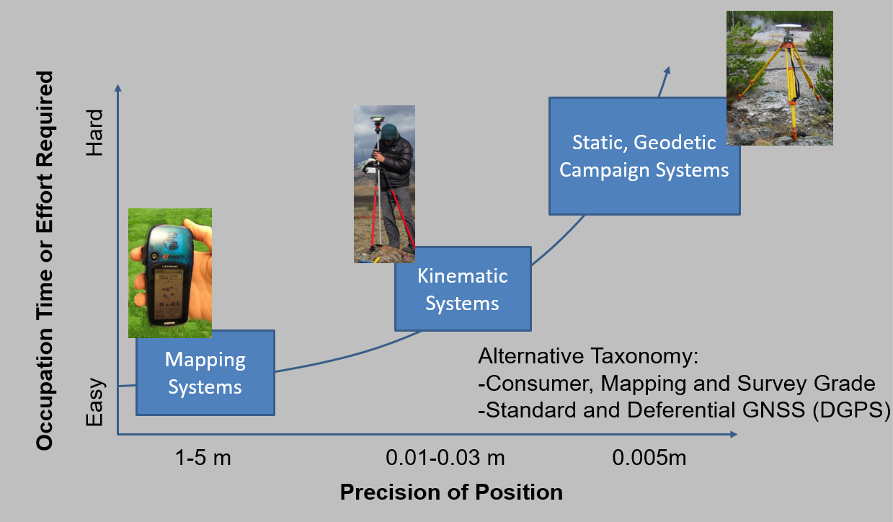
Dishonest or unethical behavior including copying assignments, plagiarizing in a report, or cheating on an exam will not be tolerated. We will enforce the University’s standards on this issue as described in the ISU Policies and Procedures (http://www2.isu.edu/policy/4000/4000-Academic-Integrity-Dishonesty.pdf ). Please read it carefully and completely. The policy also appears in abbreviated form in the course catalog . With respect to written work, the ISU Student Success Center offers a guide to avoiding plagiarism (see link entitled “Why is it plagiarism?” on the Writing Center page.
Idaho State University is committed to providing equal opportunity in education for all students. If you have a diagnosed disability or if you believe you have a disability physical, learning, hearing, vision, psychiatric) that might require reasonable accommodation in this course, please contact the Disability Services Center, Rendezvous Building, Room 125 (282-3599) or on the web at http://www.isu.edu/ada4isu. It is the responsibility of students to contact instructors during the first week of each semester to discuss appropriate accommodations.

