**Orthogonal Transformation of Cartesian Coordinates in 2D and 3D**

A vector is specified by its coordinates, so it is defined relative to a reference frame. The same vector will have different coordinates in different coordinate systems, even when the coordinate systems share the same type, origin, and scaling.

There are many occasions when we need to transform vector information from one reference frame or coordinate system to another. In plate tectonics, we might want to describe the instantaneous motion of a point on the Pacific plate relative to (that is, in a reference frame that is fixed to) the North American plate, or to the Hawaiian hotspot, or to the "no-net-rotation" reference frame, or... If this change in reference frame involves two coordinate systems that share a common origin and that are of the same type (for example, Cartesian X-Y-Z coordinates) and scaling (one unit measured along one coordinate axis is the same length as along all other coordinate axes), we say that the change involves an *orthogonal coordinate transformation*.

In the 2D illustration below, the location vector to point *Q* is {1, 2} in the X-Y coordinate system. The X'-Y' coordinate system is rotated by ** = +30° from the X-Y coordinate system. The length of the location vector to *Q* is ~2.24.

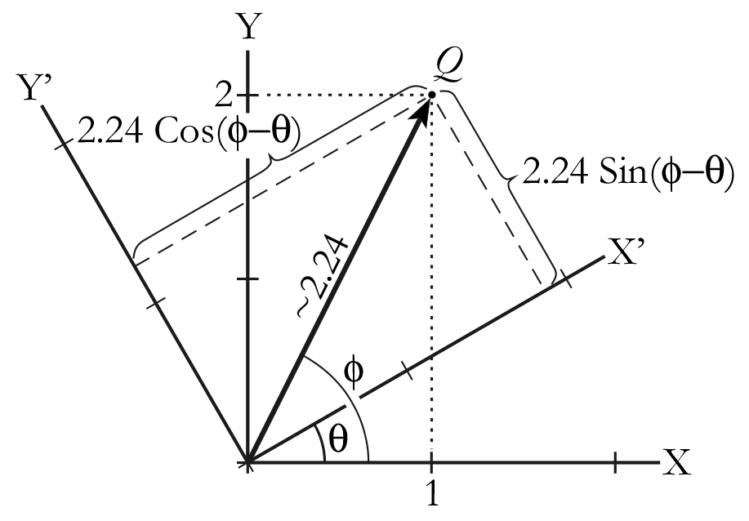

What are the coordinates to point *Q* in the X'-Y' coordinate system? We will find the answer manually at first, using plane trigonometry, and later we will learn a more general (and easier) way to solve this type of problem in 2D and 3D.

First, we determine the value to angle ** in the previous illustration, between the vector and the X coordinate axis.

**Example.** Given the previous figure, what is the angle ** between the vector to point *Q* = {1, 2} and the X coordinate axis?

*Answer.* Project a line segment parallel to the Y axis that extends from the X axis to point *Q* at the head of the vector. The length of that line segment is 2. Notice that angle ** is an interior angle of a right triangle with apices at {0, 0}, {1, 2} and {1, 0}. Using the one of the following trigonometric relationships,







we find that ** equals approximately 1.11 radian or 63.43°.

Second, project a line perpendicular to the X' axis that passes through point *Q*. Notice the right triangle with apices {0, 0}, {1, 2} and the intersection of axis X' and the line you just constructed. At the origin, one of the interior angles of that right triangle is the difference between angles ** and **.

**Example.** What are the respective lengths of the opposite (*O*) and adjacent (*A*) sides of the right triangle whose hypotenuse is equal to  and where the relevant interior angle is

(* *–**) = 63.43°–30° = 33.43°.

*Answer.* Recalling the trigonometric relationship *O* = *H* sin(* *–**),

*O* = 2.24 sin(33.43°) = 1.23

Similarly, recalling that *A* = *H* cos(* *–**),

*A* = 2.24 cos(33.43°) = 1.87

The coordinates of the vector to point *Q* in the original X-Y coordinate system are {1, 2}. In the X'-Y' coordinate system with the same origin as the X-Y coordinate system but which is rotated 30° anticlockwise from the X-Y system, the coordinates of the vector to *Q* are {1.87, 1.23}.

Now that we know how to multiply a 3x1 vector matrix by a 3x3 matrix (or a 2x1 vector matrix by a 2x2 matrix, for the 2-dimensional case), we can take advantage of a simpler and more general way to solve this kind of problem. We start by calling the unit vectors along the original X, Y, and Z axes i, j, and k, respectively. In a similar manner, we call the unit vectors along the new X', Y', and Z' axes i', j' and k', respectively. Using these unit vectors, we can define a 3-dimensional transformation matrix J3D as follows



The first row in the transformation matrix includes the coordinates of the unit vector (which is along the new X' axis) along the original X, Y, and Z coordinate axes, respectively. The second row is the projection of the  vector along the original coordinate axes, and the third row is the projection of the  vector along the original coordinate axes.

The 2-dimensional version of the transformation matrix is *J*2D, where



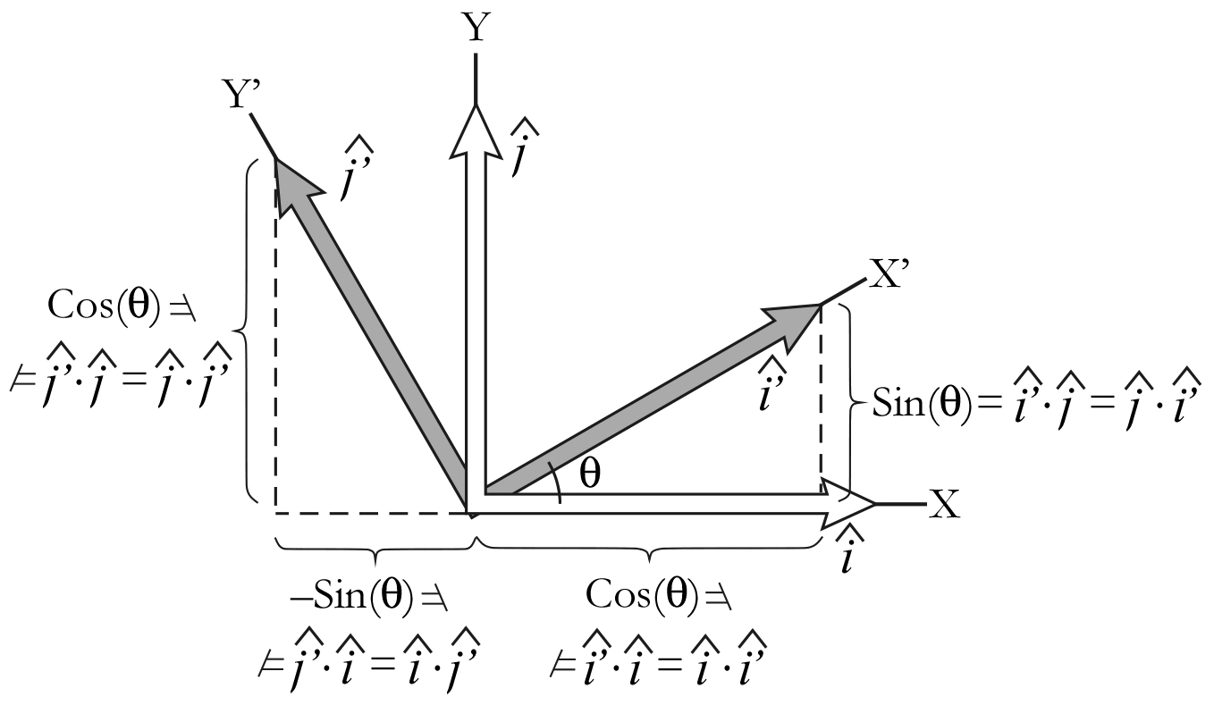

If a new coordinate system X'-Y'-Z' is rotated by a positive angle ** (anticlockwise) relative to the original coordinate system X-Y-Z, where both coordinate systems share a common origin, the transformation matrix is



The matrix equation that gives us the coordinates of a vector in a new coordinate system rotated by an angle of ** from the original coordinate system is



where {x, y} are the coordinates in the original coordinate system and {x', y'} are the coordinates in the new coordinate system.

**Example.** If the coordinates of a vector in one coordinate system are {1, 2}, what are the coordinates of that vector in a new coordinate system with the same origin and that is rotated +30° (anticlockwise) from the original coordinate system?

*Answer.* Given



where {x, y} = {1, 2} and ** = 30°,



which can be unpacked into parametric equations as follows:

x' = ((1) cos(30°)) + ((2) sin(30°)) = 1.87

y' = ((1) (–sin(30°))) + ((2) cos(30°)) = 1.23.

So {x', y'} = {1.87, 1.23}.

We had already proven that a vector with coordinates {1, 2} in one coordinate system has coordinates {1.87, 1.23} in a coordinate system rotated 30° from original, so now we have duplicated that result using a transformation matrix. Now that we have this tool, we can use it to quickly find the new coordinates of any vector whose coordinates are known in the original coordinate system. And we can find the coordinates of any vector in any coordinate system that shares an origin with our original coordinate system, so long as we know the angular relationship of the new coordinate axes to the original coordinate axes.

**Example**. Given the following unit vectors along an initial set of coordinate axes (X-Y-Z),

 = {1, 0, 0},  = {0, 1, 0} and  = {0, 0, 1},

and the following unit vectors along a new set of coordinate axes (expressed relative to the initial coordinate system and rounded to four places past the decimal),

 = {0.6409, -0.7604, -0.1056},

 = {0.6409, 0.6057, -0.4717}, and

 = {0.4226, 0.2346, 0.8754}.

Use the appropriate dot products to find the transformation matrix to go from the initial coordinates to the new coordinates, and find the new coordinates of the vector {2, 3, 1}.

*Answer*. We need to solve the following equation for {*x'*, *y'*, *z'*} given {*x*, *y*, *z*} = {2, 3, 1}:

.

Computing all of the dot products and rounding to four places past the decimal gives us



so the new coordinates {*x'*, *y'*, *z'*} = {-1.105, 2.6271, 2.4244}. To check, we can multiply the new coordinates by the inverse of the transformation matrix, and the result should be the original coordinates.

, so 



We now solve the following equation for {*x*, *y*, *z*} given {*x'*, *y'*, *z'*} = {-1.105, 2.6271, 2.4244}:

.

The solution, {*x*, *y*, *z*} = {2, 3, 1}, leads us back to where we began.

**Resources**

Summary sheets on vectors (that contains information about dot products) and matrices are available from the same source from which you obtained this summary sheet.

Davis, H. F., and Snider, A. D., 1987, Introduction to vector analysis [5th edition]: Boston, Allyn and Bacon, 365 p. ISBN 0-205-10263-8.

***Web resources***

There are several videos available online from the Khan Academy (http://www.khanacademy.org) that relate to various aspects of coordinates and coordinate transformations. For example, an introduction to Cartesian coordinates is available at http://www.khanacademy.org/math/algebra/linear-equations-and-inequalitie/v/descartes-and-cartesian-coordinates.

[Weisstein, Eric W.](http://mathworld.wolfram.com/about/author.html), Cartesian coordinates: *[MathWorld](http://mathworld.wolfram.com/)*—A Wolfram Web Resource, accessed 2 September 2012 via [http://mathworld.wolfram.com/CartesianCoordinates.html](http://mathworld.wolfram.com/OrthogonalCoordinateSystem.html)

[Weisstein, Eric W.](http://mathworld.wolfram.com/about/author.html), Coordinate system: [*MathWorld*](http://mathworld.wolfram.com/)*—*A Wolfram Web Resource, accessed 2 September 2012 via [http://mathworld.wolfram.com/CoordinateSystem.html](http://mathworld.wolfram.com/OrthogonalCoordinateSystem.html)

[Weisstein, Eric W.](http://mathworld.wolfram.com/about/author.html), Matrix: [*MathWorld*](http://mathworld.wolfram.com/)—A Wolfram Web Resource, accessed 2 September 2012 via [http://mathworld.wolfram.com/Matrix.html](http://mathworld.wolfram.com/OrthogonalCoordinateSystem.html)

[Weisstein, Eric W.](http://mathworld.wolfram.com/about/author.html), Matrix inversion: [*MathWorld*](http://mathworld.wolfram.com/)—A Wolfram Web Resource, accessed 2 September 2012 via [http://mathworld.wolfram.com/MatrixInversion.html](http://mathworld.wolfram.com/OrthogonalCoordinateSystem.html)

[Weisstein, Eric W.](http://mathworld.wolfram.com/about/author.html), Matrix multiplication: [*MathWorld*](http://mathworld.wolfram.com/)—A Wolfram Web Resource, accessed 2 September 2012 via [http://mathworld.wolfram.com/MatrixMultiplication.html](http://mathworld.wolfram.com/OrthogonalCoordinateSystem.html)

[Weisstein, Eric W.](http://mathworld.wolfram.com/about/author.html), Orthogonal coordinate system: [*MathWorld*](http://mathworld.wolfram.com/)—A Wolfram Web Resource, accessed 2 September 2012 via <http://mathworld.wolfram.com/OrthogonalCoordinateSystem.html>

[Weisstein, Eric W.](http://mathworld.wolfram.com/about/author.html), Vector: [*MathWorld*](http://mathworld.wolfram.com/)—A Wolfram Web Resource, accessed 2 September 2012 via [http://mathworld.wolfram.com/Vector.html](http://mathworld.wolfram.com/OrthogonalCoordinateSystem.html)

[Weisstein, Eric W.](http://mathworld.wolfram.com/about/author.html), Vector multiplication: [*MathWorld*](http://mathworld.wolfram.com/)—A Wolfram Web Resource, accessed 2 September 2012 via [http://mathworld.wolfram.com/VectorMultiplication.html](http://mathworld.wolfram.com/OrthogonalCoordinateSystem.html)