Displacements and Deformation: (Questions from EES223/225 midterm 2013)

Choose the most appropriate answer, 2 points each

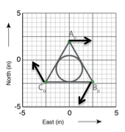
- Which term best describes the deformation of the three GPS stations whose velocities in mm/yr are pictured above?
  - eastward translation
  - clockwise rotation
  - E–W shortening
  - E–W extension

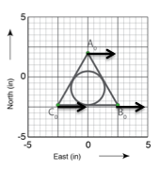
- Which term best describes the deformation of the three GPS stations whose velocities in mm/yr are pictured above?
  - eastward translation
  - clockwise rotation
  - E–W shortening
  - E–W extension

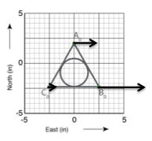
- Which term best describes the deformation of the three GPS stations whose velocities in mm/yr are pictured above?
  - eastward translation
  - clockwise rotation
  - E–W shortening
  - E–W extension

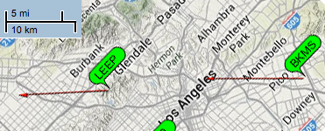
Horizontal velocity of BKMS: 40.2 mm/yr
N
Horizontal velocity of LEEP: 36.3 mm/yr

Stations are located at base of velocity arrows.

The image above shows the velocity vectors for two GPS stations near downtown Los Angeles. The velocities of the stations are nearly parallel (~315 NW) so that we can treat this as a 1D deformation problem. Use the maps and information above to answer the following questions.

- Calculate the extension and stretch of the LA metro area between BKMS and LEEP over a single year. Show your work. (10 pts.)

- Does your answer to question 10 describe the complete deformation? Explain. (5 pts.)

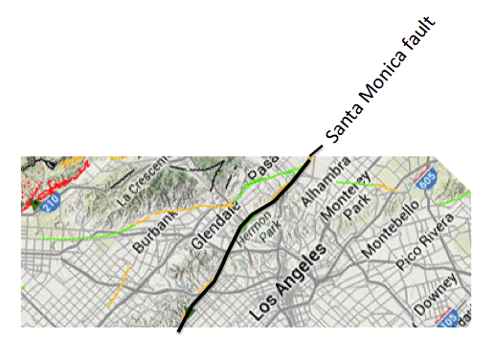
- The Santa Monica Fault runs along the base of the hills NW of Los Angeles (map above). Based on the GPS observations of deformation what type of fault is it most likely to be? Explain. (5 pts)

