Understanding Our Changing Climate Unit 4: Ice Mass Changes Measured by Vertical GPS on Bedrock Student Exercise
Susan Kaspari (Central Washington University) and Bruce Douglas (Indiana University)
Students should work in teams of three with each person analyzing and plotting the data for two of the six stations. You will work individually on your analysis of the data and hand in your own completed exercise, but you will receive some of the plots and information from your team members. You may have team discussions about the trends of the data as observed in the plots you create, as well as your discussions of how you would group the stations. Note that you and your partners do not need to have uniform agreement on the patterns observed and the explanations.

Part I. Background
UNAVCO Polar Services installs, maintains, and operates several networks of continuous GPS/GNSS (Global Positioning System/ Global Navigation Satellite System) stations including the Polar Earth Observing Network (POLENET). POLENET has stations in Greenland (GNET), Antarctica (ANET), and the Antarctic Larsen Ice Shelf System (LARISSA); other networked stations in both the Arctic and Antarctic are also under Polar Services. These networks of GPS/GNSS stations improve geophysical observations across the Earth's polar regions and provide a legacy of observational infrastructure to enable new insights into the interaction between the atmosphere, oceans, polar ice sheets, and the Earth's crust and mantle. Our focus in this unit will be GPS stations from Greenland.
One of the most significant ways that humans affect the distribution of water mass at or near the surface of the Earth is through the effects of climate change. Most of the water mass in terrestrial settings is found in the forms of snow and ice in addition to groundwater. Because of climate change there have been changes in the snow and ice mass reservoirs in Greenland, Antarctica, and mountain glaciers. The Earth responds elastically to the snow and ice mass changes on annual, decadal, and longer time periods. So, it is possible to monitor the effects of snow and ice mass changes using GPS vertical positions in both Greenland and Antarctica.
Most likely you have heard of isostasy, so you might think the vertical displacement due to snow and ice mass changes is an isostatic adjustment. What can be observed in an annual or decadal time series is an elastic response of the crustal rocks themselves, not an isostatic adjustment that involves viscoelastic processes in the mantle. Elastic response is instantaneous and ~20 times smaller; whereas isostatic viscoelastic adjustment associated with post-glacial rebound has time scales of hundreds to thousands of years, although ultimately the adjustment will be much greater. Depending on the length of the time series and the distance between the ice front and GPS station, there may also be an observed flexural response, which is dependent on the local mantle viscosity.
In this unit, we will primarily use GPS data from Greenland (Figure 1) to evaluate how changes in snow and ice mass at a given location result in vertical displacement of the bedrock at the Earth’s surface. Some of the questions you will be answering are:
- In what locations is the elastic response to snow and ice mass change the greatest?
- Are there spatial variations in the magnitude of the response?
- Does the location of the station relative to the present ice front play a role in the magnitude or timing of the response?
Regions with ice mass loss have strong negative gravity anomalies, so the changes over time can also be detected from space using the GRACE satellites. However, GRACE data has very coarse spatial resolution, so it is only possible to identify regional-scale changes in ice mass. This unit is designed to focus more closely on specific locations, but the overall trends from the GRACE data provide a good overall representation of the changes over time that are expected in the GPS data. This may be best grasped by viewing of the GRACE animation for Greenland (https://svs.gsfc.nasa.gov/30879). Important additional data is also available from various synthetic aperture radar (SAR) and photographic images processed using various techniques such as interferometric SAR (InSAR), and speckle-tracking using Landsat photographs (tracking of distinct particles over time) to develop velocity maps of the Greenland Ice Sheet as well as ice mass loss determinations (Figures 2 and 3).

Part II. The GPS Data
For each of the two sites you are responsible for, you will graph vertical position through time. You will also need to note the location of the stations and check to see if any indications have been noted involving changes in equipment or software/reference models used to correct the data. These changes can result in abrupt shifts in the time series. You will eventually need plots of all six stations to be able to carry out your evaluation of the similarities and differences of the trends for the stations. Depending on instructions given to you, a physical packet of materials or a digital file with all of the various responses, plots, and map with vertical trends plotted will need to be turned in for this unit.
- Open up the file that includes daily records of vertical position from all six stations. Make a graph of vertical position (in mm) as a function of time (in years) for each of your two stations. Make sure each graph has appropriate x and y-axis labels, as well as a title indicating which station it is. Please note that the data file contains an example station (KULL) to help get you started if you are new to working with this type of data and plots.

- For each station, calculate a trend for the vertical position data. The trend is equivalent to the slope of the linear best-fit to the data. Within Excel plots you can elect to show a best-fit line for the trend line with options for different types of fits; a simple linear fit is the most appropriate for your needs. [NOTE: Excel uses an arbitrary beginning date for the best-fit line method resulting in a y-intercept that may not match your plot.] Excel also has a slope function [=slope(y’s, x’s)], which may be the better method to use since you can specify the exact cells to use in the slope calculation. Please report the trend in units of mm/yr. Write your calculated trends in the appropriate column of the Table 1, provided at the end of this assignment handout. Table 1, once completed, will be the summary table for Unit 4. Add the corresponding values from the other stations to the table (provided by those in your group). You also need to draw an arrow that is scaled for the rate of uplift you determine (slope). Use an upward-pointing arrow for a vertical change that indicates the surface is moving upward (an increase in elevation) and a downward-pointing arrow for a vertical change that indicates the surface is moving downward (a decrease in elevation). Use Figure 2 to plot your arrows. How well do the linear best-fit lines conform to the data?

- Now, make some observations about the time series from each of the stations. Describe any key features (seasonality, magnitude of movement up or down, data quality/continuity) of the time series. Some of this information should be added to Table 1.

Part III. Interpretation and Discussion
In this section of the exercise you will compare the records from the six sites, identify similarities and differences between them, and explain your observations in terms of ice mass changes and the underlying processes that are related to the GPS station response patterns. Remember to draw a scaled vertical arrow to show the average vertical rate (positive or negative) you determined above, on the map of Greenland provided in Figure 2.
- Work with your teammates. Can you split the six sites into two or more distinct groups based on differing vertical rates? Consider both the overall trend as well as various portions of the data. Also consider the location of the station relative to the ice front (Figure 1), nearby ice velocities (Figure 2), and other ice change characteristics (Figure 3). In the space below, describe the characteristics or signatures you are using to identify the distinct groups, and list which stations are included with each group. You can also use the lat-lon locations of the stations to find the locations on Google Earth to best examine where the stations sit with regards to the ice front. It may also help you to visit the Nevada Geodetic Laboratory interactive GPS map to explore more carefully how your six stations and other Greenland GPS stations are located in relation to the main ice (use the satellite image option instead of terrain).
(http://geodesy.unr.edu/NGLStationPages/gpsnetmap/GPSNetMap.html)

Group 1 | Group 2 | Group 3

- Comment on what other supporting evidence exists that are consistent with the variations in the GPS vertical motions for the stations. Please include observations from the Greenland GRACE data animation and the InSAR and image-based velocity and ice mass loss determinations (Figures 2 and 3). Please also comment on how the trends and regions you can observe in these other resources relate to your observations based on the GPS data. Be sure to consider the scale of the footprint of the different data sets and the uncertainty within each of the different data sets.

Part IV. Summary and Conclusions
- Now hypothesize how snow and ice mass change the vertical position of the various GPS station you placed into groups. For each group of stations that you identified based on similarities in behavior, describe how snow and ice mass change affects vertical position. Consider the original overall data pattern and whether a nonlinear fit might have been better to use for some stations.
A. Are the groups affected by the elastic response to a decreasing or increasing load?

B. What about viscoelastic effects (post-glacial rebound)?

C. How do seasonal fluctuations affect the time series for each group?

D. Are specific intervals within the time series apparent that seem to show different behavior?

- Summarize your answers by providing a conceptual diagram for each group of sites.
--Provide arrows showing the relative size of each effect where present: elastic response of the crust, viscoelastic effects, and position relative to active ice.
--Include text to describe the various elements of your diagram.
--Include in your diagram how sea level would appear to change as a result of the vertical uplift of various positions around Greenland. Consider how much sea level would have changed based on your calculations from Unit 3, and compare this amount with the change that would occur as a result of bedrock uplift. Does one have a larger value than the other, and what would be the sum of the two changes?

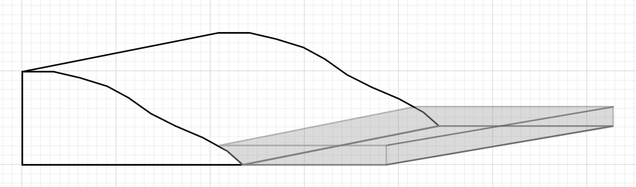

- Reflection: What do you think are the most important strengths and limitations of monitoring snow and ice mass changes using variations in vertical position recorded by GPS instruments installed on bedrock? Describe the strengths and limitations via a comparison to both traditional and other geodetic tools (like GRACE or InSAR) for monitoring snow and ice mass changes. Were you surprised by anything you encountered in this unit?

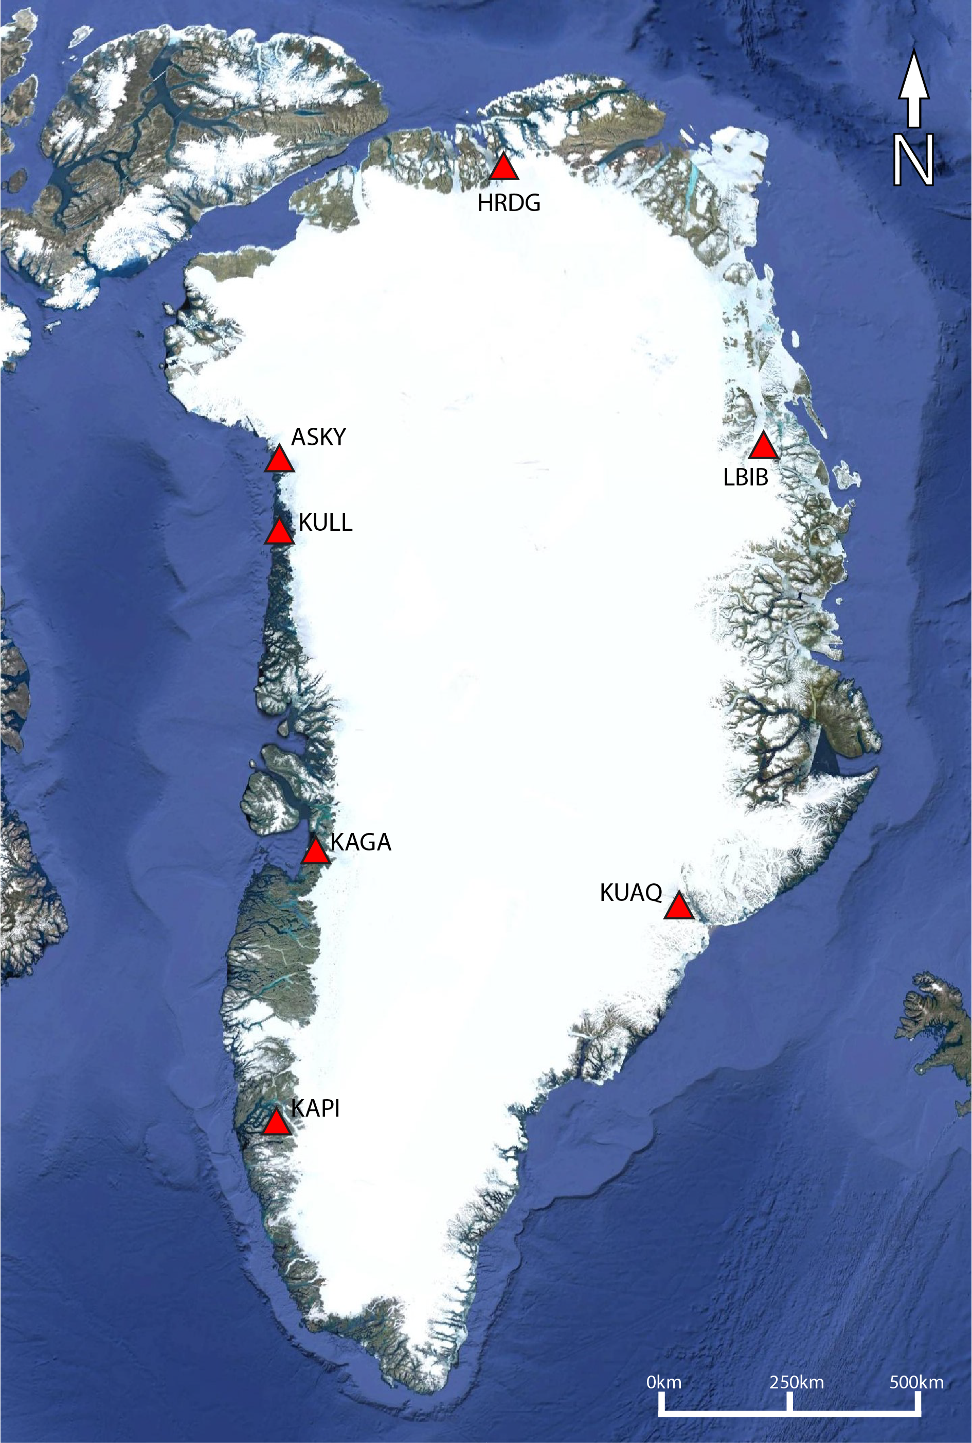
Figure 1. Map of Greenland with the GPS stations and their 4-letter codes. (background image from Google Earth)

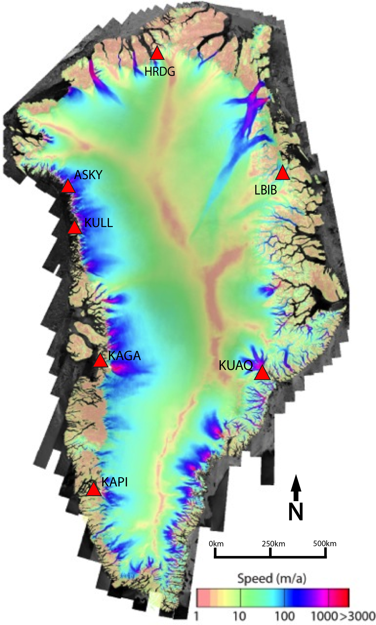
Figure 2. InSAR, SAR, and speckle tracking–derived ice velocity map of Greenland (http://nsidc.org/data/NSIDC-0670#).
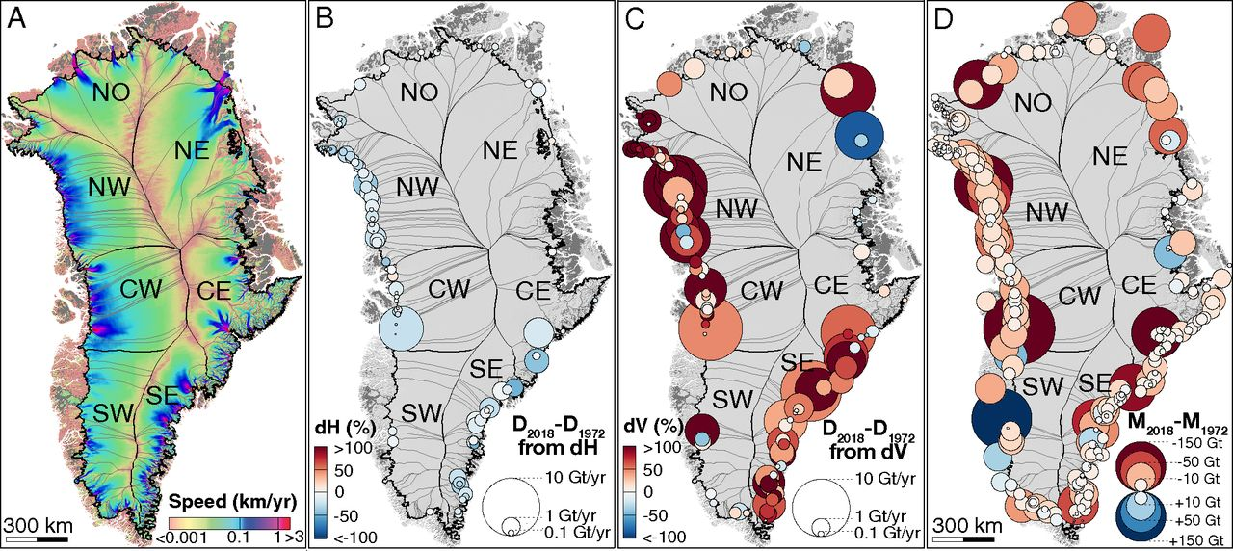
Figure 3. (A) Glacier catchments/basins for the Greenland Ice Sheet and seven regions overlaid on a composite map of ice speed (12). (B–D) For 1972–2018, the percentage (B) thickness change, (C) acceleration in ice flux from each basin, and
(D) cumulative loss per basin. The surface area of each circle is proportional to the change in ice discharge caused by a change in (B) thickness or (C) speed; the (blue/red) color indicates the (positive/negative) sign of the change in (B) thickness, (C) speed, and (D) mass.
Mouginot et al, 2019. https://www.pnas.org/content/116/19/9239
(PNAS allows reuse for educational purposes)

Table 1. Station Information Summary for six GNET sites around the margins of Greenland.
 | Station | Latitude | Longitude | Elevation  (m) | General Location, Proximity to Ice, Nearby Ice Velocity, | Vertical Trend (mm / yr)  Time series | Month of Peak in  Seasonal Cycle
Person 1 | KAPI
 | KUAQ
Person 2 | HRDG
 | KAGA
Person 3 | ASKY
 | LBIB
Example | KULL

Note: Although the term GPS (Global Positioning System) is more commonly used in everyday language, it officially refers only to the USA's constellation of satellites. GNSS (Global Navigation Satellite System) is a universal term that refers to all satellite navigation systems including those from the USA (GPS), Russia (GLONASS), European Union (Galileo), China (BeiDou), and others. In this module, we use the term GPS even though, technically, some of the data may be coming from satellites in other systems.

