Understanding Our Changing Climate Unit 1: Student In-Class Stakeholder Analysis
Bruce Douglas (Indiana University) and Susan Kaspari (Central Washington University)
Many different people and groups—stakeholders—affect and are affected by sea-level rise. You will work with your classmates to do a sea-level change stakeholder analysis for the case study region that you read about.

Stakeholder Analysis
According to the Project Management Institute (PMI), the term project stakeholder refers to “an individual, group, or organization, who may affect, be affected by, or perceive itself to be affected by a decision, activity, or outcome of a project.” The purpose of a Stakeholder Analysis is “to identify and understand different persons, groups, and institutions who will be positively or negatively impacted.”
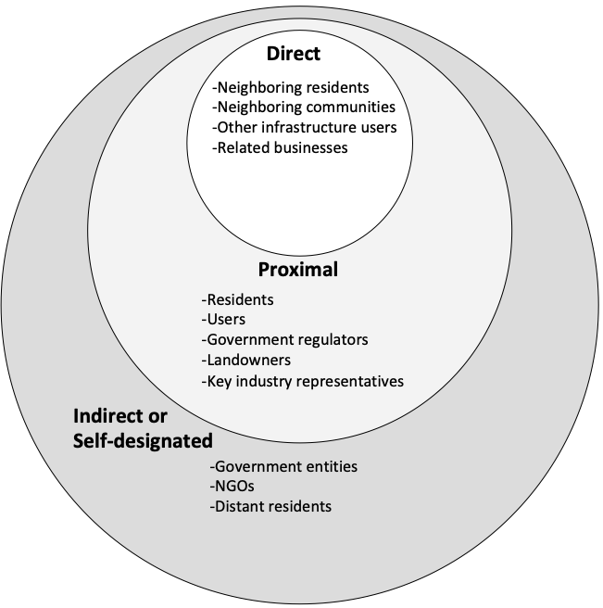
Figure 1. Stakeholder concept diagram.
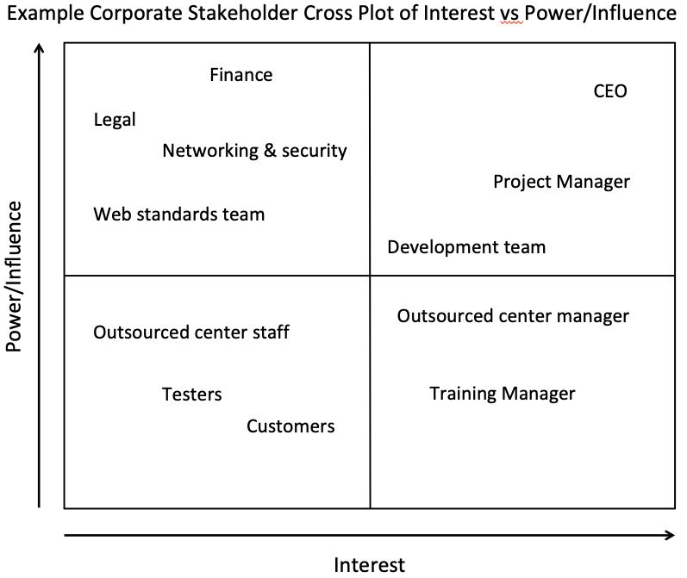
Figure 2. Example Stakeholder Cross Plot of Interest vs. Power/Influence.
Power/Influence can pertain to the ability to take action to adapt to and/or mitigate sea-level changes. Interest reflects the potential impacts of sea-level changes on the stakeholder (how much could it affect them).

Conducting a Stakeholder Analysis
Your groups will eventually be assigned to one of the stakeholder groups determined by the class. List the stakeholders decided on by the class.

Interest
Power/Influence

A) Discuss with your group and fill in the chart above based on the stakeholder list your class determines.

B) On the following page fill in a row of the chart for the stakeholder group that your team has been assigned.

C) Reflect on your experience doing a Stakeholder Analysis by completing one of the following questions:
- How has undertaking a stakeholder analysis affected your perspective on sea-level rise and why?
- What surprised you most in undertaking a stakeholder analysis and why?
- What would you like to know more about regarding the societal impact of sea-level rise?

Stakeholders | Involvement in Issue | Impact of Issue on Stakeholder (high-med-low) | Interest in Issue  (high-med-low) | Influence/Power  (high-med-low) | Resources for Action or Ways to Engage

