
Great Circle and Straight Line Distances

Annotated Teacher Edition
http://serc.carleton.edu/geomapapp

Purpose In this activity, we investigate great circles and straight lines on maps, and distances along them, and use examples from routes flown by airlines.

Red text provides pointers for the teacher. Each GeoMapApp learning activity is designed with flexibility for curriculum differentiation in mind. Teachers are invited to edit the text as needed, to suit the needs of their particular class.

At the end of this activity, you should be able to:

- Analyze and interpret maps and graphical data.
- Understand latitude and longitude and great circles.
- Examine the economics of routes used for commerce such as flight paths and shipping routes.

As you work through GeoMapApp Learning Activities you’ll notice a check box, , and a diamond symbol ♦ at the start of many paragraphs and sentences:

- Check off the box once you’ve read and understood the content that follows it.
♦ Indicates that you must record an answer on your answer sheet.

Equipment required: Calculator. Marker pen (e.g. Red Sharpie pen).

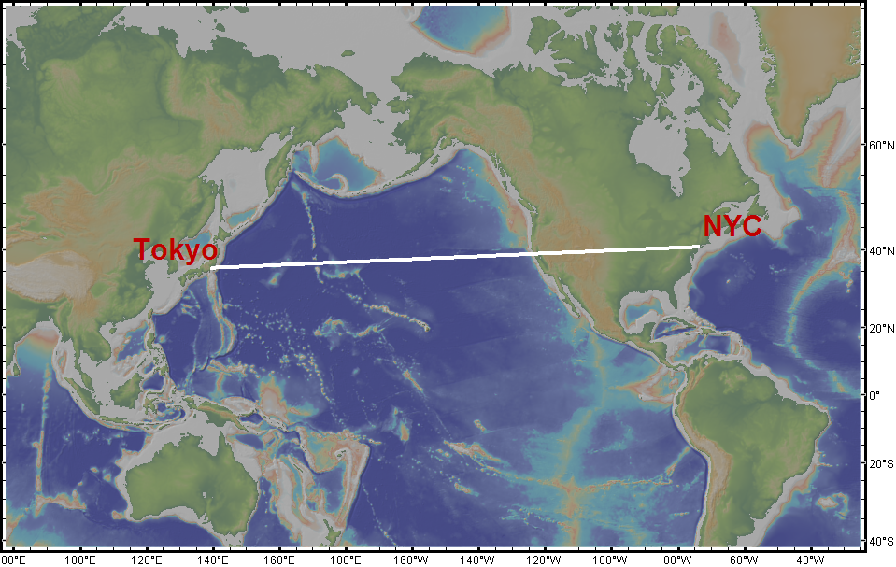
1. New York City (NYC) and Tokyo are at about the same latitude (NYC latitude is about 40 º 43’ N and Tokyo is about 35 º 41’ N). The map to the right shows a straight line connecting the two cities.

1a. ♦ At the latitude of those cities, the map above is about 21,300 km across. By estimating the length of the line compared to the width of the map, use the work space on your answer sheet to calculate the distance between NYC and Tokyo. Remember to show your work.
(We’ll show the derivation of that 21,300 km width in a moment.) The straight line between the two cities is almost horizontal and its length looks to be roughly 6/10 times the width of the map. If the map is about 21,300 km across, the distance between NYC and Tokyo is about (6/10) x 21300 = 12,780 km. Note that we were careful to specify the approximate width of the map at the average latitude of the two cities because, on a Mercator projection, as shown here, the horizontal distance scale depends upon latitude.

(We can perform a much more rigourous calculation to arrive at a more precise distance value, as follows. First, for the width of the map we’ll show how we came up with a distance of about 21,300 km. The circumference of a sphere is 2 * pi * radius. The average latitude of the two cities is about 37 degrees N and the circumference around the 37th parallel of latitude is equal to the 2 * pi * the radius at 37 degrees N. t that parallel we need to find the radius of At the latitude of the On a Mercator projection, the width of the map depends upon the latitude., and using the the radius of the Assuming Earth to be a sphere with average radius 6,371 km, we use a cosine trig function to find that the radius of the 37th parallel of latitude is 6371 * cosine (37). So, the circumference around the 37th parallel of latitude = 2 * pi * 6371 * cosine (37) = 30,640 km. Now, if we look at the longitude annotations, we find that the map spans about 250 degrees of longitude. If 360 degrees is equivalent to 30,640 km, then 250 degrees is equivalent to (250/360) * 30640 = 21,278 km, which we rounded to 21,300 km. So, that’s how we arrive at the width of the map printed on the student handout. Next, to find the length of the straight line on the map printed in the student handout, we could measure the length of the straight line with a ruler to be about 61 mm, with the map about 107 mm wide. So, the straight line is a fractional 61/107 times the width of the map. The straight line distance is thus (61/107) * 21278 = 12,130 km. So, our visual inspection of the small map is a good estimate.)

1b. ♦ Based upon the image shown in (1), explain whether or not you think that the distance calculated in (1a) is the shortest distance between the two cities.
Students may think that because the map is flat, the straight line on it shows the shortest distance. But, since Earth is not flat, we’ll see that that is not the case! Also, it is perhaps worth mentioning that the shortest distance really would be a straight line if we could tunnel through Earth but we can’t so we have to find the shortest distance over the surface of our planet.

2. The map below shows the path of an airline flight between NYC and Tokyo.
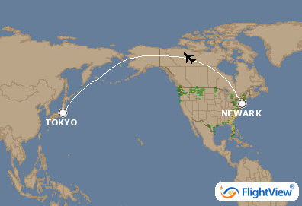

2a. ♦ Describe the shape of the flight path.
Descriptions may include any of the following: Arched, curved, not straight, goes up through Alaska.
2b. ♦ Do you think that the flight path will be longer or shorter than the path shown on the map in question (1)? Explain your reasoning.
We know from experience that the shortest distance between two points is a straight line so students may say that because the path shown on the map is curved and does not look as direct as the line in (1), and that it is longer. Students may also suggest that the flight took that particular route to avoid bad weather.
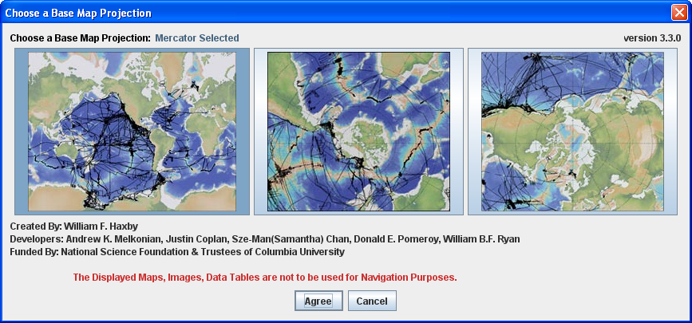
3. Start GeoMapApp. In the projections window, shown here, make sure that the left map is selected and click the Agree button.
That will open the map window in a Mercator map projection.

When the map window opens, click on the zoom button button to activate the zoom-in tool and click once on the map on Alaska. That will zoom in on the map so that it looks similar to the image below:
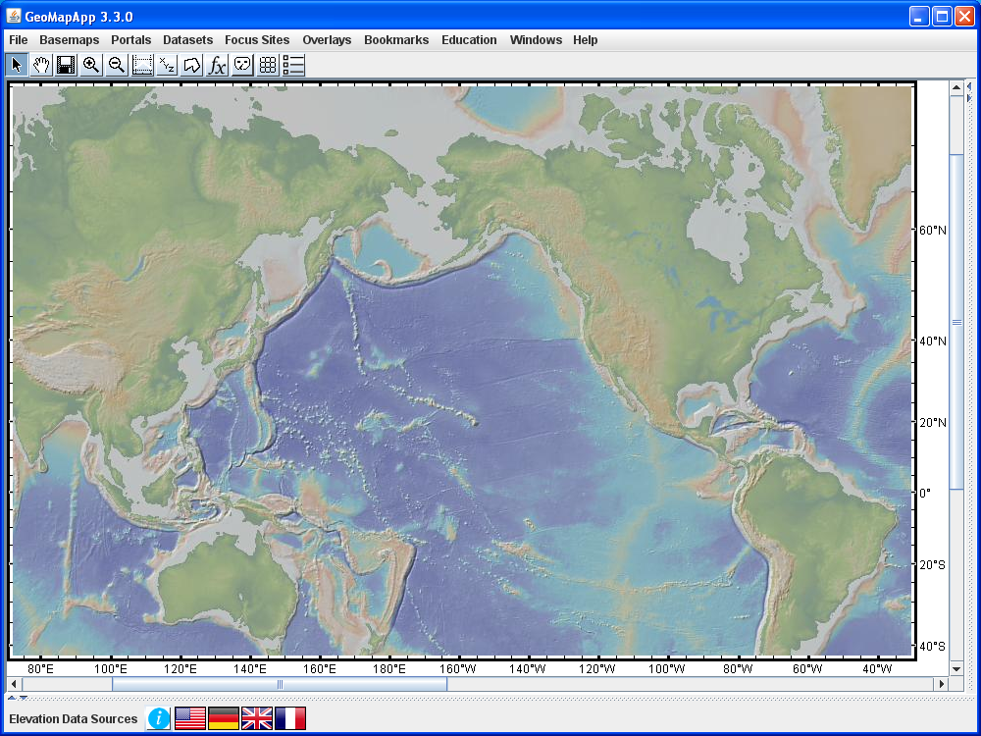

4. Activate the Profiling tool by clicking once in the tool bar on the button. Wait a few moments for the Processing window to disappear. Then, click on the map in the US northeast and drag the cursor over to Japan. When the cursor is released, a profile window comes up. It may look like the one shown below.

For the purpose of this activity, you will not need to study the profile graph. Instead, focus upon the distance given along the X-axis on the profile graph.
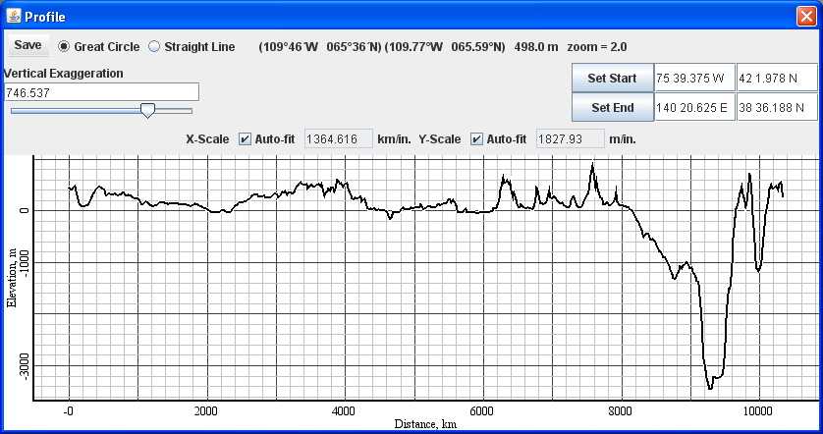

Find the portion of the Profile window with the Set Start and Set End controls. Change Set Start location to be 74 0 W (74 degrees and 0 minutes West) and 40 43 N (40 degrees and 43 minutes north) and click . Change Set End location to be 139 46 E (139 degrees and 46 minutes East) and 35 41 N (35 degrees and 41 minutes north) and click . The values are shown in the screen capture, below.

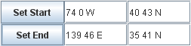
Find the portion of the Profile window that allows us to switch from a Great Circle to a Straight Line. Select Straight Line:

The Straight Line option shows a path on Earth’s surface that crosses meridians (lines of longitude) at a constant angle. On the Mercator map, it plots as a straight line, hence its name.
The straight line option draws the path of a “rhumb” line which is a line that crosses meridians at a constant angle. On a Mercator map projection, like the one we are using here in GeoMapApp, a rhumb line is, thus, shown as a straight line. Rhumb lines allow navigators the ease of steering a constant bearing. But, with modern navigational technologies, that is no longer required. A rhumb line is not the same as a small circle except in special cases.

Look at the profile line on your map. Confirm that it looks like the one shown in question (1).
It is a straight line, as shown in the map here:
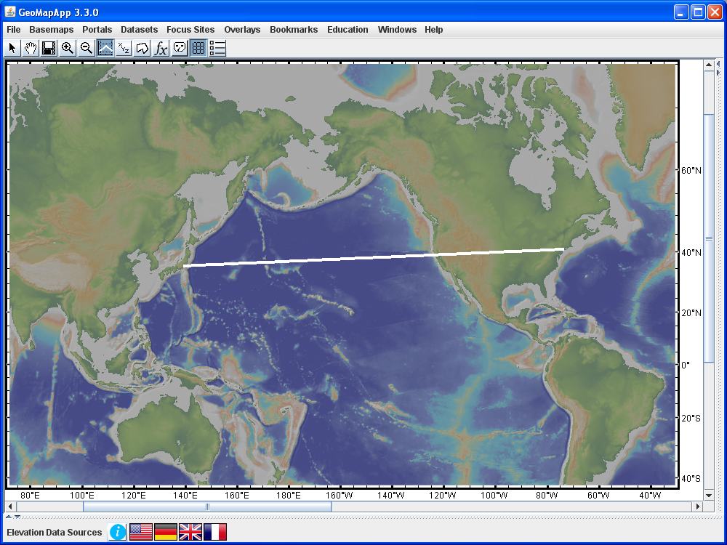

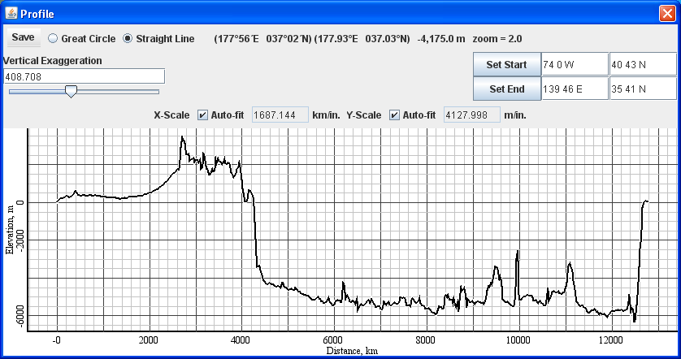
5a. ♦ In the Profile window, the distance along the straight line path is given as the length of the profile. Inspect the X-axis values on the graph to determine the length of the profile. Write the value on your answer sheet, and remember to give the units. The distance is about 12,800 km, as shown below.

5b. ♦ Find the portion of the Profile window that allows us to switch from a Straight Line to a Great Circle. Select the Great Circle option. . Describe the shape of the track on the map.
It is a curved path, as shown in the map here:
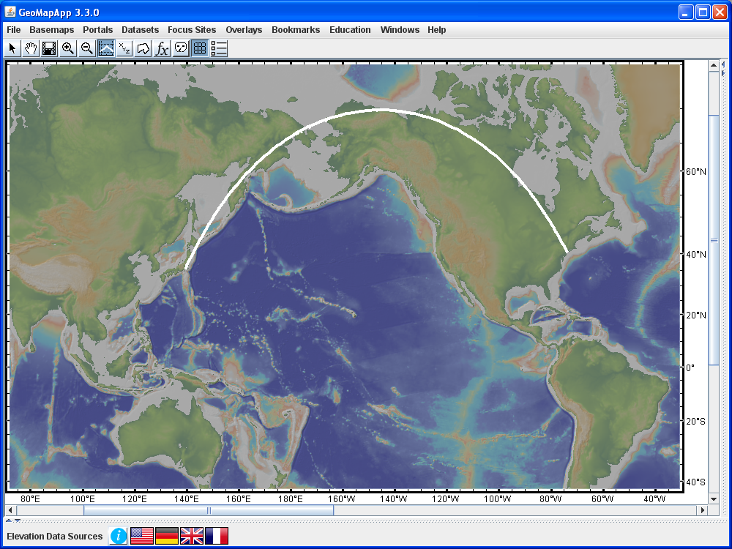

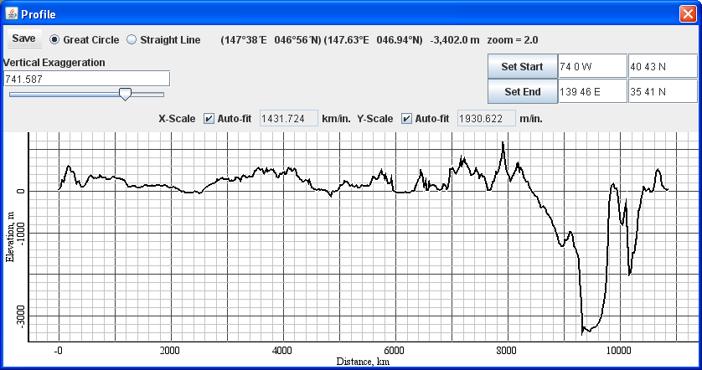
5c. ♦ In the Profile window, the distance along the path is given as the length of the profile. Read off the length of the profile and write that value, with units, on your answer sheet.
The distance is about 10,850 km, as shown on the profile below.
5d. ♦ Calculate the difference in kilometers between the distance along the Straight Line and the Great Circle routes.
Difference in distance is about 12800 – 10850 = 1950 km.

5e. ♦ Calculate the difference in distance as a percentage of the Straight Line distance, and show your work.
For the straight line distance of about 12,800 km, the difference of 1950 km corresponds to about (1950/12800) * 100 = 15%.

5f. ♦ The standard formula for speed is given by speed = distance/time. Assuming a typical airliner cruising speed of about 800 km/h, calculate the difference in flight time along the Straight Line and the Great Circle routes.
For the time calculation, we rearrange the equation to get time = distance/speed. So, the difference in flight time is given by difference in distance divided by speed = 1950 / 800 which is almost two and a half hours.

5g. ♦ A typical aircraft flying the New York to Tokyo route uses roughly 53,000 gallons of aviation fuel. There are 65 gallons per barrel of jet fuel. Calculate the number of barrels of jet fuel used for a typical New York to Tokyo flight.
Number of barrels = 53,000 / 65 = about 815 barrels of jet fuel. The numbers come from airline industry web pages.
5h. ♦ If the cost of one barrel of jet fuel is about $130, what is the total approximate cost of fuel for the flight?
Cost = 815 x $130 = $106,000.
5i. ♦ What would be the cost of fuel if the flight flew on a straight line route?
The great circle route is about 15% shorter than the straight line route. So, the great circle route is about 85% of the length of the straight line route. If 85% is equivalent to $106,000 in fuel costs, 100% is equivalent to $106000/0.85 = $125,000.
5j. ♦ What is the cost saving between the two routes? And, explain how, if you ran an airline, the cost difference and flight time difference might affect your decisions about choosing flight paths.
Cost saving = $125000 – $106000 = $19,000. That’s a substantial saving for an airline! It explains why pilots almost always fly along the great circle route that connects any two destinations. An added benefit is that great circle paths allow shorter flying times which makes passengers happier.

6a. ♦ We’ve looked at a flight in the northern hemisphere. The map below (on the next page) shows two locations which have the same longitude values as NYC and Tokyo and the same latitude values except this time the latitudes are in the southern hemisphere. On the map on your answer sheet, use the marker pen to sketch the flight path that an airliner would most likely take between those two southern hemisphere locations.
This question probes the transfer of knowledge.
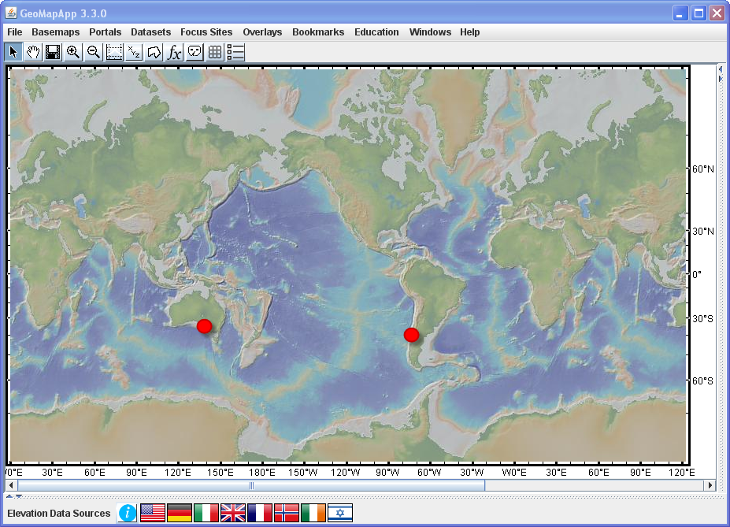

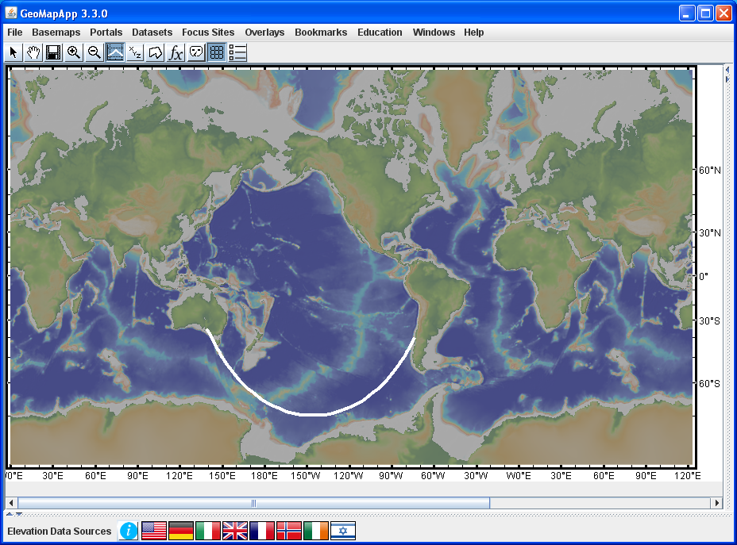
The preferred flight path would also be a great circle route. Now, since the start and end points are in the southern hemisphere, the great circle takes the aeroplane further south, towards Antarctica. Students may draw an arc that curves upwards towards the equator – that would be a small circle route. An airline would be unlikely to follow such a route because it is longer and so would result in a higher cost for fuel. The preferred great circle route can be plotted by fixing the start and end points in the profiling tool, like this:
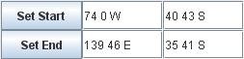

If a globe is available in the classroom, the teacher may want to have students use a piece of string or hoop to demonstrate the great circle path.

Now test your prediction: Use the GeoMapApp profiling tool to draw a profile on your computer between the approximate positions shown by the two red dots in the map above. When the profile window appears, move it out of the way so that you can see the white line on the map. That white line is the great circle route and is the one that would most likely be flown by an airliner.

6b. ♦ On your answer sheet, write down how your hand-drawn flight path compares to the great circle route between those southern hemisphere locations. Is it a close match? Does your hand-drawn line arc the same way?

7. Let’s now look at the difference between the great circle and straight line distances for points on Earth’s equator. In the profile window, change the start and end latitudes to be “0 0 S” as shown below and click and .

Note that it doesn’t matter if an equatorial point is tagged as S or N. The new route goes from near the border between Peru, Ecuador and Colombia over towards Papua New Guinea.

7a. ♦ Toggle backwards and forwards between the great circle and straight line paths. Look at the X-axis in the profile window and, on your answer sheet, write down the length of the track (the distance) along the great circle and along the straight line.
From the graph, the distance is about 16,250 km. We could also calculate it with precision: If we take the equatorial radius to be 6,378 km, Earth’s circumference is then 2 * pi * 6378 = 40,074 km. That is, 360 degrees of longitude are equivalent to 40,074 km at the equator. The longitudinal difference between our two points is 146 degrees 14 minutes = 146.2333 degrees. So, the fractional circumference distance is given by ( 146.2333 / 360 ) * 40074 = 16,278 km. So, our visual estimate from the profile was good.

7b. ♦ You've probably noticed that, at the equator, the great circle and straight line paths over Earth’s surface are exactly the same. Explain why this is the case.
When the straight line path coincides with the great circle path, the distances are identical.
(Around the equator, the great circle and straight line paths both intersect all meridians at 90 degrees. There is no difference between them so their distances are the same. Also, the equator is a special case of a small circle coinciding with the great circle so the distance along a small circle would also be identical to that along the great circle and along the straight line.)

7c. ♦ For any other pair of points that lie on the same line of latitude, the great circle and straight line distances are different. Explain.
The straight line path would be parallel to the line of latitude whereas the great circle route would arch northwards if the two points are in the northern hemisphere and southwards if in the southern hemisphere. Since the paths are different, the distances are different.

7d. ♦ Consider any two points that lie on the same line of latitude that is not the equator. Explain why a great circle path that connects the two points is arched towards the pole.
A great circle has its centre at Earth’s centre. Conceptually, we can visualise the path of a great circle by taking the equator and tilting it so that it connects the two latitude points. Since its centre is fixed in space, the location of the great circle arc is constrained. For northern hemisphere points, the portion of great circle that lies between the points is titled northwards. Vice versa for southern hemisphere points.

8. In the profile window, use the Set Start and Set End boxes, as shown below, to draw a north-south profile along the 74º W meridian from the equator to a location at 60 º N:
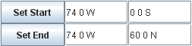
Note that it doesn’t matter if the equatorial point is tagged as N or S. The vertical straight line passes from South America up through NYC to a northern part of Canada.

8a. ♦ Toggle backwards and forwards between the great circle and straight line paths. Look at the X-axis in the profile window and, on your answer sheet, write down the length of the track (the distance) along the great circle and along the straight line.
From the graph, the distance is about 6,680 km. We could also calculate it with precision: If we take the polar radius to be 6,357 km, Earth’s circumference is then 2 * pi * 6357 = 39,942 km. That is, 360 degrees of in a N-S direction is equivalent to 39,942 km. Now, the latitudinal difference between our two points is 60 degrees so we are looking at two points that span one sixth of the polar circumference, a distance of 39942 / 6 = 6,657 km. So, our visual estimate was good.

8b. ♦ You've probably noticed that, along a meridian, the great circle and straight line paths over Earth’s surface are exactly the same. Explain why this is the case.
The straight line path again coincides with the great circle path so the distances are identical.
(Along a meridian, the straight line path is parallel to and coincident with the great circle path. There is no difference between them so their distances are the same. Also, any meridian is a special case of a small circle coinciding with the great circle so the distance along a small circle would also be identical to that along the great circle and along the straight line.)

8c. ♦ For any other pair of points that lie on the same line of longitude, the great circle and straight line distances are identical. Explain.
On the Mercator map projection, any straight line path oriented in a N-S direction is one that runs along a line of longitude. Any line of longitude is a great circle, so the straight line path and great circle path are always identical – they are the same arc that is centred at Earth’s centre.

8d. ♦ In (8a) we considered two points that lay on the 74º W meridian – one point was on the equator and the second was at 60 º N. If we look at two new points having the same latitudes but that lie on any other meridian, would you predict the distance between them to be the same or different? Explain.
Since all lines of longitude are great circles and have the same radius, the distance along the great circle is always the same.

9. ♦ How has your thinking about distances on maps and over Earth’s surface changed since looking at that first map in question (1)?

OPTIONAL WORK:

Students could use GeoMapApp’s profiling tool to create a table and then graph the difference in great circle and straight line distance for two points that are increasingly far apart. One point could be fixed at, say, London (which we know lies on the Greenwich meridian) and the second point could be chosen at exactly the same latitude but be moved in steps of, say, 30 degrees eastwards. So, the start point is at (51 30 N, 0) and the end point is incrementally chosen to be at (51 30 N, 0), (51 30 N, 30 E), (51 30 N, 60 E), (51 30 N, 90 E), (51 30 N, 120 E) and so on.

The teacher could add questions about carbon footprints. Many airlines now have programs to help reduce their aeroplanes’ carbon footprints. Questions could also be expanded to include the use of biofuels in the airline industry.

The cost of aviation fuel could be compared to that for regular gasoline and diesel.

Required prior knowledge: Ability to read and interpret maps and graphs. Familiarity with latitude and longitude and with great circles.

Short Summary of concepts and content: The relationship between great circles and distance. Comparison of map-based and graphical data sets.

Description of data sets: The base map used in this activity is from a global compilation created by Columbia University’s Lamont-Doherty Earth Observatory.

A nice explanation of great circles, rhumb lines and small circles can be found on the following MATLAB web page:
http://www.mathworks.com/help/map/great-circles-rhumb-lines-and-small-circles.html

The great circle distance between any two points on Earth’s surface is calculated as the arc length for the spherical triangle which has its apex at Earth’s centre. For that, we need to know the central angle subtended at Earth’s centre by the two points. The trigonometry can be a bit involved so various approximate methods, such as the Haversine formula, are commonly used. The following URLs link to useful web pages on great circles and the formulae to calculate a great circle distances:
http://www.movable-type.co.uk/scripts/latlong.html
http://mathforum.org/library/drmath/view/51722.html
http://mathforum.org/library/drmath/view/52318.html

