Project EDDIE: LAKE METABOLISM
Student Handout

This module was initially developed by D.C. Richardson, J.L. Klug, and C.C. Carey. 26 June 2015. Project EDDIE: Lake Metabolism. Project EDDIE Module 2, Version 1. http://cemast.illinoisstate.edu/data-for-students/modules/lake-metabolism.shtml. Module development was supported by NSF DEB 1245707.

Learning objectives:
- Discuss eutrophication of aquatic ecosystems
- Compare and contrast structural vs. functional ecosystem metrics
- Explain the drivers of diel variation in sensor data
- Calculate metabolism rates (GPP and R) from high-frequency data
- Compare rates of GPP and R from lakes with different trophic status

Why this matters: Different lakes exhibit a range of catchment sizes, morphometry, and land use that contribute to differences in lake function. These functional differences mean that lakes vary in ecosystem services such as habitat quality and recreational value. In this module, students will explore high-frequency water quality datasets from several lakes around the world, graph high-frequency data, and use simple conceptual and mathematical models to calculate estimates of metabolism (gross primary production and respiration). Finally, students will compare metabolism rates across different lakes to examine gradients of eutrophication.

Outline of Class Today
- Discussion of papers read for class and quick PowerPoint introduction
- Activity A: Graphing high frequency data
- Discussion of metabolism calculations
- Activity B: Calculation of gross primary production and respiration
- Activity C: Comparison of lakes of different trophic status

Required pre-class reading (text in blue is hyper-linked):
- Palmer, M. A. and Febria, C. M. 2012. The heartbeat of ecosystems. Science 336(6087): 1393-1394. Open access http://www.sciencemag.org/content/336/6087/1393.summary
- Odum, H. T. 1956. Primary Production in Flowing Waters. Limnology and Oceanography 1(2):102-117. Open access http://www.aslo.org/lo/toc/vol_1/issue_2/0102.pdf
- Wines, M. 2013. Spring Rain, Then Foul Algae in Ailing Lake Erie, New York Times, March 14: 3 pages. http://www.nytimes.com/2013/03/15/science/earth/algae-blooms-threaten-lake-erie.html?_r=1
- Solomon, C. T., Bruesewitz, D. A., Richardson, D. C., Rose, K. C., Van de Bogert, M. C., et al. 2013. Ecosystem respiration: drivers of daily variability and background respiration in lakes around the globe. Limnology and Oceanography 58(3): 849-866. Open access http://aslo.org/lo/toc/vol_58/issue_3/0849.html. Use specifically for the metadata in Table 1.

Activity A: Graphing high frequency data
- With a partner, pick one of the five lakes from around the world: Annie, Balaton, Kentucky, Muggelsee, and Sunapee. There is sensor data from the same time period in each of those lakes.

- Do some research on your lake. Where is it located in the world? What type of lake is it (e.g., naturally-formed or manmade, geological formation)? How big is it? What is the average and maximum depth? Hint: Check out: Solomon et al. (2013) Table 1.

- Graph each of the three variables (O₂, PAR, and wind speed) on three separate figures.
  - Make your figure have all the information needed to interpret the data being presented (i.e., include axis labels, units, adjust the axes to maximize the space used by the data, etc.)

- What patterns do you observe in PAR, O₂, and wind for the 4 days in your dataset?
  - Based on your data, predict whether your lake is oligotrophic or eutrophic.

- For your O₂ data, describe the shape of the curve. When does oxygen increase and decrease? Can you explain any irregularities in the O₂ curve using wind data?

Activity B: Calculating metabolism
- For your lake, examine the PAR values from your graph – use this figure and the data in the Excel spreadsheet to identify the sunrise and sunset times for all 4 days.

- Calculate respiration for each nighttime period.
  - Find the starting oxygen concentration (at sunset) and the ending oxygen concentration (at sunrise). Are organisms in the lake consuming or producing oxygen during this nighttime period? How much oxygen?

  - What is the rate of oxygen change for each nighttime period? Be careful with units and signs.

  - Now, what is the respiration rate (R) over a whole day? Each of the other three days?

- Calculate the gross primary production for each daytime period. Be careful with units and time periods. They matter!
  - Find the starting oxygen concentration (at sunrise) and the ending oxygen concentration (at sunset). Are organisms in the lake consuming or producing oxygen during this daytime period? How much oxygen? Be careful with the units!

  - Find the average respiration rate (R) for that daytime period using the average respiration rate from the preceding and following night (see 2c above).

  - How much oxygen was respired over that daytime period? (scale your answer in 3b for the number of daylight hours)

  - How much oxygen was produced by photosynthesis during the daytime period? Remember, GPP = Change in O₂ – R (minus a negative!).

  - What is the gross primary production (GPP) rate for each of the four 24-hour periods?

- Create two graphs of your 4 days of GPP and 3 days of R.

Activity C: Comparison of lakes of different trophic status
- After calculating the GPP and R rates over several days, calculate the mean (average) GPP and R rates for your lake.

- Write your average GPP and R rates for your lake on the board. How do the rates in your lake compare with the other lakes in the class data set?

- Which lakes are oligotrophic and which are eutrophic? Is your lake green or blue?

- Look at Figure 4 from Solomon et al. (2013) (below). How do the rates in your lake compare with other lakes in this dataset? Which lakes have the highest metabolic rates? Which have the lowest rates? What do the lakes with high metabolism rates have in common?

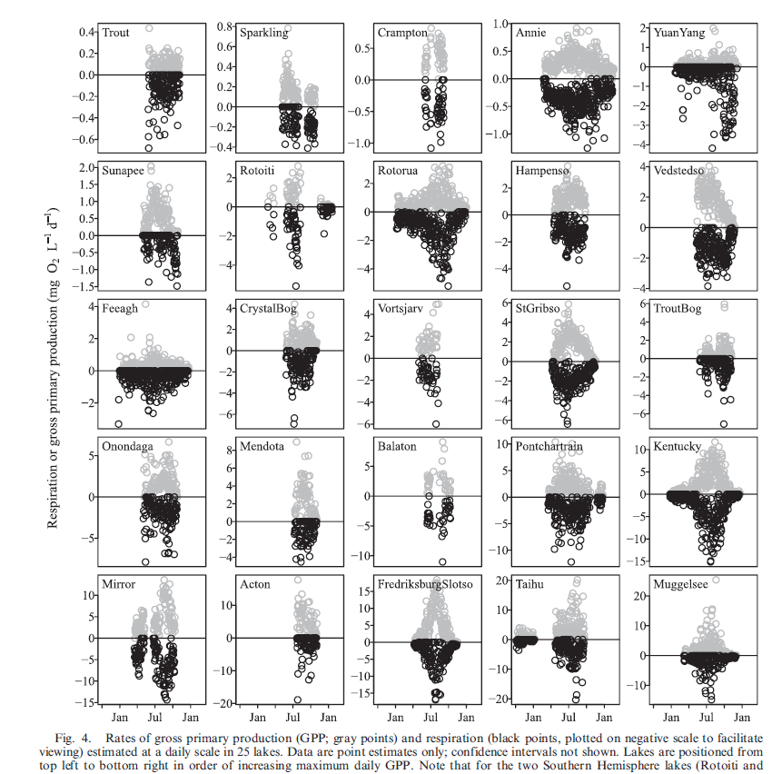

Data used in this module were collated and quality checked by:
- Solomon, CT, Bruesewitz, DA, Richardson, DC, et al. Ecosystem respiration: Drivers of daily variability and background respiration in lakes around the globe. Limnology and Oceanography 58(3): 849-866.

