Project EDDIE: Wind and Ocean Ecosystems

By the end of this module, you will be able to answer the question: how does wind impact ocean ecosystems?

Learning Objectives
- You will be able to generate a wind rose plot in Excel.
- You will be able to explain how wind direction and strength influence physical and biological ocean processes.
- You will be able to find a location on a map using latitude and longitude.
- You will be able to explain the relationships between wind bearing and direction.
- You will be able to convert between wind direction in degrees and wind direction using the cardinal and ordinal directions.
- You will be able to interpret a choropleth map.
Why This Matters
The study of ocean organisms and systems is inherently interdisciplinary. This module reinforces for students the interdisciplinary nature of oceanography. Furthermore, by using existing oceanographic observing systems, this module allows you to experience authentic oceanographic research and garner a better understanding of how science is conducted in marine settings.

Outline
1. Lecture on coordinate systems and buoys
2. Activity A: How do we find wind data?
3. Lecture on wind direction and ocean currents
4. Activity B: How does wind influence ocean currents?
5. Lecture on upwelling
6. Activity C: How does wind impact upwelling?
7. Lecture on satellite data
8. Activity D: How does wind impact ocean ecosystems?

Part A: How do we find wind data?

As scientists, whatever your background, we always need sources of real-world data. For this exercise, we will explore how wind direction influences ocean ecosystems. In order to do this, we need to access data to explore patterns. How do we find ocean current data? This might be a challenge! Fortunately for us, the United States funds the National Oceanic and Atmospheric Administration (NOAA), which pilots multiple types of scientific exploration specifically related to ocean and earth systems. The National Data Buoy Center (NDBC) is a part of NOAA’s National Weather Service (NWS). The NBDC created a system of buoys throughout the world, and maintains this system, collecting data from buoys and coastal stations. We will access the NDBC to gather real time data from buoys in the Northern Atlantic to get information of wind direction and speed.

In order to start processing this data, we need to know information about latitude and longitude. Are those terms familiar to you? They might be, but most likely you have never used latitude and longitude to plot locations on a map. Latitude and longitude are a series of imaginary lines that create a grid over the surface of the Earth.
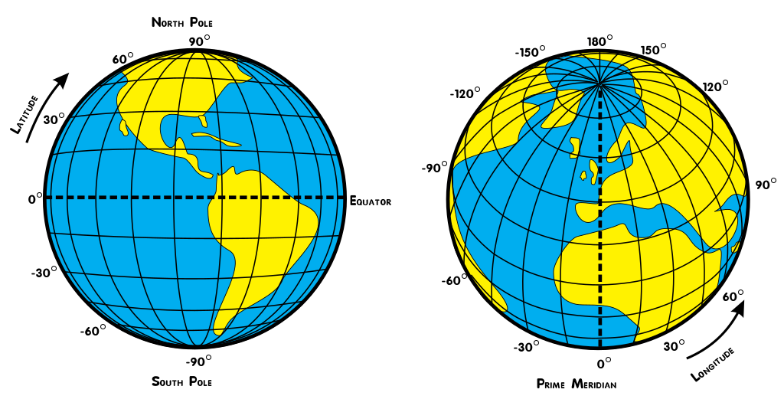
Lines of latitude run north and south moving away from the Equator. At the equator, we say we are at 0° latitude. As we move away from the Equator, we go up in degrees of latitude until we reach the poles. At the poles, we say we are at 90° N/S latitude. Latitude can also be described use + - negative to describe whether a location is north or south. North is considered positive and south is considered negative. So, the North Pole can be written as 90° while the South Pole can be written as -90°. When we navigate using longitude, we move east and west away from the Prime Meridian (In fact we call lines of longitude meridians). The Prime Meridian is 0° longitude. As we move east and west away from the Prime Meridian, we move around a circle (the Earth) and navigate up to 180° E/W latitude. Similarly, longitude can be written with positive and negative designations. In this case east is considered positive and west is considered negative.
We can use latitude and longitude to give us absolute locations of our buoys.
- First navigate to https://www.ndbc.noaa.gov/.
- Notice in the upper left there is a search box. 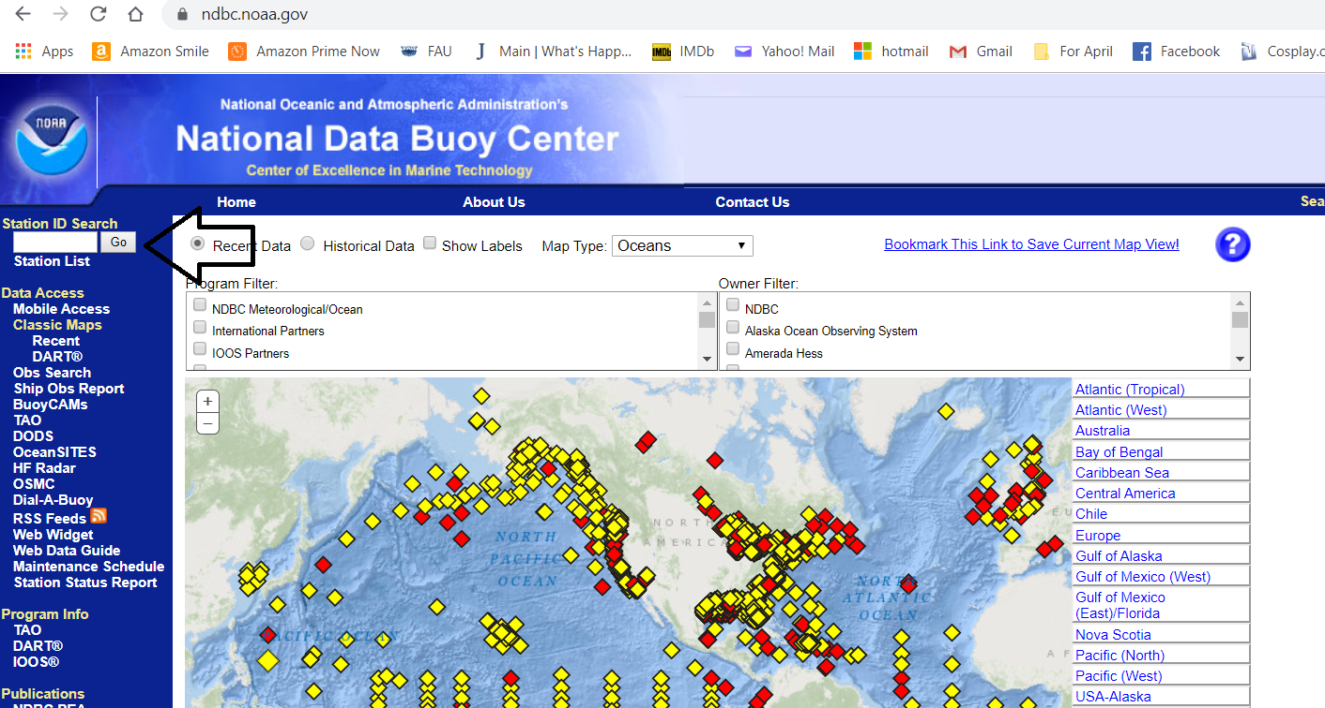
- Search for the following list of station ID’s.
Name | Latitude | Longitude
Station 44137
Station 41001
Station 41002
Station 41048
Station 41010
Station 41047
Station SPGF1
Station 44402
Station 44139
Station 44037

- As an example to help guide you, let’s look at Station 41047. When you search for the station ID, notice at the top there are numbers listed. This is the latitude and longitude listed in both decimal degrees and degrees, minutes, seconds (the first set of numbers and the second set of numbers, respectively). You can use either set to plot latitude and longitude but for this exercise, we want you to use the decimal degrees.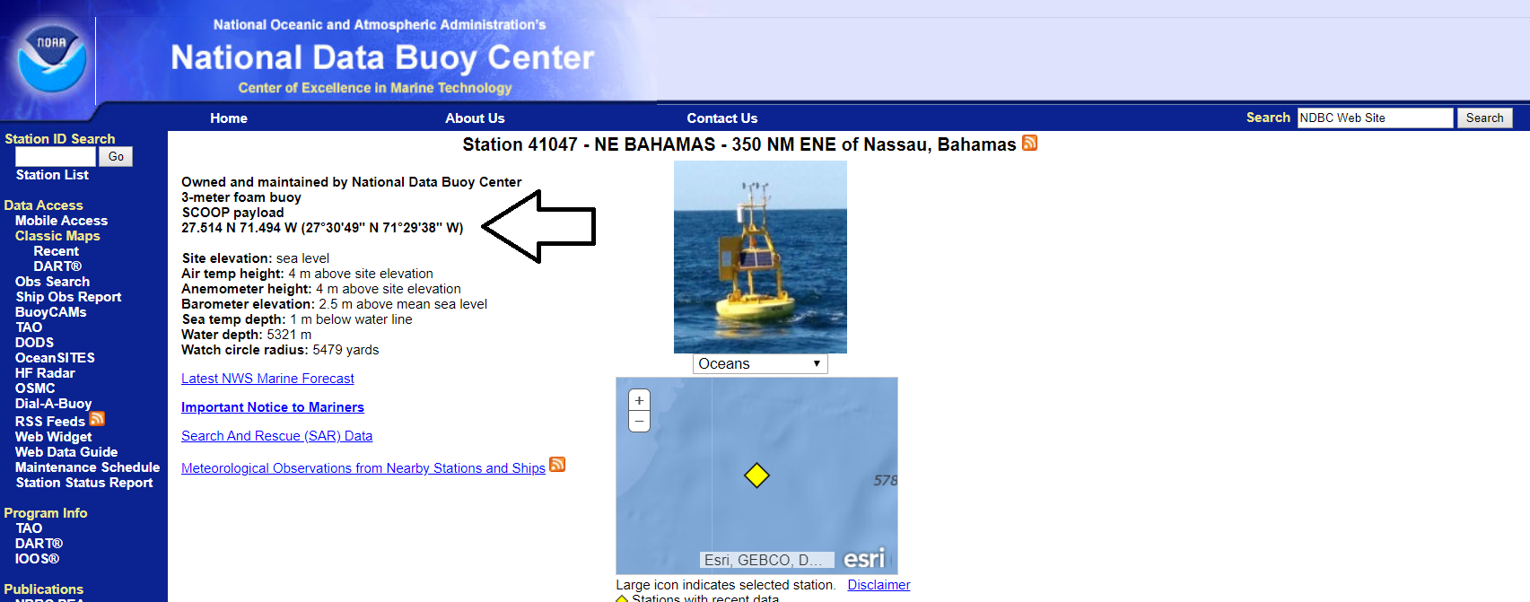
- Look at the numbers, it lists 27.514 N (North) and 71.494 W (West). Thinking about the explanation above, which is the latitude? Which is the longitude? ________________________________________________________________________________________________________________________________________________
- Repeat this step for all of your station ID’s. Fill in the table above.
- Now you will plot these stations on a map. Use the map on the next page to plot the locations of each of the stations.
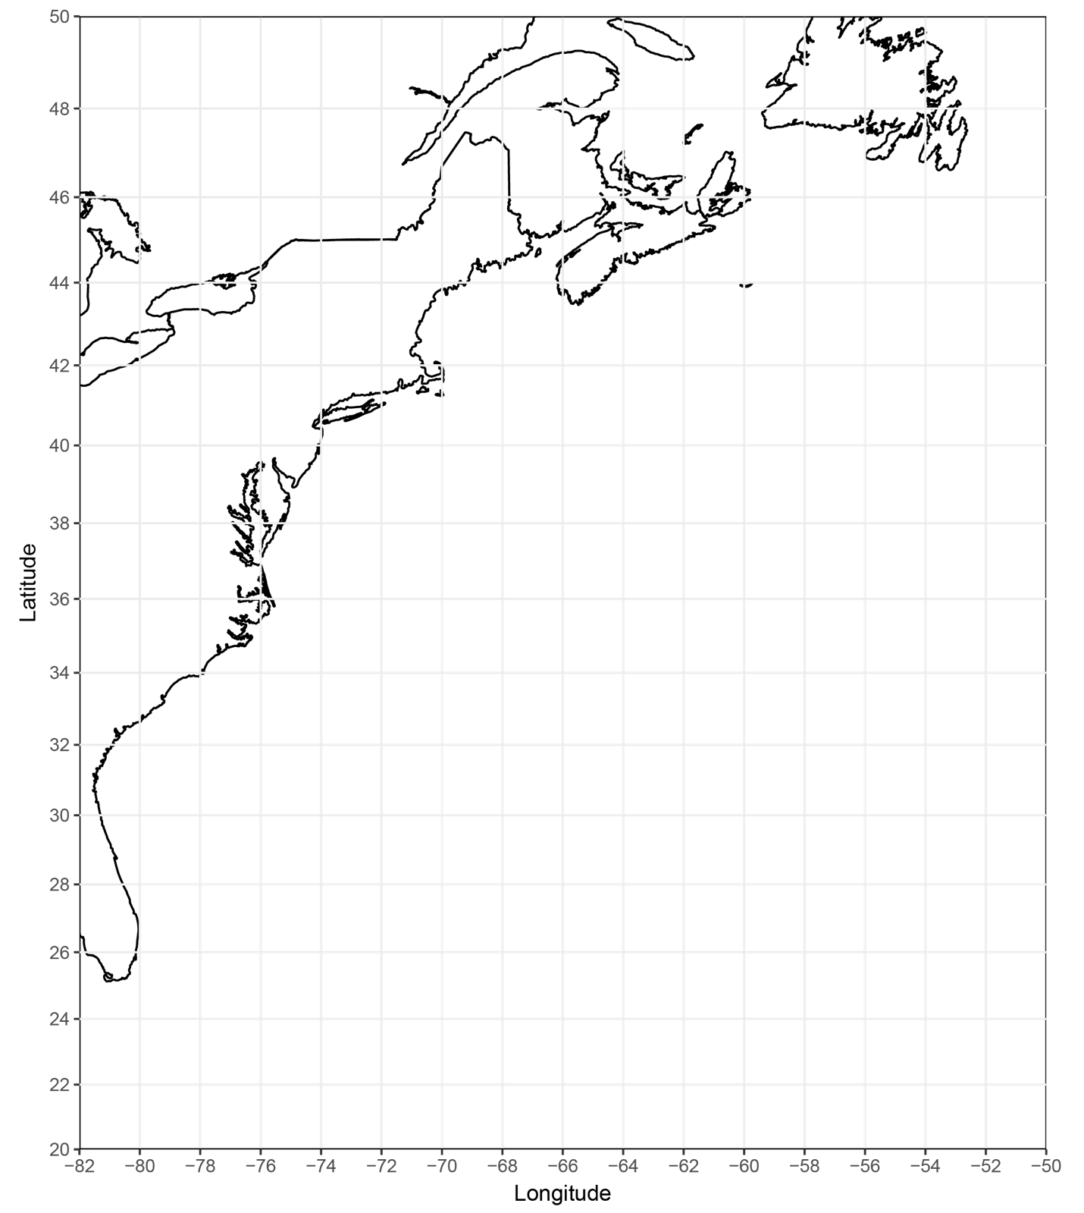

Part B: How do winds influence ocean currents?

In this section we will explore atmospheric data collected from buoys to infer how wind direction and speed influences ocean circulation, specifically currents. Currents are continuous and consistent flows of water along the surface of the ocean. For this next activity, we will download data from the NDBC that gives you wind direction in degrees. We want you to practice converting from wind direction in degrees to wind direction in cardinal and ordinal directions. This might not be something you have ever utilized, but it is a basic mapping skill. To do this, we need to use a compass rose. A compass rose gives you the cardinal directions you are familiar with (north, east, south, and west), as well as the ordinal directions (northeast, southeast, southwest, and northwest) in degrees. We can once again imagine our directions as a circle ranging from 0° to 360°. Thus, each direction you move away from north (which is both 0° and 360°), gives you a degree around the circle. That means that true east is 90°, true south is 180°, and true west is 270°. North would be a range of numbers from 337.6° to 22.5°, northeast is 22.6° to 67.5°, east is 67.6° to 112.5°, southeast is 112.6° to 157.5°, south is 157.6° to 202.5°, southwest is 202.6° to 247.5°, west is 247.6° to 292.5°, and northwest is 292.6° to 337.5°.

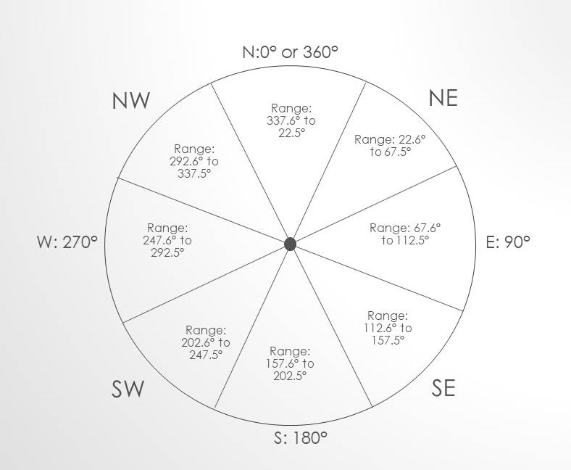

Wind direction can be described qualitatively. For example, wind blowing from the north can be described as northerly or southward. The “ly” denoted that wind is blowing from that direction. Similarly, wind that is blowing towards the east can be described as eastward or westerly. It is important to pay attention when wind direction is being described to ensure you know which way the wind is blowing.
- We will practice converting our wind directions in degrees to our cardinal and ordinal directions. Using the table below and the ranges/figure above, convert the degrees to cardinal/ordinal directions.
Degrees | Direction
145
230
93
3
201
278
112
250
242
357
315
33
153
296
181

Wind direction is often shown using a wind rose. A wind rose is a figure that shows quantitative data pertaining to wind speed and direction. Look at the wind rose below:

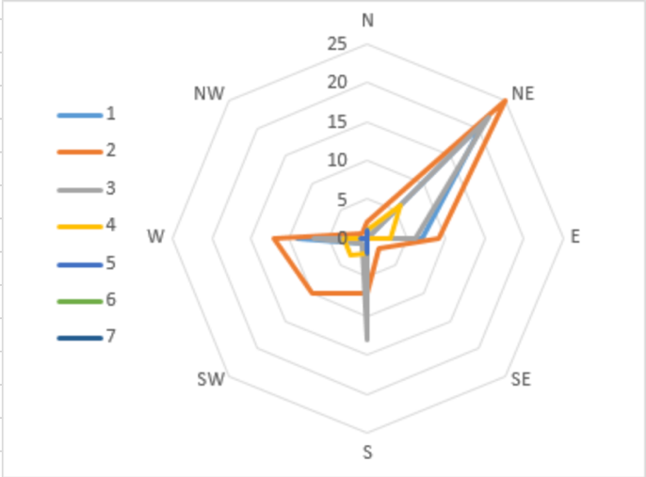

A wind rose looks like a compass. The lines radiating out from the center at regular intervals are reference lines, which denote the number of times wind was measured blew that speed. The lines extending from the center at irregular intervals represent data. The different colored lines denote different wind speeds. For example, the wind rose above shows that for this location the wind blew from the Northeast at 2 m/s 25 times. In contrast the wind blew from the south at 3 m/s almost 15 times during the data collection period.

- Now we will download buoy data for Station 41001. Navigate to https://www.ndbc.noaa.gov/ again and search for station ID 41001. Scroll all the way to the bottom of the page and click on Historical Data and Climatic Summaries.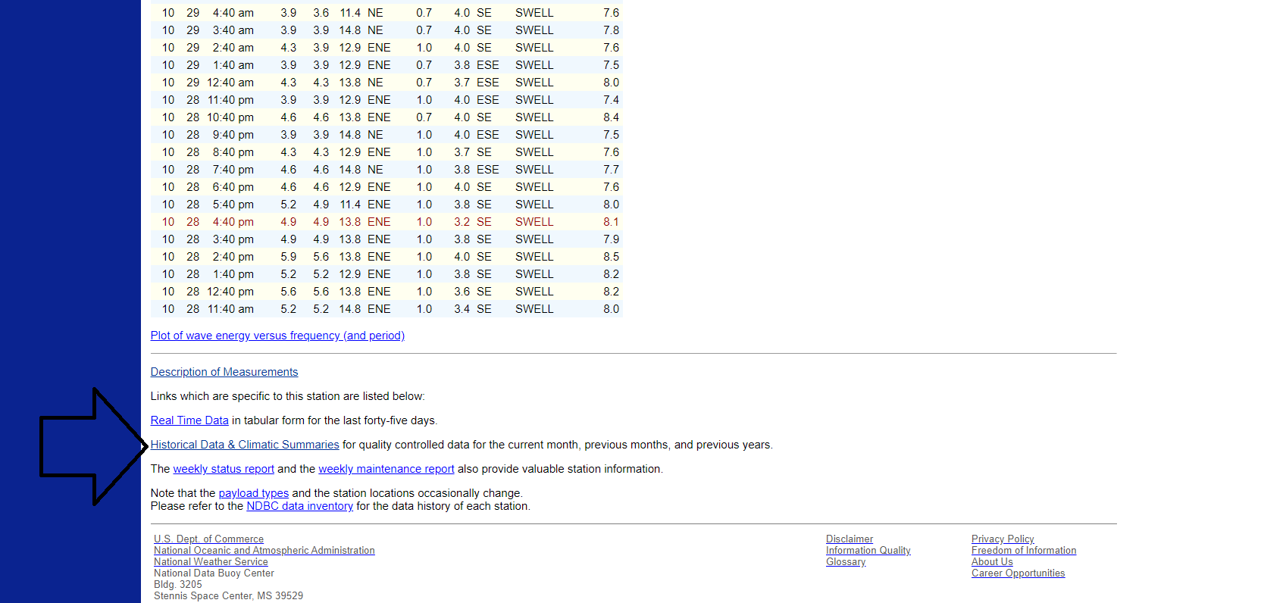

- Under Historical Data on the next page, click on data descriptions. This is metadata. Metadata is basically ‘data about data.’ In other words, where did NOAA get this data? How did they process it? What do the data categories mean?
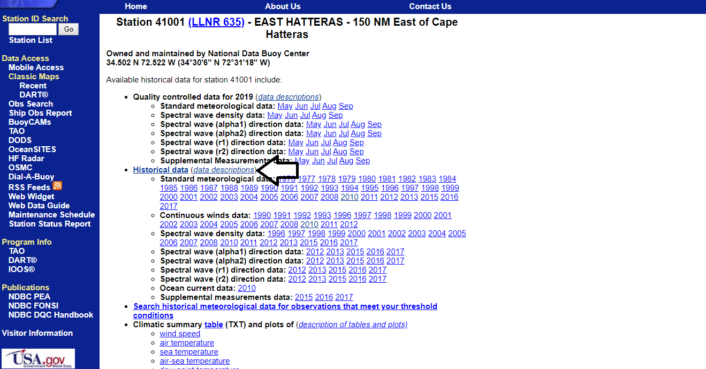

- Under Standard meteorological data, notice it lists several data categories with abbreviations. Notice MM, DD, WDIR, and WSPD. What do these abbreviations stand for? ________________________________________________________________________________________________________________________________________________________________________________________________________________________________________________________________________________________________

- Your data will come from this database. The buoy location is in the West Atlantic near where the Gulf Stream originates. You will be using data from the year 2010. Your instructor will provide it to you in an Excel file. If you access the data from the link above, you may notice that the wind direction is given in degrees. However, in the data provided for you the wind direction has been converted into the cardinal and ordinal directions of N, NE, E, SE, S, SW, W, and NW. You will now make a wind rose plot in Excel from this data. Follow the instructions below to make the wind rose plot. Note: these instructions in Excel are for the Mac version of Excel. It might look a little different on a PC, but the general flow of instructions is the same.
  - Excel is organized into columns that are represented by letters and rows that a represented by numbers. Labels are at the top of each column. Each row represents one time period that data was collected. The first thing we need to do is to make sure the labels stay where they are as we sort and process the data. Click on the ‘3’ on the left of the third row. The entire row should light up.
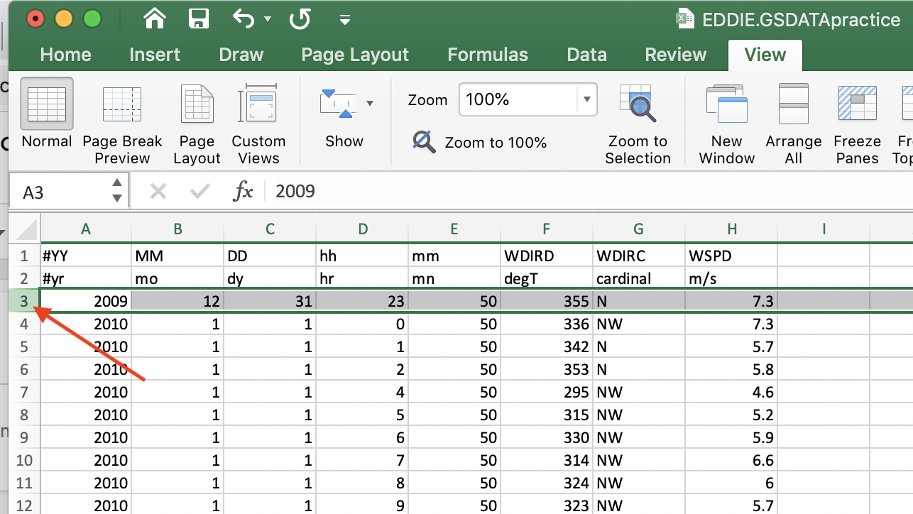
  - At the top click on the “view” tab. Click “Freeze Panes.” This will make it so that we can scroll down without losing view of the headers.
  - Create a table in your Excel sheet near the top that looks like this:

Direction | < 2 | 2 to <4 | 4 to <6 | 6 to <8 | 8 to <10 | 10 to <12 | 12 or greater
N
NE
E
SE
S
SW
W
NW

  - In this table we will put the number of times the wind was blowing from a certain direction at a certain speed. For example, the most upper left corner will contain the number of times the wind was blew from the N direction less than 2 m/s. We are going to fill in these numbers using the “COUNTIFS” formula in Excel. The COUNTIFS formula counts the number of cells that meet certain requirements. Select the cell in the table that corresponds to N <2. Type in the following formula exactly as written: =COUNTIFS($G:$G, “N”, $H:$H, “<2”). Then hit tab or enter to finish the formula. An example of this is shown below. The = at the beginning tells Excel that this is a formula that Excel needs to execute. The ‘$G:$G, “N”’ tells Excel to find cells in column G that have the letter N in them. The ‘$H:$H, “<2”’ tells Excel to find cells in column H that have values of less than 2. Excel will count the number of cells that meet both of these criteria and put that number in the N <2 cell in the table. It may take a minute for Excel to do this. You should end up with the number 74. If your number is different or you receive an error message you probably typed the formula in wrong.
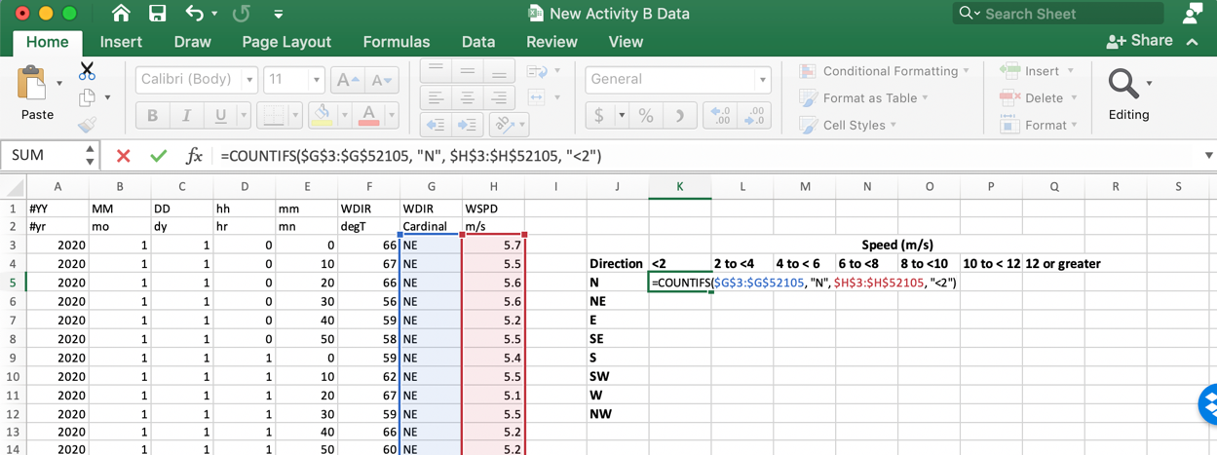
  - Now we will do the same thing for the cell N 2 to <4. In that cell type in the following formula: =COUNTIFS($G:$G, “N”, $H:$H, “>=2”, $H:$H, “<4”). In this case there are three arguments: 1) find all of the cells in column G with the letter N in them, and 2) all of the cells in column H greater than or equal to 2 (<=), and 3) all of the cells in column H less than 4. Excel will only count the cells that meet all of these criteria. You should get 153 as the number for this cell. If you get a different number or receive and error message you probably typed in the formula wrong.
  - Now we need to fill out the rest of the cells in this row of the table. There is a faster way to do this rather and retyping the formula each time. Copy the formula from cell N 2 to <4 and paste it into each of the remaining cells in this row. Then simply modify the formula for each specific cell. For the cells N 4 to <6, N 6 to < 8, 8 to < 10, and 10 to <12 you only need to change the numbers in the formulas to select for the new wind speeds you want Excel to search for. For the last row (12 or greater) you need to delete one of the wind speed arguments and change the other to just select for wind speeds equal to or greater than 12.
  - Now it is time to fill in the rest of the table with formulas to count the rest of the wind speed/direction combinations. Again, we can use the copy/paste function in Excel to maximize our output while minimizing our effort. Copy all of the formulas the N row in Excel and paste them all into the NE row below it. An example of this is shown below. Then go into each formula and just change “N” to “NE”.
To Copy:
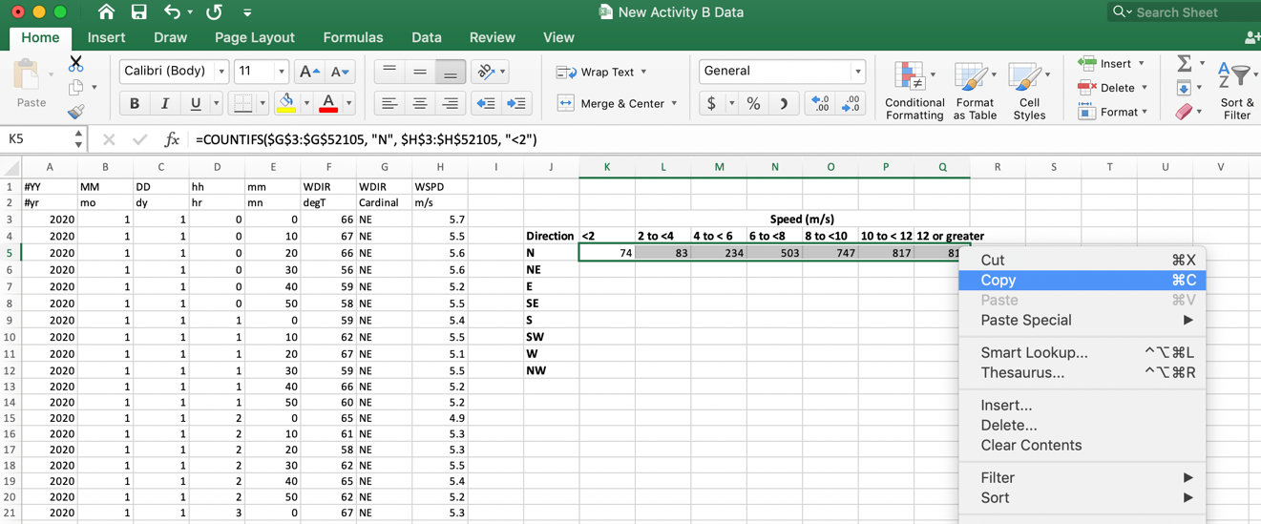
To Paste:
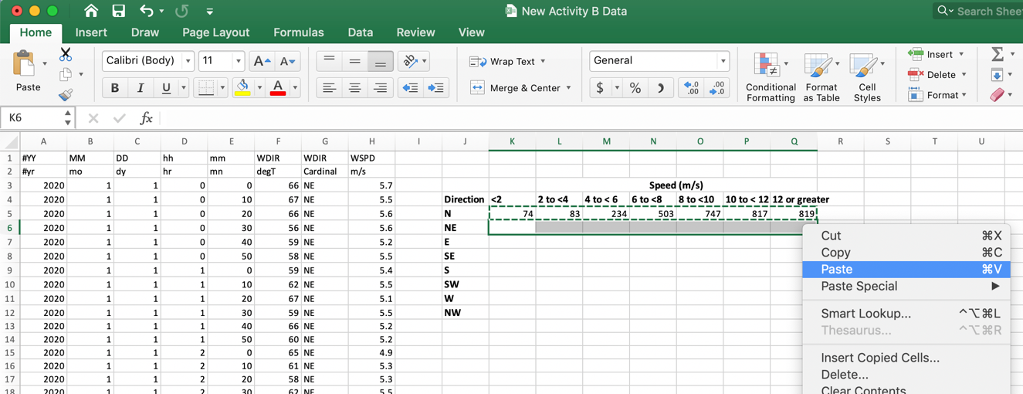
  - Fill in the rest of the table by copying and pasting down the formulas then modifying them as needed. This should quickly fill in the values of your entire table.
  - You will now use the radar plot function in Excel to make your wind rose plot. Under the top tab “Insert” find the wind rose plot.

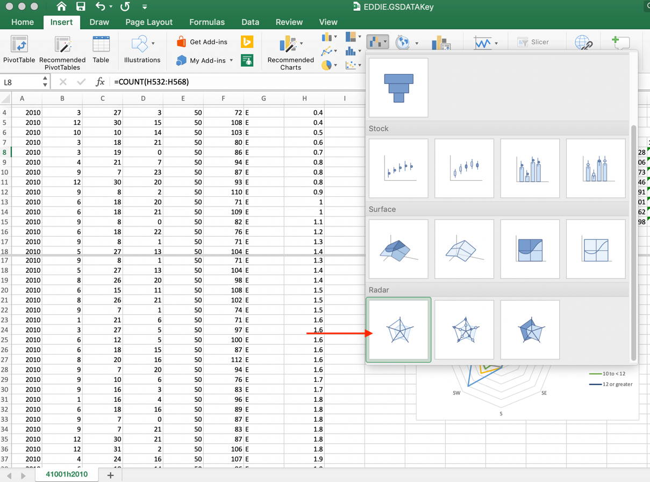
  - A new blank rectangle will appear. Right click on the rectangle. If you are using a mac you can hold down “control” when clicking the mouse to do the same thing. A dialogue box will appear. Click on “Select Data”.
  - A new dialogue box will appear. Underneath the blank box called “Legend entries (Series)” you will see a “+”. Click the “+”. A box called “Name” will appear on the upper right. Click the blank box so that a blinking cursor appears there. Then in your table in Excel click “<2”. Below that box there will be a box labeled “Y values”. Highlight the data below “<2” in your table.
  - Repeat step “p” to add all of the windspeed data to the dialogue box.
  - With the dialogue box still open click on the box labeled “Horizontal (category) Axis Labels”. Highlight the wind directions in your table in Excel. Click “OK”. Your wind rose plot is done!

6. Look at your wind rose plot. Describe the most common directions that the wind blows and the most common wind speeds:
____________________________________________________________________________________________________________________________________________________________

7. Now look at this live graphic of the Gulf Stream: Earth Null Data
This is a live 3-hour loop of the Gulf Stream. The Gulf Stream is the yellow-red current of water off of the east coast of the US. Look at the Gulf Stream off of the coast of Florida where it originates. Does the direction of your wind data match the direction of the Gulf Stream? If not, how do the directions compare? Remember the wind rose shows the direction wind is blowing from.
____________________________________________________________________________________________________________________________________________________________

8. You have stumbled across an important oceanographic concept called Ekman transport. Due to the spin of the earth, in the Northern Hemisphere, water is deflected (flows) to the right of the wind blowing above it. In the southern hemisphere water is deflected to the left of the wind blowing above it. How is Ekman transport represented by your wind data and the Gulf Stream? Be sure to consider that the location continent of North America may also influence the Gulf Stream.
____________________________________________________________________________________________________________________________________________________________

It is important to note that ocean circulation is very complex and driven by a multitude of forces. Ekman transport is the most important factor. However, it does not drive all ocean currents and circulation.

Part C: How does wind impact upwelling?

In this section we will explore upwelling. Upwelling a process that occurs at various locations in the ocean including eastern boundary currents and the equatorial Pacific and Atlantic. Upwelling occurs when deep cold nutrient rich water is brought to the surface of the ocean when surface water is displaced somewhere else. The nutrients in upwelled water serve as food for microscopic organisms called phytoplankton, causing them to use chlorophyll of photosynthesize and grow, a process called primary production. Complete the activity below to explore how wind is involved in this process.

For this activity you will explore data from Monterey Bay, California. Click on this Earth Null Map to see the location of Monterey Bay and the current wind conditions. You will use buoy data from the same database and format as you used in activity B. However, this data was collected from a buoy located in the middle of Monterey Bay and consists of the entire year from 2010. In addition to the data provided in the previous activity, this data also contains the water temperature (denoted as WTMP) in Celsius. The excel file with the data will be provided to you. You will first identify an upwelling event. Then you will compare a wind rose plot from the upwelling event to a time when upwelling was not occurring.

- The first thing you will need to do is to check the data for errors. Sometimes an instrument on the buoy will stop working momentarily or for up to weeks at a time. When an instrument malfunctions the numbers “999” will occur where the data will be. This is not a realistic water temperature since water boils at 100 degrees Celsius, liquid water does not exist at this temperature. Go through the column with the water temperature data (WTMP) and delete any entries that show “999” or “999.0”. You can delete the entire row by right clicking on the number of the row and selecting “delete.” Alternatively, if you do not have the option to right click on your computer, such as on a Mac laptop, you can delete the entire row by holding down “control” then clicking on the number of the row with the track pad. A menu should pop up, which you can then select “Delete” from.
  - Note: The easiest way to do this is to sort excluding the first and second rows (the headers). To do this, highlight ONLY the data in the column, not the headers, then go to SortSmallest to Largest (or Largest to Smallest, either is fine).
  - Then you can easily delete all the entries for “999” or “999.0.”
- There can also be issues with the wind direction. In the case of wind direction “N/A” will show up under the cardinal wind direction. Go through and delete any entries that show “N/A” in the column representing cardinal wind direction.
- Now you will create a line plot of the water temperature to identify when an upwelling event occurs. Highlight the date from the columns that show the date & time and the water temperature as shown below.
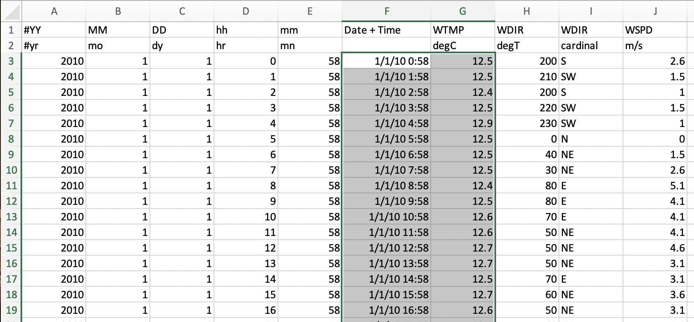
- Now create the line plot. At the top select the tab insert. The select the line plot option as shown below.
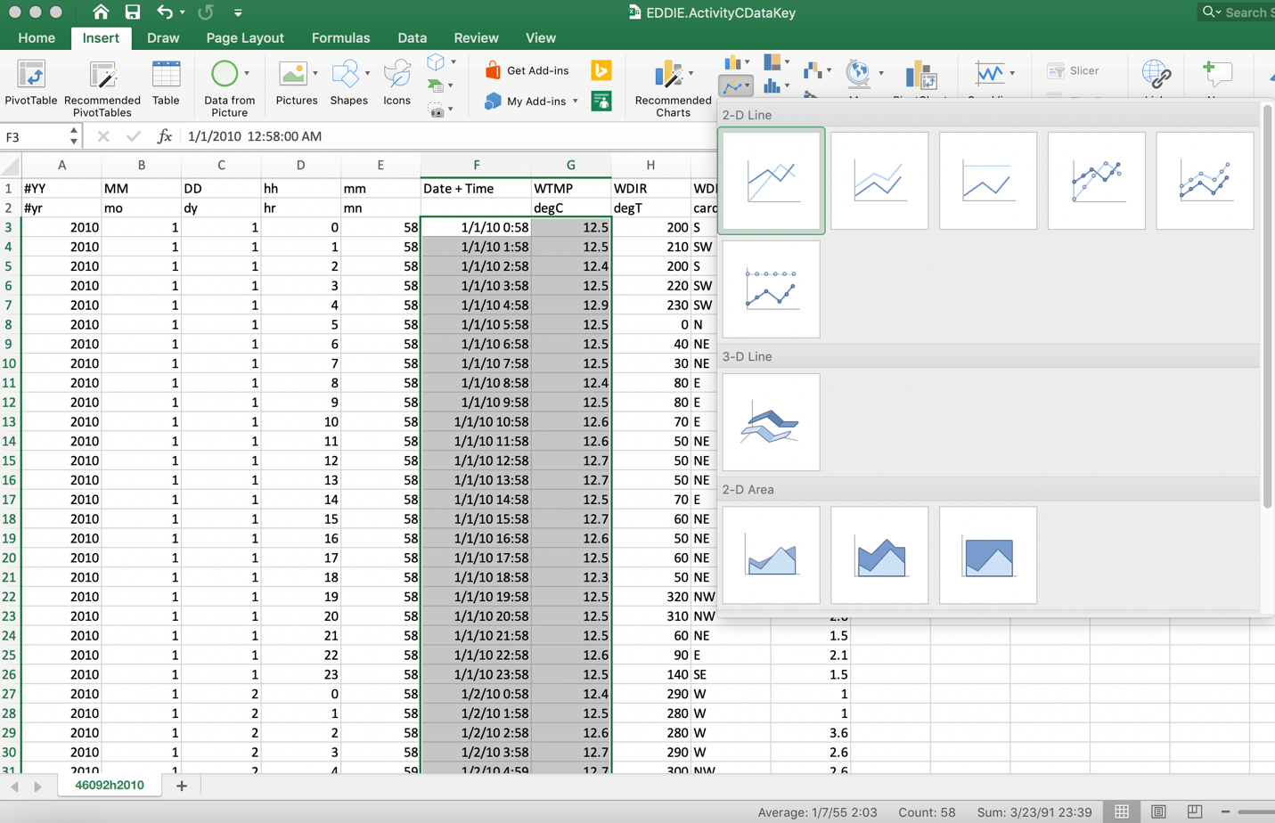
This will create a line plot where time is on the x-axis and water temperature is on the y-axis. Most upwelling events occur during a time of year when the water temperature decreases for a prolonged period of time. Looking at the line plot, in what months is upwelling most likely to occur? __________________________________________________________________________________________________________________________________________________________________________________________________________________________________________.

You should pick a single upwelling event from one of these months. To find an upwelling event look for a sharp decreased in the water temperature. This decrease in temperature will probably occur over a period of a few days and will last a few days to a few weeks until the water temperature warms again. You can hover your cursor over the line to see what date these upwelling events correspond to. Find the ending date of an upwelling event and write that date here: _______________________________________________________________________.

- You will use the 2 weeks prior to this date to create a wind rose plot. Scroll down to the 2 weeks of data you plan to use. Copy and paste the data for the 2-week period you chose to represent upwelling into a different area of the sheet or into another sheet.

- Now you will need to find a 2-week period when no upwelling occurred to compare your upwelling data to. Go back to your line plot and pick a 2-week period from the months when upwelling was NOT occurring and that a singular upwelling even did NOT occur. This will be anytime that the water is generally warmer. Write the dates of that period here: _______________________________________________________________________.

- Go back to the wind direction data for that 2-week period. Copy and paste the data for that 2-week period into another part of the sheet or a new sheet to work with.

- Now create 2 wind rose plots. One wind rose will be made from the 2-weeks of data when upwelling occurred, and the other wind rose will be made from the data of when upwelling was not occurring. Follow the directions in Part B for making a wind rose in Excel. You may find it easier to copy and paste just the data you are working with into another sheet of your Excel spreadsheet. You can make another sheet by clicking the “+” at the bottom of the sheet. Be sure to add a legend and to account to wind speed in addition to wind direction when analyzing the data.

- Compare your wind rose plots. What is the dominant wind direction in each plot? How does the wind direction of upwelling and non-upwelling times compare?
__________________________________________________________________________________________________________________________________________________________________________________________________________________________________________.

- According to Ekman transport during an upwelling event what direction should the surface ocean water flow during an upwelling event?
__________________________________________________________________________________________________________________________________________________________________________________________________________________________________________.

- Given what you now know about upwelling and Ekman transport. How does wind direction drive upwelling in this location?
__________________________________________________________________________________________________________________________________________________________________________________________________________________________________________.

Part D: How does wind impact ocean ecosystems?
In this part of the assignment, you will continue the case study of Monterey Bay by visualizing an upwelling event with satellite data. You will then use this visualization to describe how the upwelling event impacts the ecosystem in that area. Remember that upwelling events bring nutrient-rich cold water to the surface which phytoplankton use to grow and photosynthesize.

- Navigate to ArcGIS Online and sign in with your account. THIS IS IMPORTANT! The layers will not pop up if you are not signed in! Information on how to access your ArcGIS online account will be provided by your instructor.

- Once you are logged in, click on Map.

- Next click on Add, then select Browse Living Atlas Layers.

- Search for Sea Surface Temperatures (°C) (this should be a layer created by ESRI.

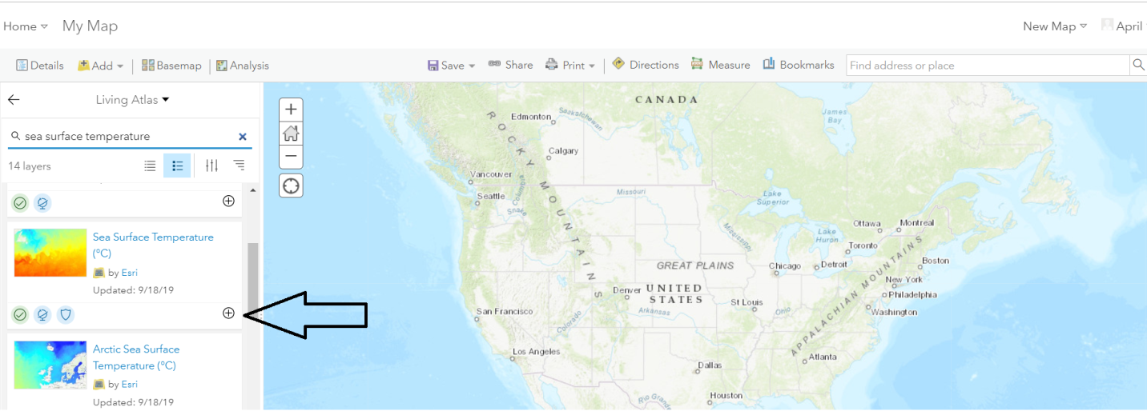

- When you locate the layer, click the + sign.

- Next, search for chlorophyll. Again, this is a layer created by ESRI.

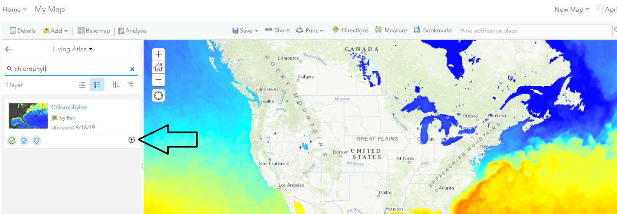

- When you locate the layer, click the + sign.

- Now we have added all the layers we need for our map.

- Next, search for Monterey Bay, CA, USA in the Search box at the upper right of the screen. Zoom to this area. Be sure to zoom in to Monterey Bay the amount shown in the image below. The outline and shape of Monterey Bay should be clearly visible. 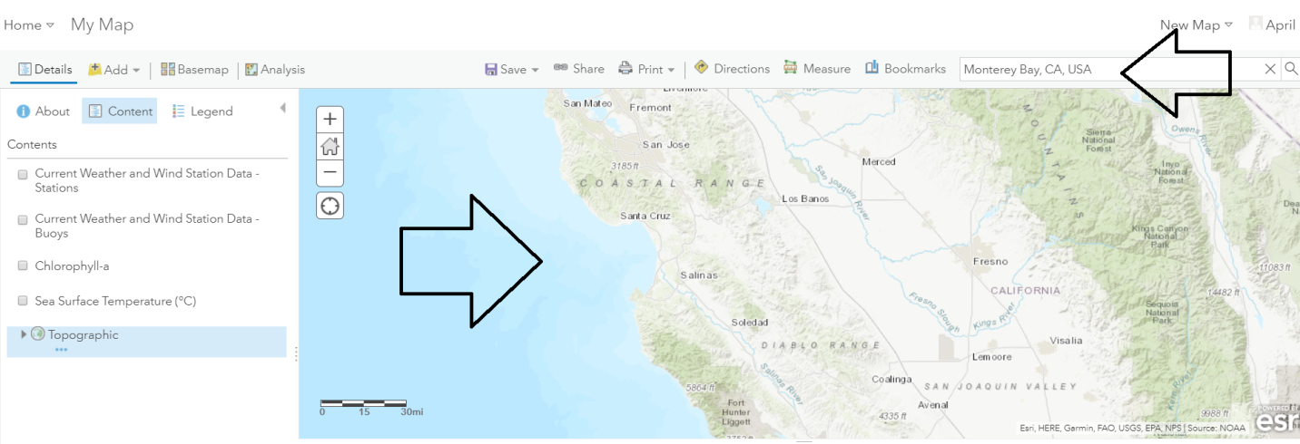
- It might be easier to turn off your layers temporarily to see the bay. To do this, click the arrow to exit the Living Atlas layers search and then click on Content. Uncheck the boxes to turn the layers on and off.
  - 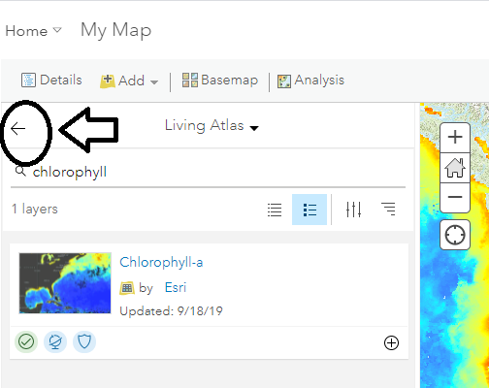
  - 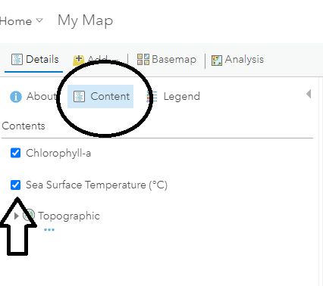

- Now we want to view the upwelling events. For this exercise, we are going to look at temperatures and chlorophyll to see when upwelling occurs. To do this, we need to manipulate the time series visible on our map. Note: time is automatically enabled for these layers. If for some reason you do NOT see a time slider on your map, go to the More Options for the Sea Surface Temperature layer, and select Enable Time Animation.
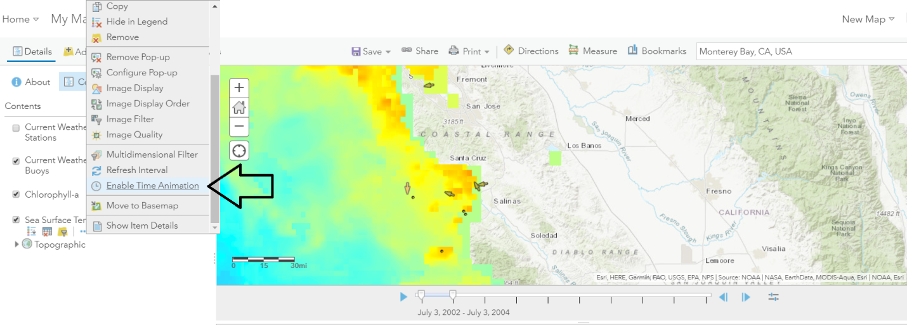
Notice the time slider at the bottom of the image.

- Let’s start with Sea Surface Temperature. Under the Sea Surface Temperature layer, hover your mouse under the layer, and then click on Show Table. This makes the attribute table visible.

- Notice in the table there is a column entitled “Standard Time.” Click on the column header and sort Ascending, then sort Descending. This will show you the range of time data available for the temperature layer. What is year range for the data? ______________________________________________________________________________.

- We want to focus on the year 2010. Notice there is a time scale at the bottom of the map. Click on the symbol that looks like a slider, then click Show Advanced Options.
  - 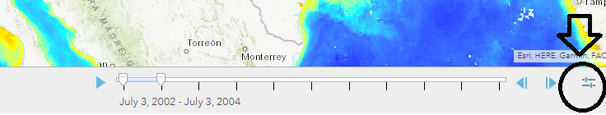
  - 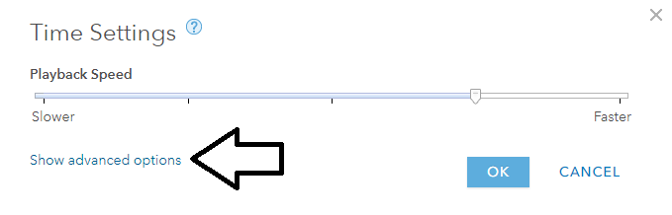

- Now we will change the time range that the time animation will show. Set the Start time to 1/1/2010 and End time to 12/31/2010. Set the time display to Count 1, interval Week. Then click Ok. 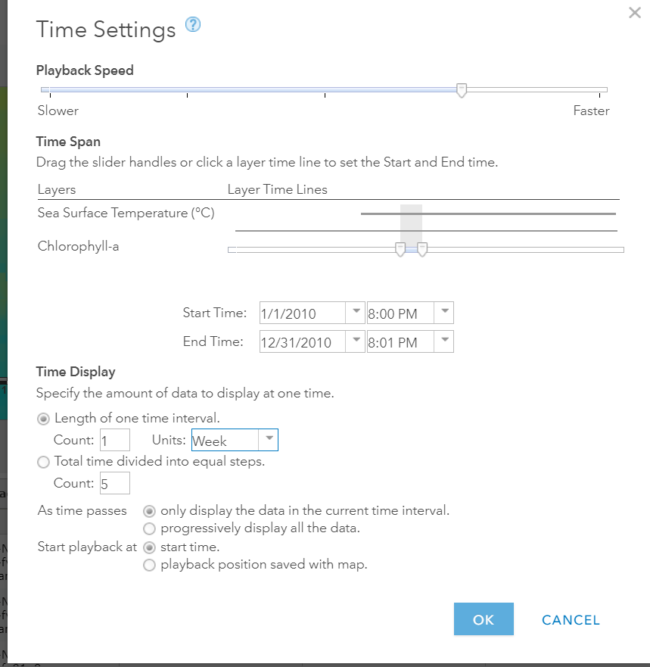

- Turn off your chlorophyll layer so the temperature layer is more apparent. Click on the Legend Tab so that you can see the legend for the temperature layer. Notice on the slider there is a play button. Hit play. Watch the sea surface temperatures change throughout 2010. What two week period are the temperatures in the bay the coolest (should appear blue)?___________________________________________________________________________________________________________________________________________

- Now we want to visualize an upwelling event. Click the Content tab again and turn off temperature and turn on the Chlorophyll layer. Click on Show Table to show the chlorophyll table. Once again we want to see the date range for the layer. Sort the Date layer ascending and descending. What is the year range for this layer? ______________________________________________________________________________.

- Follow steps 14 and 15 to change the range on our time animation from January 1st, 2010, to June 30th, 2010. Keep our time display count as 1, and the interval as weekly, then hit OK.

- Follow step 16 (except turn off temperature instead of chlorophyll) to view the changes in chlorophyll count in the winter/spring range for 2010. At what point are chlorophyll counts the highest (should appear dark red)? ____________________________________________________________________________________________________________________________________________________________.

- Describe how wind direction influences primary production. (Upwelling is an important factor to consider as part of this answer.) ________________________________________________________________________________________________________________________________________________________________________________________________________________________________________________________________________________________________________________________________________________________________________________________________________________________________________________________________________________________________________________________________________________________________________________________________________________________________________________.

- (Optional Question Depending on Class) Do some research on what organisms eat phytoplankton. How will the increase in phytoplankton due to upwelling impact larger organisms?
______________________________________________________________________________________________________________________________________________________________________________________________________________________________________________________________________________________________________________________________________________________________________________________________________

