Project EDDIE: WIND AND OCEAN ECOSYSTEMS
Instructor’s Manual

Overall description:

This module seeks to teach students about Ekman transport, upwelling, and the connection of physical processes to marine biology through an inquiry-based approach. It also introduces students to interpreting wind roses and satellite data.

Pedagogical connections:
Phase | Functions | Examples from this module
Engagement | Introduce mapping, wind rose plots, upwelling, and the importance of wind and ocean currents for ocean ecosystems. | Small group discussion. Introductory lecture.
Exploration | Engage students in inquiry using authentic data. | Exploring ocean buoys. Understanding what data is collected by NDBC.
Explanation | Utilizing additional information to allow students to visualize and conceptualize wind and ocean movement. | Examining the relationship between wind direction and wind degrees. Observing the connection between wind direction and ocean current.
Expansion | Build upon students’ understanding of ocean and wind circulation to visualize and conceptualize upwelling events. | Expanding the spatial/temporal understanding of ocean/wind currents to other geographic areas and understanding how these impact ocean ecosystems.
Evaluation | Assess students’ understanding via checkpoint questions as well as summative information. | Checkpoint questions throughout the activities as well as wrap-up discussion and results questions.

Learning objectives:
- Students will be able to generate a wind rose plot in Excel.
- Students will be able to explain how wind direction and strength influence physical and biological ocean processes.
- Students will be able to find a location on a map using latitude and longitude.
- Students will be able to explain the relationships between wind bearing and direction.
- Students will be able to convert between wind direction in degrees and wind direction using the cardinal and ordinal directions.
- Students will be able to interpret a choropleth map.
How to use this module:
This module can be adapted depending on the level of the students and the length of the class. Instructors can choose to skip Activity A if students are proficient in using latitude and longitude. Instructors can also choose to skip Part B in which students convert between wind direction in degrees and wind direction in the cardinal/ordinal directions. Activity A and B together can be completed in one 3 hour lab period or two 50 minute lecture periods for introductory or intermediate level students. Activities C and D can be completed in one 3 hour lab period. Optionally, instructors could also assign Activity A and Activity Part 1 as homework, and have the students complete the rest of Activity B, Activity C, and Activity D in class.

**Activity D requires an ArcOnline account. To access the appropriate layers will need a paid account. Many schools have access to these accounts. However, Activity D is designed to be supplemental to Activities A-C, which contain the core content. The main ideas of this module can be completed without completing Activity D. ArcOnline is completely in the browser and can be used on tablet such as an iPad.**

Quick overview of the activities in this module
- Pre-module work: Create an account with ArcGIS online,
- Activity A: Find latitude and longitude of buoys from the NOAA National Data Buoy Center in the Northwest Atlantic Ocean and plot the buoys on a handout.
- Activity B: Create a wind rose plot in Excel of wind direction and strength of a specific buoy in the Gulf Stream.
- Activity C: Identify and upwelling event using ocean temperature data and create wind rose plots of winds associated with upwelling and non-upwelling events.
- Activity D (Optional): Create a choropleth map time series of ocean temperature and MODIS chlorophyll data of upwelling and non-upwelling events to determine how wind-induced upwelling impacts the biota of an ecosystem. This activity requires an ArcGIS Online subscription.

Workflow of this module:
- Assign any pre-class readings. These are fairly introductory/general level, so these may not be appropriate for upper level classes.
- Give students their handout when they arrive to class
- Instructor gives brief Power Point presentation with background material. Discussion of the readings can be integrated into this presentation or done before. There are notes in the Power Point presentation.
- Students can then work through the module activities.
- We suggest having the students complete Activities A and B before they read the peri-/post-module readings. This gives students the opportunity to ‘discover’ the concepts first before they read about them.

Potential Pre-module readings:
Wind driven circulation: http://www.stccmop.org/files/Wind%20Driven%20Circulation.pdf
Ocean Circulation (includes short video): https://oceanservice.noaa.gov/podcast/apr14/mw123-currents.html
Interactive wind rose generator where students can find wind data and generate wind roses automatically: https://www.climate.gov/maps-data/dataset/worldwide-wind-roses-graphics-and-tabular-data

Wind: https://www.nationalgeographic.org/encyclopedia/wind/

Potential peri-/post-module readings:
Ocean motion and surface currents: http://oceanmotion.org/html/background/patterns-of-circulation.htm

Module Activities:
Activity A
1. Go to the NOAA National Data Buoy Center, enter in the station IDs in the "Station ID Search". Copy down the latitude and longitude of each station.
Answers:
Name | Latitude | Longitude
Station 44137 | 42.26 | 62
Station 41001* | 34.502 | 72.522
Station 41002 | 31.892 | 74.93
Station 41048 | 31.838 | 69.585
Station 41010 | 28.878 | 78.485
Station 41047 | 27.514 | 71.494
Station SPGF1 | 26.704 | 78.995
Station 44402 | 39.287 | 70.632
Station 44139 | 44.24 | 57.1
Station 44037 | 43.497 | 67.876
* Gulf Stream buoy

2. Plot the stations on a map handout.

3. Compare station locations to ArcGIS online to check locations.

Activity B
1. Practice converting from wind direction in degrees to wind direction in bearing (using the cardinal and ordinal directions).
Answers:
Degrees | Direction
145 | SE
230 | SW
93 | E
3 | N
201 | S
278 | W
112 | E
250 | W
242 | SW
357 | N
315 | NW
33 | NE
153 | SE
296 | NW
181 | S

2. Sort and process buoy data to create a wind rose plot of a buoy station in the Gulf Stream in Excel. There is an instructor key available hidden in the module. Contact the SERC team to get a copy of the key if needed. There is a video of how to do this in Excel in the materials online.

3. Infer how wind speed and direction influence ocean currents through Ekman transport.

Activity C
1. Identify an upwelling event in Monterey Bay, California using a time series line plot of water temperature data collected from a buoy.

2. Create 2 wind rose plots of buoy data from Monterey Bay: 1) a 2-week period of an upwelling event and 2) a 2-week period of a non-upwelling event.

3. Compare the wind rose plots to determine what wind direction and speed induces upwelling.

Activity D
1. Generate simulations of temperature changes and chlorophyll changes in Monterey Bay using MODIS satellite data in ArcGIS online.

2. Watch a simulation of chlorophyll concentrations in Monterey Bay, California from the beginning of the year to the upwelling event, and describe how upwelling influences primary production.

Notes on the student handout:
- The student handout that is included in this module packet was generally designed for an environmental statistics course and to be used in combination with the power point presentation. However, this can easily be adapted for use in a general education, or environmental science, or oceanography course.
- We recommend that the instructor revise the student handout and presentation as appropriate for their own classroom. For example, instructors may want to change the buoy locations if that makes sense for them, change the location of upwelling that students examine, or change the location example used in the presentation for representing degrees, minutes, seconds or decimal degrees. Alternatively, for a more advanced class some material may be removed from the module, such as Activity A or the practice converting wind degrees to wind direction.
- Step by step instructions are including in the student handout for both the wind rose plots in Excel and the mapping visualization in ArcGIS Online. However, if instructors choose, they can remove the step by step instructions.
- One issue students have with the ArcGIS portion is that they may not zoom in enough, and they will produce images like the one shown below. For them to actually see an upwelling event occur in the bay Monterey Bay needs to fill the screen. Make sure students zoom in fully. This is an example of an image that is not zoomed in enough:
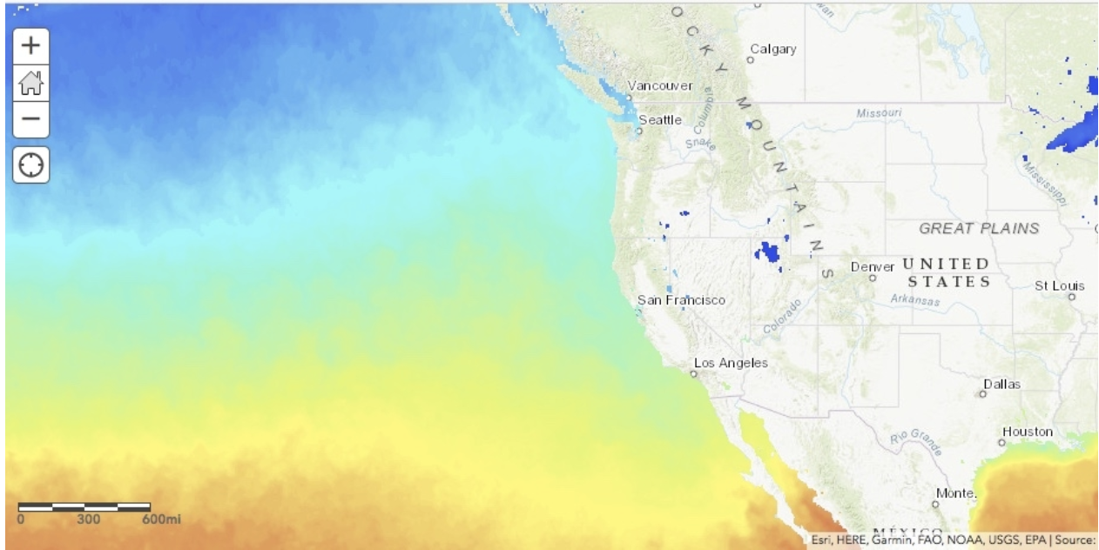
The image below is adequately zoomed in:
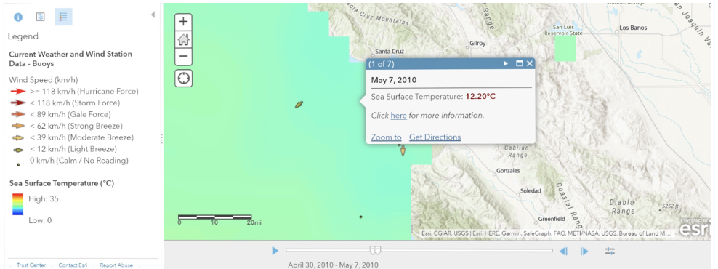
- Some students don’t read wind roses correctly. Consider the wind rose below. This student thought the dominant wind from the NE, because they did not add up all of the lines going to the south. They also failed to put a legend on the wind rose. Had they put the legend on they would have seen that the winds blowing from the south were also the strongest winds. It may be a good idea to check that students are interpreting their wind roses correctly.
- **We highly recommend you have students take screen shots of their wind roses and submit them to you, so that you can look at all of the wind roses together and discuss. Sometimes students may have chosen a bad set of data that might not reflect upwelling the way it is intended in this activity. However, if they look at enough wind roses together, they can look at overall patterns for answering questions 8-10 in Activity C.
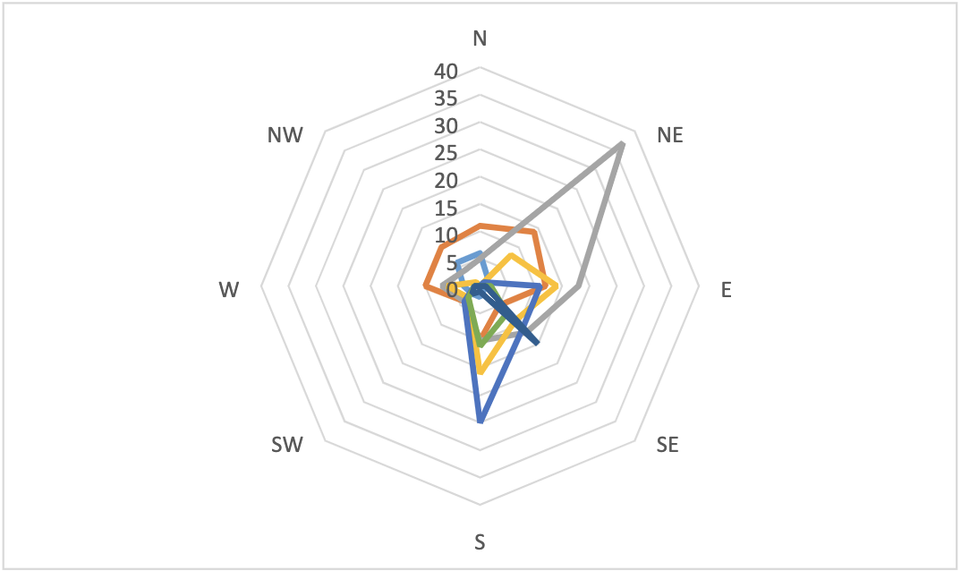
- If students are struggling to see the connection between wind direction and chlorophyll/temperature changes, follow these instructions:
In your ArcGIS Online map, search for layers and search for Buoy 46092. This is a buoy located near the center of Monterey Bay. Click the plus sign to add it to your map.
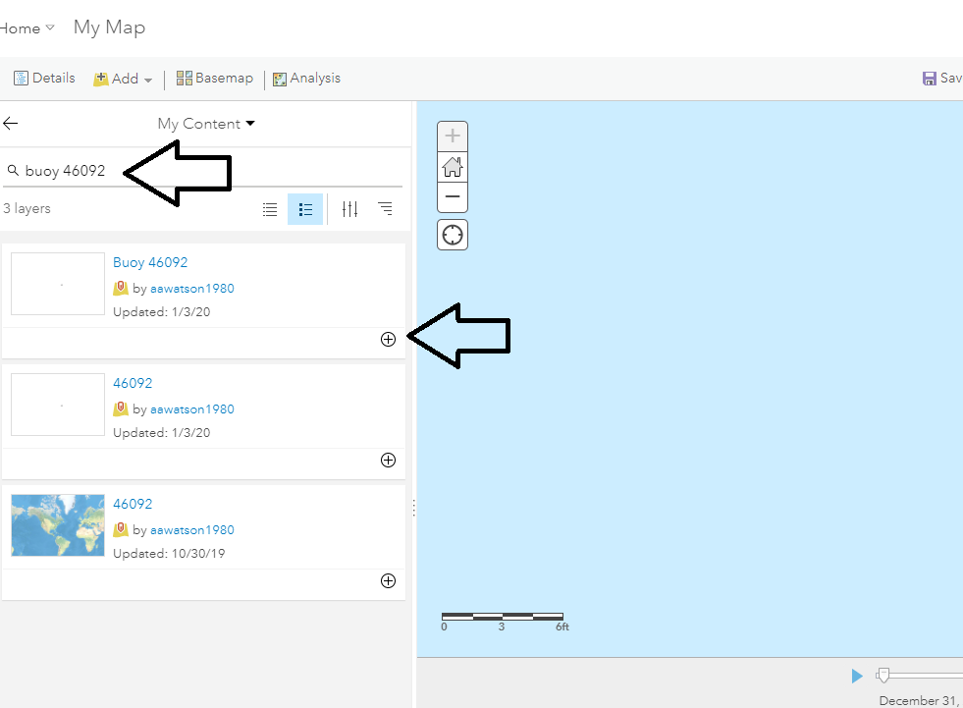

Click on the table symbol under the layer to make the attribute table visible. Notice that time is enabled for this layer as well. Follow the instructions given in the Student handout to adjust the time settings. We recommend displaying the time stops as 1 week as that is the way that the measurements were taken for the buoy.
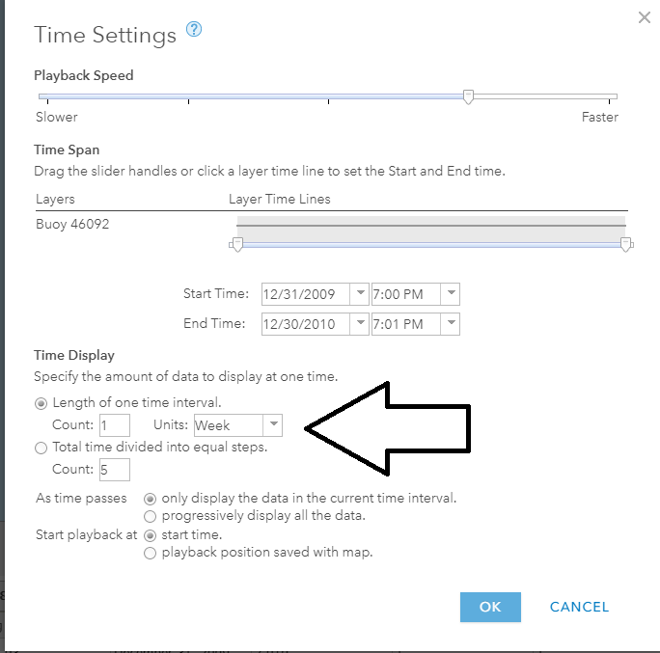

Now we can change the symbology to make the changes in wind direction and speed more obvious, just like we saw in the surface temperature and chlorophyll layers. Click on the change style symbol under the layer name.
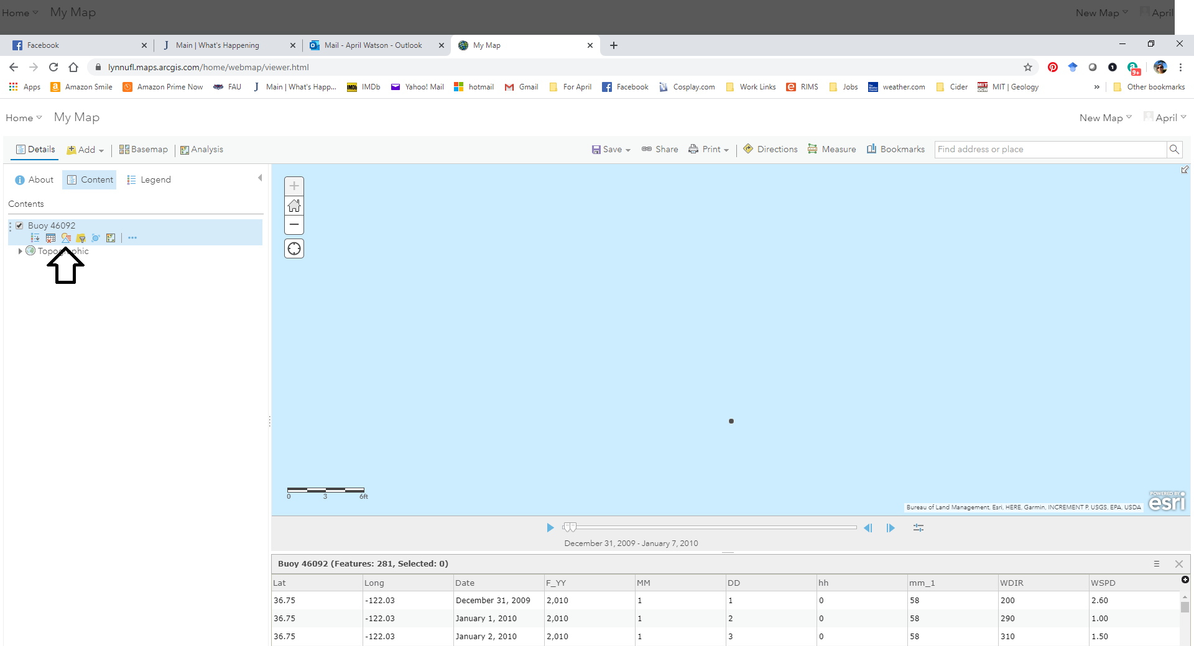

Then in Number 1, choose the attribute to show as wdir (wind direction) or wspd (wind speed). 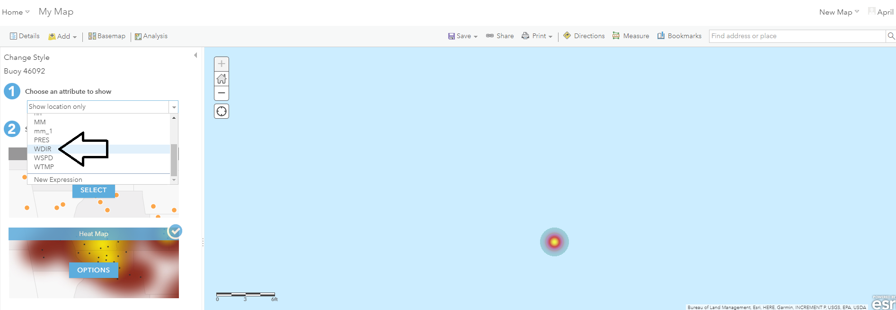
Under Number 2, you can change the symbol to whatever will make the changes most apparent. In the example given here, we chose counts and amounts based on color. Click on options. 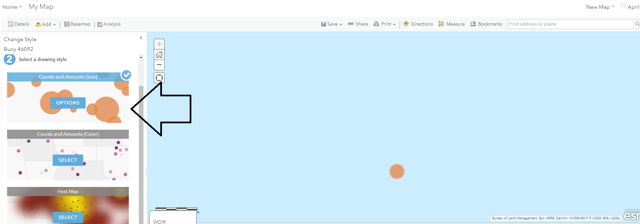Then click on Symbols to change the color ramp, the size of the symbol, or the shape.

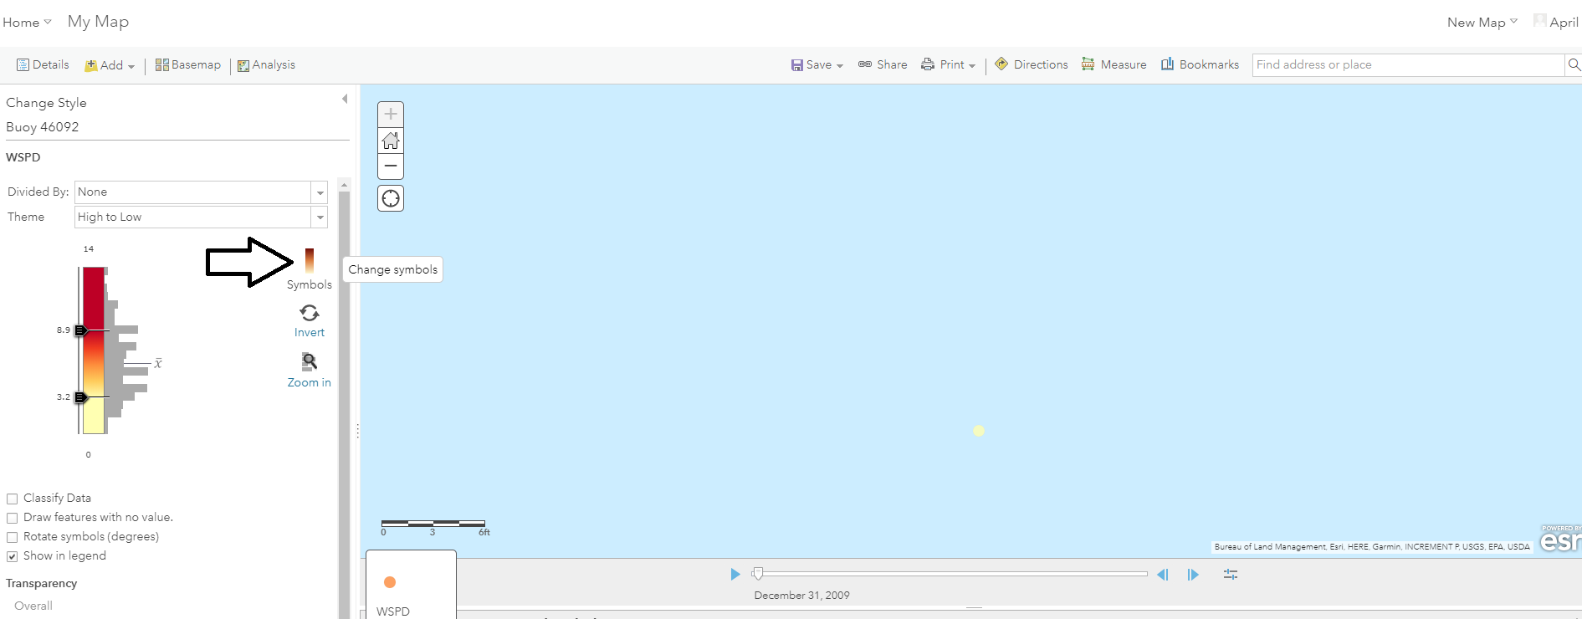

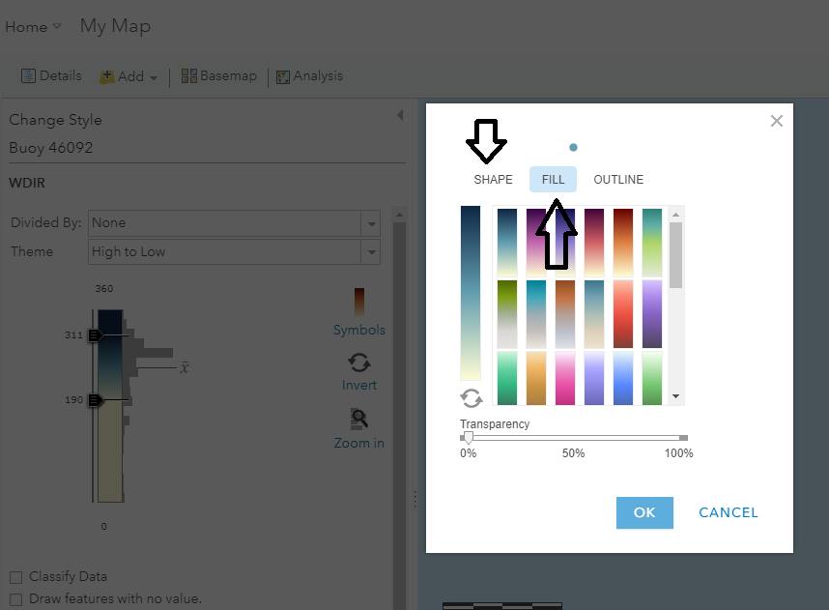

Once you have selected the shape and color combination you want, you can play the time on the Time slider to see the changes to wind direction or speed. Compare this to the changes in temperature and chlorophyll concentrations to see what happens.

Presentation
The notes below apply to the slide within the PowerPoint presentation. They are intended to help the instructor think about the key concepts that students need to know. Instructors should alter this presentation to focus on what’s most appropriate for their classroom.

Degrees, minutes, seconds:
This is for Boca Raton, Florida.
You should feel free to change this to be your location.

Decimal degrees:
Decimal degrees express geographic coordinates as decimal fractions

Wind Rose Plots/custom compass rose diagram:
We created a custom compass rose diagram for this module to eliminate and simplify the wind rose plot that the students will create in Excel. This eliminates some of the ordinal directions (NNE, SSE, etc.). This diagram is shown in the PowerPoint, in the student handout, and the ranges are given in both places.

Using Satellite Data:
Part of remote sensing
We gather images of the Earth in order to ask a number of different scientific questions
How is the Earth changing?
What are patterns of heat on the Earth’s surface?
What concentrations of algae on Earth?
What percentage of the Earth’s ice has melted?
AND MORE!
How do geographers use satellite data? This can be used in a WIDE variety of ways and settings. Depending on the specific classroom setting/student levels, instructors may choose to include more background context on satellite imagery. We specifically choose to limit our explanation to the MODIS satellite, which is the satellite being used for the chlorophyll layer in Activity C. Sea Surface Temperature data is being taken from the Advanced Very High Resolution Radiometer (AVHRR), the Advanced Microwave Scanning Radiometer for EOS (AMSR-E), and the Geostationary Operational Environmental Satellite (GOES) Imager (https://podaac.jpl.nasa.gov/dataset/NAVO-L4HR1m-GLOB-K10_SST). Instructors may want to expand on the different types of satellites, and the different satellite products.

