Project EDDIE: Biomes, Vegetation Structure, and Canopy Height

Student Handout (Activity A): Does annual precipitation and temperature accurately predict the presence of biomes at particular locations?

This module was initially developed by Mulcahy, M. 10 February 2022. Project EDDIE: Biomes, Vegetation Structure, and Canopy Height.

Learning objectives – Activity A:
- To understand and appropriately use the terms “biome” and “land cover”
- To use temperature and precipitation data to predict an expected biome using the Whittaker biome diagram
- To verify biome vegetation predicted by the Whittaker biome diagram with the data-determined vegetation types documented on the homepages for the NEON core terrestrial field sites
- To identify factors, other than precipitation and temperature, that might determine biome and land cover
- To propose explanations for why grasslands are generally found in low precipitation conditions, while forests are found in higher precipitation conditions

Recommended Video:
NEON begins to monitor changing ecology of the U.S. NSF. https://youtu.be/DdcBtUCmMuk

Overview:
What is a biome? You have likely encountered the term in your science courses more than once, and it was possibly defined in different ways. Biomes are an attempt by humans to broadly classify or group locations on the Earth by the types of vegetation, the type of animals, and climate characteristics. Many factors that influence vegetation and animal type, but temperature and precipitation are considered especially important in determining whether a habitat is dominated by woody trees, woody shrubs, broadleaf non-woody plants (forbs), plants with a grass-like morphology (graminoids), or other major groups of plants.

In this set of activities, we will be focusing exclusively on terrestrial biomes. Since 71% of the Earth’s surface is covered by water, those aquatic environments are tremendously important in understanding Earth’s biodiversity too. The number of biomes that exist on Earth is debatable. Are there six terrestrial biomes, nine, or even more? Should mangroves and temperate rainforests be included as biomes? There are no right or wrong answers to these questions, and the decision of how many biomes to use depends on the purpose of the classification. At times the term biome may not be adequate, and other terms such as land cover may be more useful than the term biome. In the United States, land cover names have been standardized by the Multi-Resolution Land Characteristics (MRLC) Consortium into a set of National Land Cover Database (NCLD) classes. NCLD classes are determined using remote sensing data from Landsat satellite images. NCLD classes are similar to biomes, but they include more than just wild and natural categories of vegetation. NCLD classes include additional classes that are relevant to developed areas with human components such as cultivated farm fields, and buildings and houses, among other features. The NCLD classes use somewhat different terminology than classic biomes names. For example, there is no “tropical forest” nor “rainforest” nor “boreal forest” in the NCLD classes, instead all these forest types are lumped into “evergreen forest.”

The dataset used in this activity comes from the National Ecological Observatory Network (NEON) which is a large, long-term ecology project. This open-science project attempts to collect high quality and reliable ecological data from across the entire United States, and to make that data freely available to anyone who might need to use it. To ensure highest quality and consistency, a network of NEON scientists have carefully-developed sampling procedures, which are standardized at all the sites.

The core terrestrial sites in the NEON project are generally located in undeveloped (wild or natural) locations. Each field site has its own URL where the NCLD class for the NEON sites are listed. These NCLD classes are based on data from satellite images of land cover as well as confirmation by scientists at the sites. In this activity, you will see if Whittaker’s classic biome diagram agrees with the satellite-determined NCLD classes. The activity will also give you an opportunity to explore details of some of the interesting field sites established by the NEON project.

Outline:
- Use Whittaker’s Biome Diagram to make predictions of what biome to expect at selected field sites for the NEON project
- Verify the accuracy of Whittaker’s prediction using the NLCD classes (determined by satellite imagery) documented on the NEON field site homepages.
- If there are any mismatches between the biome expected and the biome documented, propose possible explanations for the mismatch

Directions
Your instructor will guide you on whether the assignment is to be completed online or on paper
- Use the Whittaker Biome Diagram and complete Table 1 with the biome you would predict at each location based on temperature and precipitation levels. Do your best to estimate where on the graph the precipitation and temperature values fall. Select two additional field sites from the entire list of all sites for the last two rows of the table.
- Determine the accuracy of your Whittaker-biome predictions by visiting the homepages for the NEON core terrestrial field sites and recording the NLCD class or classes listed for each site in Table 2. NLCD classes are determined by data from Landsat satellite images with ground verification by field scientists in some cases. Correcting Land Cover Maps for NEON Field Sites

Question Set for Assignment A
- Reviewing Whittaker’s diagram, you will see that grasslands are generally expected to be restricted to low precipitation levels, below 50 cm per year, and that most forest biomes are absent from these same dry/arid conditions. Explain in a short paragraph some of the plant vulnerabilities and adaptations that explain why grasslands often prevail at low precipitation levels while forests of tall trees are more common at greater precipitation levels.

- Did all of your biome predictions from the Whittaker diagram (Table 1) agree with the National Land Cover Database Classes that were recorded by NEON scientists (Table 2)? Propose some reasons for the mismatch between any of the predicted and observed vegetation types.

- Review the information on the NEON pages for one or more of the field sites. List some additional abiotic variables besides temperature and precipitation that are collected by the NEON project that might influence the type of vegetation and the biome at each location.

- Explain how the terms “biome” and “land cover” are similar but not equivalent. If you would like additional information on “land cover,” consider visiting these internet sites: land cover (EPA) and national land cover database class legend and descriptions.

- Consider one of the following three scenarios or create a new unique scenario. Justify whether you would use the term “biome” or “land cover” or both of these terms. Your justification is as important (or more important) than your choice of terms to use.

Scenario 1: You are teaching a high school biology class and you want your students to recognize similarities and differences in flora and fauna globally. Your class will be discussing conservation in the next part of the course. Will you use “biome” or “land cover in your class discussions and why?

Scenario 2: You are on an advisory board for the Nature Conservancy, and you are writing a strategic plan for your organization to help identify, protect, and possibly purchase and restore locally endangered habitat such as tall grass prairie, mangrove, or other special threatened habitats. Your team is utilizing satellite decadal Landsat satellite imagery and associated datasets to help identify plots of land that the organization should seek to purchase and protect. Will you use the terms “biome” or “land cover” in your strategic plan and why?

Scenario 3: You are an agricultural scientist who works at a university. You are writing a grant proposal to seek money to study how climate change will affect the abundance and distribution of suitable land for cultivation of crops to feed humans. Will you use the terms “biome” or “land cover” in your grant proposal and why?

Tables and Figures for Activity A

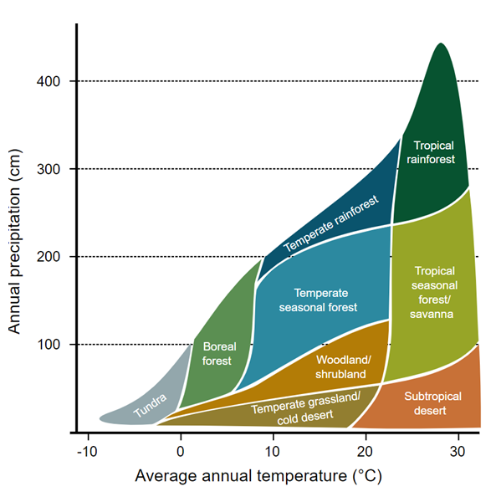
Figure 1. Whittaker’s biome diagram. Navarras, CC0, via Wikimedia Commons

Table 1: Biome predictions based on Whittaker Biome Classification and the average yearly temperature and precipitation. Use Whittaker’s diagram to complete this table. Use the links of all NEON field sites at the end of this handout to add information on two sites of your choice to the table.
Domain | Latitude | Longitude | Average yearly temperature (C) | Average yearly precipitation (cm) | Predicted Biome based on Whittaker’s Diagram
D01 | 42.53691 | -72.1727 | 7.4 | 119.9
D07 | 35.96413 | -84.2826 | 14.4 | 134
D10 | 40.81554 | -104.746 | 8.6 | 34.4
D11 | 33.40123 | -97.57 | 17.5 | 92.6
D14 | 31.91068 | -110.835 | 19.3 | 34.6
D17 | 37.10878 | -119.732 | 16.4 | 54
D20 | 19.55309 | -155.317 | 12.7 | 265.7

Table 2: Land cover at selected NEON terrestrial field sites. Visit the homepage for each field site to complete this table. Use the links of all NEON field sites at the end of this handout to add information on two sites of your choice to the table.
Domain | Homepage of the NEON field site | NLCD class from the NEON page (if there is more than one listed, please list all of them) | Does this “MATCH” or “DIFFER” from Whittaker’s predictions in Table 1?
D01 | https://www.neonscience.org/field-sites/harv
D07 | https://www.neonscience.org/field-sites/ornl
D10 | https://www.neonscience.org/field-sites/cper
D11 | https://www.neonscience.org/field-sites/clbj
D14 | https://www.neonscience.org/field-sites/srer
D17 | https://www.neonscience.org/field-sites/sjer
D20 | https://www.neonscience.org/field-sites/puum

Links to homepages for all the NEON core terrestrial sites:
D01 | https://www.neonscience.org/field-sites/harv
D02 | https://www.neonscience.org/field-sites/scbi
D03 | https://www.neonscience.org/field-sites/osbs
D04 | https://www.neonscience.org/field-sites/guan
D05 | https://www.neonscience.org/field-sites/unde
D06 | https://www.neonscience.org/field-sites/konz
D07 | https://www.neonscience.org/field-sites/ornl
D08 | https://www.neonscience.org/field-sites/tall
D09 | https://www.neonscience.org/field-sites/wood
D10 | https://www.neonscience.org/field-sites/cper
D11 | https://www.neonscience.org/field-sites/clbj
D12 | https://www.neonscience.org/field-sites/yell
D13 | https://www.neonscience.org/field-sites/niwo
D14 | https://www.neonscience.org/field-sites/srer
D15 | https://www.neonscience.org/field-sites/onaq
D16 | https://www.neonscience.org/field-sites/wref
D17 | https://www.neonscience.org/field-sites/sjer
D18 | https://www.neonscience.org/field-sites/tool
D19 | https://www.neonscience.org/field-sites/bona
D20 | https://www.neonscience.org/field-sites/puum

