Global Carbon Budgets

How much carbon is emitted each year due to human activity? How does that number compare to rates of exchange between carbon cycle reservoirs? Where do our carbon emissions go? In this activity, you will 1) evaluate data for the global carbon budget and determine rates of change in carbon emissions, 2) explore changes in carbon cycle sinks over time to investigate where carbon emissions end up, and 3) determine what kinds of rates of change are needed to reduce carbon emissions to zero in the future.

Our overarching goal in this activity will be to better understand carbon emissions goals that are increasingly the focus of climate policy. How likely are we to meet these goals? What is the scale of this challenge?

This activity can be done in any spreadsheet software with which you are comfortable, but there is also an accompanying R script available for those who would like to explore this data using R. Datasets used in this activity are publicly available and provided to you here after some pre-processing.

Part A: How much carbon do we emit from fossil fuels?

The largest source of anthropogenic carbon emission comes from the use of fossil fuels (coal, oil, and natural gas) for energy, industrial processes, and manufacturing. To begin, we are going to explore how much fossil-based carbon we emit each year by looking at global carbon budget data from the Global Carbon Project (https://www.icos-cp.eu/science-and-impact/global-carbon-budget/2021).

- Create a graph of fossil-based carbon emissions over time for the entire period of available data (1959-2020). Your graph should only include fossil-based carbon emissions. Answer the following questions by just visually interpreting your graph:
  - How much carbon did we emit from fossil-carbon use in 2020?
  - What units did you use in your answer above? Be sure to update your Y-axis label. Looking at the metadata available in Appendix 1 below will be helpful here.
  - How much carbon did we emit per year in 1959 (the first year of available data)?
  - What is the average rate of change in fossil-based carbon emissions from 1959 to 2020?

- We could be more rigorous with our estimated rate of carbon emissions over time by fitting a line (a linear model) through the data during different time periods.
  - For example, fit a line through the data for fossil-based carbon emissions for the entire available time period of 1959-2020. What is the unit on the slope? How does that value compare to the rate you calculated without fitting a line?
  - Is the rate of change in carbon emissions getting faster or slower over time? Test your answer by investigating the rate of change in at least two other 20-year windows.

- Aside from carbon emissions, it is probably most common for people to think about changes in the concentration of carbon dioxide in the atmosphere. The most famous dataset for this comes from a monitoring station on Mauna Loa in Hawaii. Concentrations of carbon dioxide are typically expressed as parts per million (ppm).
  - Transform your data for fossil-based carbon emissions to be equivalent to ppm of CO₂ (note: 1 ppm CO₂ is equivalent to ~2.13 Gton C). Create a plot of emissions in ppm of CO₂ equivalents over time. Compare the graph you created with the graph below showing the change in atmospheric CO₂ concentrations each year from the Mauna Loa CO₂ record (original graph available here; https://gml.noaa.gov/ccgg/trends/gr.html). Do the two datasets agree? Discuss your comparison of these two graphs and write a few ideas about why they match or don’t match.
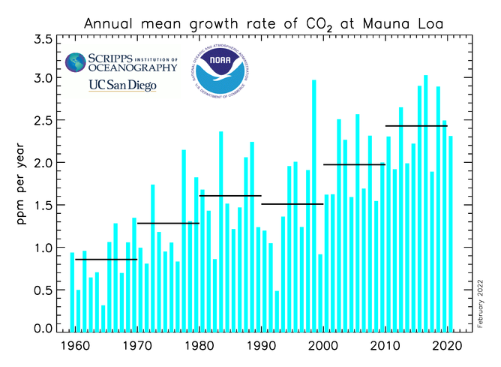

Part B: Where do our carbon emissions go?

This dataset is also helpful for us to begin investigating where carbon emitted from fossil-based fuel sources ends up (i.e., which carbon cycle components “soak up” the carbon that we emit).

- Create a new graph that shows all components of the carbon cycle that are included in the data set over the entire period. Answer the questions again by just visually interpreting your graph:
  - Describe the variables on your graph: which variables are sources of carbon, sinks for carbon, and/or some other component.
  - Write a few sentences to describe the general trends (change over time) in each carbon cycle component in the dataset.

- For all components in the dataset that are “sinks,” calculate the percentage of total carbon emissions that goes to that sink and then plot those percentages over time.
  - Create a plot of these sink percentages over time.
  - Where do carbon emissions go? Describe, using general percentages, where most our carbon emissions end up.

Part C: By how much do we need to reduce carbon emissions?

For a long time, scientists have been emphasizing the need for global carbon emissions to decrease rapidly in order to avoid the worst outcomes of climate change. Recent international reports from the International Panel on Climate Change (IPCC; https://www.ipcc.ch/) emphasize that rapid reductions in carbon emissions are needed to meet internationally-recognized limits on warming. The questions below are intended to give you a sense for the scale of the challenge we face in reducing carbon emissions.

- Calculate total net carbon emissions per year and create a graph of total carbon emissions over time for the duration of the available data. How much carbon do we emit each year (including all sources of carbon emissions, not just fossil carbon)?
- Choose a time period and determine the rate of change in carbon emissions by fitting a line to the data (in other words, what is the slope of that line?).
- Imagine that, starting today, we could magically reverse the rate of change in carbon emissions from the period you picked above and start decreasing emissions by that much every year going into the future. What year would we achieve net-zero carbon emissions?
- Create a graph to show the information you’ve calculated in this part of the activity to include in your write up.
- Finally, estimates from the recent IPCC report suggest that global carbon emissions need to be cut in half by 2030 and should reach net-zero (or even become net-negative) by 2050 in order to adequately limit warming according the international agreements. By how much would carbon emissions have to change over the next 8 years to achieve a 50% reduction?
- Write a paragraph to speculate about how feasible this could be. What types of changes would need to be made? If the carbon cycle were involved in removing some of the emitted carbon, what types of changes would be needed to absorb some of these additional emissions?

Appendix 1. Metadata from the Global Carbon Project for the historical carbon budget dataset used in this lab.

Historical CO₂ budget
All values in billion tonnes of carbon per year (GtC/yr), for the globe. For values in billion tonnes of carbon dioxide (CO₂) per year, multiply the numbers below by 3.664.
1 billion tonnes C = 1 petagram of carbon (10^15 gC) = 1 gigatonne C = 3.664 billion tonnes of CO2
Please note: The methods used to estimate the historical fluxes presented below differ from the carbon budget presented from 1959 onwards. For example, the atmospheric growth and ocean sink do not account for year-to-year variability before 1959.
Uncertainties: see the original papers for uncertainties
Cite as: Friedlingstein et al. (2021; see summary tab)
Fossil fuel combustion and cement production emissions: Friedlingstein et al. (2021)
Land-use change emissions: As in Global Carbon Budget from 1959: average of three bookkeeping models: H&N (Houghton &Nassikas, 2017), BLUE (Hansis, et al., 2015) and OSCAR (Gasser et al., 2020). Cite as: Friedlingstein et al. (2021; see summary tab)
Atmospheric CO₂ growth rate: Joos, F. and Spahni, R.: Rates of change in natural and anthropogenic radiative forcing over the past 20,000 years, Proceedings of the National Academy of Science, 105, 1425-1430, 2008.
The ocean CO₂ sink prior to 1959 is the average of the two diagnostic ocean models: DeVries, T. et al., Global Biogeochemical Cycles, 28, 631-647, 2014; and Khatiwala, S et al., Biogeosciences, 10, 2169-2191, 2013.
The land sink is as in Global Carbon Budget from 1959: average of 17 dynamic global vegetation models that reproduce the observed mean total land sink of the 1990s.
Cement carbonation is the average of two estimates: Friedlingstein et al. (2021)
The budget imbalance is the sum of emissions (fossil fuel and industry + land-use change) minus (atmospheric growth + ocean sink + land sink + cement carbonation sink); it is a measure of our imperfect data and understanding of the contemporary carbon cycle.

