Background reading: Go to the provided link for Hurricane Florence facts and figures to know specifics on the temporal and spatial context of this analysis.
This exercise is divided into four parts:
I: Access, explore and download radar reflectivity data
II: Import, visualize, and export radar reflectivity data using NOAA Weather and Climate Toolkit
III: Add selected radar reflectivity data into ArcGIS and calculate rain-rate
IV: Evaluate the accuracy of rain-rate
Part I:
Go to the NOAA’s website for NEXRAD sites. On the main page, under “Data Access” (the third heading from the top), click “radar data access” that takes you to the page of NEXRAD Data Archive, Inventory and Access.
While on this page, click “Select By Map”. Note that this exercise is for single site and selected dates. On the next page, you will choose Wilmington as your station from the State of North Carolina.
Q.1. How many NEXRAD stations are located in North Carolina? List their names.

Q. 2. How many are located in your home state? List their names.

On the next page, you will read the metadata of this station (Wilmington) and choose the day and product you wish to order.
Right-click and open the Site Metadata link on a new tab and note the following info about this station.
Coverage Date | Principal Name | County, State | NEXRAD ID | Latitude | Longitude | Ground elevation | UTC offset

On the main page NEXRAD inventory (which you have it open in another tab), under period of record, you will notice a gap of data availability between the level II and level III products.
Q. 3: Why level III products are a few days behind? (TIPS: Read relevant part of Meteorological Handbook for the details of radar products).

Q. 4. Find and report the information on spatial and temporal resolution of NEXRAD base reflectivity data.

Now under Examine Inventory, choose the date 09/14/2018 and select Level-II (Base Data) under Choose Product and hit Create Graph button. Once the graph is loaded on the next page, you will see continuous precipitation mode plots until about 20:00 GMT. In the box below the graph, put your email address, change the End Time to 20:00 GMT and hit Order Data. Read the info on order submission page, it provides you the order number starting with three alphabets HAS.
Q. 5: Write your order number. Check with your colleague if individual order has unique order number.

In the meantime, go to the public document folder of your computer and launch the application “wct” which is Noaa’s Weather and Climate Toolkit to visualize and export radar reflectivity data (If it is not installed in your computer, you can download the right version of the toolkit suggested for your computer and install it).
Once your HAS order is delivered in your e-mail, you are ready to import the data into NOAA Toolkit. Your course instructor will show a demonstration with an example data. However, your exercise and answers for the rest of the questions should be from your own data.
In the web download link, check fileList text file.
Q. 6.
a) Copy and paste one file name on your answer document and try to understand what each part of the file name means. Write your best guess here.

b) Generally at what time intervals, the data are filed? (see the list from the top to bottom).

Part II
The data files can be downloaded, saved, and extracted (twice if needed), and imported to the weather toolkit or you can feed your HAS order number directly into toolkit under NCEI/CLASS order field.
The file list in the toolkit shows the same naming format you found in the list of files in fileList followed by Level-II NEXARD Dual Pol.
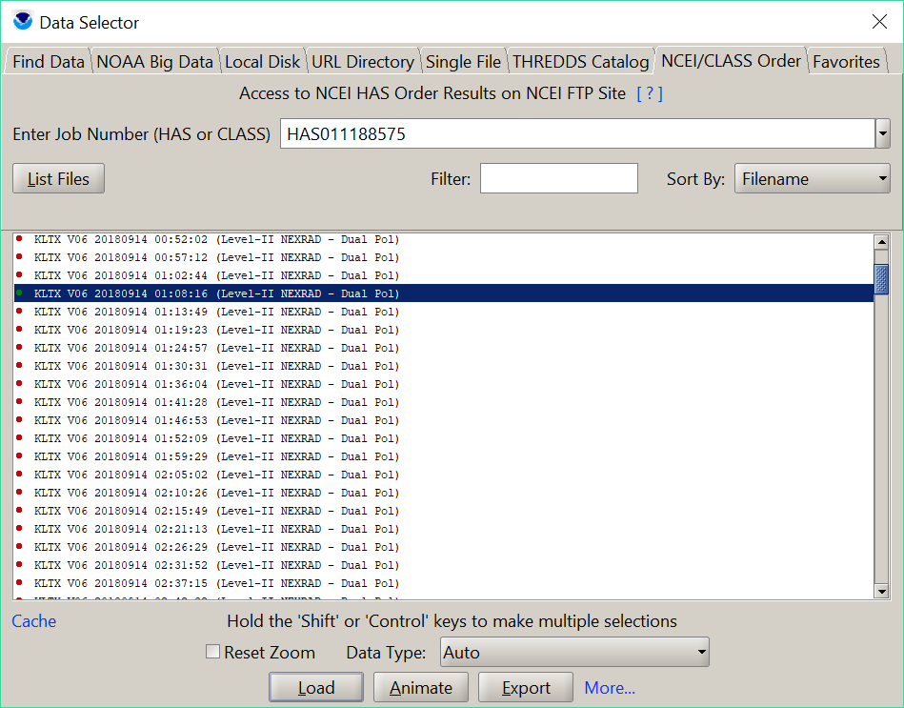
Q. 7.
a) Describe what does dual-pol mean (Hint: search in NOAA radar documentation or meteorology handbook)

Select a file and hit Load in Toolkit. Once a file is loaded, it will show reflectivity image on the map. Note the legend in dBZ.
b) What does dBZ mean? Also note VCP: 212 under the file header description, what does it indicate? (Hint: Read radar reflectivity documentation or meteorology handbook ).

c) Which part of the state of North Carolina (or elsewhere) has the eye of Hurricane Florence from the first (top) and last (bottom) files you loaded? (Tip for instructor: Assign at least two radar sweeps for each student. A student can load a file assigned to them, approximate the location of the eye if there is a distinct one, and provide latitude and longitude of the center of the eye putting cursor at that location and reading Latitude/ Longitude values on the bottom of the viewer window. They can use zoom in/zoom out, and pan as needed).

d) Could you see the eye movement between the two sweeps you loaded? If yes, in what direction?

Select the assigned files to you from the list and Hit export button at the bottom which takes you to an export wizard showing step-by-step progress of your export process. In the first window, select output format as “shape file (point centroid)” and browse for the output directory where you would like for your exported file to be saved. Hit next, Select moment: reflectivity, elevation: lowest angle from the given list in the select variables window. Hit next, Check: lock spatial filter to viewer and engage spatial filter. Alternatively, you can define the coordinates of four corners on the same window if you wish to export for specific area of your interest. Hit next, don’t change anything in the value filter. Alternatively, you can define minimum value (for e.g., 40 dBZ) if your objective is to analyze only high intensity reflectivity. After you hit next button two times, you will be on the review window for you to confirm your export selections. Then hit “start export” which decodes the original data format into the point shape files.
Part III
Q. 8.
a) Import the first point shape file in ArcGIS and present a map of reflectivity using symbology for different reflectivity classes.
In attribute table, “select by attribute” for the “value” “equal or greater than 40”.
b) How many points you have?
Now use minimum threshold as 45 dBZ to make a new selection,
c) how many points meet this criteria?
To those two shape files you exported, add fields in the attribute table to calculate the rain rate using a standard reflectivity-rain rate (Z-R) relationship.
To calculate rain rate of the storm of this scale we will use the following Z-R relationship:
Z = 300R^{1.4}
Where,
Z = reflectivity
R = rain rate (mm/hour)
The steps you take in attribute table calculations are:
- Calculate Z which is (10^(dbz/10))
- Calculate R(mm/hr) which is (Z/300)^0.71
- Calculate R (inch/hr) (Hint: find what conversion factor you need to do the calculation in this field)
d) What data type, precision, and scale you would choose for the added fields in attribute table and why? (TIP: Use ArcGIS Desktop Help to know the properties of a field).

Q. 9.
a) What are the mean rain rates (inch/hr) from your first and last sweeps?
b) Calculate mean rain rate selecting only the reflectivity larger than 45 dbz? Report the new rain rates from those selections.
Check with your classmate to see how the mean rain changed over the period.
c) How did the rain rate changed?

Q. 10. Use symbology (graduated symbol) in ArcMap to display rain rate (from your first sweep). Decide the visualization strategy, i.e. number of classes, symbol type, size, color etc. and prepare a GIS map with US counties added from ArcGIS Online. Insert your map on the answer document.

Part IV
Q. 11. How you can cross check the accuracy of rain rate calculated using the method suggested in this lab? Describe the process briefly and report your accuracy.

Q. 12. Discuss some of the factors that may have contributed to the errors in rain-rate calculated using radar reflectivity.

