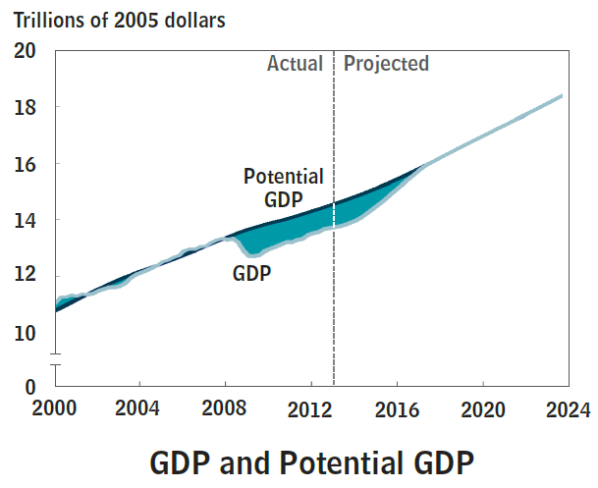

Source: Congressional Budget Office (2013, February). The Budget and Economic Outlook: Fiscal Years 2013 to 2023 (Pub. No. 4649). Washington, DC. https://www.cbo.gov/publication/43907

Image is not copyrighted. The image is government work and for the public domain. The image may be reproduced without permission as long as the Congressional Budget Office is attributed. https://www.cbo.gov/about/privacy

