TBL Application Exercises: International Trade Issues
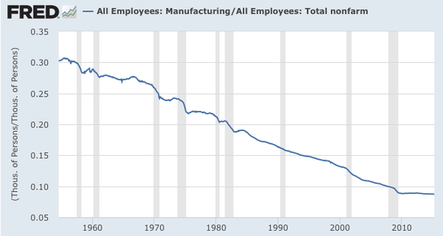
- The graph above shows the percentage of U.S. workers in manufacturing, which has declined from thirty percent of all workers in the 1950s to less than ten percent today. These shifts have been driven by technological change and globalization, with many manufacturing firms finding it profitable to outsource production to other countries where labor is less expensive. Outsourcing has led to complaints from U.S. workers that the government should protect their jobs. What do you think is the best policy approach to outsourcing?
  - Tax U.S. firms that shift production overseas.
  - Require most advanced manufacturing products such as cars and smartphones to be made in the U.S.A.
  - Do nothing.
  - Set up a fund to compensate workers who lose their jobs to globalization.
  - Establish worker training programs to help displaced workers develop new skills and find jobs in other sectors.
- Climate change could lead to the end of the world as we know it, yet the WTO and most trade agreements do nothing to address carbon emissions. What should be done?
- All countries must agree to meet certain carbon standards, which should be uniform worldwide.
- Countries should be on a sliding emissions scale, with poorer countries allowed to have higher levels of emissions and richer countries held to stricter standards.
- Nothing needs to be done internationally; individual countries can determine their own policies.
- A global carbon market should be developed with tradable emissions permits to manage carbon emissions in the most efficient way possible.
- Any trade agreements should include requirements to control or reduce carbon emissions.

