Earth’s Energy Balance

Goals:
After completing this investigation, you should be able to:
- describe how incoming solar radiation is reflected, absorbed, and transferred throughout the Earth system;
- model Earth's energy flow and budget, both qualitatively and quantitatively;
- list the major greenhouse gases and their role in planetary balance; and
- describe the role of the water cycle in maintaining Earth's energy budget.

PART A: Solar Energy and the Water Cycle

1. Relate each part of your model to the water cycle diagram pictured below. For example, the lamp represented the sun. What other Earth system processes were demonstrated in this lab?

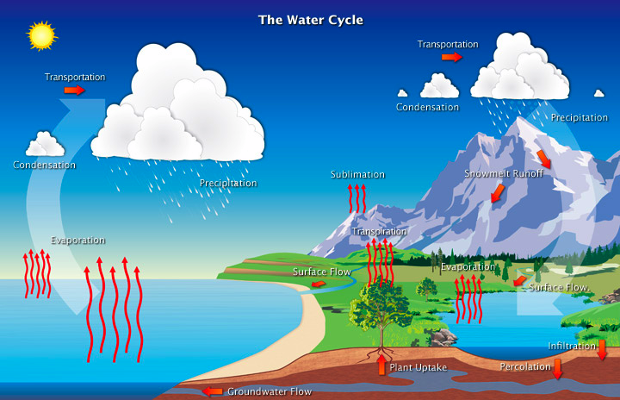

2. What was the energy source for the water cycle?

3. How does the water cycle "transport" energy?

4. What do you think would happen if you added a second or even third lamp?

5. Describe what you think would happen if you left the water cycle in a shoebox in the dark for several hours.

PART B: Following the Energy Flow

6. Now that you have worked through the Earth's energy balance, discuss how changes in Earth's surface characteristics and / or atmospheric composition could contribute to global warming or cooling.

7. Complete the following phrases and add one of your own:

- More radiation = ________________ warming

- Less reflection = ________________ warming

- More absorption = _______________ warming

- ______________ = ________________

PART C: Explore the Greenhouse Effect

8. Complete the table below. Record the average global temperature and each of the Greenhouse gas concentrations.

Year | Temperature | CO₂ | CH₄ | NO₂
1850
Today
2100

9. Why are greenhouse gases (GHG) important to life on the planet?

10. In the simulation, which was the most potent of the greenhouse gases, how did you discover this? (Hint: note the concentrations of the gases.)

PART D: Greenhouse Gas Lab

Analyze your data. Consider the following questions:
11. Describe the general trends that you see in the temperature over time.
  - Did one gas warm more quickly than the others? Was the increase in temperature gradual or were there changes in the slope of the line?
  - Which gas had the greatest change in temperature while heating?
  - How did the cooling of the gases compare to the warming? Which gas appeared to hold the heat the longest of the three that you tested?

12. Recall that temperature is a measure of kinetic energy of molecules. Explain in terms of kinetic energy, why the bottles remained warm after the light source was turned off or the bottles were shaded.

13. How does the composition of the gases in the bottles differ from the composition of gases naturally found in the atmosphere?

14. If you increased the concentration of CO₂ in the bottle, how might this affect the temperature trend in the lab?

15. How do greenhouse gases affect the Earth's radiation balance?

