Hurricane Anatomy

Part B: Types of Satellite Data

Step 1: Satellites and Forecasting
1: The video mentioned that the amount of rain that fell during Hurricane Isabel's lifetime was 400 trillion tons of water. Knowing that a ton is 2000 pounds and one pound is 2.20 kg, how many kg of water is this? (Do the calculation and write your answer in scientific notation.)

2: If we say that the density of water is 1.0 x 10¹² kg per cubic kilometer, how many cubic kilometers of water condensed as rain out of Hurricane Isabel?

3: How does your answer compare to the volume of Lake Superior which contains 12,100 cubic kilometers of water?

Step 3: Rainfall from Hurricane Wilma
4: Why does there seem to be less cumulative rainfall during the time Wilma is traversing the Florida peninsula than when it was in the vicinity of the Yucatan Peninsula? Hypothesize about the factors involved and support your hypotheses with observations from the video.

Part C: Under the Hood

Step 1: Internal Structure
1: There isn't a legend to explain it, but what does the color of the arrows denote in the image?

Step 2: Hot Towers
2: Remember the calculations of how much water fell as rain during Hurricane Isabel from Part B? Using the numbers that you calculated, determine the total amount of heat released by the condensing water. You need to know that the energy released in the condensation of 1 kg of steam into 1 kg of liquid water is 2,260 kJ.

3: The largest nuclear device ever detonated was a 58-megaton bomb tested by the Soviet Union in 1961 which released 2.4 x 10¹⁴ kJ of energy. How does this compare to the heat energy released by Hurricane Isabel over its lifespan? Show your math and then interpret the results in your own words.

Part D: Comparing North and South

1: Which side of a Southern Hemisphere cyclone will experience the higher storm surge? Draw a diagram of a hypothetical storm to illustrate how you came to your conclusion. Label the relevant parts of the storm as well as the wind and motion directions.

2: Based on your answer to #1, was the storm surge from Cyclone George to the East of the eye or to the West when it came ashore?

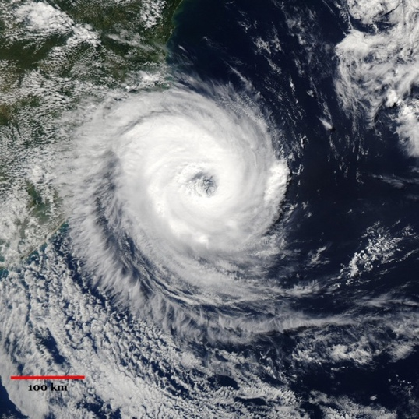
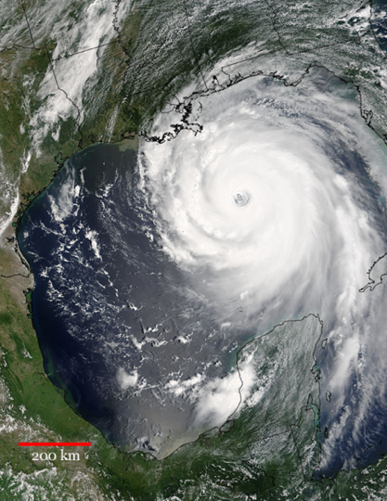
Left image:
Hurricane Katrina

Right Image:
Hurricane Catarina

3: Based on these two images and text in the lab, compare and contrast these two storms.

4: Catarina was on the borderline between Category 1 and 2. Despite its relatively weak status, the storm damaged or destroyed about 26% of all the buildings in the region of Brazil where it came ashore. The storm caused about $25 million in damages. Based on what you've learned, formulate an explanation for how a relatively weak storm could cause so much damage.

