Directions for Lab 4A using Google Maps

1. Choose a storm from the HURDAT2 database. You might choose a storm from the very active 2005 hurricane season, a notable storm from history, or one that had the name of someone you know. Once you've chosen your storm, select, copy, and paste those rows of data into a text document and print it so that you'll be able to read the details of the storm.
Use this key to interpret the daily data for the storm you chose.
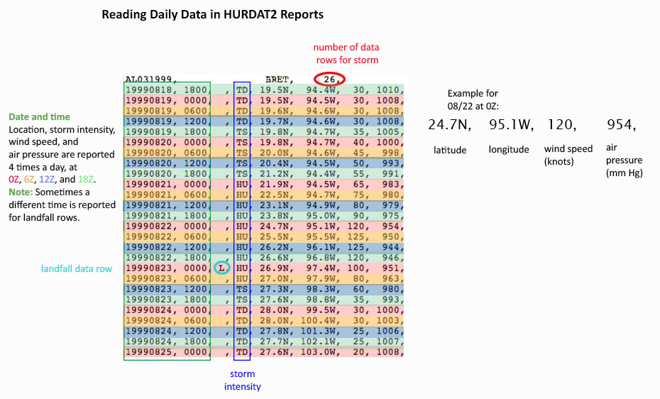

2. You'll plot the storm's location and status just one time for each day. Decide which rows you'll use and highlight them or cross out the other rows.

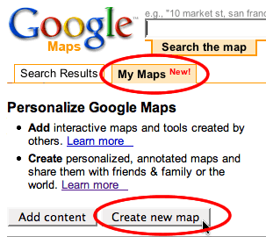
3. Open Google Maps (https://maps.google.com/). Click the My Maps tab then click the Create new map button.

4. Google Maps requires users to have a Google Account to use their services. If you already have an account with Google, sign in.
If you are allowed to set up accounts, click the Create an account now link and proceed through the instructions.

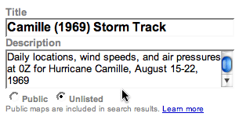
5. Enter a name and description for your storm track map.

6. In the Search the map field, enter the first latitude and longitude values of your storm: use N for north and W for west (example: 19.7N 82.7W). Click the Search Maps button. You may need to zoom out several levels in order to see any land around the location you requested.
If you have other questions about using Google Maps, access the maps help link. (https://maps.google.com/support/?hl=en)

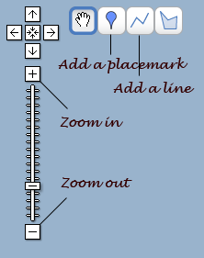
7. Click the Add a placemark button then drop the icon on the point indicated by your search. You can click and drag the placemark to get it in just the right spot. Double-click the placemark icon if you need to edit its label.

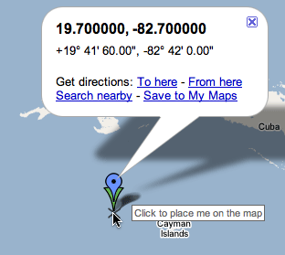

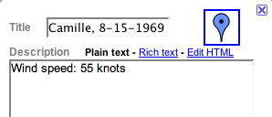
8. Enter a name for the placemark. In the description field, provide information such as the wind speed and atmospheric pressure, if reported. You can also click the placemark icon in the edit window to change the icon color or shape to indicate the storm's wind speeds.

9. Repeat steps 6 through 8 to add a placemark for each day of the storm. Click the Save button to save your map on Google's server.
Optional: You may want to add line segments between the placemarks for each day. You might choose to color code the line segments based on wind speeds.
10. Save or print your completed storm track. Share and discuss your track with your lab partner or classmates.

