Temperature and Water Vapor patterns across a region
Interpreting satellite images with NASA NEO

This optional activity instructs users how to use satellite images and an online graphing tool to explore how temperature and water vapor patterns vary across the United States.

Go to the website NASA NEO: https://neo.sci.gsfc.nasa.gov/
Click the “atmosphere” tab

From the list of images to view, select Water Vapor.

Learn more about the dataset by reading the “About this dataset” section below the image.

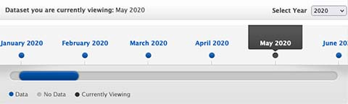
You will see an image for a single month. Choose the image for May by clicking the blue May 2020 above the slider. Change the year if necessary using the Select Year box to the right above the months.

Click on the blue box “Add to Analysis.” The program will store the image in the analysis area for you.

In the bar at the top of the screen, click “Energy” tab.
Select Land Surface Temperature (Terra/MODIS).

Select the year 2020 and click the month of May to view. Click “Add to Analysis” box.
Again, the program will store the image in the analysis area for you. (MAX 3 images)

Above the box that reads “Add to Analysis”, you will see a small tab labeled Analyze. Click on the tab. This will take you to a new screen where you will see thumbnails of the images that you selected and an Analysis Options menu.

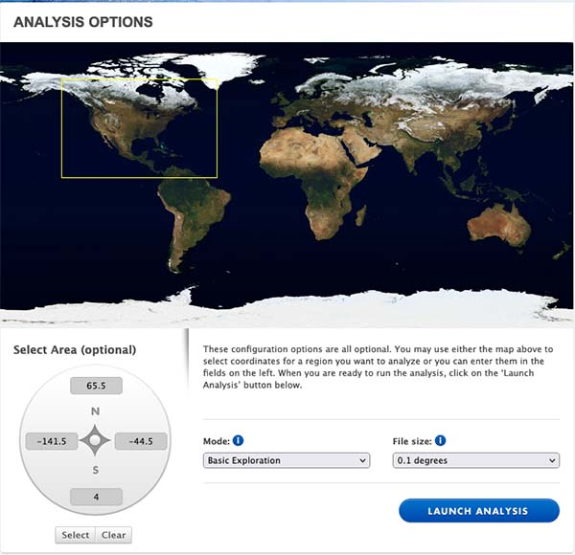
First, select the area you are interested in. Use your mouse cursor to click and drag a box around the United States. You will see the coordinates appear in the “Select Area” fields at the lower left.
Keep the Mode at “Basic Exploration” and click the launch analysis button.

Wait a moment and you will see a new screen where you can begin exploring your images.

Click the Plot Transect checkbox. This will open a graphing window near your images. Use your mouse to click and drag a line across the US to see how water vapor and temperature vary at locations along your line from California to the East Coast. 