Future of the Cryosphere

PART A: Sea Level Rise

1: Make a prediction. Which type of ice (sea ice or land ice) do you think poses a larger threat to sea level rise if large-scale melting due to climate change were to occur? Explain.
Land ice poses a larger threat to sea level rise. When frozen and floating, ice displaces enough water to support its mass. When the ice melts, the added volume of water is the same as the volume that was displaced by the floating ice. In the oceans, sea ice expels salt when it freezes, so the ice itself is essentially freshwater ice. However, it is floating in salty water, which is denser than freshwater. Because the freshwater ice is less dense, it floats higher and displaces less water than it would if it were floating in freshwater. Therefore, when the ice melts, it contributes a slightly greater volume of melt water than it displaced when it was frozen. This means that melting sea ice can have a small, but real contribution to sea level rise. Glaciers or ice sheets, which are not in the oceans, will add significant volume to the oceans and increase sea level when they melt. Some degree of melting can also cause land ice to break off and slide into the ocean, which can contribute to sea level rise as the added ice displaces ocean water. Therefore, melting land ice has a much greater impact on sea level rise than does melting sea ice.

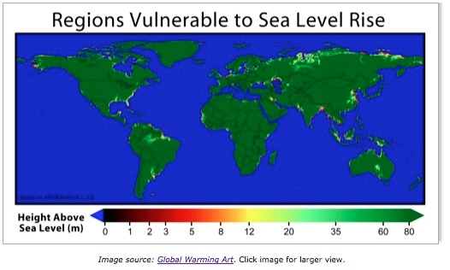
2: According to the map, what areas of the world will be most threatened if sea level rises by a few meters? Visit this web site to look at additional close-up regions of areas at risk. Would large-scale melting of ice sheets only impact countries at high latitudes? Explain.
According to the world map, coastal regions all over the world including parts of Europe, Asia, Africa, South America, North America, Australia, and Greenland are in danger of flooding from sea level rise. The entire east coast of the U.S. is at risk due to low elevations above current sea level. Based on these maps, melting ice sheets could cause significant flooding even in low latitude, warm climate regions of the world.

3: The plot above only shows coastal areas that are at or near current sea level. There are also island nations at risk of entirely disappearing as a result of sea level rise. Do an Internet search to find at least one example. Then answer the following questions:
- What is the name of the island nation?
- What is the nation's average elevation?
- What is the nation's population?
- How soon does this nation expect to be affected by sea level rise?
Answers will vary.

4: Describe the consequences the United States may face if sea level rises by just a few meters. Give specific examples of coastlines, cities, industries, and habitats that would be impacted.
Rising sea levels would threaten dozens of major U.S. cities including New York, Boston, Washington D.C., Miami, New Orleans, San Francisco, and more. These cities are home to millions of people and are vital to the nation’s economy. Coastal wetlands are also at risk from sea level rise. Wetlands provide habitat for many species, play a key role in nutrient uptake, serve as the basis for many communities’ economic livelihoods, provide recreational opportunities, and protect local areas from flooding.

