Frozen In Time?

PART B: Why We Study the Cryosphere

1: What albedo did you find for the:
- snow/ice?
- soil?
- gravel?
- sand?

2: How much more reflective is the snow/ice than the soil (i.e., what is the ratio of the ice's albedo to the soil's albedo)?

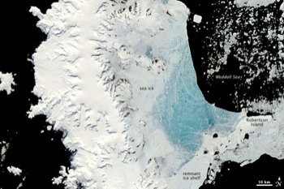
3: How did the temperatures of the two regions compare over time?

PART C: The Changing Cryosphere

1: In your own words, summarize the cryosphere. What is it? What is it made of? Where can you find it?

2: Why do you think it is important for scientists to monitor changes in the cryosphere? Explain.

