Optional Activity: Modeling Erosion and Deposition on Ocean Margins
Part B: Modeling Sediment Deposition in Coastal Ocean Margins
The thickest accumulations of sediments in the world are in the oceans. Our ocean basins contain 92% of Earth’s sediments. These sediment layers can be up to 9 km thick. Below is a cross section (not to scale) of the structure and characteristics of the ocean margins.
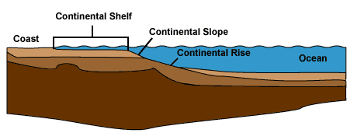
Checking In
1. Considering the structure of the ocean bottom shown above, where would you expect the sediment layers to be the thickest?
a. deep ocean floor
b. continental slope
c. continental shelf
d. continental rise.
2. Considering the structure of the ocean bottom shown above, where would you expect the sediment layers to be the thinnest?
a. deep ocean floor
b. continental slope
c. continental shelf
d. continental rise.

To understand how sediment deposits form on coastal margins, you will work with a simple model. The materials needed are:

- Play sand
- Craft sand
- Flour
- Measuring cup

- Bucket or other container to mix the sediments
- Roller tray (deep is better) with a hole drilled in the deep end about 2/3 up from the bottom
- A sink or bucket to catch runoff
- A spaghetti sauce jar or similar clear glass or plastic container
- Coffee stirrers or popsicle sticks to take sediment samples

Procedure
1. Mix the following dry ingredients in a large beaker, measuring cup, graduated beaker, or bucket:
- 2 cups (500 ml) of play sand
- 2 cups (500 ml) of craft sand
- 2 cups (500 ml) of white or wheat flour

2. Add water a little at a time and mix the sediments with your hands. Your end result should be a mixture that has the consistency of wet cement. Be careful not to add too much water. If the sediment gets too runny, add play sand to make it more firm.
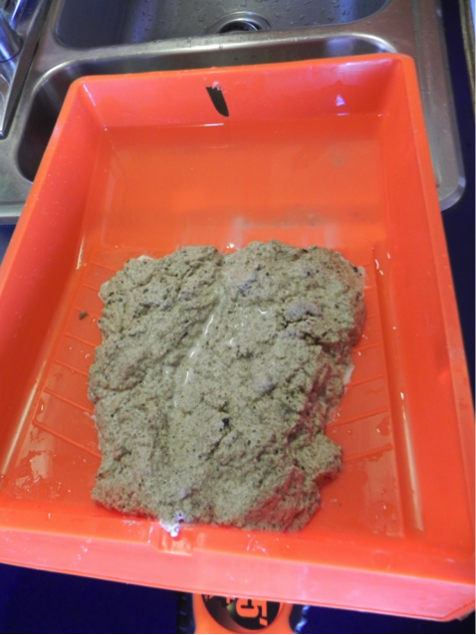
3. Place the sediment on the slope of a paint tray to form a model river valley. Don’t place any sediment in the deep part of the tray (ocean in your model). Cut a channel through the sediment with your finger. See image to the left.

4. Place a book or other object under the back of the tray so you raised it 10 cm or so. Then place the tray on the edge of a sink or a table with a bucket on the floor to catch runoff water. Then place the tray on the edge of a sink or a table with a bucket on the floor to catch runoff water.

5. Place water in the deep part of the tray until it meets the “shoreline,” the edge of your sediment (land mass).

6. Fill a 500 ml beaker or measuring cup with water. SLOWLY pour it into the top of the channel you have constructed. Observe what happens when the water carrying sediment reaches the edge of the model ocean.

7. Pour 2 more beakers of water into the channel (Slowly!). You may find that you have to take additional sediment and put it in the channel when the bottom of the tray is exposed.

8. When you have finished, make a sketch of what you observe. Wait until the next class period and finish your sketch after the water has mostly cleared.

9. Use a plastic straw to take a core sample from near the mouth of the river, middle and outer edge of the sediment deposit. (Stick the straw down into the sediment then place your thumb over the top of the straw. Remove your sample. Spread your core samples on a piece of white paper or place them on glass slides. Look at them under a 10 X or low power microscope if available.

Checking In
3. Describe the three sediment samples you examined in step 9 above. How do they differ?

Stop and Think
1. Look at the three images below. Each one shows sediments being deposited into large bodies of water. What do all of them have in common? Why are there differences between them?

NASA/NEO
Yellow River delta in China

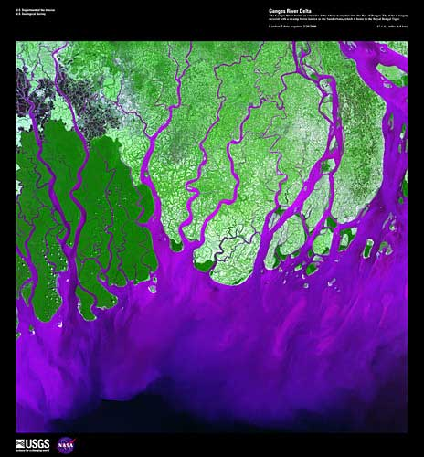
USGS/EROS
Sediments in purple entering and being deposited into the Bay of Bengal by the Ganges River.

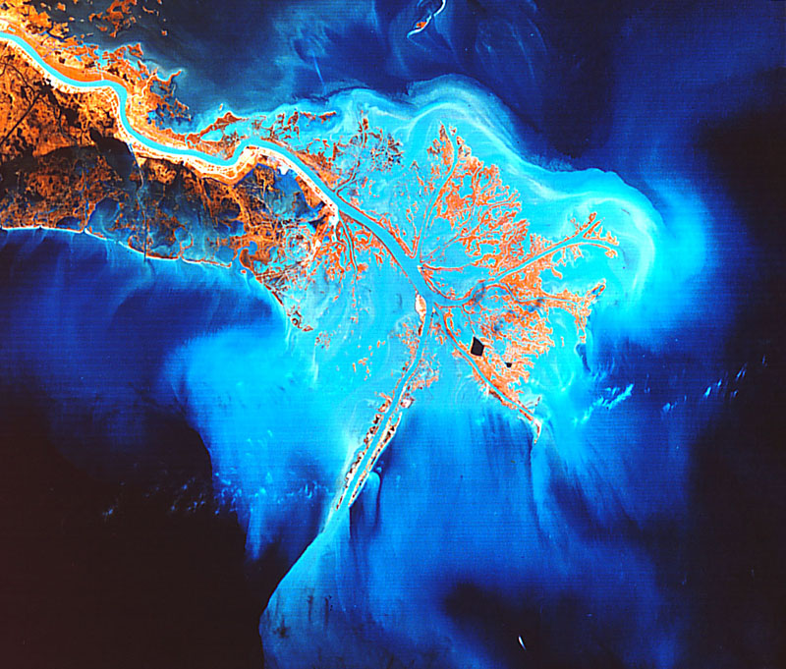
NASA/ GSFC
The Mississippi River emptying into the Gulf of Mexico.

2. Why do you think the sediment deposits are so different in shape, size, and structure at these three locations?

3. In the Mississippi River image, where do you think the thickest deposits of sediment would be found?

