Living in a Carbon World

PART A: Trees - The Carbon Storage Experts

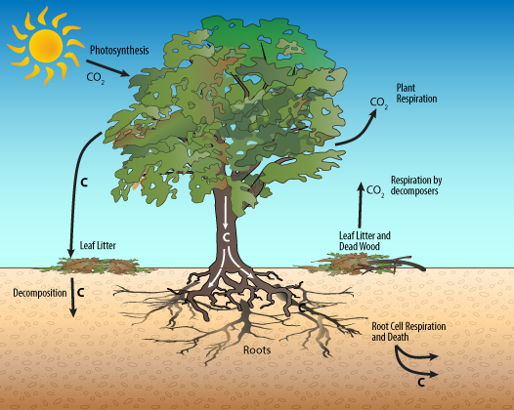

1: Using the tree diagram above to help you, explain why trees (and all plants) represent a small but complete carbon cycle.
Draw your own diagram to help you illustrate your answer.

PART B: Carbon Storage in Local Trees
2: Carbon dioxide (CO₂) is a greenhouse gas that naturally warms the atmosphere as part of the greenhouse effect. Unfortunately, the amount of CO₂ in the atmosphere has been increasing over the past hundred years. According to scientists, this increase in atmospheric CO₂ has caused the average global temperature on Earth to increase by about 0.8° Celsius (1.4° Fahrenheit) since 1880. Two-thirds of the warming has occurred since 1975, at a rate of roughly 0.15-0.20°C per decade. (NASA)
- Explain how planting and growing more trees could mitigate (slow down) this warming trend in global temperature.

PART C: Building Carbon Compounds
3. Explain why the carbon atoms in carbon compounds such as proteins and DNA originally came from CO₂ molecules in the atmosphere.

4. Explain why a lack of soil nutrients (ex. nitrogen, phosphorus, sulfur, and magnesium) limits a tree's ability to grow and store carbon.

5. Explain how trees and all other organisms in the biosphere are able to make millions of different configurations of carbon compounds.

PART D: Fossil Fuels, Hydrocarbons and CO₂
6. Describe how combustion can move carbon atoms from being stored deep in the ground to the atmosphere.

7. Identify and explain at least one piece of evidence supporting or refuting the claim that humans are changing the carbon chemistry of the atmosphere.

