Minerals: GL 210
Syllabus
Professor: Katy Johanesen (she/her/hers) Office: BAC P-110
Email: johanesen@juniata.edu Classroom: BAC P-122
Office phone: (814) 641-3601 Meeting Times: MWF 3 – 4:50 pm
Office Hours: MWF 11:30-12:30 P-110; or by appointment
Walking office hours 12:30 MWF (meet in front of BAC at 12:30)

Teaching Assistant: ### TA office hours: M & Th 7-8 pm
Email: ### Cell phone: ###
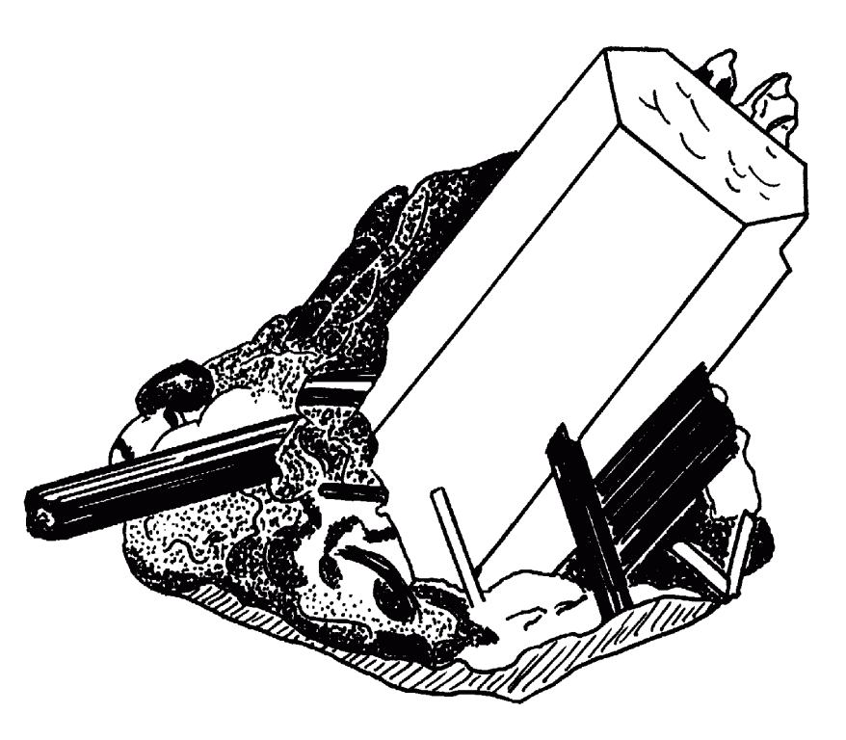
Welcome to Minerals! In this course, we will explore the building blocks of the earth: Minerals. The material covered under mineralogy is important to all disciplines of geology as well as environmental science, chemistry, and more.

You will draw on readings from the textbook as well as outside sources, work with real mineral samples, hands on models, and digital representations or minerals and crystals.

Inclusion Statement
I expect every member of this class to treat one another with respect, and you should expect this of me as well. We share this space and have a responsibility to understand each other and support each other in our effort to grow academically. Unprofessional, disrespectful, or abusive language or behavior will be handled seriously. Most of all, I want you to think about the impact of your words and actions. I will try to do the same. If I ever misstep or overlook the actions of others, I hope you will bring it to my attention.

Names and Pronouns: Many people use a name in daily life that is different from their legal name. In this classroom, we seek to use people’s preferred names and pronouns. You are invited (if you want to) to share the name and the pronouns you go by. In this classroom, we will respect and refer to people using the names and personal pronouns that they share.

Respect for Diversity: It is my intent that students from all diverse backgrounds and perspectives be well served by this course, that students’ learning needs be addressed both in and out of class, and that the diversity that students bring to this class be viewed as a resource, strength, and benefit. It is my intent to present materials and activities that are respectful of diversity: race, gender, sexuality, disability, age, socioeconomic status, ethnicity, and culture. Your suggestions are encouraged and appreciated. Please let me know ways to improve the effectiveness of the course for you personally or for other students or student groups. In addition, if any of our class meetings conflict with your religious events, please let me know so that we can make arrangements for you.

Responsibility to the Community
This class is functioning in the midst of an ongoing pandemic. We have a responsibility to prevent the spread of the virus and must remain vigilant. We will wear masks indoors (including school vehicles) until the CDC and college say it is safe to stop. If you need to eat or drink during class, please replace your mask between bites and sips. Try to avoid breathing on me or your classmates. In the event that masks are no longer required for all, I expect anyone coming to class with symptoms of illness to wear a mask. This will prevent the spread of whatever you have to the rest of us. You are encouraged to stay home if you are ill.

Learning Outcomes:
In this Scientific Process Way of Knowing course, students will:
- Manipulate and interpret quantitative information to draw appropriate conclusions
- Engage in scientific reasoning through the use of theories, hypotheses, data, and conclusions
- Consider the role of science in relevant public practices, policies, or popular media

Course Goals:
The goals of this course are those outlined on pages xiv-xv of the textbook, with two additions (*).
- Introduce crystallography, crystal chemistry, and systematic mineralogy.
- Relate the physical properties of minerals to their crystal structures.
- Introduce the polarizing light microscope and some other analytical methods used in modern mineralogy.
- Learn how minerals are classified and named.
- Identify minerals in hand sample and thin section.
- Become comfortable working with mineral formulas and know the formulas for some common minerals.* (As a geologist, it is simply too cumbersome to go looking up a mineral formula every time. These will be minerals you will come across throughout your career.)
- Appreciate the influence of crystal chemistry on mineral assemblages and mineral weathering.
- Develop the ability to research and learn mineralogical topic individually and in groups.
- Develop 3-dimensional thinking and visualization skills. * (3-D thinking is crucial in geology- structural geologists, geomorphologists, and stratigraphers also use it, to name a few.)

Textbook and reading expectations:
The textbook for this course is: Mineralogy and Optical Mineralogy by Dyar, Gunter, and Tasa 2008 -Mineralogical Society of America, ISBN: 9780939950812. OR the 2019 second edition. It comes with a DVD/online access to materials that I encourage you to browse to reinforce the readings. Assigned readings are meant to be completed prior to the class time they are due. We will draw on the readings for in-class exercises, so students who have not read the material may fall behind in class.

I’ve chosen this text because it is published by a non-profit organization committed to supporting students and early career professionals in geoscience. The authors are both white, as is common in this field. To better represent the diversity in the field of Mineralogy, we will explore cutting-edge research related to each topic that have been produced by scientists of color and underrepresented identities through the “Scientist Spotlight” activity.

Optional Suggested Readings:
An introduction to The Rock-Forming Minerals by Deer, Howie, and Zussman.

Other required materials:
- You should have a 3-ring binder to keep your notes and handouts for class. Put this syllabus in as the first page! It answers most of the logistical questions that will come up during the semester and also has my contact information.
- A working laptop with Microsoft Excel will be required for a few of our exercises (announced ahead of time), and is helpful for looking up minerals in the database that comes with the book, or in an online database. Laptops are available to borrow for short periods from the TSC if yours is not functioning- it is your responsibility to make sure you have a working computer on days when we will be using computers.

Other Recommended Materials:
- You may want to use a digital camera or phone to photograph specimens in lab for studying purposes. Keep in mind you will not be permitted to use photographs (or your phone) during any quizzes or tests.
- A hand lens can be very helpful for small specimen examination. Note- if you take Petrography (for which this is the pre-requisite), you will be required to have a hand lens for that class.

Attendance:
Please notify me prior to the end of class via voicemail or email if you will be late to or missing class for any reason. You are only eligible to make up missed activities or quizzes if you notify me on time (major medical emergencies are an exception to this). Keep in mind that chronic absences will affect your grade. If you have a scheduled event, which requires you to leave early on a particular day, please discuss this with me ahead of time so that we can make any necessary arrangements.

Evaluation and Ungrading
The traditional system of grading has been recognized to exacerbate inequalities and is not the best reflection of one’s understanding of the material. Because of this, we will not be using grading on individual assignments or exams. Instead, we will use the “ungrading” procedure outlined here.
Assignments and assessments in this course will be collected for feedback, but will not be assigned a grade. Four times over this semester, you will write a 1-page, guided reflection to discuss your progress and assign yourself a grade based on your work. After each reflection, I will meet with you to discuss your response and give my feedback regarding your progress and grade in the class. The conversation between us will cultivate deeper and more accurate reflection and self-assessment of your learning. Your grade in the course will come from our discussions, informed by your reflections and my feedback. In this way, your assessment becomes a dialogue between us rather than a monologue from me. Best of all, this process takes the focus off of numerical grades and allows you to focus on learning.
How to assess your grade in this course:
For each reflection, you will be given guiding questions to help you with the assessment. While they will take approximately the same format, some of the questions will change as your knowledge of minerals deepens and as I refine the ungrading process for this course.
- Did you achieve the learning outcomes? I will give a detailed description of the expected learning outcomes from each quarter of the class. Describe how you have met these and where you need to improve.
- Evaluate your participation so far:
- What grade have you earned? Use the guidance below to determine your approximate grade in the course.
- Is your work satisfactory? Are you content with your grade estimate and progress in the course? How will you modify your behavior or study habits to achieve your desired result? What can I do as the professor to help you achieve your goal?
Essentially, the grading categories are:
A: You have a solid understanding of the material demonstrated on DLs, assignments, and the final project. You demonstrated thoughtfulness about your learning process and made progress developing good habits, including consistently completing work on time and communicating whenever you needed to adjust deadlines or miss classes.
B: You have a decent understanding of the material demonstrated on DLs, assignments, and the final project. You made some progress on thoughtful reflection and good learning habits, but had a week or two when some issues arose (e.g., not communicating about missing class, late or missing assignments).
C: You have a basic understanding of the material demonstrated on DLs, assignments, and the final project. Some assignments may have been late, incomplete, or contain incorrect information. You made some progress on thoughtful reflection and good learning habits, but had issues with consistency (e.g., not communicating about missing class, late or missing assignments).
D: This grade is to be used rarely. A “D” indicates that you demonstrated a basic understanding of at least part of the course, but did not complete a significant number of assignments, learning goals, or other portions of the course. Please meet with me to discuss if you believe you are earning a D.
F: You did not complete the course. You do not understand the material and missed a Demonstration of Learning, Signature Assignment (portfolio submission) or the final project. Few assignments were completed and/or you did not attend class most of the time. You did not follow through on attempts to catch up or re-connect with the class.
If you’re on the cusp between two categories, use the + and – modifiers such as A- or B+.

Using Moodle
We will be using Moodle to track and organize documentation of your learning and reflections. The positives of this method are that we can both see all documentation and feedback related to the course (yay, transparency!) and have a central location to communicate about your work. The negatives are that Moodle is hard-coded with grading language, no matter how much of the grade calculation features I deactivate. We will together have to do our best to avoid the built-in grading systems and discuss your learning and progress in a more descriptive way.

Assignments:
This course is designed to immerse you in the material and give you space to construct your understanding. Rather than traditional lectures, class sessions will feature problem sets and assignments designed to help you unpack the material covered in the readings. Sometimes these will be broken down into a separate worksheet for each day. Other times you may have several class sessions to work through a longer problem set. This will average out to approximately 30 assignments over the course of the semester. Typically, you will complete these during class time.

Knowledge Checks and Demonstrations of Learning:
There are several scheduled Knowledge Checks (KC) as well as the possibility of unannounced reading checks. These are an opportunity to check your understanding on a specific topic based on readings and class assignments. We will conduct these during class time. First, you will attempt the KC without notes and briefly reflect on your understanding so far, then you’ll be able to open up your notes or text and fill in anything you missed. We will usually go over the answers for these as a class immediately after you take them.
We will have three cumulative, comprehensive Demonstrations of Learning (DL) three times over the course of the semester. You will be asked to complete short written answers and sketches explaining course content. The goal of the first two assignments is to determine what you have learned so far and identify areas for further growth. I will give feedback on your completed DL and then provide an opportunity to complete test corrections to improve your understanding. The third DL will be a final opportunity to demonstrate all you have learned in the class. I will work with you to design the best way to accomplish this task in a way that is fun and useful to you.

Box o’ Minerals:
Over the course of the semester, you will be given 6 different mineral sets to identify and study. You will use the methods you learn in lab to identify the minerals in each set, and then present your findings to me in an oral quiz format. A more detailed description of this process will be handed out with the first box of minerals. The mineral identification lab practical will then test your knowledge by asking you to identify a set of 20 unknown minerals, using your notes and mineral ID tools.

Please note that, while mineral ID is important, it is only one learning outcome of many and not the only component of your grade. Therefore you should plan your study time accordingly and make sure to spend appropriate time on the other topics covered in this course as well.

Mystery Mineral Project:
Throughout the course, you will apply the methods and skills you’ve obtained to identify and characterize a “mystery mineral,” about which you will give a final presentation during the last week of classes. This project will be introduced early in the semester. After your presentation, you will have the opportunity to revise and annotate your presentation slides before you submit your presentation as your portfolio contribution on Portfolium.

Lab Access and Care:
You have access to the room outside of class hours, and are encouraged to use it. It is important to take care of the lab space and prevent loss or damage of expensive or possibly irreplaceable materials and equipment. If materials or equipment go missing we all suffer. Please notify me as soon as possible if any thin sections, mineral specimens, or equipment are accidentally damaged. Please clean up your workstation when you leave for the day and take proper care of the microscope and other tools assigned to you. Another class uses this space MWF 10:30-11:20 and Tuesday 1-4:50. Keep it neat for them and they will do the same for you!

Citation of References
In scientific writing, we need to support our claims by providing evidence from prior research. We give credit for this research with in-text citations and references. Citing the prior literature strengthens your study and proves that you have a grasp of the reasoning behind it. While Wikipedia and other websites are useful for familiarizing yourself with a topic, they do not constitute primary literature and should not be used in citations for student papers or projects (hint- many times these pages cite their sources- go check out those!). In short, your paper always needs:
- In-text citations in the format: (author lastname(s), year).
- A “References Cited” section that lists all cited articles with last names and first/middle initials for ALL authors, year and title of article, journal name, volume, and pages (or publisher and city for books).
- Your references must include peer-reviewed journal articles; a book or conference abstract is permissible, but no web pages should be cited.
Note that direct quotes are typically inappropriate in this type of scientific writing. To avoid accidental plagiarism, always incorporate information from multiple sources and explain it in your own words, not theirs. Changing one or two words in their sentence does not make it yours.

A full description of Juniata’s standard policies for academic integrity, accessibility, discrimination, harassment, and bias are here: https://more.juniata.edu/academics-classes/syllabus-statements/syllabus-statement-2021-22.php This class will comply with college policies.

Accessibility Accommodations:
I am working to make my classes accessible to all and reduce the need for accommodations, but I understand that I may still have policies or strategies that inadvertently create barriers for you. I will work with you to honor any accommodations requested in order to support your learning.

If you are or think you may be colorblind, please let me know. Color in thin section is a common diagnostic tool, but many successful petrologists have been able to compensate for colorblindness by relying on other properties like relief, cleavage, and extinction. We can work together to help you master these and, at the very least, I can identify colors in thin section for you when needed.

Academic Integrity Policy
My goal in this class is to support your learning. This means that the work you submit must be original work by you, so that I can provide feedback meaningful to you. If I have a concern that the work you submit is not your own, I will bring it up with you and try to resolve this concern internally before bringing it to the Associate Provost.
Attendance
I often plan activities, including group assignments, for class and it is helpful to know ahead of time if students will be missing. If at all possible, please notify me prior to the end of class via voicemail or email if you will be late to or missing class. You do not need to explain your reason. I will try to provide all handouts and brief descriptions of class activities on Moodle for you to access should you miss a class. If you have a scheduled event that requires you to miss or leave early on a particular day, please discuss this with me ahead of time so that we can make any necessary arrangements. Keep in mind that chronic absences may make it difficult for you to reach the learning objectives of the course.

Access to Resources
The Writing Center: Please make appointments with the Writing Center, a FREE service for Juniata students. This is a great resource for all writers—you are encouraged to use it! The three-step process to get an appointment with Writing Center tutor:
- Email writing@juniata.edu to request a tutoring session & tell them a few details about the essay (what course? which professor? tutor preference?)
- When you receive an email assigning you a tutor, please send your paper and a copy of the assignment to the tutor (IF you have a paper – you can also be brainstorming and just want to talk! IF you have an assignment – sometimes instructors just give oral instructions)
- Meet your tutor face-to face, via Zoom, Facetime, or any other medium that works for both of you to receive feedback and share ideas about how to improve your writing.

Academic Coaching is available to all students by appointment through the Learning Services office. Coaches guide students to identify their real and perceived barriers to academic success. They assist students with navigating those barriers by cultivating self-awareness of their strengths, and help them develop skills and strategies to become better learners and better self-advocates for their learning. For more information or to schedule an appointment please contact Blair Cutright, Coordinator of Learning Services, Case Management and Academic Support, at LearningServices@juniata.edu

Peer mentoring is available to all students by appointment through Learning Services. Peer Mentors help students meet their goals with academic and personal success skills development. Through individual and group interactions (both online and face-to-face), they cultivate and model healthy peer relationships, improve study and communication skills, encourage teamwork, collaboration, problem solving, empathy and understanding of others. Peer Mentors are knowledgeable about resources on campus, facilitate connections to resources and serve as a role model. For more information or to schedule an appointment please contact Blair Cutright, Coordinator of Learning Services, Case Management and Academic Support, at LearningServices@juniata.edu

Withdrawal Deadline:
The last day to withdraw from this class is the last day of classes at 12:00 noon.
Outline of course topics, readings, and major assignments:
KC = Knowledge Check; DL = Demonstration of Learning; all chapter readings are from the textbook.
Date | Topic/Activities/Assignments | Reading/Homework | Box o’ Min
January 19 | The Essence of Mineralogy | Preface, syllabus | “Big 10” minerals
21 |  | Ch 1
24 | Week 1 worksheet due by beginning of class Monday  Mineral ID techniques,  Scientist Spotlight: Prince | Ch 2 (reading check) | Start Group 1
26
28 | Week 2 worksheet due by end of class Friday  Box o’ Min procedure
31 | Elements of Crystal Chemistry  Chem Problem set 1 due by beginning of class Friday | Ch 3 (reading check) | Group 1
February 2
4
7 | Crystal Systems | chem. prob. set 2 due Ch 4 | Group 1
9 |  | Wk 4 worksheet due after class Friday
11
14 | Microscope KC I  Scientist Spotlight: Wise  Intro to Optics | Ch 5
16 |  | Wk 5 Optics worksheet due Wednesday in class
18 | DL 1 Friday Feb. 18
21 | Bonding, Packing, and Coordination | Ch 7 (chem refresher) | Group 1 ID Challenge
23 |  | Ch 8
25 |  | Wk 6 worksheet due in class Friday
28 | Silicates  Mineral Formulas and chemistry | Ch 6; | Group 2
March 2 |  | Ch 10, 22 for ref
4 |  | Wk 7 worksheet due in class Friday
7 | 2D symmetry  No Class Friday | Ch 11 | Group 2
9
11
12-20 | Spring Break!
21 | Intro to phases  Symmetry KC Friday | Ch. 12 pp. 251-282
23
25 |  | Ch. 12 pp. 283-300
28 | Phase diagrams in T-X space |  | Group 2 ID Challenge
30 | 3-D symmetry | reading questions due Wednesday
April 1
4 | Microscope KC 2  Optic theory and optical microscopy methods  Mystery mineral progress check-in | Ch. 16 | Group 3
6
8
11 | Optics continued;  Scientist Spotlight: Chin |  | Group 3
13 | DL 2 Wednesday April 13
15 | Diffraction | Ch. 15
18 | FIELD TRIP to PGS Mon. 4/18  *asbestos diagnosis and public policy
20
22 |  | Ch. 9
25 | Phase diagrams and crystallization  Wednesday and Friday:  Mystery Mineral Presentations | Ch. 20 | Group 3 ID Challenge
27 |  | Submit reflective essay on asbestos policy to Portfolium
29
May 2 | Mineral ID Challenge | Submit presentation file to portfolium
May ?? | DL 3 is scheduled for ______. This date is set by the Registrar’s office.
Other important dates:
- Liberal Arts Symposium is Thursday, April 21, 2022- you are strongly encouraged to attend
NOTE: This schedule is a rough draft and is likely to change. When changes occur, I will post a new version on Moodle and announce them in class. Last updated 1/18/2022.

