**Name: _______________________**

**Predicting and Interpreting Sedimentary Sequences**

1. **What does Walther’s Law state?**

**What is the lateral sequence of sediment types at a continental margin?**

For the purposes of this exercise the passive continental margin is divided into the five sedimentary settings shown below (**Figure 1**). Coarser material is deposited closer to source, in ‘higher-energy’ environments on the landward side, and finer sediment is deposited farther from source on the oceanward (basinward) side of the transect. In this experiment the sediment deposited in each setting will be represented by a different colored porcupine balls. The position of sea level is marked by the transition from beach sediments to stream sediments; every time sea level changes it will move landward (rise) or oceanward (fall) one ‘setting’, so the sedimentary settings (colored porcupine balls) shift location to the right or left depending on sea level position.

1. Make sure you know what sediment type (and the color porcupine ball associated with it) is deposited where (and the color porcupine ball associated with it) by using **Figure 1** to help you fill out the table below:

|  |  |  |  |  |  |
| --- | --- | --- | --- | --- | --- |
|  | **Stream**  **(= fluvial)** | **Beach** | **Shelf & Slope** | **Ocean Basin** | **Distal Basin** |
| **Particle size of sediment deposited** |  |  |  |  |  |
| **Color of porcupine ball representing sediment** |  |  |  |  |  |



**Figure 1.** Simple cross section model of a continental margin showing sequence of sedimentary environments and sediment particle size and type

**The Experiment – Using our Model!**

We will use our model to see what happens when sea level is raised or lowered. For each experiment, record the changes in the table, then fill in each column to show the sequence of sediments deposited at the location represented by the tube. Fill in the key using colors or symbols. Then use your information to draw the sea-level curve represented by the sequence and answer the questions below.

1. **Experiment 1**

|  |  |  |  |
| --- | --- | --- | --- |
|  | Sea Level (SL) | Sea level up or down? | Did location of beach sediments move west (left, landward) or east (right, basinward)? |
| SL 5 |  |  |
| SL 4 |  |  |
| SL 3 |  |  |
| SL 2 |  |  |
| SL 1 - start |  |  |



Fill in the blanks with the correct terms (***regression***, ***transgression***):

In the absence of other changes, a rise in relative sea level produces a ______________________

and a lowering of relative sea level produces a ______________________.

Write a short sentence summarizing the record of transgressions and regressions in Experiment 1:

1. **Experiment 2**

|  |  |  |  |
| --- | --- | --- | --- |
|  | Sea Level (SL) | Sea level up or down? | Did location of beach sediments move west (left, landward) or east (right, basinward)? |
| SL 5 |  |  |
| SL 4 |  |  |
| SL 3 |  |  |
| SL 2 |  |  |
| SL 1 - start |  |  |



Write a short sentence summarizing the record of transgressions and regressions in Experiment 1:

What are some of the assumptions made when using this model (list four)?

1. Examine the maps and diagrams for SE Minnesota and the Central Midwest below. **Figures 2a and 2b** show high and low sea level positions for the Paleozoic ocean that covered the area between 545 and 480 my ago. **Figure 3** shows the sequence of sediments recorded along a transect that runs WSW to ENE. Use your knowledge of sea-level control on sediment types to draw a sea-level curve for this sequence in the space provided. NOTE: Use the position of ‘shoreface sands’ and ‘offshore carbonates’ as a guide. Use the data to draw the sea level curve on Figure 3, then answer the question.

**Figure 2.** Distribution of sediments at high- and low-sea level positions.

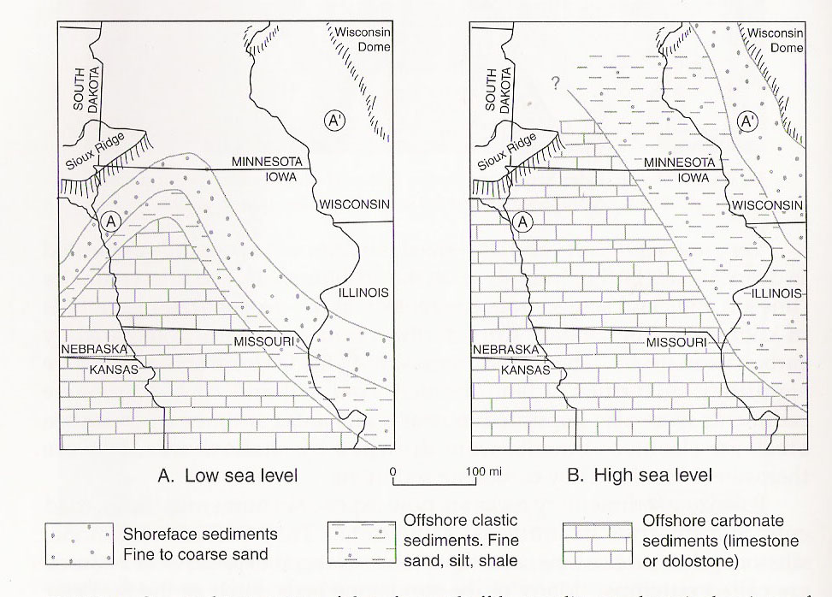

**Figure 3.** ‘Vertical Slice’ (a cross section) showing sequence of Paleozoic sedimentary rocks in Central Midwest. A is in WSW and A’ is in ENE. Adapted from Minnesota at a Glance ‘Ancient Tropical Seas – Paleozoic History of Southeastern Minnesota (<https://conservancy.umn.edu/handle/11299/59447> )

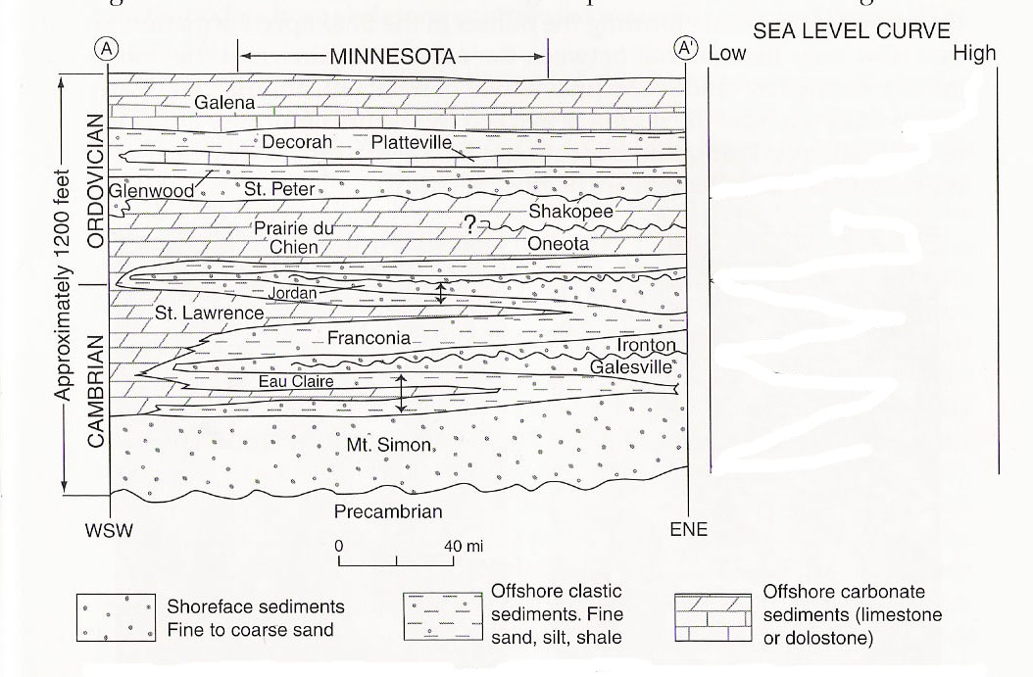

Which Formations provide a record of higher sea levels?

Explain your reasoning for your answer to the previous question: