**Demystifying Walther’s Law: Large Pickleball Models and Tabletop Challenges to Stratigraphic Column Interpretation**

**Abstract:**

Many students find the application of Walther's Law a temporal-spatial challenge. In this demonstration a set of large plastic tubes represents geographically separated locations (ultimately stratigraphic columns) for laterally adjacent environments. Brightly colored pickleballs are used to represent sediment deposited in each environment. As sea-level is lowered or raised, sediment (pickleballs) is deposited, producing a color-coded record of sedimentation. Students use this visual and interactive demonstration to practice interpreting the record of sea-level change from sedimentary sequences. A parallel table-top activity allows students to challenge each other to interpret the sea-level change history using colored beads and test-tubes, drawing facies boundaries on plexiglass. This activity scaffolds into stratigraphic column interpretation exercises for marginal marine and glaciomarine environments where students can validate their interpretations using the large or table-top models.

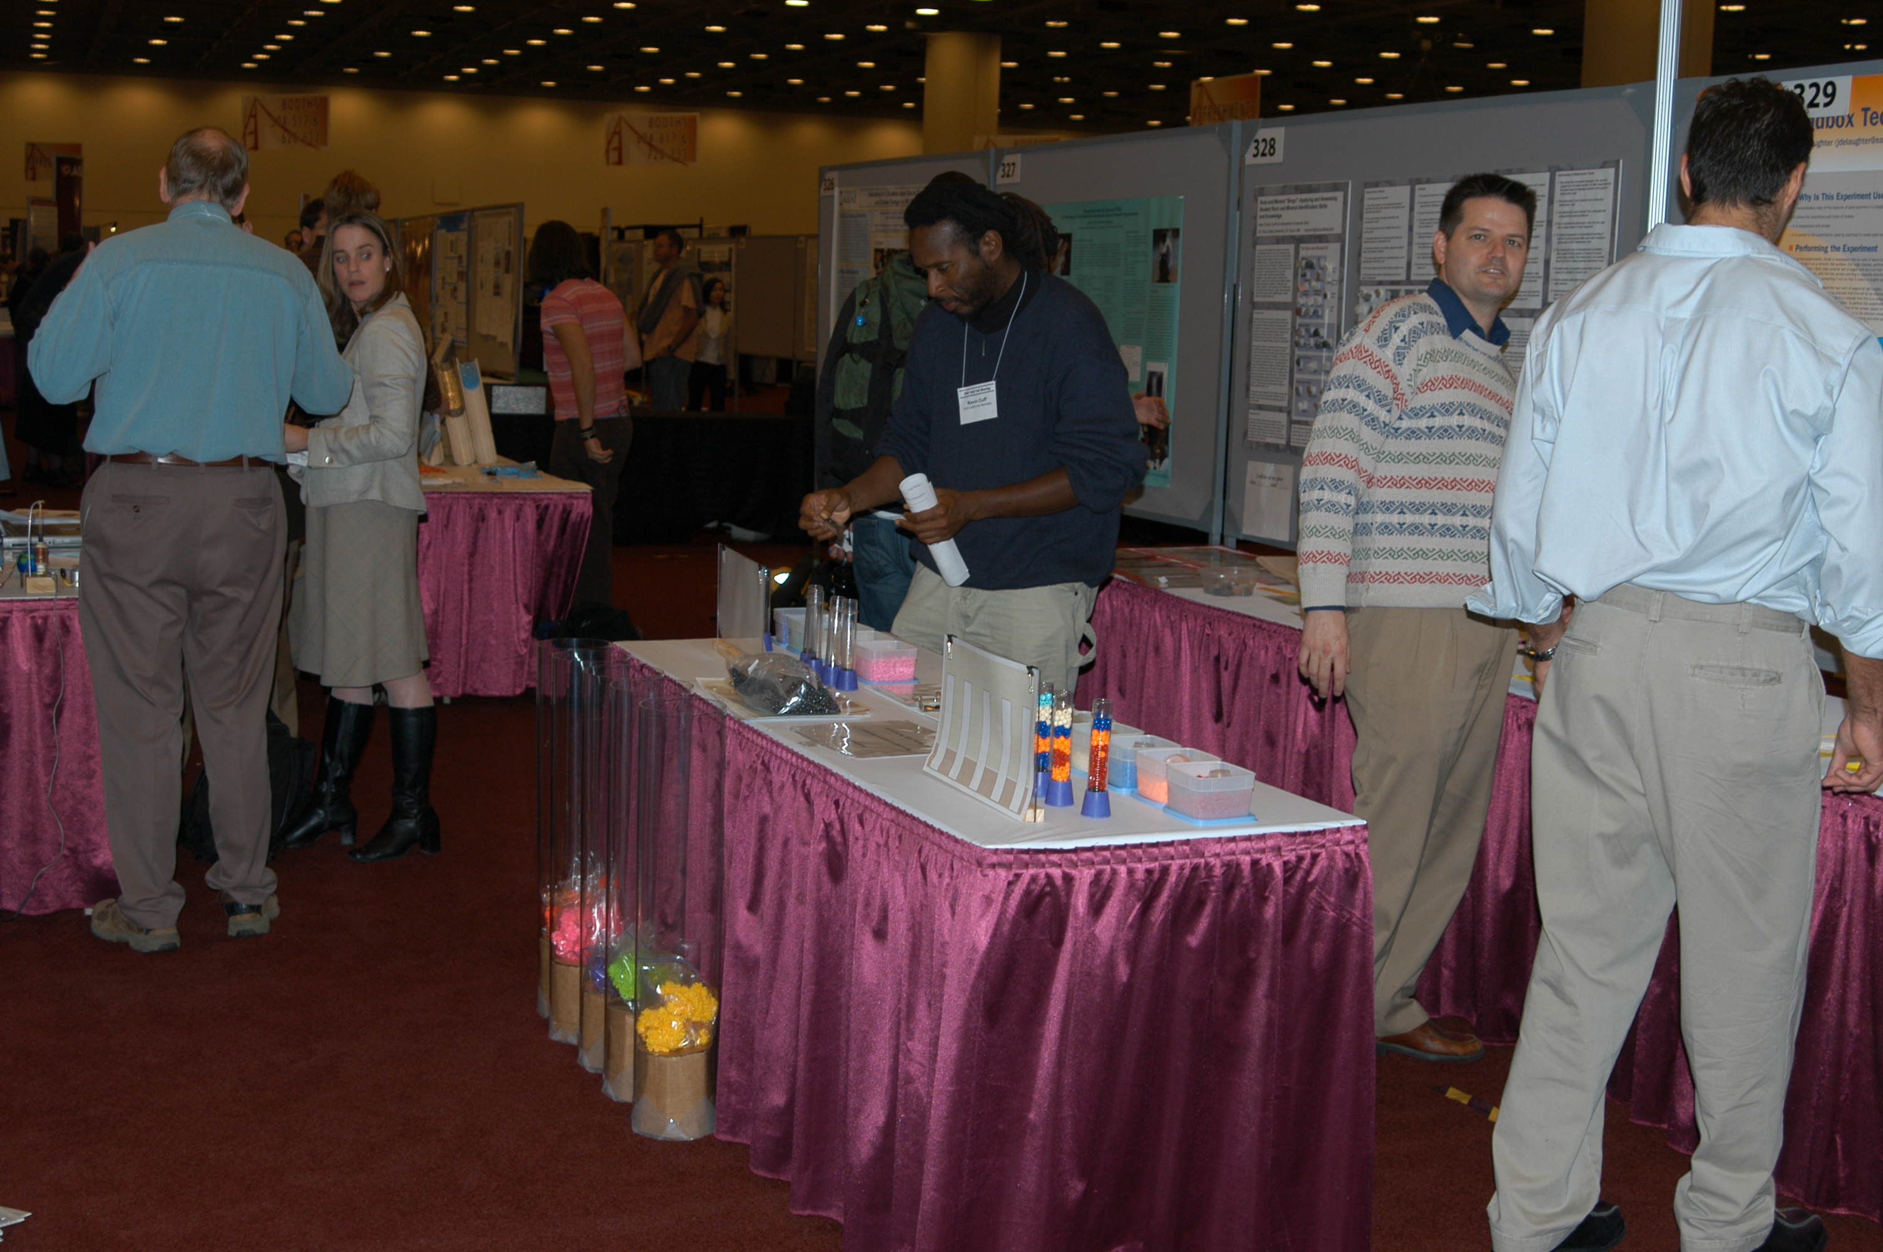The models at AGU 2005  
  
Large Class Demo – Ready to go!

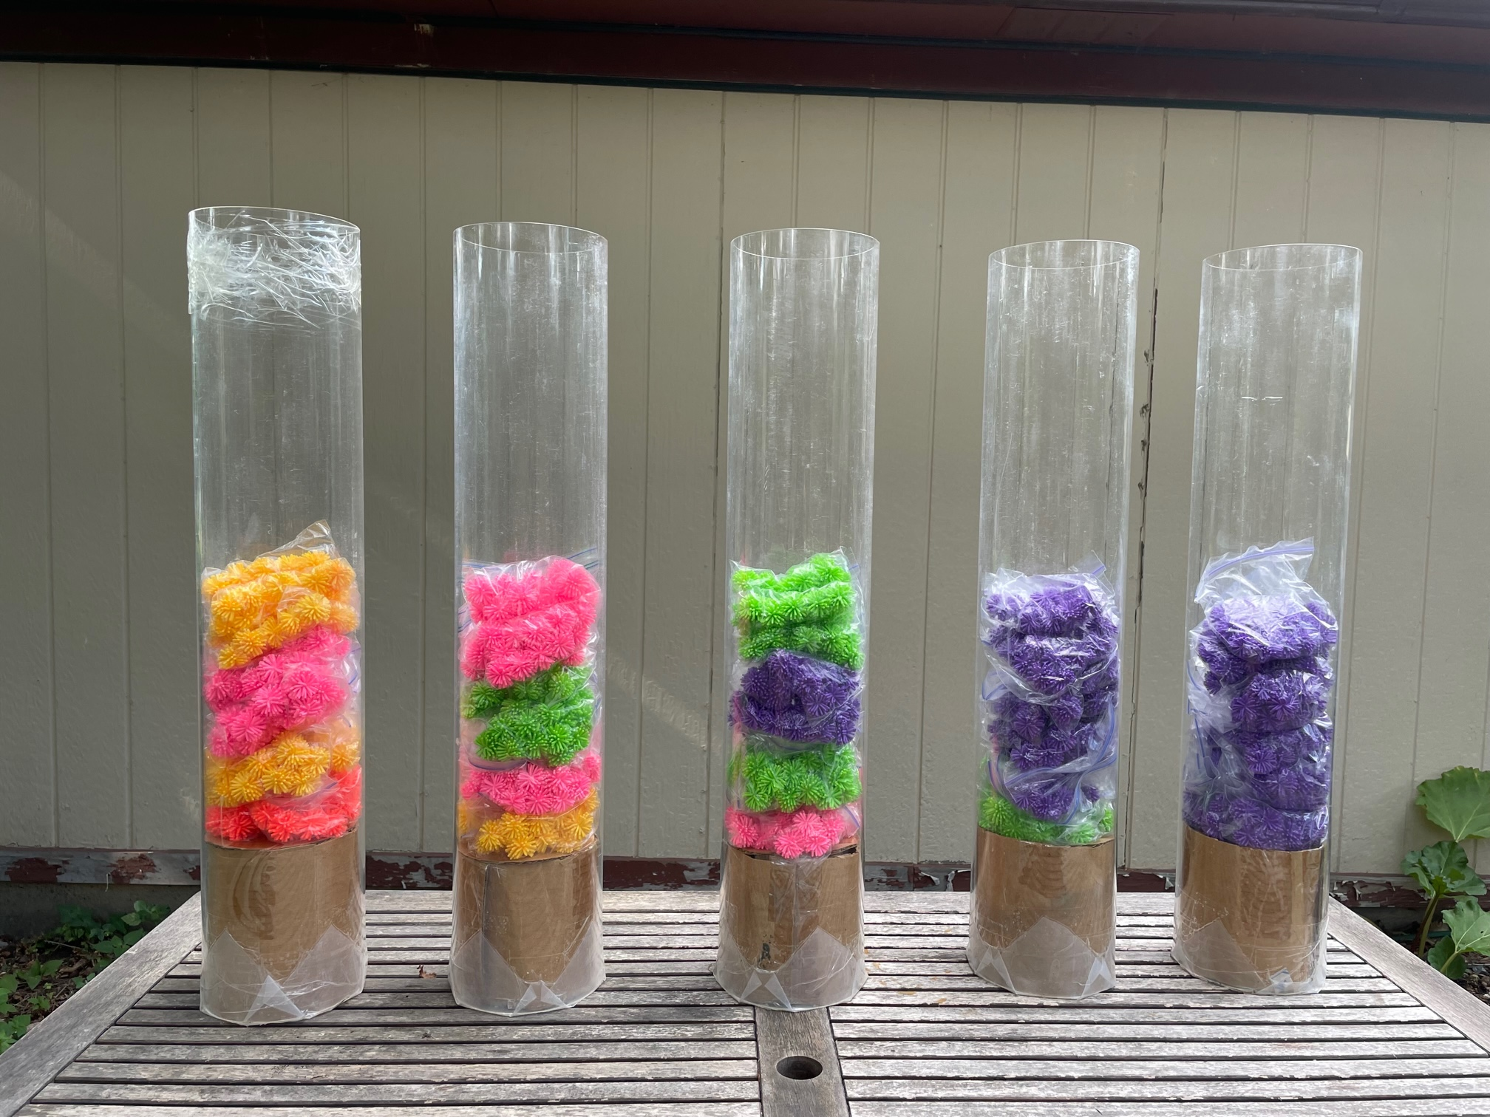Large Class Demo – Transgression followed by regression

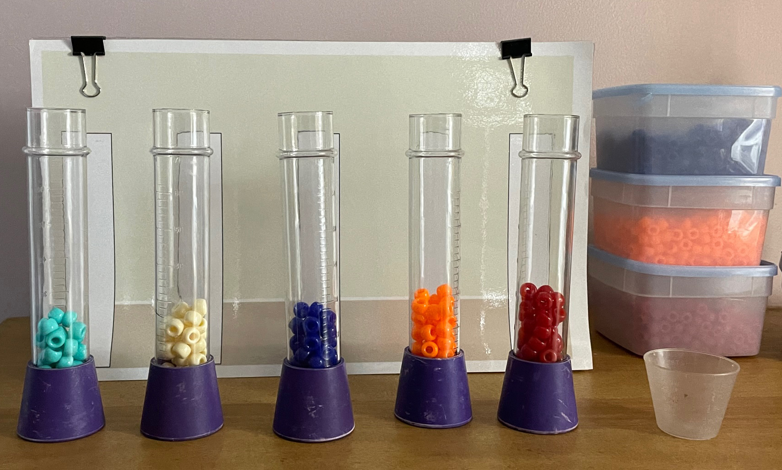  
Tabletop Challenge – Ready to go!

**In-Class Use:**

I use this activity in several ways:

* When I am introducing sedimentary environments, the stratigraphic record, Walther’s law, lateral and vertical facies changes, transgressions, regressions, stratigraphic columns, and correlation in both introductory AND advanced classes
* When I am teaching students about how we learn about past climates from sediments deposited on the Antarctic margin
* When I am working with teachers or students to understand the sedimentary sequence in the Twin Cities and SE Minnesota

**Why it works:**

* Students enjoy putting their pens down and just being slightly goofy
* The large colored pickleball 'columns' are easy to understand, and don't come with all the intimidating 'baggage' of geological symbols
* Students can go back to the models and use them to test their understanding

**Large Classroom Demonstration:**

* **See-through Tubes:** I ordered mine from <http://www.mcmaster.com/> <https://www.mcmaster.com/rods/fabrication~cast/clear-scratch-and-uv-resistant-cast-acrylic-tubes/> ‘Clear Scratch- and UV-Resistant Cast Acrylic Tubes’ and cut on a table saw (depending on length purchased). Mine are far too wide (6” diameter - expensive to buy materials to fill them); they crack easily too... I’d suggest 4” diameter at the widest.
* **Colored Objects (‘Pickleballs’):** I did a volume/cost determination and decided on “mini porcupine balls” from Oriental Trading ([www.orientaltrading.com](http://www.orientaltrading.com)) item # 39/983, 72 per bag, $12.99/bag. They were still really pricey (# bags required depends on column width). <https://www.orientaltrading.com/mini-porcupine-ball-assortment-72-pc--a2-39_983.fltr?keyword=porcupine+balls>
* **Bags to keep color-sorted porcupine balls in (easier to manage):** ziplock bags
* **Something to form ‘basement’ at bottom of tube:** cardboard, old material, foam rubber…….
* **Position of Sea-level:** meter stick
* **Camera:** cell phone

**SUPPLIES / equipment fOR LARGE CLASS DEMONSTRATION**

In the Large Class Demonstration (most suited to a lower-level class, or speed-review in an upper-level class) colored pickleballs are the proxy for sediment deposited adjacent to a simplified continental margin. Students review Walthers Law and sedimentation adjacent to a continental margin prior to demonstration.

|  |  |  |  |  |  |
| --- | --- | --- | --- | --- | --- |
|  | **Stream (= fluvial)** | **Beach** | **Shelf & Slope** | **Ocean Basin** | **Distal Basin** |
| **Particle size of sediment deposited** |  |  |  |  |  |
| **Color of porcupine ball representing sediment** |  |  |  |  |  |

Students record sea-level changes during the demonstration:

|  |  |  |  |
| --- | --- | --- | --- |
|  | Sea Level (SL) | Sea level up or down? | Did location of beach sediments move west (left, landward) or east (right, basinward)? |
| SL 5 |  |  |
| SL 4 |  |  |
| SL 3 |  |  |
| SL 2 |  |  |
| SL 1 - start |  |  |

Students draw and interpret the data they have collected:



**Tabletop Challenge:**

* **Tubes:** These are the ‘stratigraphic columns’. I used the *‘Unbreakable Super Tubes with Stopper’*, set of 10, product # 96-1987, $19.95, from <http://www.carolina.com>. If not available, try ‘Steve Spangler’s Large Plastic Test Tubes & Rack’ on Amazon ($13.86).
* **Colored Beads:** I used ‘Pony bead mix. Opaque multicolored, 9x6mm, sold per package of 900 beads, cost $14.17 / pkg, I used 10 packages, from <https://www.firemountaingems.com/itemdetails/h201678pb> I then had to bribe friends and family to sort them by color.
* **Containers for sorted beads:** Plastic containers from the back of your kitchen cupboard or a hardware store
* **Measurer:** Five small ‘pourable’ containers that can easily measure ~ 5ml beads for each ‘setup’ (old medicine cups)
* **Perspex / Plexiglass ‘Holder’:** I got Perspex, cut to ‘legal size paper (8.5” x 14”) at the hardware store, where I also got the wood and screws to stand them up.
* **Template:** print out and use bulldog clips to hold on stand
* **Something to form ‘basement’ at bottom of tube:** black beads, old material, sand…..

Camera: phones

**SUPPLIES / equipment fOR**

**Tabletop**

**challenge**

I use the Tabletop Challenge in advanced classes, often as a follow-up ‘Lab’ or in-class activity after having reviewed Walthers Law, transgressions and regressions via the larger demonstration. Sometimes I follow the student handout verbatim, other times I focus on giving the students the opportunity to challenge their classmates.

The set-up is similar to that used for the large demonstration, but uses beads and test tubes, and more importantly a Perspex ‘cover’ or laminated sheet that students can draw facies boundaries on.

In addition to the interpretation of Minnesota stratigraphy (also used in the Large Demo), this exercise includes additional follow-up questions.

**Link to real situation:**

In both activities the students advance from using the model data to applying their understanding to a real-world situation (Adapted from Minnesota at a Glance ‘Ancient Tropical Seas – Paleozoic History of Southeastern Minnesota (<https://conservancy.umn.edu/handle/11299/59447> ). They interpret changes sea level.

**References and Links:**

Minnesota Geological Survey, Minnesota at a Glance ‘Ancient Tropical Seas – Paleozoic History of Southeastern Minnesota (<https://conservancy.umn.edu/handle/11299/59447> )

Smith C.,**Pound, K.S**., Jones, M.H., Schmitt, L., Campbell, K., 2005, [Classroom Demonstration and Interactive Model of Sea-Level Control on Lateral and Vertical Facies Changes](http://abstractsearch.agu.org/meetings/2005/FM/ED52A-05.html)[abs], EOS Trans. AGU, 86(52), Fall Meeting Suppl., Abstract ED52A-05.

Pound, K., Earth and Atmospheric Sciences Dept., St. Cloud State University, Modeling Sea Level: Lateral; and Vertical Facies Changes On the Cutting Edge Peer Reviewed Teaching Activities Collection <https://nagt.org/nagt/teaching_resources/teachingmaterials/11402.html> (includes instructions)

Pound, K., Earth and Atmospheric Sciences Dept., St. Cloud State University, Sea Level & Lateral and Vertical Facies Changes, NAGT / SERC website <https://nagt.org/nagt/teaching_resources/teachingmaterials/11383.html> (I don’t know why there are two separate NAGT pages, I need sort that out, this page provides less info than the one above!)

Student work: dry-erase pen on laminated sheets Regression followed by a transgression