Student lab materials: Investigating geologic structures for introductory physical geology or earth sciences using craft foam models

Authored by Andrea Bair, Delta College, MI, USA

Questions or comments: andreabair@delta.edu

Latest version: July 18, 2019

This work is licensed under the Creative Commons Attribution-NonCommercial-ShareAlike 3.0 United States License. To view a copy of this license, visit http://creativecommons.org/licenses/by-nc-sa/3.0/us/ or send a letter to Creative Commons, PO Box 1866, Mountain View, CA 94042, USA.

You are free to:

Share — copy and redistribute the material in any medium or format

Adapt — remix, transform, and build upon the material

Attribution — You must give appropriate credit, provide a link to the license, and indicate if changes were made. You may do so in any reasonable manner, but not in any way that suggests the licensor endorses you or your use.

NonCommercial — You may not use the material for commercial purposes.

ShareAlike — If you remix, transform, or build upon the material, you must distribute your contributions under the same license as the original

Non-compliant images have been removed from this document; placeholders have been included where images are missing. Or, add your own! This document is also not yet fully accessible (in progress!) I am working towards accessibility for screen-reading software and creating my own images, and will produce an updated version with their inclusion. Please contact me via email at andreabair@delta.edu if you would like an updated and compliant file.

I welcome and appreciate information on how you use this document, including modifications! Please feel free to contact me to suggest edits, and/or send me any versions you use as well as how it worked for you!

A suggested answer key is available upon request, although some aspects will vary significantly depending on your model design.

Implementation notes: Students are assigned the “pre-lab/warm-up” questions as homework due just at the start of the class time the lab is to be done; questions are designed to utilize text background information from the lab and/or textbook pages. I suggest giving credit for attempting all/majority of questions, and using the student answers and questions for a “Just in time” teaching approach. I work through any of the pre-lab questions requested by students, and/or questions I suspect are troublesome, and confirm best answers in a class-wide discussion. I also conduct a short demo contrasting “rock” tensile strength in warm vs. cold Laffy Taffy to illustrate differences between the concepts of “weak” and “fragile”, and that a material can differ in its deformation depending on temperature conditions. This helps students struggling with the table on the first page of the pre-lab/warm-up. I usually do include pre-lab/warm-up questions in grading for correctness and collect it as part of the whole lab exercise. Attempting the pre-lab/warm-up questions before class time earns students about 5% of their whole lab score. If students do not complete it ahead of time, they still need to complete it for my implementation but cannot earn the 5% attempt part of the grade for that lab. Blank pages in the document are by design, so that the student lab pages can be removed from the background info, and so that each section can be separated cleanly without losing something on the backside of a page from another section. This lab is included in a “course pack” self-authored lab book that is 3-holed punched; all sections start on the right (or an odd) page in book format.

LAB 9: Rock deformation and geologic structures

INTRODUCTION

Purpose: The following activities are designed to help you connect fault and fold types with the main types of directional stress.

Why? Folds and faults are geological evidence of large-scale rock deformation, often related to stresses due to tectonic movement and plate boundaries. Faults and folds are used to interpret the type of stress and conditions the rock experienced when being stressed.

Learning goals: Upon completion of this activity, students are expected to be able to:
- Apply the concept of scale.
- Sketch and describe the three main types of directional (or differential) stress.
- Give examples of geologic structures that form in each kind of directional stress regime.
- Identify, sketch, and label the three major types of faults.
- Identify, sketch, and label the two major kinds of folds.
- Link the major kinds of geologic structures with a) the type of stress that causes the structure to form, and b) the type of plate tectonic boundary that is most often associated with the stress and structure.

Materials required:
- Materials you provide:
  - Lab 9 background information in lab pack.
  - Your textbook (specific sections or pages)
  - Pencil with eraser.

- Materials provided in the lab room:
  - Ruler.
  - 1-2 sheets of Graph paper.
  - Foam blocks and layers set (1 set per table/group of 2-3 students).
  - Colored pencils (3-4 colors included in the foam blocks).

Estimate of time required:
Warm-up/Pre-lab: 30 minutes – 1 hour (including readings and study.)
Lab exercises: About 1 hour.

Instructions:
- Using background information and your textbook, complete the “Pre-lab/warm-up exercises” as directed by your instructor. Complete these questions BEFORE working on the Lab Exercises.
- Complete the “Lab Exercises” as directed by your instructor. Work with one or two other students.
- Note: you are encouraged to work with other students but must do your own work. Permissible: comparing answers after you’ve tried at the questions, consulting if you get stuck, listening to another student’s description of his/her answer and then putting it in your own words. Not permissible: splitting up the questions so you each do only a portion, handing another student your answers for another student to see or directly copying word for word from another student’s paper.
- As you are working your way through the lab exercises and afterwards, review the learning goals and assess your ability to complete the goals.

LAB 9 BACKGROUND INFORMATION

Large bodies of rock in the Earth’s crust change in size and shape due to forces acting on them. Rocks can bend, fold, flow, or break, building mountains and valleys. Any change in size or shape that happen when rocks respond to stress is known as deformation.

What kind of deformation will happen? Structural geology is a subfield within geology that seeks to understand how rocks deform, and how their deformation gives us clues to their history. This is a very active area of research and there’s a lot of complexity that scientists are constantly trying to understand better. Lucky for us, a few fairly simple concepts are very good at predicting the basics of rock deformation much of the time.

What causes rock deformation?
A force is broadly defined as a push or a pull that tends to cause an object move. What are these forces strong and big enough to cause rocks to permanently change their size or shape (to deform)? Mostly, these forces are related to plate tectonics, and as it turns out, it’s not only the force that’s important; it's the stress.
In geology, “stress” does not mean exactly the same thing as in everyday life. Stress refers to a force applied to a rock (or other material) divided by the area over which the force is applied.
Another way to put his is:
Stress = Force
Area

So, the area over which a stress is applied is important in how rocks and other materials behave.
Some analogies from everyday life can help you visualize this concept. If you’ve ever walked on snowshoes, you have experienced how spreading out your weight over a large area makes you sink less into snow, effectively putting less stress onto the snow (so the snow does not deform as easily, and you don’t sink in). Alternatively, if you’ve ever walked (or tried to walk) in high heels, you have experienced how concentrating your weight into a small area can make walking feel very different as you try to balance with greater stress than in non-high heel shoes. And, if you’ve walked in high heels in the grass, you know how easy it is to sink in to soft ground, when you would not deform the ground while wearing other shoes.

Stress that impacts rocks can be equal in all directions (called confining pressure), or it can be mostly in one direction or plane (called differential or directional stress.)
Rocks that are buried within the crust experience confining pressure: they feel the weight (a force) of all the overlying rocks pressing down on them, but they also feel the weight of all the rocks surrounding them on the sides equally. So, the rock experiences the same amount of force from each direction. You experience something similar when going underwater – if you’ve ever gone deep enough to feel pressure on your ears, you’re feeling the stress of the water pushing in on your body all around you.
Confining pressure is what compresses sediment into solid rock.

Crustal rocks can also experience directional stress, usually related to what’s happening at nearby plate boundaries. Three major kinds of directional stress can occur:
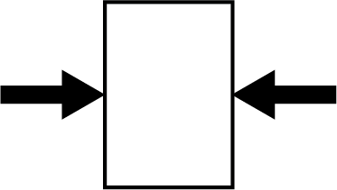

Compression occurs when stress presses in on a rock in one plane (or more strongly in one plane than the others.) Usually compression in rocks is pushing in from one or both sides.

Tension (sometimes called extension) occurs when stress pulls outward on a rock from one plane. Usually tension in rocks is pulling apart from one or both sides.

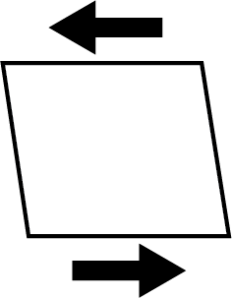

Shear occurs when stress pulls or pushes on a rock from opposite directions.

Do the images above remind you of anything? (Hint…back to plate tectonics?)

What are different ways rocks (and other materials) can deform?
Rocks (and pretty much all materials) deform – change in shape or size - when exposed to enough stress. Rock in the crust is almost all solid but can deform in response to stress in three main ways.
  - If a material breaks, or bends and then breaks, in response to stress, it is said to experience brittle deformation. Imagine a wooden stick, pencil, or piece of chalk breaking when bent enough – that’s brittle deformation.
  - If a material bends then bounces back to its original shape, it is said to experience elastic deformation. Imagine stretching an elastic waistband, or rubber band, or bungee cord, or clothes made of spandex.
  - If a material bends and then stays bent, or flows, this is considered ductile deformation. Think of bending a piece of metal that will never quite go back to its original shape or stretching or shaping a piece of clay or silly putty.

Rocks can deform in any of these three ways, and most materials actually deform in a combination of two or more ways. Usually we’re focused on the kind of deformation that stays recorded in rocks (they only bounce back in elastic deformation), so mostly we concern ourselves in situations in which brittle and ductile deformation dominate.

What controls how rocks deform?
Will the rock deform mostly n a ductile way, or mostly in a brittle way? Four things strongly influence rock deformation:

- Temperature – Rocks and other solids tend to experience ductile deformation under high temperatures (even while remaining solid) and are more likely to have brittle deformation when colder. Ever have something made of plastic suddenly break and shatter in cold weather, when it was perfectly stable in warmer weather? The cold temperature made it more likely to break rather than bend.

- Confining pressure – Rocks and other solids under a great deal of pressure tend to flow or bend under stress (ductile deformation), while the same rock under less pressure will break (brittle deformation) when exposed to additional stress.

- The speed at which stress occurs – Solids exposed to a very quick or fast stress will tend to break (brittle deformation), while the same solids exposed to the same stress occurring over a very long period of time will tend to be bend or flow (ductile deformation). So, the quick jolt of an earthquake will tend to make rocks break, while a slower application of the same stress will bend or fold the rock instead. You can experience the same phenomenon with Silly Putty.

- Rock properties – Some rock types tend to be very strong, and will resist a great deal of stress, while others are very weak and break, bend, or flow easily with little stress. In general, rocks made of mostly very hard minerals will tend to be very strong (think quartzite), and rocks made of mostly very soft minerals will be weak (think rock halite, or marble). Weak materials tend to experience ductile deformation with stress, so we would expect rock halite to flow when exposed to stress. In fact, rock halite flows so easily, shifting surrounding rocks around, that there is an entire branch of geology called “salt tectonics”.

What geologic structures form from brittle deformation?
Fractures, or breaks in a rock, form from brittle deformation. Most fractures are either joints or faults. (Fractures, joints, and faults ALL could form from brittle deformation.)

The simplest and most common kind of fracture is a joint – a fracture in rock layers that does not move the layers in relation to each other but pulls them apart a small amount.

Faults
Faults are fractures in which rocks have slipped past one another, so that rock layers have moved in relation to each other. Different faults can form as a result of different kinds of stress (compression, tension, or shear).

Most faults are not oriented perfectly vertically but are more often a diagonal plane or trace. That means that no matter which ways rocks are moving or have moved on either side of the fault, one rock block on one side of the fault is always above the fault, and the other rock block on the other side of the fault is below the fault. Miners and engineers were the first to notice this pattern, because ores of metals like gold, copper, and silver are often concentrated in the fault zone, and they noticed that rocks on one side of the fault were not lined up with rocks on the other side.

Notice that the “hanging wall” block is the side above the miner, who could hang a lamp from the rock of the hanging wall block. The miner is standing on the “footwall” block, the side below the miner. Naming the rock blocks is useful in describing the movement of rocks on either side of the fault.

Kinds of faults

Three major kinds of faults are recognized, and in turn these three kinds are lumped into two groups.

The two groups are dip-slip faults and strike-slip faults.

Dip-slip faults
Rock movement along a dip-slip fault is along the slope (or dip) of the fault plane, so one block moves up or down relative to the other block. Fault slip is along the dip.

Movement along the dip

Dip-slip fault example.
(Quiz yourself – which is the hanging wall block, and which is the footwall block in this example?)

Two major types of dip-slip faults are recognized:

Normal faults
A normal fault is a type of dip-slip fault in which the hanging wall block moves DOWN relative to the footwall block. Normal faults aren’t more common or more “normal” than other kinds of faults; the name is a legacy of early work by miners and mining geologists who more commonly found minable materials along normal faults than other kinds.

Reverse faults
A reverse fault is a type of dip-slip fault in which the hanging wall block moves UP relative to the footwall block.

Strike-slip faults
Rock movement along a strike-slip fault is horizontal, from side to side, or perpendicular to the slope (a direction called the strike).

Strike-slip fault example.
(Quiz yourself – which is the hanging wall block, and which is the footwall block in this example?)

To summarize: the three main types of faults of interest in this class are normal, reverse, and strike-slip faults.

What geologic structures form from ductile deformation?
The type of structure forming from ductile deformation depends on the type of directional stress applied.

- Structures made by compressive stress + ductile deformation
Structures formed by compressive stress with ductile deformation are known as folds, which literally have folded and rumpled rock layers.

Two main kinds of folds are recognized. Anticlines are folds in which rock layers are warped upward into the shape of an “A”. Synclines are folds in which rock layers are bent downwards into a “U” or “V” shape. (Quiz yourself – label anticlines and synclines on the examples above.)

- Structures made by tensional stress + ductile deformation
When exposed to tension stress with ductile deformation, rocks thin and stretch. A small-scale feature that shows this thinning and stretching is boudinage, a French word meaning “little sausages”, as boudinage are the result of a layer being stretched and separating into eye-shaped segments (known as boudins).

Two examples of boudinage

- Structures made by shear stress + ductile deformation
Structures formed by shear stress with ductile deformation are known as shear zones, which are more inconsistent and less recognizable features than folds or boudinage.

NAME:

LAB 9 PRE-LAB/WARM-UP EXERCISES
Use the information from your notes and textbook to help you answer the following questions before working on the rest of the lab exercise.

- What’s the main purpose of this lab?

- What materials will you need in class to complete this lab?

- Use information from the background information for this lab and your textbook to fill in the table below that predicts how rocks will deform under different conditions.

Type of  Deformation | Temperature  (High or  low?) | Confining  pressure  (High or  low?) | Depth in  crust  (Shallow or  deep?) | Stress  speed  (Fast or  slow?) | Rock strength  (Strong or  weak?)
Brittle
Ductile

- Label the diagrams below with “hanging wall” and “footwall” on the appropriate rock blocks on either side of the fault.

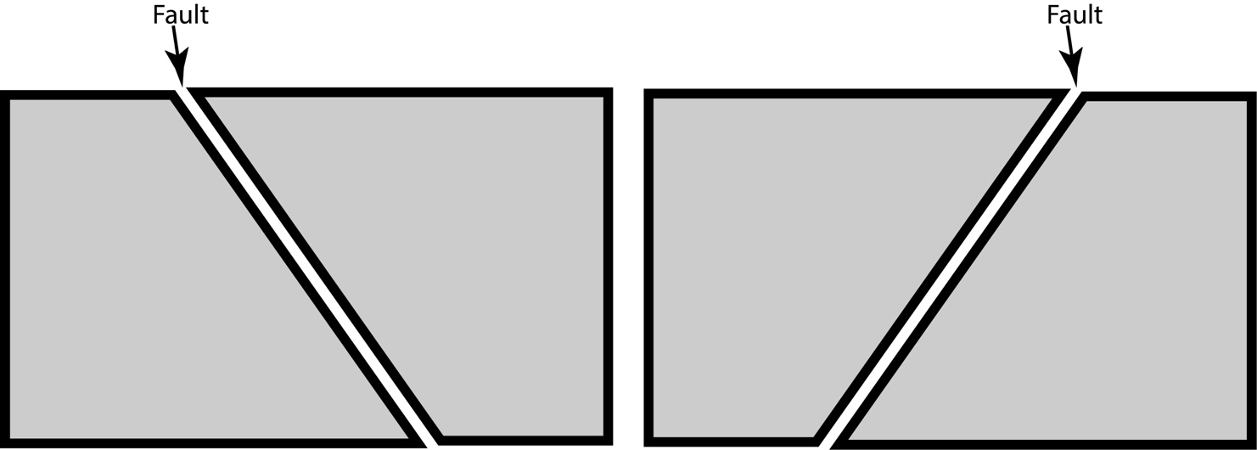

- Match the following geologic structure concepts with their definitions:

Anticline __
Boudinage __
Confining pressure __
Deformation __
Dip-slip fault __
Directional stress __
Fault __
Fold __
Force __
Fracture __
Joint __
Normal fault __
Reverse fault __
Stress __
Strike-slip fault __
Syncline __

- Break in a rock, most common geologic structure.
- Break in a rock in which the rock has pulled apart a small amount, but fault blocks have not slipped past one another.
- Break in a rock where fault blocks have slipped past one another on either side of the structure.
- Characterized by movement in which fault block moves up or down relative to the other fault block.
- Characterized by movement in which one fault block moves sideways or horizontally past another fault block.
- Fault in which the hanging wall block has moved down relative to the footwall block.
- Fault in which the hanging wall block has moved up relative to the footwall block.
- Crease or bend in a set of rock layers formed by compression stress.
- Fold in which rock layers warp up in the middle, forming the shape of an “A”.
- Fold in which rock layers warp down in the middle, forming the shape of a “U” or “V”.
- Stretching and thinning of a rock layer to form eye-shaped blobs, which look like a chain of sausage links.

- Write the name of each major type of stress next to the description of its movement.
  - Pulling apart

  - Pushing together, or pushing in on a rock

  - Moving past each other, or one side of a rock moving in the opposite direction as the other side.

7. Examine the cross-section diagrams (side views) of faults displacing rock layers below and use them to answer the following questions.
  - For each diagram, label the hanging wall block and the footwall block.

  - Along the fault in each diagram, draw arrows showing the direction of movement of each side based on the offset of the layers. Use the geologic convention of drawing the arrows parallel to the fault plane.

  - Write the name of each type of fault underneath the appropriate diagram. Choose from NORMAL or REVERSE faults.
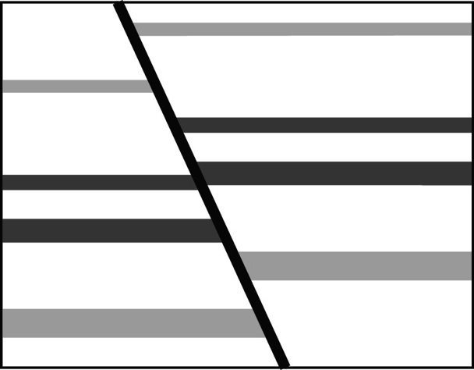
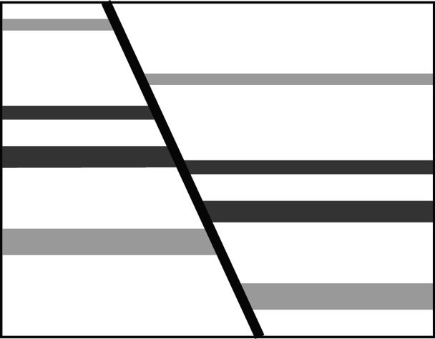
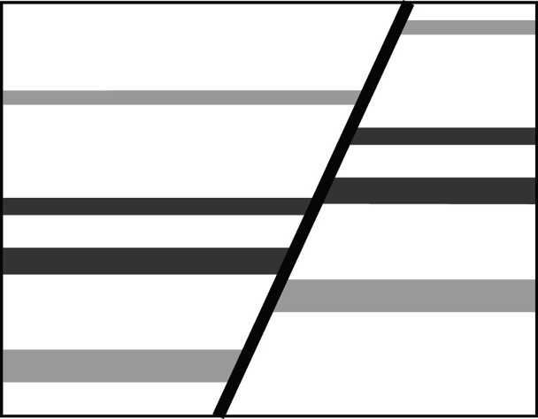
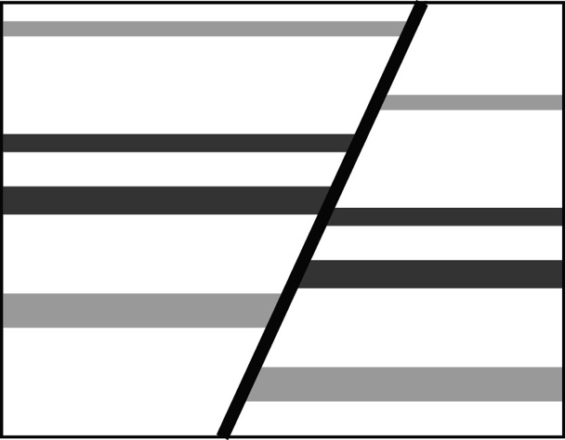

LAB 9 LAB EXERCISES
Instructions: record your answers here! Note: you are encouraged to work with other students but must do your own work.

In the next set of exercises, you’ll work with foam models. Read carefully to follow the directions on how to arrange and move the foam models, and then make measurements, sketches, and answer questions on the models. You’ll use the graph paper to sketch the models and attach it to the lab pages when done.

Fault model experiments

Experiment A: Set up (before faulting)

Make sure your three foam blocks all have the same number on their white sides, and write that number here:

  - Place the three foam blocks on your table so that they are white side up. Locate the breaks in the colored rock layers – these are fractures that will become faults when you move the rock blocks relative to each other.

  - Arrange the blocks so they are all connected, with the two blocks with vertical sides on the ends (one on each end with the vertical sides facing out), the block with diagonal sides in the middle, and the river (blue curved line) lining up across all three pieces.

  - Answer the following questions:

    - Making sure the three blocks stay touching and aligned, measure the total length of the land represented by the three blocks together, in centimeters to the nearest 1/10th (ex. 9.4 cm), and record your measurement here:

cm

    - Keeping the blocks in the same arrangement, sketch a side view of the land represented by all three blocks together (so you can see the colored rock layers) at a 1:1 scale on graph paper.

This means you’ll need to make it the same size on your paper as it is in real life. To view and draw the blocks from this perspective, you may want to set the blocks on their sides, or move your head so you’re looking at them from “side view”.

1:1 scale means that the length and the height of the blocks should be the same on your sketch as they are in real life. You can move the blocks onto your graph paper to trace around them if that helps. Remember, you’re making a side view!

It also means that the length of the land represented by all three blocks lined up should be exactly the same as drawn in your sketch as it is in real life.

You do NOT need to indicate each individual colored layer. Pick three colored layers to sketch in and color with colored pencils; you do NOT need to color in all of the layers!

Experiment B: Faults made by pushing together

- Start as you did for Experiment A: Set up, with the blocks aligned in the same way.

- One person will next gently grab on to each of the end blocks (one in each hand) and carefully push them slightly together, so that the block in the middle pops up a little. You can pick up the blocks, or keep them on the desk top. You may need to shift them around a bit, but what you want is the three blocks all touching, with the middle block higher up than the end blocks.

- Place the blocks in this new configuration onto the desk table.

- Answer the following questions:

    - Making sure the three blocks stay aligned, measure the total length of the three blocks together, in centimeters to the nearest 1/10th, and record your measurement here:

cm

    - Sketch a side view of the land represented by the blocks at a 1:1 scale on graph paper (so that you can see all the layers).

      - Make sure the length of the land represented by the blocks is exactly the same as your measurement above (in 4a).

      - Color in the same three layers as you did for Experiment A with colored pencils.

      - Label the hanging wall and footwall for each fault.

      - Draw arrows on either side of both faults (parallel to the fault plane, using the geologic convention) to indicate the relative movement.

    - Using what you know about the types of faults and your sketch of the faults, name the fault type (or types) that are created in this experiment.

    - Identify the type of stress that you applied to produce these faults.

    - Identify the type of plate boundary you’d expect to be associated with this type of fault.

    - Compare the total length of the blocks in this experiment with the total length before stress was applied (as in Experiment A: Set up).
Experiment C: Faults made by pulling apart

- Start as you did for the other experiments, with the blocks aligned in the same way. As in Experiment B, you’ll need one person to grab on to each of the end blocks (one in each hand) and pick up the blocks so they are a little off the table in this experiment.

- Pull the two end blocks slightly apart from each other, letting the middle block drop down a little bit. You may need to shift them around a bit, but what you want is the three blocks all touching, with the middle block lower down than the end blocks.

- Place the blocks in this new configuration onto the desk table; another person will keep the middle block shifted upwards by inserting the support block into the gap.

- Answer the following questions:

- Making sure the three blocks stay aligned, measure the total length of the three blocks together, in centimeters to the nearest 1/10th, and record your measurement here:

cm

- Sketch a side view of the land represented by the blocks at a 1:1 scale on graph paper (so that you can see all the layers).

- Make sure the length of the land represented by the blocks is exactly the same as your measurement above (in 4a).

- Color in the same three layers as you did for Experiment A with colored pencils.

- Label the hanging wall and footwall for each fault.

- Draw arrows on either side of both faults (parallel to the fault plane, using the geologic convention) to indicate the relative movement.

- Using what you know about the types of faults and your sketch of the faults, name the fault type (or types) that are created in this experiment.

- Identify the type of stress that you applied to produce these faults.

- Identify the type of plate boundary you’d expect to be associated with this type of fault.

- Compare the total length of the blocks in this experiment with the total length before stress was applied (as in Experiment A: Set up)
Experiment D: Faults made by one side moving past the other.

      - Start as you did for Experiment A: Set up, with the blocks aligned in the same way.
      - In this experiment, the goal is not to make the hanging wall move up or down relative to the footwall. Instead, you will move the hanging wall sideways past the footwall a short distance., keeping the blocks so that they are touching each other. Gently push the middle block an inch or so to the side, so that the river is offset.
      - Answer the following questions:

- Making sure the three blocks stay aligned, measure the total length of the three blocks together, in centimeters to the nearest 1/10th, and record your measurement here:

cm

- Sketch a MAP view of the land represented by the blocks at a 1:1 scale on graph paper (so that you can the river cut by the faults).

      - Make sure the length of the land represented by the blocks is exactly the same as your measurement above (in 3a).

      - Draw the river to show how it is displacement by movement along the faults.

      - Draw arrows on either side of both faults (parallel to the fault plane, using the geologic convention) to indicate the relative movement.

- Using what you know about the types of faults and your sketch of the faults, name the fault type (or types) that are created in this experiment.

- Identify the type of stress that you applied to produce these faults.

- Identify the type of plate boundary you’d expect to be associated with this type of fault.

- Compare the total length of the blocks in this experiment with the total length before stress was applied (as in Experiment A: Set up).

- Why do you think the instructions ask you to sketch the blocks and faults from ABOVE (map view) in this experiment, rather than from the SIDE (side view) like the other experiments?

Experiment E: Making folds
- Use the loose foam sheets as rock layers (NOT the blocks you’ve been using for modeling faults!).
- Stack up the loose foam sheets (rock layers), and fold them to make a) an anticline, and b) a syncline.
- Answer the following questions:
  - What kind of stress did you apply to make the anticline?

  - Did the total length of the rock layers increase, decrease, or stay the same as compared to before you applied stress to make the anticline?

  - What kind of stress did you apply to make the syncline?

  - Did the total length of the rock layers increase, decrease, or stay the same as compared to before you applied stress to make the syncline?

  - Could you make a fold using tension stress? Briefly explain why or why not.

  - What type of plate boundary would you expect to be associated with folds?

Summarize your findings
Fill in the table linking geologic structure type, stress type, and plate boundary type, based on your findings in this lab.

Geologic structure name | Land width (lengthens, shortens, no change) | Stress type | Plate boundary  type
Anticline
Normal fault
Revere fault
Strike-slip fault
Syncline

Part D. DISCUSSION QUESTIONS: Answer with complete sentences.
- Which aspect (or aspects) of identifying geologic structures, deformation types, and stress types did you find most challenging? Explain.

- What activities (pre-lab, lecture and discussion, e-quiz) did you find helpful when working on this lab?

- What is one thing you learned in this lab about geologic structures that you did not know or understand before? Explain.

- Of the learning goals stated for this lab, which are you most comfortable with or confident you can do well now?

- Of the learning goals stated for this lab, which would you most like more practice with?

