Objectives
- Download and explore the GeoMapApp
- Clearly explain potential reasons that cause the change in climate during the PETM
- Be able to plot multiple core logs
- Increase knowledge of δ¹³C and % CaCO₃ information in sediment cores.

Your employer has asked you to investigate a preliminary set of sediment data from cores in order to determine if the data are from the Paleocene-Eocene Thermal Maximum, PETM, which resulted in rather distinguishable data. They have also asked you to clearly explain the trends in the data and provide potential causes for the shift in the climate during the PETM. If you are able to do these tasks, your employer is willing to get you more ocean sediment core data, so you can make a more accurate interpretation!
Therefore, you will need to clearly explain the sediment data from the cores, including the δ¹³C and % CaCO₃ data, provide picture(s) of the locations of the cores, an image of a core identifying the PETM, and what additional information could be gained by having additional ocean sediment data.
In order to investigate this time period of Earth’s history, you will need to download additional core data from the Atlantic Ocean using the program GeoMapApp, and use the data downloaded during the last lecture. The data from class does not contain the sediment core locations or the images of the sediment.
The website to download the GeoMappApp is: http://www.geomapapp.org/, which has some additional data that will be useful. Download GeoMappApp to your computer then…
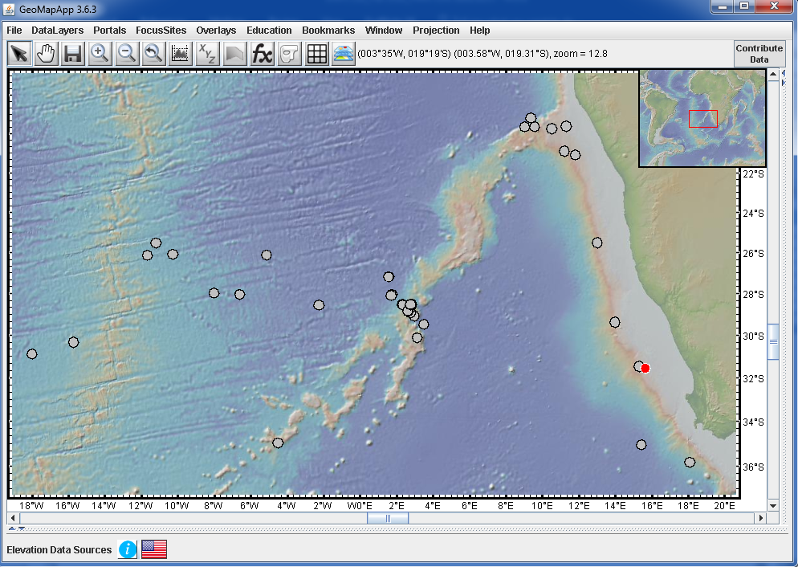
Go to “Portals” select “Ocean Floor Drilling”, which will open the “DSOP – ODP – IODP DRILL HOLES” window (both shown below)
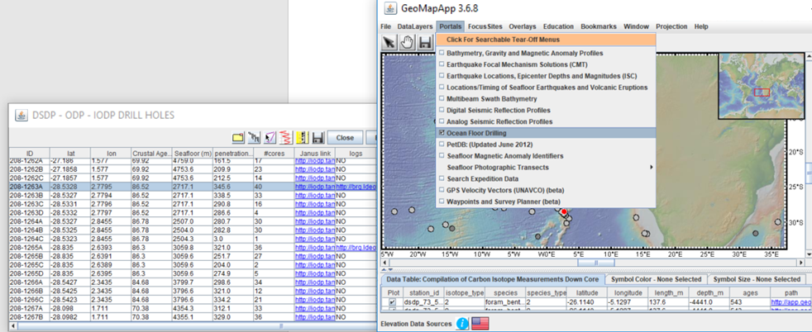
Deliverables
- Graph the sediment core data used in class (δ¹³C and depth), but with shallow depth on top of the graph’s y-axis. Use labels, make graphs that look good, and have the x- and y-axis on the edges of the graphs
- Create a graph of depth versus δ¹³C and depth versus weight % CaCO₃ for the 5 cores.
- Screen shot(s) of the locations of the Cores (using the GeoMapApp)
- Write two pages double-spaced describing what δ¹³C and % CaCO₃ data indicate. Also include the influence of CO₂ on the sediment and how the CO₂ got into the sediment, and the role of plate tectonics on the data. Be sure to cite sources using APA or a similar format
- Provide a brief description of any limitations (such as core data resolution) of the data, or additional data that would be helpful
The assignment should be between 2 and 3 typed double-spaced pages. Pictures, your name, title, date and similar do not count towards the formal page length. Submit the assignment electronically to Canvas, and indicate if you worked with someone on the assignment. Limit groups to two people.

