Entering a Field Guide into Flyover Country

The main webpage for entering information from your field guide into the Flyover Country App is
https://admin.flyover.umn.edu/login/auth. If you don’t yet have an account setup, please reach out to us via this Google Form. All guides entered are freely available via API call and can be used in other apps, if some should exist.

From the list, click the option titled FieldGuideController.

If you’re working from a PDF of a field guide see our tips for cleaning up the text here: z.umn.edu/cleanpdf

This page contains a list of field guides entered into the app, if there are any in your group. Start a new field guide by clicking the New Field Guide button near the top left.
The boxes outlined in red with a star need to be filled out in order to move on or save progress. Other information is optional.
- Identifier: a unique code or text that defines your field guide (for example, the digital object identifier [doi]). If you are entering your own material, or the content you’re inputting does not have an identifier already associated with it, you’ll need to create one yourself. An example might be a combination of the title of the work, the publisher, and the year.
- Publisher (Ex: Geological Society of America, Minnesota Geological Survey)
- References (if entering your own work: “none”)
- Title
- Publication - Optional. (Ex: The Geological Society of America Special Paper 522)
- Year Published
- Status - This field is used by the the admins to deploy finished guides.
- Group - The field guide group you’re a part of. Assigned when you sign up.
- Audience - General public, K-12, Undergraduate, Professional Geoscientists
- Authors - Enter as they appear in the guide, or last name, first name
- Shape: Overall area of the guide. Use the map’s polygon tool (highlighted in orange) to draw a shape that encompasses the entire region of the guide (All stops should be within this shape)

  - Make this shape simple (<6 vertices) and allow significant (~25-50 miles) buffer around the stop locations. Once you’ve created the shape, press “map it.” you should see some text in the box below:
  - 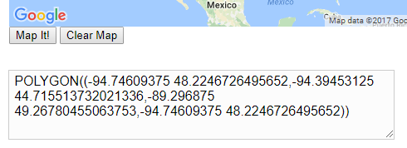
  - This shape can be edited later to match the distribution of stops after they’re entered below, just make a first pass here.
  - If there is an overview map figure in the guide, use that as a starting point.

- Abstract and Keywords if your guide includes them (make sure there are commas between keywords).

Hit Create on the bottom left of the screen. This will save your field trip and from there you can edit the other sections.

Now that your guide is created, select the Edit button in the lower left corner.

Figures
We will add all of the figures in the guide before moving on to stops and sections.

Scroll down to the Figures section. Select Add Figure.
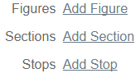

You should now see this view:
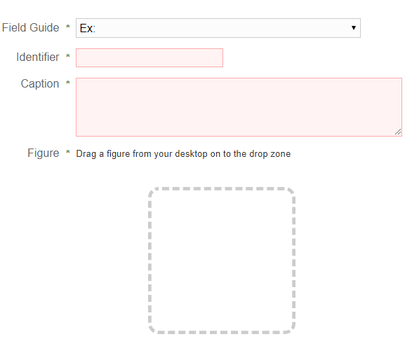
- The “Field Guide” field should already contain the identifier of the guide you’re currently editing.
- Next create an identifier for the figure you’re uploading. Ex: Fig1
- Paste in or type the caption to be associated with this figure. Watch for erroneous line breaks during this step if pasting from PDF.
- Drag and drop a figure into the box, and wait for the upload to finish
- Select Create
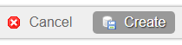

You will now see this view:

If you’re satisfied with the result, go ahead and repeat the process after hitting the New Figure button above (highlighted in orange).

Once you have added all of your figures to the guide you are ready to start adding Sections and Stops.

Sections
What’s a section?
Sections are for portions of the field guide that are not related directly to a geographic region or “stop.” These often include “Introduction”, “Geology of the ___ Region”, or other background material.
In the edit view of your guide, select Add Section.
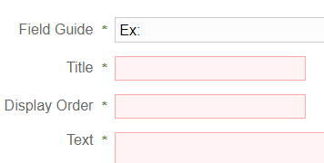
- Title the section Ex: “Introduction”
- Add a display order. This will determine the order which sections will appear in the app (the same order as they appear in the guide). A good practice for this is using multiples of 10 instead of single digits. Ex: section one: display order 10; Section two: display order 20. This allows ‘shimming in’ of sections at a later time if necessary. For example: if you wanted to add a section between one and two after their creation you could use display order 15.
- Paste in or type the main section of text into the “Text” section.

Next you’ll associate figures with your section. If entering a published guide, look for which figures are mentioned in that current section. Drag the figures associated with the section from the “Available Figures” section to the Selected Figures (ordered). These will appear in the app at the bottom of the section in the order (left to right) that they appear here.

After each addition of a section, it may be useful to navigate to the guide’s main view and check the “mobile proof” to see that things are showing up as expected. (see “proofing the guide” section below) The most common issues here are with the appearance of text. Many issues can arise when copying text out of PDFs, most having to do with erroneous line breaks.
Stops
Stops are geographic. They can be points, lines, or polygons and have associated text and figures.

From the main Edit view of your field guide, select Add Stop

- Identifier: Add the stop number here. Basic field guides with simple stops should just have 1, 2, etc. If there are sections in your guide for things to see between stops, you can create a 1.5 or other identifier to specify this.
- Title
- Display Order: Same concept as display order from the sections. Listed in order of how you want them displayed on the app. Use multiples of 10 for future flexibility.
- Shape: Here you can use either the point tool, line tool, or the polygon tool depending on the stop’s geometry. Switch between tools using the toolbox at the top of the map
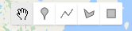
- Linestrings work well for stops driven past in a car, points for individual sites, and polygons for general regions of the field guide area.
- Be sure to press “map it” after drawing the stop on the map.

- Paste in or type text for the stop you’re editing.
- Figures: Same concept as figures from sections. Drag and drop those associated with the stop and order them accordingly.
- Click Create (or update if editing) in the lower left.

Repeat these steps for all of the stops in the guide by hitting the 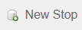 button at the top of the page.

After each addition of a stop, it may be useful to navigate to the guide’s main view and check the “mobile proof” to see that things are showing up as expected. (see “proofing the guide” section below). The most common issues here are with the appearance of text. Many issues can arise when copying text out of PDFs, most having to do with erroneous line breaks.

Proofing the guide
The main view of your guide (accessed from the FieldGuide List) will have a small version of Flyover Country with a copy of your guide.
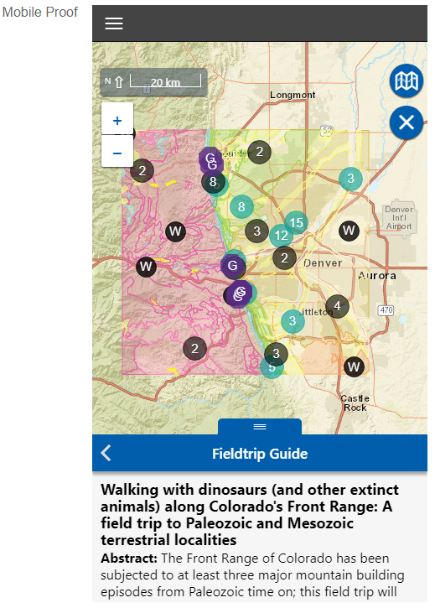
Here you can check to see that all of the stop locations (purple G’s) that you’ve entered are within the overall guide’s shape defined when creating the guide initially. If you see that stops are outside of this shape, go ahead and edit it by hitting the edit button in the lower left and repeating the steps to create the shape outlined in the first section of this tutorial.

From this mobile proof view you can scroll through the content (browsers handle this differently. If you have a touchscreen laptop, use your finger to scroll through content, some require clicking and dragging with the mouse, and others respond to the scroll wheel). Check to see that the correct figures are showing up in the correct sections and stops as well as that the ordering of sections, stops, and figures, is correct. This view can be busy since it is also showing the app’s other data sources. Turn them off by selecting the button in the map’s top right corner and toggling them. The extent of the geologic maps is determined by the the shape you’ve specified for the overall guide.

When you think that your guide is ready to go, email Shane at Loeff081@d.umn.edu to start the approval process.

