Volcanic hazards and risks

Prior to class

Watch the video Volcano: Nature’s Inferno. While you are watching the video, keep a running list of the volcanoes mentioned - write down every volcano they talk about, and a quick note about what happens there.

After you've watched the video, use your list to find all of the volcanoes mentioned on your volcanoes map and circle them. Use your map and notes to answer the following questions.

- List the volcanoes mentioned in the movie and the country where they are located. (Bring your map to class.)

- What kinds of hazards are associated with volcanic eruptions? In other words, what sort of things happened that harmed people or infrastructure (buildings, roads, etc.)?

- Describe where the most destructive volcanic eruptions in the movie occurred, both in terms of where in the world geographically and where with respect to plate boundaries.

- Describe where the least destructive volcanic eruptions in the movie occurred, both in terms of where in the world geographically and where with respect to plate boundaries.

- What did you find most interesting or surprising in this video, and why?

Volcanic hazards and risks

Part 1: Hazards and risks globally

Compare your map with a partner or the people at your table, and remind each other of the characteristics of the different volcanoes. In the list below, indicate what kind plate boundary or other tectonic setting is associated with each volcano (you can use abbreviations, like C for convergent, D for divergent, and HS for hot spot). Circle the eruptions that took the most lives.

____ Vesuvius, Italy
____ Santorini, Aeolian Islands, Italy
____ Surtsey, Iceland
____ Heimeay, Iceland
____ Nevado Del Ruiz, Columbia
____ Galeras, Columbia
____ Sakurajima, Japan
____ Unzen, Japan
____ Pinatubo, Philippines
____ Tambora, Indonesia
____ Kilauea, Hawaii, U.S.
____ Augustine, Alaska, U.S.
____ Mt. St. Helens, Washington, U.S.
____ Pelee, Martinique
____ Oldoinyo Lengai, Tanzania
____ Mid-ocean ridge volcanoes

Feel free to look them up if you aren’t sure where they are.

As a whole group, we’ll talk about the difference between hazard and risk. Once we’ve had a chance to talk about it, write the definitions below:

Natural hazard

Risk

Exposure

Vulnerability

Now that you have definitions, use your volcano map along with the population density map and what you saw in the movie to fill in the table below to summarize volcanic hazards.

Volcanic hazards, risks, and plate tectonics
 | Convergent boundaries (subduction zones) | Divergent boundaries | Hot spots
Characteristics of eruptions
Hazards
Risk (relative level of risk, as determined by exposure and vulnerabilities)

With respect to plate boundaries, geography, and demography, where do the most destructive volcanoes occur? Your answer should be more specific than “convergent boundaries” or “South America”, and could describe a few specific locations or types of locations. In other words, where is both the hazard and the risk the highest? Why do you think the hazards are greatest here (be specific with respect to what you know about plate tectonic processes and the rock cycle) and why are the risks the greatest? Put your group answer on a white board to share with the rest of the class.

Part 2: Volcanic hazards and risks in Cascadia

Now we’ll zoom in to our local volcanoes. We’ll start by watching a short video about what has happened at Mt. St. Helens since the 1980 eruption.

What are some of the modern methods for monitoring volcanoes that have been developed since the 1980 eruption? How do those help geoscientists understand a volcano’s activity?

Mt. Rainier is one of the more heavily monitored volcanoes in the country. Why do you think that’s the case, when it’s not the most active?

Take a look at the attached hazard map for Mt. Rainier. Our ultimate goal is to fill in the table below, but we’ll start with each group taking a particular hazard and learning more about it. You’ll present it briefly to the class to fill in the rest of your table. Circle the hazard assigned to your table. Use the links provided in Canvas to give you more information.

Type of Hazard | Types of Damage Caused (e.g. blowing down houses, fires, etc.) | Areas where this hazard occurs (e.g. river channel, high plains, downwind, etc.; use hazard map) | Populations at risk from this hazard
Lava Flows, Domes
Pyroclastic Flows/Surges
Lahars Flooding & Sedimentation
Ash/Tephra Fall (see map below)

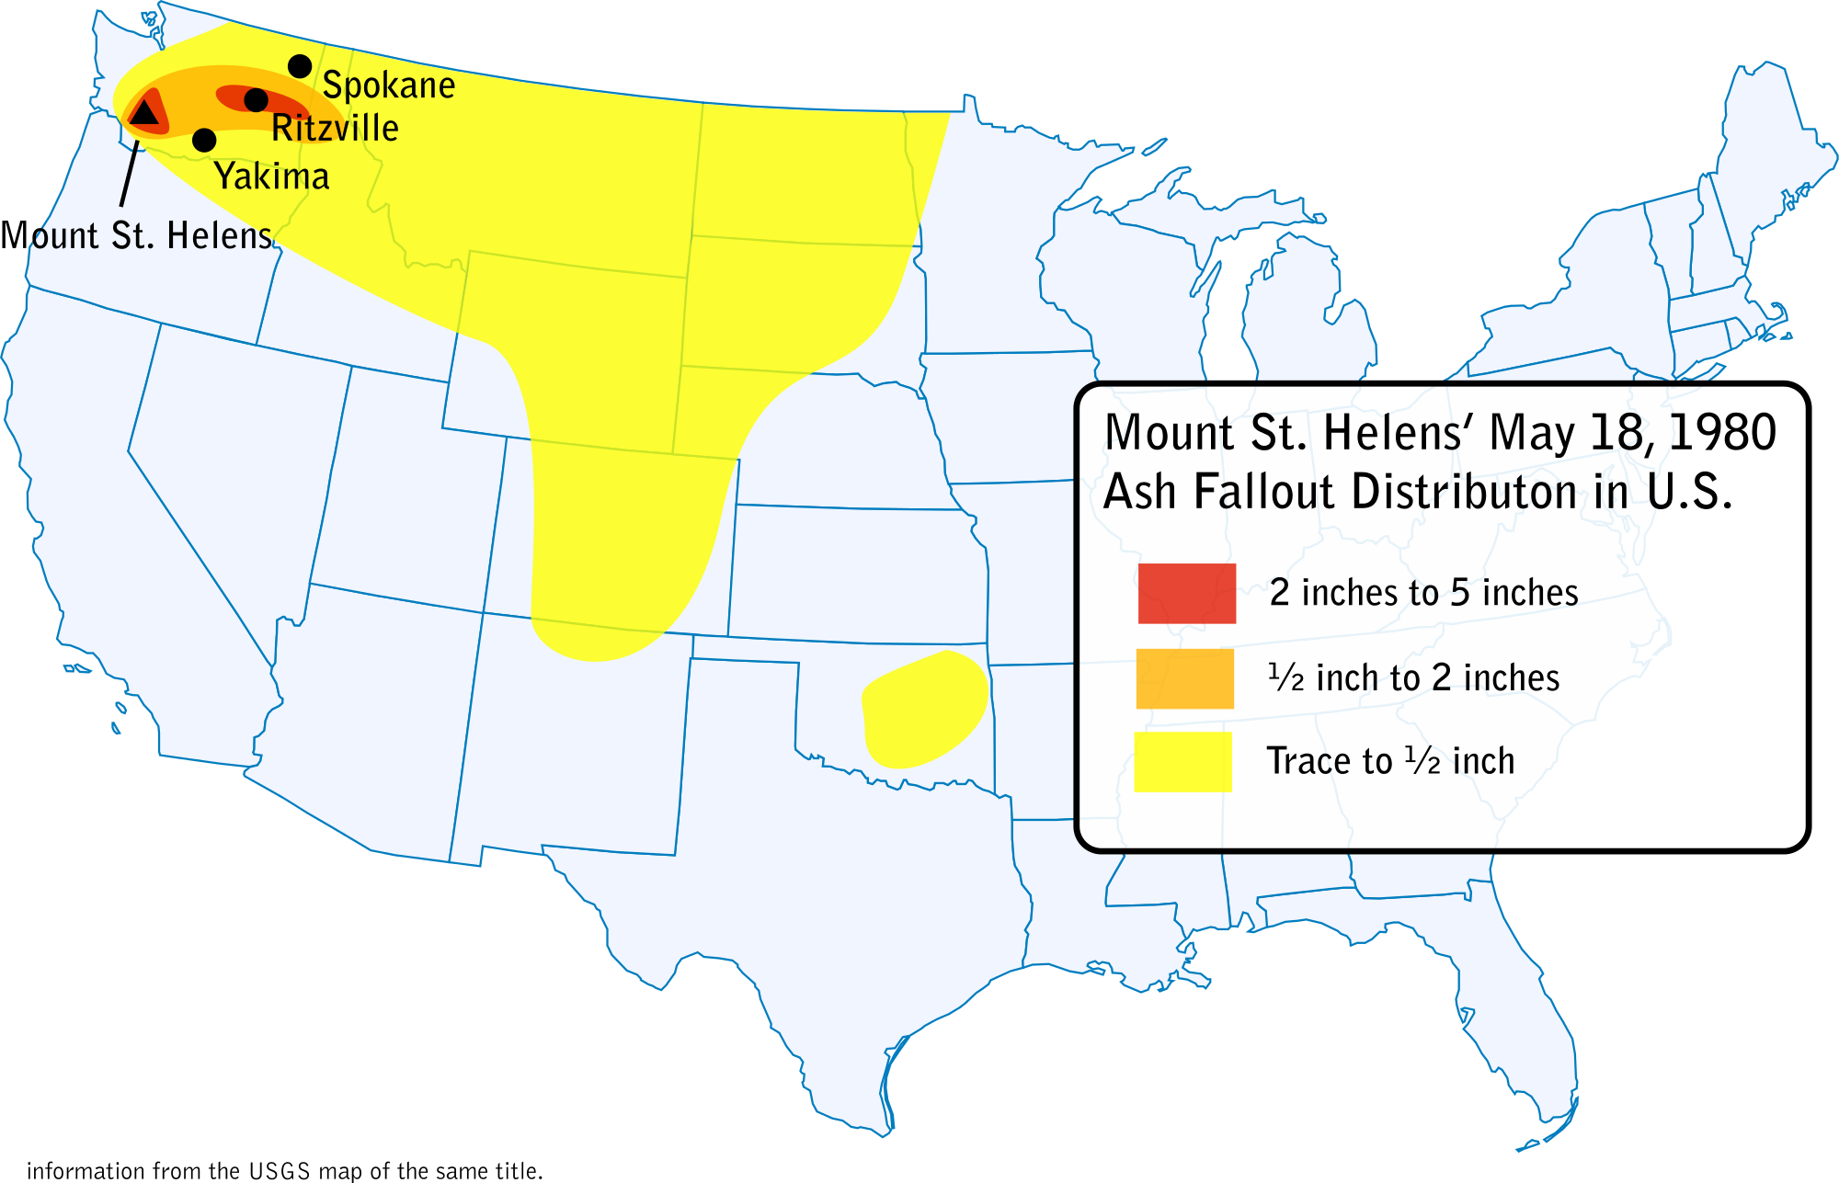

Describe two ways how monitoring Mt. Rainier continuously benefits society.

What are the roles of scientists and citizens in the event of an eruption? How do you envision your role as a teacher?

