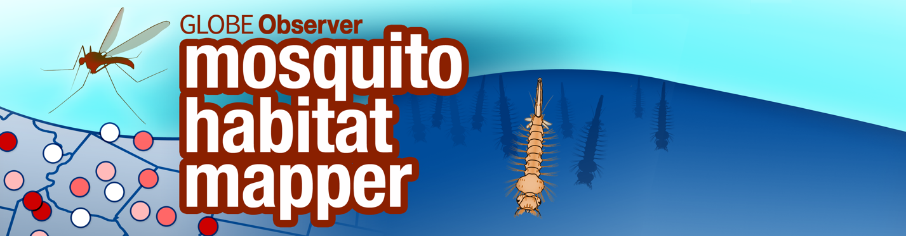

Developing a Research Project, using the GLOBE Observer Mosquito Habitat Mapper
Does Source Reduction Make a Difference?

What is Source Reduction?

Container-breeding mosquitoes such as the yellow fever mosquito, Aedes albopictus, and the tiger mosquito, Aedes aegypti, have the ability to transmit a number of diseases to humans, such as dengue, chikunguna, yellow fever and the Zika virus. The best way to prevent reduce these health risks is to reduce the size of mosquito populations. Container mosquitoes pose challenges to municipalities because these mosquitoes have adapted to live alongside humans, and find their preferred breeding sites in yards and inside houses. Applying larvicide broadly isn’t very effective for these species, as it misses most of the small opportunistic containers that these species prefer. Also both these mosquitoes bite during the day, so the typical practice of pesticide fogging in the evening is not effective for these species. As a result, they are a serious challenge for mosquito control.

One practical strategy to reduce the number of mosquitoes is to eliminate access to standing water in containers. Fewer accessible containers result in fewer breeding sites, and thus mosquitoes will have fewer places to lay eggs. Effective mosquito control includes removing extraneous container habitats and covering water storage containers with a fine mesh, so that females cannot lay eggs that will develop through their aquatic states, as well as dumping water so that the eggs, larvae or pupae can’t develop into adult biting mosquitoes

The strategy to combat mosquitoes by eliminating potential breeding habitats is called source reduction. Source reduction has proved to be effective when a neighborhood or community is mobilized and looks to remove breeding sites at regular intervals. The GLOBE Observer App- Mosquito Habitat Mapper https://observer.globe.gov/ is a tool that can be shared not only with your class but with everyone in your community to ensure that most of the container breeding habitats are eliminated. Community actions, such as clearing blocked gutters or drains, eliminating the storage of used tires outdoors and other simple activities can make a big difference. The lifetime geographical range of Aedes aegypti is about 500 meters, so these local initiatives will serve to reduce risk in communities where people live.

How important is source reduction in the control of mosquito populations and disease? The GLOBE Observer Mosquito Habitat Mapper can assist in conducting class research on this project- and provide important information to your community that can assist in controlling disease.

Developing a Research Project

Lead the class in a discussion and have them develop their research project. Here are some discussion topics you can use to assist the students in creating their own project.

Task 1: Hypothesis. Develop a hypothesis of what the class expectations are, if there is a concentrated effort to remove containers from use by mosquito females, by either eliminating the container, dumping the water, or covering the breeding habitat.

- What are some hypotheses you consider as a class?

- What is the hypothesis you want to test?

Task 2. Research Design: What data can you use to determine the initial conditions, prior to your source reduction work?
Some suggestions:

- Egg data from ovitraps
- Adult mosquito volume from adult traps
- Disease data from local health agency
- Mosquito data from local mosquito control agency

Task 3. Research and Data Collection.

What data will you need to collect? Some examples:

- Conducting surveillance and habitat removal using the GLOBE Observer Mosquito Habitat Mapper
- Setting egg traps and checking at intervals (what length of time?)
- Setting adult traps and checking at intervals (what length of time?)

When will your study take place, How long will your study be, and How often will you need to conduct your experiment and/or collect data?

- How would you decide how often you need to visit your traps or habitat sites?
(Hint: think about the length of the mosquito life cycle. You want to be sure that the eggs or larvae do not develop into adults and fly away.)

How will you record your data? (Will you use the GO Mosquito Habitat Mapper?)

Task 4. Conducting your analysis

What data will you compare?

Task 5. Reporting your conclusions

What data visualizations will accompany your analysis? Graphs? Maps? Data tables?

