Researching Local Mosquito Growth and Development and Degree-days, using GLOBE Atmosphere Protocols

The growth and development of insects are dependent on several environmental factors including temperature (heat), light and humidity. Insects are cold-blooded, so temperature has the greatest effect on insect development rates.

Getting started:

You will need to have access to a Min/Max thermometer to take frequent temperature readings.. The GLOBE Air Temperature protocol provides information and instructions on obtaining air temperature data for use in your study.

You will also need to to observe mosquito larvae growth and development. You must first set out traps (Ovitraps) to capture some adult mosquitoes. Once eggs are laid, you can observe the contents of the trap daily until the larvae become adults. Be sure to put a net over the top of the trap once you have eggs!

Temperature and Insect Metabolism
Here is a generalized graph of insect development rate (red dots) versus temperature:
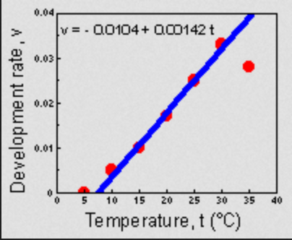
As you can see, insect development rate increases as temperature increases, up to a certain point. In the temperature range from 10 to 30 degrees Celsius, development rate changes almost linearly with increasing temperature. At very low temperature there is no development, and at very high temperature development drops off. (Can you figure out why this might be the case?)
Mosquitoe eggs need a certain temperature to hatch into larvae. Temperature also influences the rate at which the larvae change to pupae and pupae change to adults. One piece of temperature data that biologist use is “degree-days.” Degree-days is a measure of how much (in degrees) and for how long (in days) the temperature supports mosquito growth and development. Different species of mosquitoes have a base temperature at which their eggs will start to develop and a temperature cut-off point at which development stops
Degree-days are calculated to measuring insect growth or development in response to daily temperatures. The easiest way to calculate degree days for a specific date is to add the daily high and low temperature and divide by two. Then, subtract the threshold temperature for the particular insect. For example, if the Min/Max thermometer indicates a low of 45 degrees F and a high of 75 degrees F, then the average temperature for the day was (45+75)/2 = 60 degrees F. If the threshold temperature was 50 degrees F, then 10 degree days would have accumulated.
Degree-days are used by scientists to develop predictive models of mosquito population dynamics. The models used by scientists are usually developed by growing mosquitoes in a laboratory under known conditions. However, the models aren’t always predictive because other factors besides temperature affect mosquito development such as precipitation, food availability, and predation. Obtaining degree-day data in field conditions using GLOBE protocols will help scientists to develop better models.
Check your thermometer and make this calculation each day. Add the daily value to the total from all the previous days. You can keep up with the progress toward your target number. Minimum and maximum temperatures should be recorded from a Min/Max thermometer about the same time each day, preferably in the mid morning or late afternoon.
After making a few observations, pose questions as a class that you could investigate using the the Mosquito Habitat Mapper and GLOBE protocols. Here are some useful resources that can inform your discussions:
https://entomology.ca.uky.edu/ef123
http://weather.uky.edu/class/class.php
http://www.virginiafruit.ento.vt.edu/Understanding_Degree_Days.html

