Curiosity Launch
By Matthew Vonk University of Wisconsin River Falls
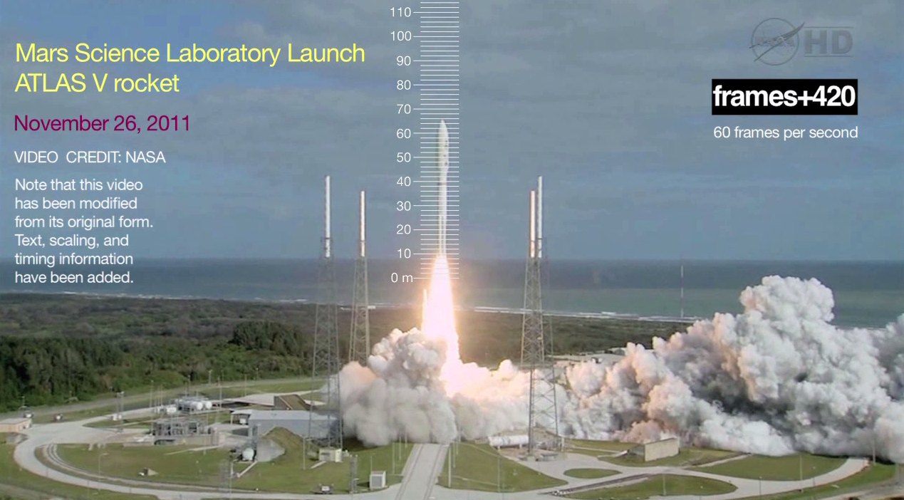
- Open and watch the Curiosity Launch all the way through.

- Make a list of a few things that you notice happening in the video.

- A bird flying
- The exhaust plume seems to emanate from a side bunker first
- There’s lots of smoke or vapor given off
- There’s a nice ocean view with white caps breaking
- It’s a Mars Science Lab Launch on an ATLAS V rocket
- It’s November 26, 2011

- Sometimes it can be difficult to tell exactly when the motion starts in a Direct Measurement Video. What is your best estimate of when the rocket started to accelerate upward?

It took me a while to realize that the camera appears to be vibrating in such a way that the whole image moves up on one frame and down on the next. This is easiest to see if you look at the line of the beach on the side of the frame. This motion of the camera makes it tough to know exactly when the rocket starts to move. I’m pretty sure that the rocket starts its upward motion at frame 175 ± 15 frames.

The rocket reaches the 100 m mark at about frame 476 ± 1, so the total time is about 301 and the uncertainty is around 16 frames or just over 5%. That 5% uncertainty will be the same for all of the calculations below with the exception of the acceleration measurement which will have double the uncertainty since its dependence on the final velocity and the time add together.

- How many frames does the rocket take to go 100 m?

It starts moving at around frame 175 and reaches the 100 m mark at around 476.

So 476-175=301 frames.

- How long is that in seconds?

301 frames x (1 second / 60 frames) = 5.0 s

- What is the rocket’s average velocity during that interval?

100 m / 5.0 s = 20 m/s

- Assuming that the rocket’s acceleration is constant, solve for the acceleration of the rocket from 0 – 100m.

x = v_{o}t + ½ a t²

100 = 0 + ½ (a) (5.0 s)² → a = 100*2/5²=8.0 m/s²

- Assuming that the rocket’s acceleration is constant, solve for the velocity of the rocket when the tip of the rocket has travelled 100 m.

v = v_{o} + at = 0 + (8 m/s²) * 5.0 s = 40 m/s (which is about 89 miles an hour).

Another way to solve this is to simply multiply the average velocity by two, since the rocket starts at rest.

- Assuming that the rocket’s acceleration remains constant, how long would it take to reach the height of Mount Everest, 8848 m?

x = v_{o}t + ½ a t²

8848 = 0 + ½ (8.0 m/s²) t² → t = √(8848*2/8.0) = 47 seconds

- Assuming that the rocket’s acceleration remains constant, how long would it take to reach the international space station, 330 km?

x = v_{o}t + ½ a t²

330,000 = 0 + ½ (8.0 m/s²) t² → t = √(330000*2/8.0) = 290 seconds or just under 5 minutes

- Why is it likely that the acceleration of the rocket will not be constant over such a long time?

The jets may burn out.
The rocket is getting less massive as it burns off fuel.
The earth’s gravity will diminish slightly, to about 8.9 at 330 km.
You wouldn’t want to be travelling that fast (8 m/s² * 290 s= 2320 m/s) when you reach the space station.

You may also want to have your students graph the solution. My data table and graph are below:

According to this fit the Displacement of the rocket tip = ½ a t² + v_{o}t + x_{o} = ½ (8.379) t² + -26.092 t + 42.763

Notice that the acceleration just 2 times the first fit parameter (4.1893) or 8.379 ≈ 8.4 m/s². That’s in good agreement with the value for the acceleration that we got above.

I plugged the fit parameters into the math is fun quadratic equation solver (http://www.mathsisfun.com/quadratic-equation-solver.html) and it graphed it for me (on the right). Notice that the fit parameters correspond to a full parabola not just the section that we were able to measure. As such, the other two fit parameters don’t make much sense. They imply that if we ran the movie of the rocket backwards all the way to time t=0 but *maintaining* the same upward acceleration that it has when the engines are firing, then the only way it could end up where it does is if it started at t=0 with its tip at 42.762 m, and with a downward velocity of 26.092 m/s. We know that didn’t happen since the rockets didn’t kick in until about 3 seconds into the video and we know that it started at rest on the ground.

We can however find the time when the fit says that velocity should be zero. That’s the minimum point on the graph on the right. You can see that it’s about 3.1 seconds. Another way to find it is to take the derivative of the equation (which would represent the vertical velocity) and set that equal to zero.

dy/dt = 2*4.1893 t - 26.092 = 0 t = 3.11 seconds 3.11 s x (60 frames/ 1 second) = frame 187

According to our fit (which assumes constant acceleration which may or may not be the case) the motion started from rest at frame 187, when the rocket tip had a displacement of 2.1 meters above the ground (see graph).

Be aware that if you try to solve the original fit equation for the time when y=0, then you’ll get an imaginary number since the parabola never actually makes it down to zero.

