Assignment on Data & Theory
This assignment explains or interprets the arrest data on the relationship between race and the arrest rates by types of crimes. You will select an assigned crime type (see the Assignment Topics) from the Bureau of Justice Statistics database, and run the graphs to show the trends by race. Assess whether you can explain the arrest rates by race. The file on the list of assigned crimes is attached here. You find out the assigned crime for you from this file.
The work is due by

Step 1: You already wrote your intro. Now, review at least seven scholarly resources on the relationship between race and derive a hypothesis.
Step 2: Derive data from the Bureau of Justice Statistics. Let me illustrate below how you do it.
Please follow the steps below:
- Listen to the video clip I had attached before.
- Go to bjs.gov (arrow)
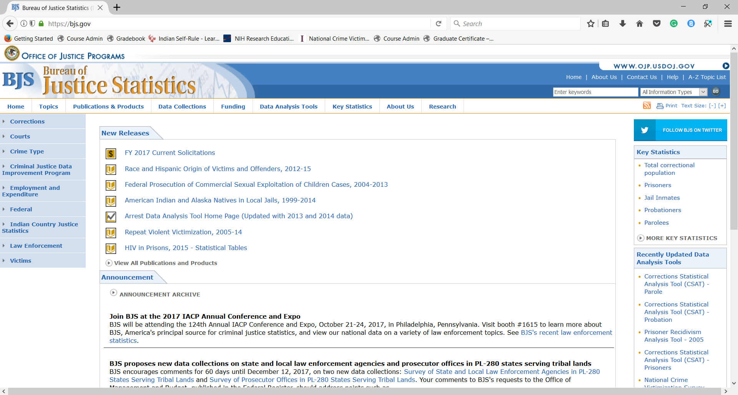

- Go to “Data Analysis Tool”
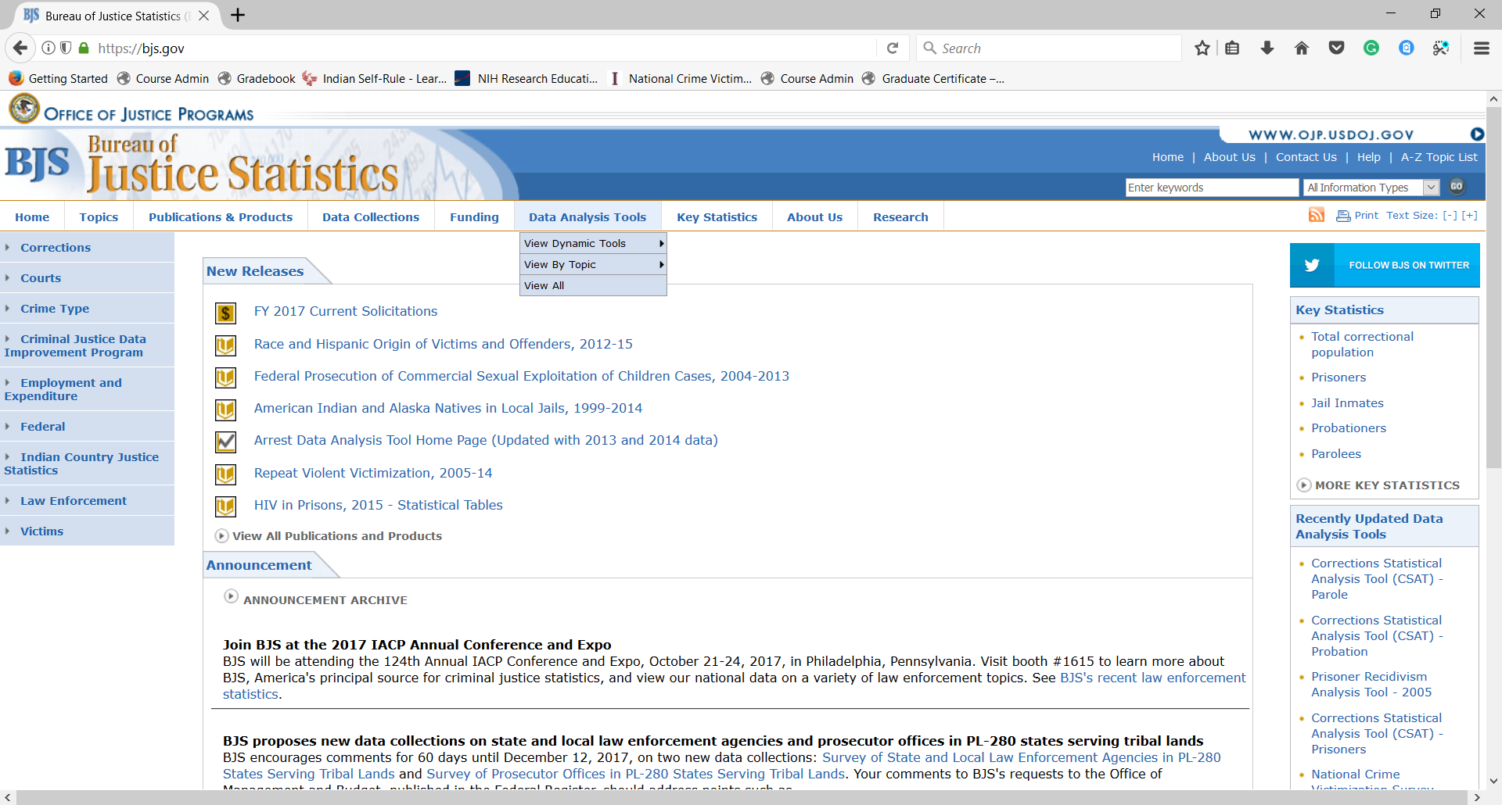

- On “View Dynamic Tools”, Click on “Arrest Data Analysis Tool”

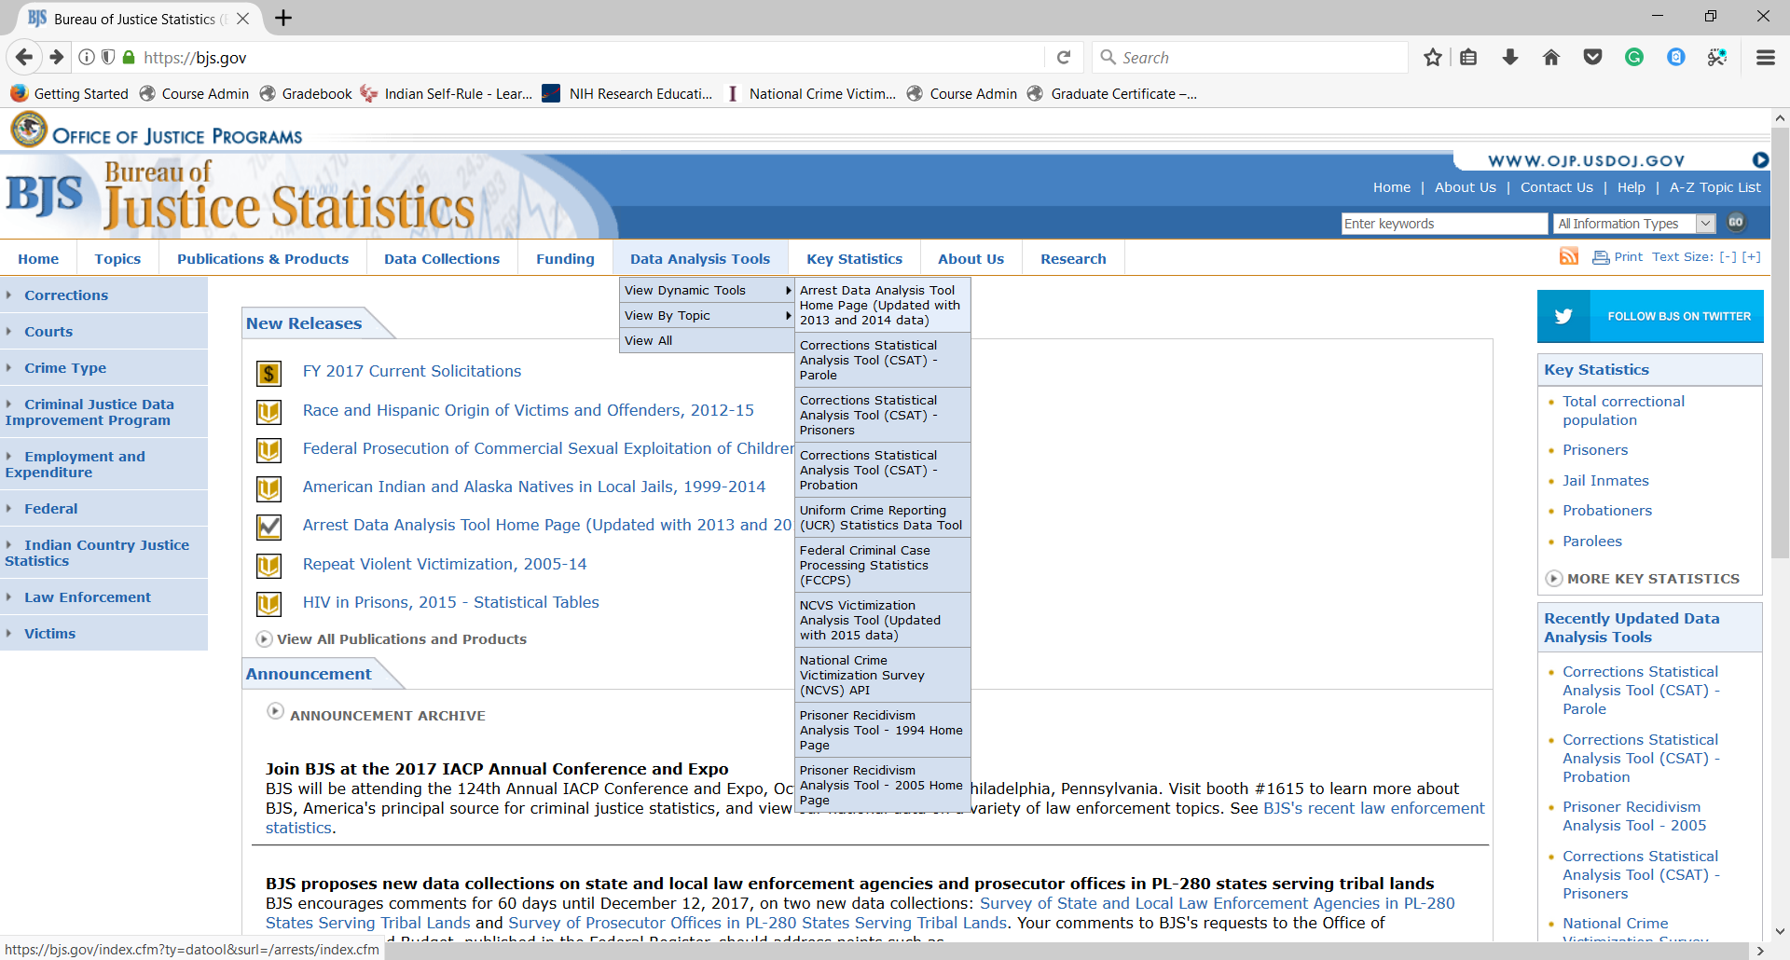

- You have the following page. Click on “National Estimates”
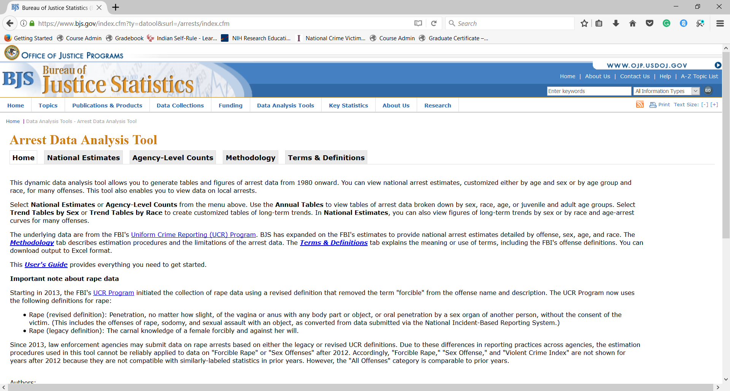

- You have the following. Now, you click “Trend Graphs by Race”
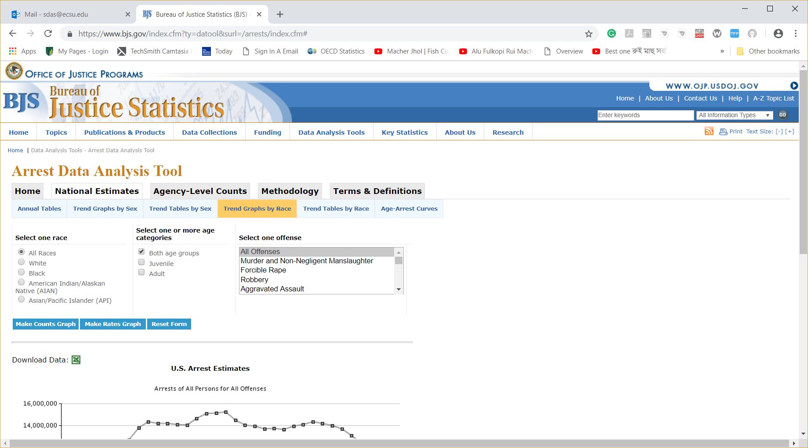

- You have the following:

- Select “All Adults”; Check out “White”, and “Adult”. Select the crime type you are assigned. I choose “Prostitution and Commercial Vice”. Now, click “Make Rates Graph”.
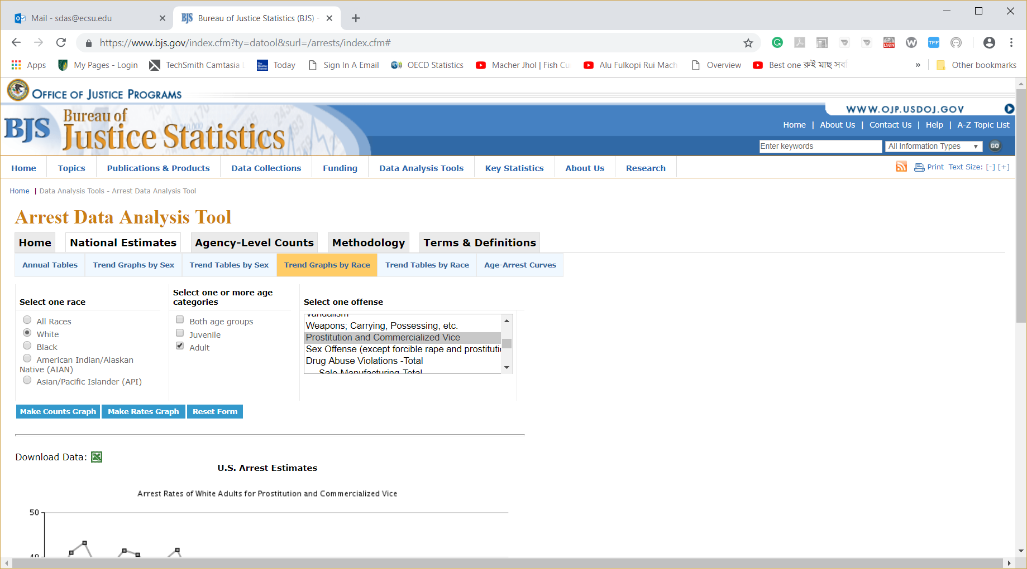

- You have the following graph:

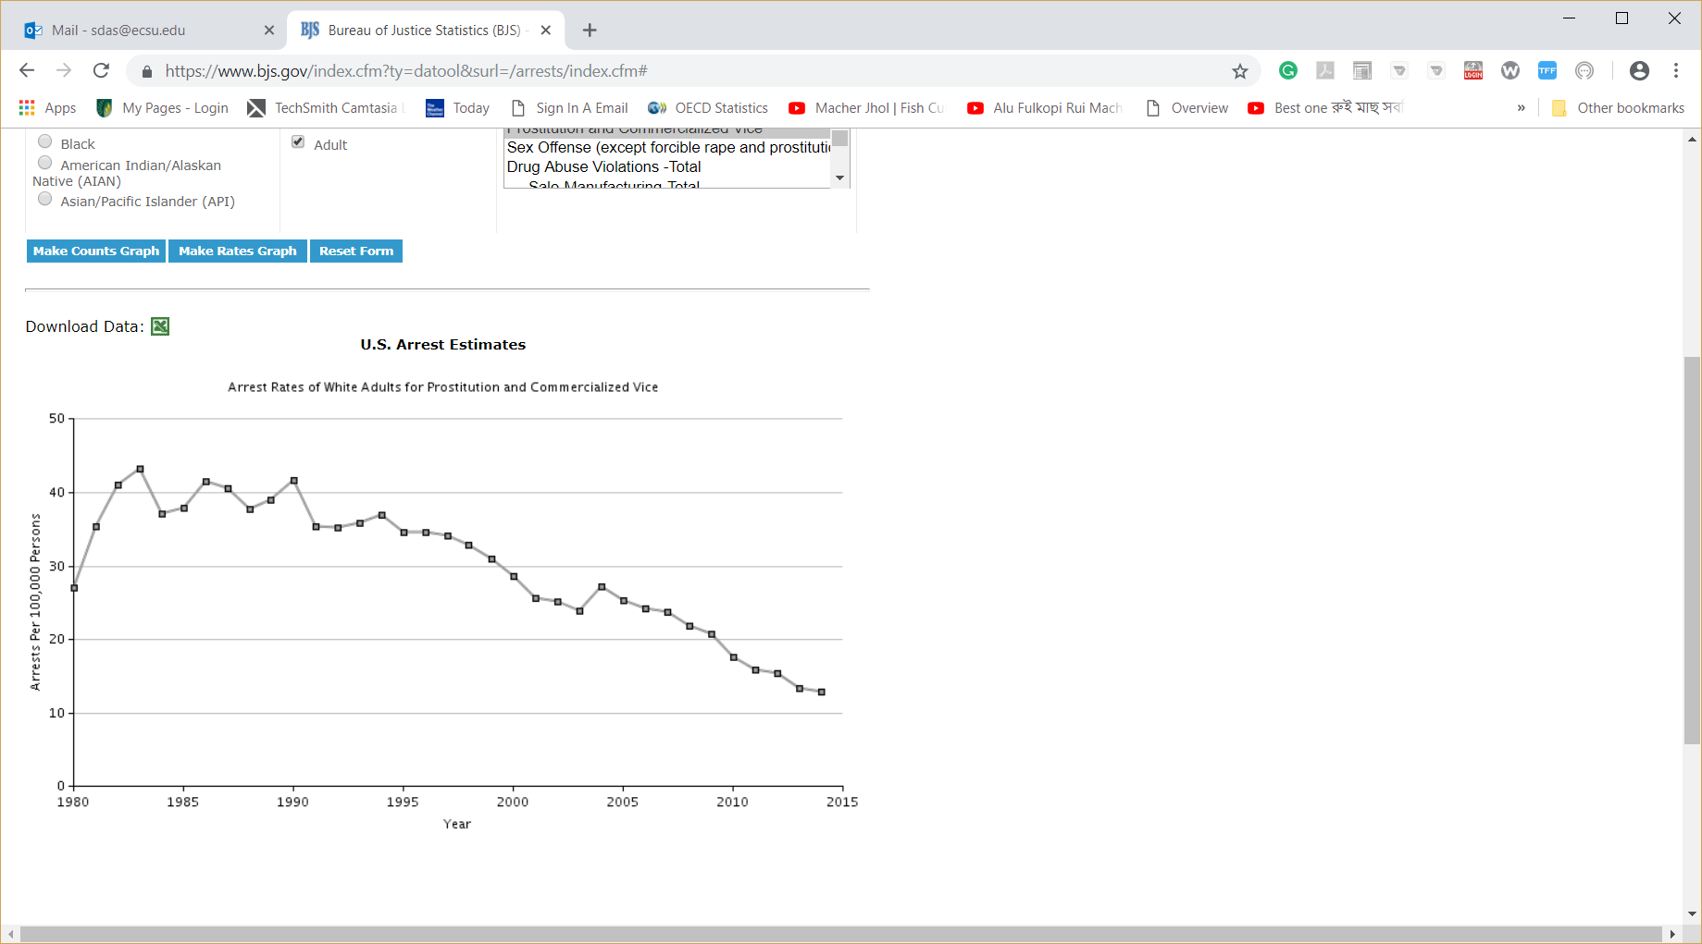

- Now, you need to save the graph. Right click the cursor on the graph. Click “Save Image As”

- Save it on Desktop or anywhere else as follows:

- Open the file from the Desktop.

- Now Right Click on the graph, and select “Copy”
- Open a blank Word document, and paste it there.

- Follow all steps for “Black”. Put both graphs (White & Black) on a single word document. (No picture is acceptable. You will receive a zero if you do not follow the steps outlined here).
- Now, you need to write the interpretations of the trends here comparing the Blacks with Whites over time. Use numbers.
Step 3: You now wrap up the items to submit your final paper. Here are the items you need to provide in your completed paper:
- Introduction
- Present a theory on the relationship between race and crime. Do you agree with it? Provide at least one counter-argument.
- Based on the (ii) what is your hypothesis? Test whether your assumptions are tenable using the graphs you have pulled out from the Bureau of Justice Statistics site.
- Why do you use the data from the Bureau of Justice Statistics? Is it a credible source? Why?
- What do the trends presented in your graphs suggest the relationship between race and crime?
- Do the above trends support your theory. How?
- Please make sure that you write some reasons for the changes in crime rates by race over time. When did rates increase? When did they decrease? Why? Write your thoughts.
- Provide some solutions to the problem you have worked on in this research assignment. How to reduce the arrest rate for Black people? What is suggested by your textbook? You should also consult some articles available online.
- Conclusion

Make sure that you write in your own words which are grammatically correct. Provide citations and references following APA.
After you are done, save the document, and submit it to the assignment link.

The work is due by

