APPENDIX 1:

OVERALL CALENDAR OF SEMESTER PER WEEK:

 | Class # | Topic | Readings Ahead of Lab | Techniques Practiced  in Lab
Module 1 | 1 | Laboratory Introduction  - summary & discussion of goals  - schedule for entire semester | - | -
 | 2 | Introduction to:  - Microscopes  - C. elegans (including basic  husbandry techniques) | - Corsi et al., 2015  - C. elegans Lab  Protocol | - Viewing, identifying &  picking C. elegans  - Microscope usage
 | 3 | - Introduction to CRISPR/Cas9  - Discussion of overall methodology | watch posted videos | - picking and  maintaining C. elegans
 | 4 | Introduction to: C. elegans websites, gene of interest, ApE software and primer design | WormBase Protocol | - navigating WormBase  - downloading genomic  sequences  - navigating ApE to  analyze genomic  sequences
Module 2 | 5 | C. elegans CRISPR-based Methods | Dickinson et al., 2016 | - maintaining C. elegans
 | 6-8 | Identification of PAM sites, designs of  crRNAs and repair oligonucleotides | Paix et al., 2015 | - ApE software  - NCBI Blast  - maintaining C. elegans
 | 9-10 | Purification of GFP construct | - | - maintaining C. elegans  - Plasmid Mini-Prep
 | 11 | Lab Meeting: Student Presentations | - | - maintaining C. elegans
 | 12 | Introduction to PCR  and  Test PCR reaction | PCR Protocol | - PCR  - gel electrophoresis  - PCR purification  - maintaining C. elegans
Module 3 | 13-14 | Preparation of repair template  and  Sequencing of PCR product | - | - PCR, gel  electrophoresis, PCR  purification  - sequencing prep  - Nanodrop  - maintaining C. elegans
 | 15 | Analysis of sequenced PCR product  and  Confocal Microscopy | 1-Introduction to  Fluorescence  Microscopy  2- Introductory Confocal Concepts | - ApE software  - NCBI Blast  - Introduction to confocal microscopy
 | 16-17 | Preparation of injection mixes  and  injection of animals | Fluorescence live cell imaging, Spinning-disk confocal microscopy | -Introduction to confocal microscopy
Module 4 | 17 | Screening of edited animals | - | - PCR  - Gel electrophoresis  - Confocal microscopy  - Data analysis
 | 18 | Screening and  expression analysis of edited animals | -
 | 19 | Lab Meeting: Student Presentations | -
 | 20 | Screening and  expression analysis of edited animals | -
 | 21 | Screening and  expression analysis of edited animals | -
 | 22-23 | Expression analysis of  edited animals | - | - Confocal microscopy
 | 24 | Final Student Presentations | -
 | 25 | Final Student Presentations | -

***Note- this course meets twice per week***

APPENDIX 2: INSTRUCTIONAL GUIDE

Instruction Guide for "A one-semester, undergraduate, CRISPR/Cas9 endogenous genome editing research experience in C. elegans"

Table of Contents

- Overall Scope of the CRISPR/Cas9 technology Semester
  - Example of Laboratory Grading

- Flowchart of the Semester

- Detailed Materials and Methods
  - Module 1
    - C. elegans husbandry
    - Introduction to databases: WormBase, CRISPR website
    - Introduction to ApE Software
  - Module 2
    - Introduction to primer design, identification of PAM sites, PCR, gel electrophoresis, PCR and gel purification
    - Methods for all of the above
  - Module 3
    - Refer to Paix protocol
    - List of primers utilized for GFP identification
  - Module 4
    - Background on Microscopy
    - Protocol for live imaging of C. elegans
    - Protocol (or references) for other phenotypic characterization assays.

- References

OVERALL SCOPE OF THE CRISPR/CAS9 RESEARCH SEMESTER

Course Goals and Objectives:
In this laboratory, students will learn and practice the endogenous genome editing technique CRISPR/Cas9 in the common model organism Caenorhabditis elegans. The lab course will emphasize experimental design, methodology, critical thinking, data analysis, and the importance of keeping a detailed scientific notebook. By the end of the semester, students will be able to plan and execute CRISPR experiments in C. elegans, gather and interpret the results, and present the outcome of their experiments in clear and concise scientific notebooks, presentations and a short scientific article.

Laboratory Grading:

The laboratory has been graded using the following breakdown:
Laboratory Notebook 40%
Lab Meeting Presentations 20%
Final Laboratory Report 20%
Final Presentation 15%
Participation in Class Discussions 5%

Laboratory Notebooks (40% of the final lab grade)

Each student is expected to diligently maintain an up-to-date lab notebook. This notebook is their working record of all activities in the lab, and will be kept according to sound scientific practices. The notebook is used to keep notes and calculations as they prepare experiments, to record observations as the experiments are performed, and to note additional data and conclusions.

Lab Meeting Presentation (20% of final lab grade):
Twice during the semester, each student is responsible for presenting an update on the current research they are conducting in the laboratory. The presentation should be in PowerPoint format and last 15-20 minutes. It should include a general overview of their research, a reason for the study, the methods utilized, the results and broader conclusions. Presenting students should meet with the instructor at least 3 days before the scheduled lab meeting days to go over their presentation. The instructor will then give insights and/or suggestions for the presentation.
Note- it is suggested to grade this according to a rubric.

Final Laboratory Report (20% of the final lab grade)

Lab reports generally have three goals: 1) to justify the reasons for performing the experiment, 2) to record the results of the experiment, and 3) to allow others to evaluate the results. The report should be written in the format of a scientific article and contain the following 7 sections: Title, Abstract, Introduction and Background, Materials and Methods, Results, Discussion and Conclusions, and References.

Final Presentation (15% of final lab grade):
At the end of the semester, each student is responsible for presenting a final research presentation on the entirety of the research they conducted over the course of the semester. Presentations should be ~30 minutes long and prepared in PowerPoint format. As per the “lab meeting presentations”, a brief introduction should be provided, the experiments conducted over the course of the semester should be presented, and the results summarized in appropriate format (ie- tables, charts, images, etc). In this case an overall conclusion should be presented.

Laboratory Participation (5% of final lab grade):
Asking and answering questions is expected and required, as such class discussion is an integral part of this course. The participation grade will come largely from attendance and participation in discussion of the assigned readings and of fellow students’ presentations.
Note- it is suggested to grade this according to a rubric.

FLOWCHART OF SEMESTER

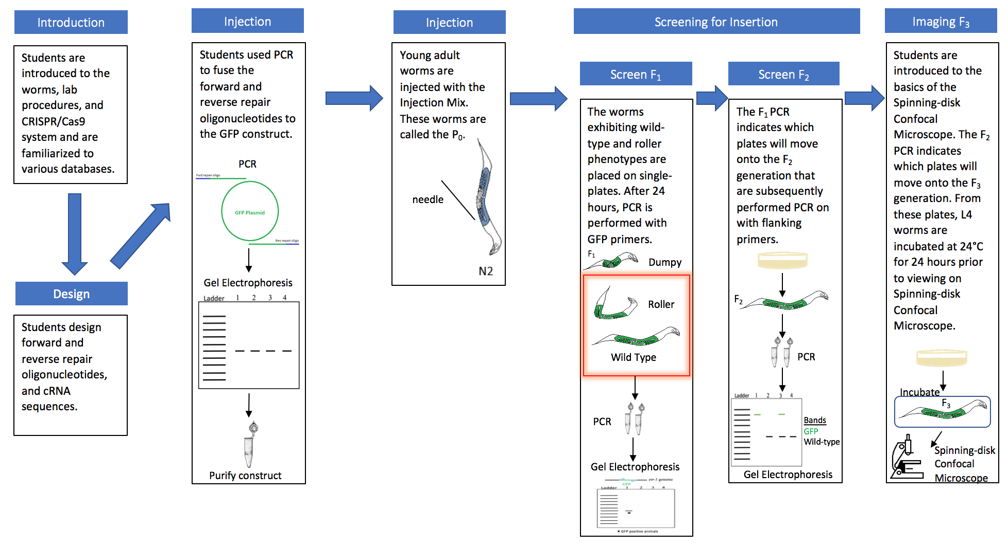

DETAILED MATERIALS AND METHODS

Module 1: Background on C. elegans and CRISPR/Cas9

C. elegans husbandry
Students were introduced to C.elegans as a model organism. They learned how to maintain their own worm strains. They were also introduced to the different C. elegans phenotypes to ensure familiarity of mutants verse wild-type C. elegans strains.
See Appendix 3

Introduction to Wormbase
Wormbase is a biological database about the nematode model organism. Students navigated Wormbase to learn about the genome of C. elegans and to obtain both the protein and the DNA sequences of the gene of interest.
See Appendix 4

ApE, A plasmid Editor software
Students download and are instructed in the basics of genomic sequence analysis using ApE, including how to identify restriction enzyme sites, locate specific nucleotide sequences, and determine melting points of nucleotide sequence.

Module 2: Selection of desired modification and CRISPR protocol design

Students were introduced to the Paix et al, 2016 protocol for conducting CRISPR/Cas9 endogenous genome editing experiments in C. elegans.

Identification of Insertion Site for Gene of Interest
Using the ApE software, students download the genomic sequence of the gene of interest and pick a NGG motif within their identified exon, followed by the sgRNA sequence which was based off of the criteria of the protocol of Paix et al., 2016. HDR was chosen as the method of repair since a GFP was being inserted into the genome. In brief, students designed their repair template by combining 20 base pairs (bp) GFP sequence to 30-35bp homology arm of surrounding the cut site within the gene of interest. The wobble base in the NGG site or the three consecutive codons was mutated in the repair template to prevent Cas9 from regenerating the DSBs.

Polymerase Chain Reaction (PCR) and Gel Electrophoresis
Students were introduced to the concept of PCR and performed test PCR reactions (see Appendix 5). They verified their PCR products via gel electrophoresis and practiced both PCR and gel purification following the standard manufacturer included protocols. After purification, students quantified the amount of DNA.

Module 3: CRISPR/Cas9 experiment

All CRISPR/Cas9 experiments were conducted following the detailed protocol included in Paix et al, 2016. This includes, primer design, crRNA guide design, and generation of the PCR repair template. Information about PCR protocols can be found in Appendix 5 if need be.

Injection of Strains
The co-conversion method as described by Arribere et al. 2014 was used. Animals were injected with a mixture of the sgRNA for the specific etr-1 exon and a marker gene dpy-10, and the repair template for the etr-1 locus was fused to GFP construct by Polymerase Chain Reaction (PCR). The repair template for the dpy-10 locus is a single-strand oligonucleotide which a missense mutation which causes a dominate roller phenotype enabling the screening of animals with the edited genome.

Module 4: Characterization of genome-modified animals

Genotyping of generated strains
F1 roller progeny of the injected animals was selected and allowed to lay for 24 hours. The animals were then screened via PCR for insertion of GFP using GFP specific primers (see table below). F2 progeny of the F1 positive animals were screened with using both GFP specific primers as well as exon specific etr-1 primers to ensure GFP was inserted into the correct exon.

GFP Primers used:
PRIMER NAME | SEQUENCE
Superfolder GFP- Forward #1 | GTCAACGGACACAAGTTCTC
Superfolder GFP- Reverse #1 | GTCCTCCTTGAAGTCGATTC
Superfolder GFP- Reverse #2 | GACTTGAAGAAGTCGTGACG
Superfolder GFP- Reverse #3 | GGGTGTTTTGTTGGTAGTGG

Confocal imaging of strains
The progeny of F2 GFP positive animals were imaged using spinning disk confocal microscopy to analyze the expression pattern of ETR-1. Wild-type animals were also imaged to ensure that the expression visualized in the edited strains was that of ETR-1.

REFERENCES:

Articles
- Tyler MS. 2010. Developmental biology, A guide for experimental study, 3rd ed. Sinauer Sunderland, MA.
- Leica Microsystems: Leica E Series Manual
- Introduction to Fluorescence Microscopy https://www.microscopyu.com/techniques/fluorescence/introduction-to-fluorescence-microscopy

Introductory Confocal Concepts https://www.microscopyu.com/techniques/confocal/introductory-confocal-concepts
- Ettinger A, Wittmann T. 2014. Quantitative Imaging in Cell Biology, Fluorescence live cell imaging, 1st ed. Academic Press.
- Oreapoulos J, Berman R, Browne, M. 2014. Quantitative Imaging in Cell Biology, Spinning-disk confocal microscopy: present technology and future trends, 1st ed. Academic Press.
- Corsi AK, Wightman B, Chalfie M. 2015. A Transparent window into biology: A primer on Caenorhabditis elegans. WormBook 1–31.
- Dickinson DJ, Goldstein B. 2016. CRISPR-based methods for caenorhabditis elegans genome engineering. Genetics 202:885–901.
- Paix A, Folkmann A, Rasoloson D, Seydoux G. High Efficiency, Homology-Directed Genome Editing in Caenorhabditis elegans Using CRISPR-Cas9. Genetics 201(1):47-54.

Videos on CRISPR/Cas9 to Watch (in order)

- Carl Zimmer explains the CRISPR DNA editing system in 90 seconds https://www.youtube.com/watch?v=ZImVkl8QTW8&feature=youtu.be
- Genome Editing with CRISPR-Cas9. https://www.youtube.com/watch?v=2pp17E4E-O8&feature=youtu.be
- Genome Engineering with CRISPR-Cas9. https://www.youtube.com/watch?v=SuAxDVBt7kQ&feature=youtu.be

APPENDIX 3: C. ELEGANS INTRODUCTION AND HUSBANDRY

Lab Protocol: C. elegans Introduction

Learning Objectives:
1. To become familiar with the genetic model organism Caenorhabditis elegans (a.k.a- “the worm”).
2. Learn common laboratory techniques used to study gene function:
- extraction of DNA
- how to design and use primers to direct DNA polymerase to specific sites on DNA for PCR
- Polymerase Chain Reaction (PCR) to amplify specific pieces of DNA
- prepare, run, and interpret electrophoretic gels to separate DNA fragments based on their size

Background:
C. elegans as a model system for studying basic biological processes & disease
C. elegans is a non-parasitic soil nematode that is widely used as a model system for studying numerous cellular, physiological, and disease processes. There are over 200 laboratories world-wide that use C. elegans in biomedical research. C. elegans has several features that make it particularly useful as a model system, including the following:
1. Ease of culture. C. elegans thrive at room temperature and can be grown in Petri dishes seeded with E. coli bacteria, which is one of the worm’s food sources. They can survive prolonged periods of starvation and can be frozen for storage. Adults are only ~1 mm long, so large numbers (~10,000 / 6 cm Petri dish) can easily be generated and stored.
2. Fast life cycle. C. elegans only take approximately 3 days at 20°C to go from being a fertilized egg to a fertile adult. There are four larval stages before they become adults. Under optimal conditions, C. elegans will live for 2-3 weeks. The C. elegans life cycle and images of different stages are shown in Appendix B.
3. Reproduce as hermaphrodites. C. elegans exist predominantly as hermaphrodites (XX), and rarely as males (XO). Hermaphodites self-fertilize themselves. This facilitates genetics because a single worm can create numerous clones of itself by self-fertilizing.
4. Large brood size. One C. elegans hermaphrodite produces approximately 300-350 progeny, and even more if it is fertilized by a male.
5. Transparency and simple body plan. C. elegans embryos and worms are transparent and have a simple body plan (refer to http://www.wormatlas.org/handbook/anatomyintro/anatomyintro.htm), facilitating visualization of cells and tissues. C. elegans has nerves, muscles, epithelial, and endothelial cells that develop and function in similar ways to their human counterparts.
6. Defined Lineage. C. elegans have about 1000 somatic (non-germline) cells and the lineage for each is known (i.e. when and where it was born and what cells it was derived from). The development of wild-type C. elegans embryos is strongly determinative – it proceeds the same way each time.
7. Strong genetics. C. elegans was the first multicellular organism to have its entire genome sequenced (in 1998). Its genome has about a hundred million base pairs, which is 20x bigger than E. coli, but only 1/30 the size of the human genome. Deletions in its genes can be generated by mutagenesis (using chemical agents or radiation to alter DNA) and then identified by gene mapping and sequencing. Gene function can be reduced using RNA interference (RNAi). Engineered DNA can be introduced into the germline to generate “transgenic” worms, typically this engineered DNA consists of a gene tagged with a fluorescent reporter such that one can visualize protein localization.

Although C. elegans are a lot simpler than humans, their tissues develop, function, and can become diseased in similar ways. Furthermore some major signaling pathways (cell communication pathways) that control processes like cell division, differentiation, and programmed cell death (apoptosis) are remarkably well conserved between C.
elegans and vertebrates. As mentioned above, C. elegans is actively being used as a model system to investigate numerous different diseases.

Nematode Anatomy
The body of a nematode is long and narrow. The epidermis (skin) is composed of a cellular material that secretes a thick outer cuticle that is both tough and flexible. The cuticle protects the nematode and allows the worm’s movement. Under the epidermis there are long muscles that are aligned longitudinally along the inside of the body. The muscles are activated by two nerves that run the length of the nematode on both the dorsal (back) and ventral (belly) side. The head of a nematode has a few tiny sense organs and a mouth opening into a muscular pharynx (throat where food is pulled in and crushed). This leads into a long gut cavity that ends near the anus at the other tip of the body. The tail section is different between males and hermaphrodites. Hermaphrodites have a tail that comes to a point, whereas the males have a specialized broad structure for mating. Not surprisingly, the gonads are also different between males and hermaphrodites. In both sexes the gonad is a simple tubular structure in which the germ line replicates through meiotic cell division. The maturation of the germ line occurs with passage along the tube towards a single opening. In males the opening is close to the tail. In hermaphrodites the single opening in the uterus located in the mid-body into the vulva.
C. elegans Cultivation:
As mentioned, the life cycle of the worm is about 3 days. A Petri plate filled with MYOB (Modified Youngren's, Only Bacto-peptone) is used to culture the worm. In the lab, the Escherichia coli (E. coli) strain OP50 is the worm’s favorite food, and the worm is fed by seeding (placing a drop of OP50 bacteria on) an MYOB plate. C. elegans’ growth rate differs under different temperatures. Development from an embryo to an adult takes about 2.5 days at 25°C, and 6 days at 15°C. A bincocular dissecting microscope is used to observe the worms, and most work can be done at 25X magnification. To move (or pick) and transfer a worm, a worm picker (platinum wire embedded in a glass pipette) is used.
Practical Aspects of Working with C. elegans

Sterile techniques should be practiced at all times. (gloves!)

E. coli (strain OP50) is used as nematode food.

The wild-type nematode strain is referred to as N2.
- See Appendix C for information on nomenclature in worms and an explanation on genetic balancers

References and Database:
For more information about C. elegans, please see the following websites:
http://wormbook.org
http://www.wormclassroom.org
http://www.wormbase.org
Also, Appendix D provides additional resources.

To analyze DNA sequences:
To easily analyze genomic DNA sequences, you will download the following free sequence program to your computer. This program will allow you to copy and paste DNA sequences into it. In addition, you can compare wild-type sequences and deletion sequences to determine where the deletion occurs.
ApE = http://biologylabs.utah.edu/jorgensen/wayned/ape/

APPENDIX 4: INTRODUCTION TO WORMBASE

Lab Protocol: C. elegans WormBase Introduction

C. elegans WormBase
- Go to http://www.wormbase.org
- In the upper right corner in the search box, enter the Gene name/number in the search box and click “go” or press enter to start search. (Note- make sure the search box looks like the following when you start because you want to search for a gene and not for any of the other options such as antibody, protein, or strain…)
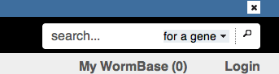

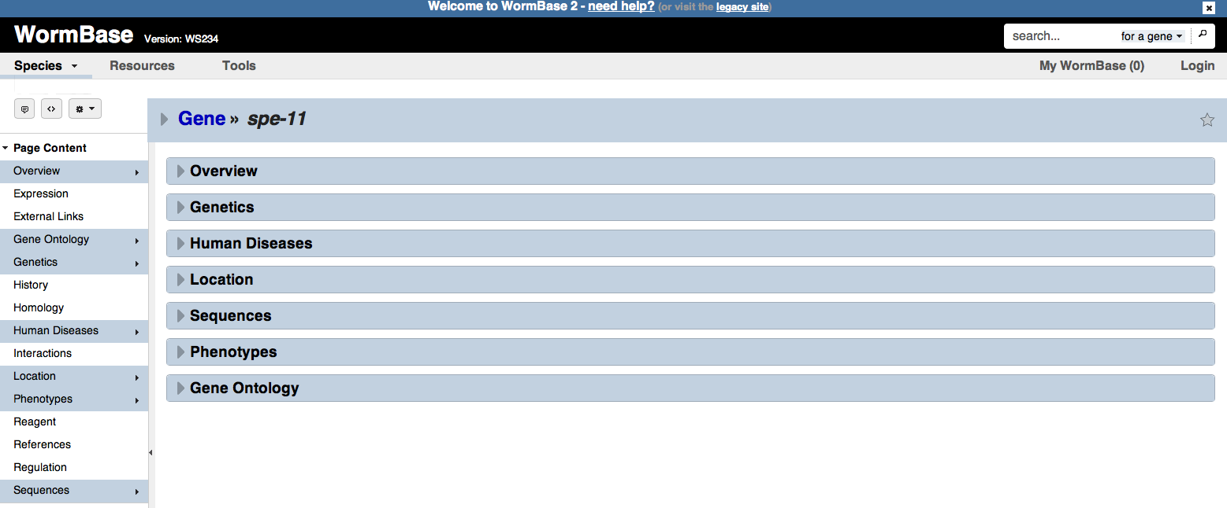
- The search will open a dedicated page for that gene. That should look something like the following:

Subheadings! Must be shaded blue in order to see information.

- You should read through the overview to learn some general information about the gene you will be researching throughout the semester.
Note- Your window may not look exactly like this image, because you need to select the subheading that you want to open in order to view more information.
- To the left of the window, you will see a list of subheadings under “Page Content”. Within each subheading you can find additional relevant information. In order to see the information contained within each subheading, that specific subheading must be selected and show up highlighted in blue (as you can see above).
- If information for that subheading does not immediately appear, you may have to expand the information box by clicking on the button to the left of the subheading in the main field box and changing it to . See image below for example:
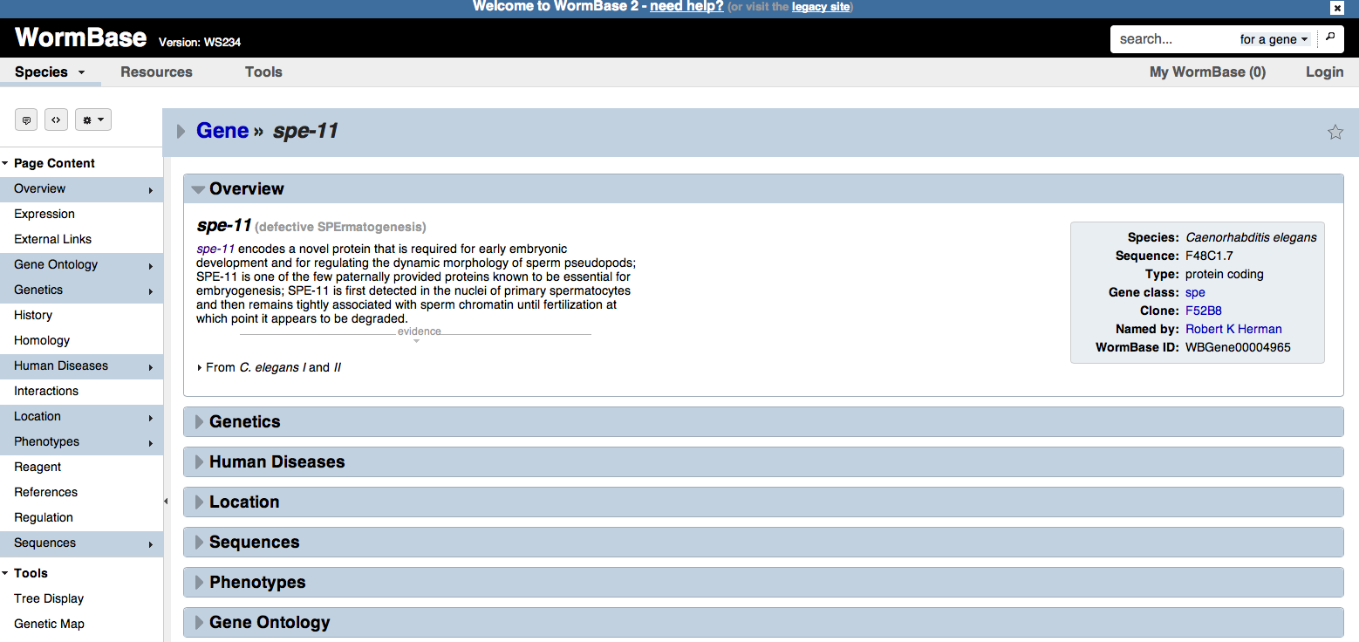

- Subheadings that will be particularly useful for you are:
    - Overview = provides you with a general summary of what the gene is, what the gene name stands for, and processes in which the protein coded for that gene are involved in
    - Gene Ontology = tells you about the biological and cellular processes the gene is involved in
    - Homology = lists other genes within the C. elegans species or in different species that are similar to the gene you are investigating
    - Location = provides you the genetic and genomic position of the gene. Also includes a Gene Model with information about intron and exon structure. The Gene Model appears as a figure and is clickable. If you click on the gene model, a more detailed image will open in a new window.
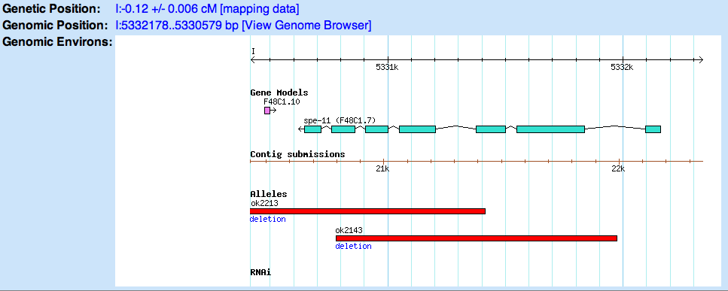

Note- in this figure you can see the intron/exon structure of the gene. For example, this gene has 7 exons (blue boxes) and 6 introns (black lines connecting exon boxes).
    - Phenotypes = lists the observable physical characteristics/features found in animals where that gene is mutated
    - Sequences = will give you information on the genomic sequences, coding sequence lengths, protein sequences, and protein length for all the different potential isoforms of the gene of interest. This is where students can download the genomic sequence for their gene of interest.

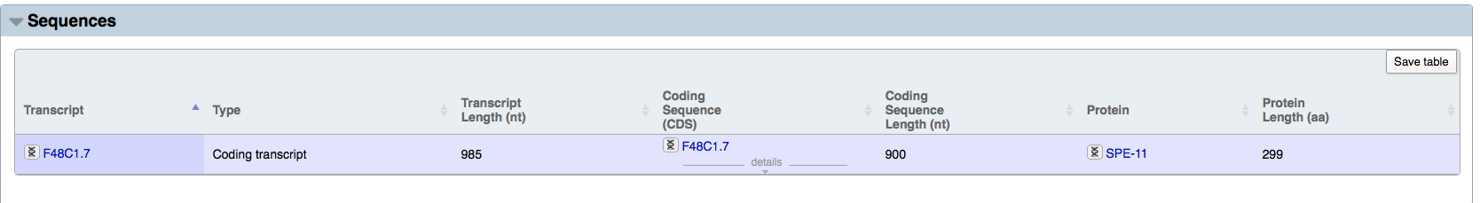
For example: You can see for this gene, there is one only one predicted transcript (F48C1.7). The transcript length (or genomic DNA length) for this gene is 985 nucleotides, that means the total length of all the exons + introns combined is 985 nucleotides. However, the coding sequence length is much shorter, only 900bp. The coding sequence length corresponds to the length of the transcript if you have removed the introns, in other words just the exons all added together (or the equivalent of the complementary DNA). The protein length is 299 amino acids long.

Note: If you click on the transcript number (F48C1.7) this will open a new window with more information about the transcript, including specific details on the exon/intron numbers and boundaries.

Note: If you click on the Protein name (ie- SPE-11) this will open a new window with more information about the protein, including an estimated molecular weight in kDA (kilo Daltons) and information on predicted domains.

APPENDIX 5: POLYMERASE CHAIN REACTION AND GEL ELECTROPHORESIS

POLYMERASE CHAIN REACTION (PCR) AND GEL ELECTROPHORESIS

Learning Objectives:
- To learn common laboratory techniques used to study genetics and molecular biology.
  - DNA extraction
  - Polymerase Chain Reaction (PCR)
  - Gel Electrophoresis

Background:

The Polymerase Chain Reaction

The polymerase chain reaction (PCR) is a method used by scientists to rapidly copy, in vitro, specific segments of DNA. By mimicking some of the DNA replication strategies employed by living cells, PCR has the capacity for churning out millions of copies of a particular DNA region. It has found use in forensic science, in the diagnosis of genetic disease, and in the cloning of rare genes. One of the reasons PCR has become such a popular technique is that it doesn’t require much starting material. It can be used to amplify DNA recovered from a plucked hair, from a small spot of blood, or from the back of a licked postage stamp.

There are some essential reaction components and conditions needed to amplify DNA by PCR. First and foremost, it is necessary to have a sample of DNA containing the segment you wish to amplify. This DNA is called the template because it provides the pattern of base sequence to be duplicated during the PCR process. Along with template DNA, PCR requires two short single-stranded pieces of DNA called primers. These are usually about 20 bases in length and are complementary to opposite strands of the template at the ends of the target DNA segment being amplified. Primers attach (anneal) to their complementary sites on the template and are used as initiation sites for synthesis of new DNA strands. Deoxynucleoside triphosphates containing the bases A, C, G, and T (NTPs) are also added to the reaction. The enzyme DNA polymerase binds to one end of each annealed primer and strings the deoxynucleotides together to form new DNA chains complementary to the template. The DNA polymerase enzyme requires the metal ion magnesium (Mg⁺⁺ ) for its activity. It is supplied to the reaction in the form of MgCl₂ salt. A buffer is used to maintain an optimal pH level for the DNA polymerase reaction.

PCR is accomplished by cycling a reaction through several temperature steps. In the first step, the two strands of the template DNA molecule are separated, or denatured, by exposure to a high temperature (usually 94° to 96°C). Once in a single-stranded form, the bases of the template DNA are exposed and are free to interact with the primers. In the second step of PCR, called annealing, the reaction is brought down to a temperature usually between 37°C to 65°C. At this lower temperature, stable hydrogen bonds can form between the complementary bases of the primers and template. Although human genomic DNA is billions of base pairs in length, the primers require only seconds to locate and anneal to their complementary sites. In the third step of PCR, called extension, the reaction temperature is raised to an intermediate level (65°C to 72°C). During this step, the DNA polymerase starts adding nucleotides to the ends of the annealed primers. These three phases are repeated over and over again, doubling the number of DNA molecules with each cycle. After 25 to 40 cycles, millions of copies of target DNA are produced. The PCR process taken through four cycles is illustrated in Appendix A.

Gel electrophoresis
To determine the size of your PCR amplified bands, you will need to visualize the products of your amplification. This will be done using a process called gel electrophoresis in which electric current forces the migration of DNA fragments through a special gel material. Since DNA is negatively charged, it will migrate in an electric field towards the positive electrode. When electrophoresed through a gel, shorter fragments of DNA move at a faster rate than longer ones.

Loading dye is a colored, viscous liquid containing dyes (making it easy to see) and sucrose, Ficoll, or glycerol (making it dense). You will add loading dye to your amplification reaction and then pipet an aliquot of the mixture into one of the wells of your agarose gel. When all wells have been loaded with sample, your instructor will switch on the power supply. The samples should be allowed to electrophorese until the blue loading dye is 1–2 cm from the bottom. The gel can then be stained with ethidium bromide and photographed.

The PCR products separated on the agarose gel are invisible to the naked eye. If you look at your gel in normal room light, you will not be able to see the amplified products of your reaction. In order to “see” them, we must stain the gel with a fluorescent dye called ethidium bromide (EtBr). Molecules of ethidium bromide are flat and can intercalate, or insert, between adjacent base pairs of double stranded DNA. When this interaction occurs, they take on a more ordered and regular configuration causing them to fluoresce under ultraviolet light (UV). Exposing the gel to UV light after staining, allows you to see bright white bands where there is DNA.

PROTOCOLS

Protocol: Isolation of Single- worm C. elegans genomic DNA

- Make Lysis Buffer, filter sterilize, and store at room temperature.
Single Worm Lysis Buffer:
50 mM KCl
10 mM Tris pH 8.2
2.5 mM MgCl2
0.45% NP-40
0.45% Tween-20
0.01% gelatin
- Just before use, add 3 ul of 20 mg/ml proteinase K (in H20) per ml of lysis buffer need
- Place 2.5ul of lysis buffer (+ Proteinase K) into the cap of a PCR tube.
- Pick a single worm from a bacteria-free region of a plate into the lysis buffer in the cap.
- Repeat Step 4 for all worms you wish to analyze via PCR
- Invert PCR cap back over the PCR tube and snap shut
- Perform a quick spin to move worms to bottom of tube and place tube on ice
- Freeze worms at -80C for 15 minutes
- Perform the lysis:
  - Incubate PCR tubes at 60C for one hour and then 95C for 15 minutes
  - Pellet insoluble material and transfer supernatant to a fresh PCR tube
  - You now have worm lysate to use in your PCR reactions

Protocol: PCR Amplification
- Wear gloves, and use only PCR-certified sterile tubes, tips, and solutions. Be very conscious of human contamination.
- Set up a PCR reaction in a 200 µL PCR tube (thin-walled tube can collapse if squeezed too hard). Keep tubes on ice until ready to place into thermocycler.
- Place 2 µL of your C. elegans genomic DNA per 20 µL PCR reaction into the fresh PCR tube
- Keeping tubes on ice, add 18 µL of ice-cold PCR Master Mix.
- Master Mix contains the following:
2.0 µL 10x PCR Buffer
0.2 µL dNTP Mix (stock = 10 mM each dATP, dTTP, dCTP, dGTP)
0.5 µL Forward Primer (10 µM stock)
0.5 µL Reverse Primer 10 µM stock)
0.5 µL Taq DNA Polymerase
14.3 µL water (PCR grade)
- Setting up the controls. Two students will set up negative control reactions for the whole class (–C). They will use sterile water in place of the isolated genomic DNA. There should be enough –C PCR sample for one lane on each gel.
Negative Control = 2 µL of water + 18 µL of ice-cold PCR Master Mix

- Once the volumes have been checked, put your PCR reaction on ice. Your instructor will put all the PCR tubes from the class into the thermocycler and run the following program overnight:

95°C 2 min initial denaturation step
30 cycles of:
95°C 30 sec denaturation
65°C 30 sec annealing
72°C 2 min elongation
72°C 7 min final elongation step
4°C indefinitely (or until removed and placed in fridge)

** note PCR annealing temperature and elongation time will vary depending on primers used and region being amplified***

Protocol: Gel Electrophoresis

- When PCR runs are complete, the tubes should be placed on ice or in the fridge.
- Retrieve your PCR tube and spin it briefly to bring the liquid to the bottom of the reaction tube.
Note- Make sure the centrifuge is balanced before you begin spinning your sample and that you are using a tube adapter if needed!
- To your 20 μL PCR sample, add 4 μL of 5x loading dye.
- Wearing gloves, load your sample onto a 1% agarose gel, making sure to keep a record of which gel and which lane you loaded your sample in.
Note- You must also load a DNA Ladder
- After the gel has been fully loaded, place the lid on the gel assembly, plug the leads into the power supply, and run the gel at ~100V until the dye front is 80% to the end (100 bp band is the dye front). This could take anywhere from 35-75 minutes.
Note- Make sure that you have properly connected the electrodes such that you are running your samples from the negative side towards the positive side.
- When electrophoresis is complete, turn off the power supply, remove the lid, and one student (wearing gloves) will remove the gel to the container provided by your instructor.
- You will then view the gel on an UV transilluminator to visualize the DNA and photograph the gel.
- After obtaining the photograph, you will be able to determine the sizes of your PCR product by comparison to the loaded DNA ladder. This is information that should be in your notebook.

CAUTION: Ethidium bromide is considered a carcinogen and neurotoxin. Always wear gloves and appropriate PPE (personal protective equipment) like safety glasses when handling.

CAUTION: Ultraviolet light can damage your eyes and skin. Always wear protective clothing and UV safety glasses when using a UV light box.

