BIO397N, Fall 2019
FINAL Paper Instructions and Grading Rubric (40 points)
+ Course Reflection (5 points)

Overview:
Final Paper: When you write a science article for publication, you rarely write it alone. Science is about collaboration and teamwork, something that has been an integral part of this class. This final paper is a “group” assignment and therefore it is expected that you will collaborate and contribute to the creation of this document equally. You will be graded as a group.
Course Reflection: This is “individual work” and you will get 5 points for participation. Details are presented at the very end.

Due Date: Dec 9, 2019 for Mon Lab/ Dec 11, 2019 for Wed Lab—please bring in printed copies of the assignment. Make sure to include your Names, Group # and Lab Section.

Final Paper: Sections, Grading Rubrics, General Instructions
We would like you to write your final report in the form of an actual research paper. Remember, this is a CURE class, so we are doing real science! As such, you have read review articles (think back to assignment #1) and several primary literature papers (think about assignment #4). You must include all these readings in your write up and should cite them correctly.

The following instructions have been adapted from the scientific journal Development. Feel free to scan through a few papers in the journal Development to get a sense of how scientific data is presented and how an article is written. Good Luck!

Abstract (5 points)
Provide a brief abstract of no more than 200 words. This should succinctly and clearly introduce the i) topic of the paper, include the ii) hypothesis and iii) predictions, iv) summarize the main findings and v) the conclusions you have drawn from the data. Do not include subheadings or references and avoid any non-standard abbreviations.

Introduction (5 points/1-2 pages)
The introduction establishes the context of the research being conducted by summarizing current understanding and background information about the topic, stating the purpose of the work. Thus, this section should succinctly provide the background information that is required to set the results into their proper biological context. It should not contain subheadings. Remember to discuss the following topics:
- Importance of zebrafish as a model organism
- HPT axis and gene regulation by thyroid hormones
- Proliferation and differentiation of adult neural stem cells
- What is known about the role of thyroid hormone regulating neural stem cell proliferation and differentiation
- What is your hypothesis and predictions and how did you arrive at it?

Note: You cannot use the hypothesis shown in class (Week 8 Lecture Slides). You must use those examples to rework/polish/tweak/improve the hypothesis you have been using thus far. I will be comparing it to previous renditions of your hypothesis.

Grading Rubric for Introduction Section:

5 | 4 | 3 | 2 | 1
- Discusses all the topics mentioned above.  - Ties together information from all relevant sources. Paper flows from one issue to the next without the need for headings.  - Author's writing demonstrates an understanding of the relationship among material obtained from all sources.  - No spelling &/or grammar mistakes and all cited works, both text and visual, are done in the correct format with no errors. | - Discusses all the topics mentioned above.  - For the most part, ties together information from all sources. Paper flows with only some disjointedness  - Author's writing demonstrates an understanding of the relationship among material obtained from all sources.  - No spelling &/or grammar mistakes and all cited works, both text and visual, are done in the correct format with no errors. | - Discusses all the topics mentioned above  - Sometimes ties together information from all sources. Paper does not flow - disjointedness is apparent.  - Author's writing demonstrates an understanding of the relationship among material obtained from all sources.  - Minimal spelling &/or grammar mistakes. Some cited works, both text and visual, are done in the correct format. Inconsistencies evident | - Touches upon the topics mentioned.  - Does not tie together information. Paper does not flow and appears to be created from disparate issues. Headings are necessary to link concepts. Writing does not demonstrate understanding any relationships.  - Author's writing does not demonstrate an understanding of the relationship among material obtained from all sources.  - Noticeable spelling & grammar mistakes. Inconsistent and incorrect citations | - Does not discuss all the topics.  - Does not tie together information. Paper does not flow and appears to be created from disparate issues. Headings are necessary to link concepts. Writing does not demonstrate understanding any relationships.  - Author's writing does not demonstrate an understanding of the relationship among material obtained from all sources.  - Unacceptable number of spelling and/or grammar mistakes. Citations absent

Results (20 points/up to 5-10 pages with figures)
The results section should include the findings of your study and ONLY the findings of your study. The results section should simply state the findings, without bias or interpretation, and arranged in a logical sequence. The results section should always be written in the past tense. This section should be broken up by subheadings to organize the findings presented and walk the reader through the results.

Note: Most of the instructions for making figures, graphs, and tables are identical to the instructions for your PowerPoint presentation (i.e. do the work once and use it for both the assignments!!!). There are a few extra things you will have to do, so please read the instructions carefully.

Text of the “Results” section (4 points):
- An introductory context for understanding the results by restating the research problem that underpins the purpose of your study.
- A summary of your key findings arranged in a logical sequence.
- Inclusion of non-textual elements, such as, figures, graphs, tables, etc. to further illustrate the findings (i.e. the number of cells were counted in the hypothalamus (Fig.3))
- In the text, a systematic description of your results, highlighting for the reader observations that are most relevant to the topic under investigation.
- Must be written in past tense.

Grading Rubric for the text of the “Results” section:

4 | 3 | 2 | 1
- Provides introductory context for understanding the results  - Summarizes findings in a logical, sequential manner.  - Includes “non-textual” elements in the writing to guide reader to appropriate data set.  - No spelling &/or grammar mistakes. | - Provides introductory context for understanding the results  - Summarizes findings in somewhat logical, sequential manner.  - Inconstant or missing “non-textual” elements in the writing to guide reader to appropriate data set.  - Minimal spelling &/or grammar mistakes. | - Provides insufficient introductory context for understanding the results  - Findings are not summarized in a logical, sequential manner.  - Inconstant or missing “non-textual” elements in the writing to guide reader to appropriate data set.  - Noticeable spelling & grammar mistakes. Inconsistent and incorrect citations | - No introductory context for understanding the results  - No logical organization to findings.  - Inconstant or missing “non-textual” elements in the writing to guide reader to appropriate data set.  - Unacceptable number of spelling and/or grammar mistakes. Citations absent

Figure with figure legend (8 points):
  - In Trial 2, you scored the EdU reacted brains as “good-reaction” and “poor-reaction”. Please make TWO figures, one showing the “good-reaction” brains and the other showing the “poor-reaction” brains. For each figure, use 2 representative images of each of the 3 conditions (total of 6 pictures) to make one figure. If you do not have two pictures for a condition—you should explain why.
    - Images should be merged, pseudo-colored, and at 10X magnification
    - Make sure anterior is to the left
    - The regions in the brain (i.e LR/PR) are properly labelled
    - Label the image (type of fish and what the cells are)

Data table with cell counts: (2 points)
  - Show one table with your group’s cell count data (Trial 2 only).
    - You must include an appropriate heading
    - Show the average and STDEV
Graphs: (6 points)
- Graph#1: showing (your group’s) data from the “good-reaction” brains.
- Graph#2: showing (your group’s) data from the “poor-reaction” brains.
- Graph#3: showing class data from the “good-reaction” brains.
- Graph#4: showing class data from the “poor-reaction” brains.
    - Show error bars representing the calculated STDEV
    - Each graph should have a title
    - Each group of graphs should have a figure legend
    - Each graph should have a legend showing what the bars represent.
    - Each graph should have the same “y-axis” values-helps in comparison

Discussion and Conclusion (8 points/2-3 pages)
The purpose of the discussion is to interpret and describe the significance of your findings in light of what was already known. The discussion will always connect to the introduction by way of the research questions or hypotheses you posed and the literature you reviewed, but it does not simply repeat or rearrange the introduction. The discussion should always explain how your study has moved the reader's understanding of the research problem forward from where you left them at the end of the introduction. Things that you should include are:

- What is/are the main conclusion/s from the data and how does it relate to your hypothesis and prediction—do you believe your data?

- Comparisons between the two trials.

- How does your data compare to the class’ data?

- Discuss (if any) discrepancies amongst data sets, caveats and shortcomings of the experiment and what would you need to do to improve upon them.

- What is/are the importance of your findings (or trend of your data)

- Based on the data that you have collected, and all the papers you have read, how do you think

- thyroid hormones regulate neural stem cells (is TH involved in proliferation? Differentiation? Both? Neither?)

- what sort of cell signaling mechanisms (Notch? Wnt? Shh?) might be involved in the process?

- What would be you new hypothesis and prediction based on the data you have collected and the papers that you have read.

- What experiments would you do to test this new hypothesis?

Grading Rubric for Discussion section:
8 | 7 | 6 | 4 | 2 | 1
- Discusses all the topics mentioned above.  - Author demonstrates a thorough understanding of biological concepts and uses terminology correctly,  - New hypothesis and predictions are written correctly.  - Ties together information from all relevant sources. Paper flows from one issue to the next without the need for headings.  - Author's writing demonstrates an understanding of the relationship among material obtained from all sources.  - No spelling &/or grammar mistakes.  - All cited works, both text and visual, are done in the correct format with no errors. | - Discusses all the topics mentioned above.  - Author demonstrates a thorough understanding of biological concepts and uses terminology correctly,  - New hypothesis and/or predictions are written incorrectly.  - Ties together information from all relevant sources. Paper flows from one issue to the next without the need for headings.  - Author's writing demonstrates an understanding of the relationship among material obtained from all sources.  - No spelling &/or grammar mistakes.  - All cited works, both text and visual, are done in the correct format with no errors. | - Discusses all the topics mentioned above.  - Author demonstrates a thorough understanding of biological concepts and uses terminology correctly,  - New hypothesis and predictions are written incorrectly.  - Ties together information from all relevant sources. Paper flows from one issue to the next without the need for headings.  - Author's writing demonstrates an understanding of the relationship among material obtained from all sources.  - Minimal spelling &/or grammar mistakes.  - Minor mistakes in formatting citations. | - Discusses all the topics mentioned above.  - Incorrect explanations of biological concepts and uses terminology.  - New hypothesis and predictions are written incorrectly.  - Sometimes ties together information from all sources. Paper does not flow well.  - Author's writing does not demonstrate an understanding of the relationship among material obtained from all sources.  - Minimal spelling &/or grammar mistake  - Minor mistakes in formatting citations. | - Touches upon the topics mentioned above.  - Incorrect explanations of biological concepts and uses terminology.  - New hypothesis and predictions are written incorrectly.  - Sometimes ties together information from all sources. Paper does not flow well  - Author's writing does not demonstrate an understanding of the relationship among material obtained from all sources.  - Noticeable spelling &/or grammar mistakes  - Noticeable mistakes in formatting citations. | - Does not discuss all of the topics mentioned above.  - Incorrect explanations of biological concepts and uses terminology.  - New hypothesis and predictions are written incorrectly.  - Paper does not flow - disjointedness is apparent.  - Author's writing does not demonstrate an understanding of the relationship among material obtained from all sources.  - Noticeable spelling &/or grammar mistakes.  - Noticeable mistakes in formatting citations.

Bibliography (1 point):
All references cited in the text, tables and figure legends should be included in a single reference list at the end of the article. For of example of reference formatting, please see below.
Detailed Instructions for formatting the text (1 point):
General information:
- Use 1.5 line spacing.
- Embed figures with legends in the text.
- Cite each figure and table in numerical order. Figure or table parts should be labelled with uppercase letters (A, B, C, etc.). Use the following format for citations: Fig. 1A, B or Figs 1, 2 or Table 1.
- Define abbreviations at first mention.

Nomenclature:
- Taxonomic nomenclature: use Genus, species.
- Genetic nomenclature: gene symbols should be in italic type, but the protein product of a gene should be in Roman type. Genetic nomenclature should be in accordance with established conventions. Remember to consult ZFIN for this!! (https://wiki.zfin.org/display/general/ZFIN+Zebrafish+Nomenclature+Conventions)

References in text:
Literature citations in text are as follows.
One author – (Jones, 1995) or (Jones, 1995; Smith, 1996).
Two authors – (Jones and Kane, 1994) or (Jones and Kane, 1994; Smith, 1996).
More than two authors – (Jones et al., 1995) or (Jones et al., 1995a,b; Smith et al., 1994, 1995).
Website URLs: cite in the text but do not include in the Reference list; provide the URL and, if the website is frequently updated, the date that the site was accessed.

Reference List:
References are listed in alphabetical order according to surname and initials of first author. Use the following style:
Rivera, A. R. V., Wyneken, J. and Blob, R. W. (2011). Forelimb kinematics and motor patterns of swimming loggerhead sea turtles (Caretta caretta): are motor patterns conserved in the evolution of new locomotor strategies? J. Exp. Biol. 214, 3314-3323.

PLEASE CONTINUE TO THE NEXT PAGE FOR FURTHER INSTRUCTIONS……..

Course Reflection (5 points)

Overview:
The final portion of this assignment is a “course reflection”. This is an “individual assignment” and you get 5 points for full participation. Points will be taken off if you do not complete the form. These questions are very specific to the “learning goals” of this course (refer to Figure. 1 below from the first day of class). This reflection is NOT redundant with the UMass “SIRTI survey” or the “CURE-Post Course Survey”. Your answers will serve as data in my “science education research project”. There is no right or wrong answer. Please be thoughtful/critical in how you respond.

Please attach the form to end of your group’s final paper write-up and include your name.

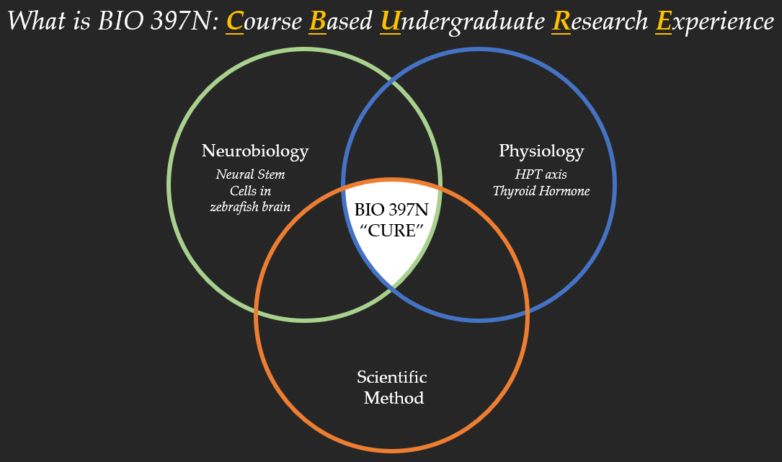
Figure.1 Venn Diagram showing the components of the BIO397N course

- On the first day of class, I asked you the following question “What is the learning goal of BIO397N?”. Now that you have gone through the course, according to your experience, which one of the following statements accurately describes the “learning goals” that was most emphasized in BIO397N?
- The learning goal for BIO397N was to understand and appreciate the scientific method.
- The learning goal for BIO397N was to become proficient in zebrafish biology
- The learning goal for BIO397N was to become proficient in Neurobiology
- The learning goal for BIO397N was to become proficient in Physiology

- In this course we talked about the HPT axis and how thyroid hormones regulate gene expression. How confident do you feel in your ability to explain these concepts to your fellow science majors?
- Very confident
- Some-what confident
- Less confident, but would like to spend more time learning the material
- Not confident and still very confused about the material

- In this course we talked a lot about the neural stem cell proliferation and differentiation. How confident do you feel in your ability to explain the difference between these concepts to your fellow science majors?
  - Very confident
  - Some-what confident
  - Less confident, but would like to spend more time learning the material
  - Not confident and still very confused about the material
- What is your confidence level in explaining the difference between a “hypothesis” and a “prediction”?
  - Very confident
  - Some-what confident
  - Less confident but would like more practice in formulating hypotheses and predictions.
  - Not confident and still very confused about the material

- After this course, what is your confidence level in writing/formulating a hypothesis? (This could be in any field of science)
  - Very confident
  - Some-what confident
  - Less confident but would like more practice
  - Not confident and still very confused about the material

- What is the most difficult part about writing a hypothesis?
  - Not difficult, I can write it confidently
  - Making sure that the hypothesis does not sound like a prediction
  - Including the “testable and falsifiable” biological mechanism behind the hypothesis.
  - Both “b” and “c”

- In this class, do you think you had “ownership” in writing the hypothesis? Which of the following statements accurately represents your experience in writing the hypothesis in this class.
  - I had full ownership--I had to read the background information and write a hypothesis
  - I had ownership and guidance—I read the background information, wrote a hypothesis and received feedback to improve it.
  - I had little ownership-- I read the background information, wrote a hypothesis, but then was given the “correct answer”.
  - I had no ownership-- I was told by the instructor as to what the correct hypothesis should be.

- Consider this--you have written a hypothesis and have performed some experiments. You have statistically significant data that rejects your hypothesis. In your opinion, what is the correct thing to do next?
  - Perform other experiments that will prove your hypothesis “correct”
  - Change your “original” hypothesis to match your results
  - Acknowledge that your hypothesis in wrong
  - Acknowledge that your hypothesis in wrong and provide logical explanations to explain your experimental results.
  - Acknowledge that your hypothesis in wrong, provide logical explanations to explain your experimental results, and write a new hypothesis.

- Which of the following statements do you agree with the most?
  - The scientific process is a straight line that starts with a question and ends with a result that answers the initial question.
  - The scientific process is “circular”, it starts with a question which is followed by results, which leads to the formulation of new questions.

- After this class, do you feel like you gained a thorough understanding of the “scientific method”
  - Yes, I understand each step of the process and appreciate the importance of each step.
  - Some-what confused about the information in the papers, the in-class experiments and observations, and how to synthesize all the information.
  - Very confused about the information in the papers, the in-class experiments and observations, and how to synthesize all the information.

- Which of the following statements do you most agree with now that you have encountered and practiced the steps of the “scientific method”:
  - Understanding the steps in the “scientific method” has improved my critical thinking skills.
  - Understanding the steps in the “scientific method” has improved my critical thinking skills and I find myself using these skills in other science classes.
  - Understanding the steps in the “scientific method” has improved my critical thinking skills and I find myself using these skills in other classes, including non-science subjects.
  - Understanding the steps in the “scientific method” has improved my critical thinking skills and I find myself using these skills “inside” and “outside” of the classroom.
  - Understanding the steps in the “scientific method” has not improved my critical thinking skills.

