Understanding Global Change
Unit Planning Guide and Template
This guide and template outlines the five key steps you can use to design and implement coherent instructional units that incorporate the Understanding Global Change (UGC) Framework and Earth system modeling tools. This resource was codesigned with classroom teachers, and reflects the practices used to integrate UGC materials into classroom instruction.* This template will support the modification of existing curricula or the development of a new unit using the UGC materials. The instructional practices described below are also informed by resources from Ambitious Science Teaching and Next Gen Storylines.
The UGC Framework and Earth system modeling tools will help you visualize the interdisciplinary science connections you want students to construct during an instructional unit. Iterative revisions to the scope and sequence of instruction and the corresponding Earth system models will help to design a unit that sequentially and coherently builds students’ understanding of global change phenomena. Likewise, students can construct and iteratively revise UGC Earth system models to visualize and explain their understanding of global change phenomena during the unit. This planning guide also provides guidance for integrating the UGC Framework and Earth system models into classroom instruction to enhance students’ thinking about the Earth as a dynamic, interconnected system.


STEP 1. Identify disciplinary standards
Determine the grade level standards you plan to address in this unit, and how this unit connects to content in other parts of your curriculum. If you are using the Next Generation Science Standards, please refer to the UGC-NGSS Crosswalk spreadsheet to explore the K-12 standards that are relevant to each topic/ icon in the UGC Framework.
Course/ subject area
Grade level/ age
Disciplinary/ curricular standards
Relevant UGC topics/icons and other concepts
Prior knowledge (Content or disciplinary standards, such as NGSS Performance Expectations, that were addressed in this or another courses prior to this unit of study.)
Unit time requirements
Curricular connections & extensions  (Topics/ icons relevant to the unit content that could be addressed in this course and extend, the learning experience.) | .


STEP 2. Selecting an anchoring phenomenon to drive student learning
An anchoring phenomenon is used to focus, motivate, and sustain students’ interest in learning. Students will construct an explanation of the anchoring phenomenon over the course of the unit. As students figure out what causes the phenomenon, they should demonstrate their understanding of the Earth as an interconnected system. We suggest using anchoring phenomena that are one of the UGC Measurable Changes, because these are often the observable and/or quantifiable changes in the Earth system that motivate scientific inquiry.

STEP 2.A. Phenomenon criteria checklist
The following criteria will help you select an appropriate anchoring phenomenon for a unit of study. Duplicate this table and repeat this process, if necessary, to identify the best phenomenon for the standards identified in STEP 1.
Description of the anchoring phenomenon:
Relevant UGC Measurable Changes:
- Does an explanation of this phenomenon require connecting ideas from all three categories of the UGC framework (Causes of Global Change, How the Earth System Works, and Measurable Changes in the Earth System)? | Yes/ No, Explain:
- Is this phenomenon an observable event that happens over time? (Phenomena could occur over a short or long time period, and can be experienced by direct observations or second hand through images, video, and/or datasets.) | Yes/ No, Explain:
- Does this phenomenon happen in a particular place? (Phenomena can occur over small areas or large geographic regions, and should be events and changes that are context-rich.) | Yes/ No, Explain:
- Does this phenomenon have the potential to be explored through a variety of engaging resources (e.g., observations, pictures, videos, datasets) and investigations (classroom and outdoor experiences)? | Yes/ No, Explain:
- Does this phenomenon have the potential to motivate and sustain students’ interest and purpose for learning? | Yes/ No, Explain:
- Does this phenomenon connect to prior student classroom or out-of-school-time experiences? | Yes/No, Explain:

Please visit the following links for additional information about selecting an anchoring phenomenon:
- NGSS@NSTA Criteria for Evaluating Phenomena
- Ambitious Science Teaching Planning for Engagement with Important Science Ideas
- Using Phenomena in NGSS-Designed Lessons and Units
STEP 2.B Introducing the phenomenon, formulating a unit driving question, and eliciting students’ ideas
Determine how students will be introduced to the phenomenon. This could be images, a video, dataset or a combination of resources that represents a Measurable Change in the Earth System . Even though some phenomena are global and/or occur over large geographic regions, students are also more likely to be interested in the anchoring phenomenon if the introduction provides a connection to human experiences or local environments.
To help focus and engage students in their learning, formulate a unit driving question about the anchoring phenomenon. The driving question should not be answerable with a yes/no response, and should require students to connect ideas throughout the unit. Driving questions that are sufficiently complicated often include the words how or why. Student responses to the driving question can be revised and revisited as the unit progresses. All activities and learning experiences in the unit should contribute in some way to students’ ability to answer the driving question.
Following the introduction of the phenomenon, students should have the opportunity to record, discuss, and share their initial ideas about the anchoring phenomenon. A subset of relevant UGC icons and the Earth scene could be used to help students organize their initial ideas. Please also see Ambitious Science Teaching resources for ideas about eliciting students’ ideas.
Use the table below to explain how students will be introduced to the phenomenon, formulate the driving question, and describe how students will share their initial ideas about the anchoring phenomenon.

TABLE 2.B Introducing the phenomenon, formulating a unit driving question, and eliciting students’ ideas
Resource(s) to Introduce the anchoring phenomenon | Provide an image, video or dataset that represents an observable/ measurable change. Try to include resources that make human connections to the phenomenon. If the resource is a video, you will likely want to show it at least twice.
Driving question | Identify the overarching question about the phenomenon that students will work to answer over the course of the unit. Answering this question should require students to gather and analyze data/ information from various learning experiences. The driving question often includes the word how or why.
Eliciting students’ ideas and prior knowledge/ experiences | Example: Students will: 1) Construct an initial model explaining how and why this phenomenon occurred/ is occurring, and then, 2) Students will share their ideas with peers during a gallery walk, 3) Record additional questions students have about the phenomenon. Example prompts for this might include:  What’s going on in the image/dataset? Do we see a pattern? What might explain the pattern or change we are observing? What else do we want to know/find out?

STEP 2.C. Explaining the phenomenon, writing investigative questions, and identifying relevant UGC topics

Use the table below to develop a coherent explanation of the anchoring phenomenon and record questions that will be addressed in the unit to explain the anchoring phenomenon. These questions will be sequentially investigated and answered using various activities and resources that will be vetted and organized into an instructional sequence in STEP 4. Identify the concepts from the UGC Framework that are relevant to each part of the explanation. The UGC topics/icons will be used to develop Earth system models and explanatory statements about the phenomenon in STEP 3. Organize related parts of the explanation in a way that makes sense to you, and helps you break down the essential cause and effect relationships needed to explain the phenomenon. Add more rows to the table, as necessary.

TABLE 2.C Explaining the phenomenon, writing investigative questions, and identifying relevant UGC topics

Explanation of the anchoring phenomenon: | Investigative questions/anticipated student questions about this part of the explanation: | UGC topics/ icons relevant to this part of the explanation of the anchoring phenomenon
Explanation Part 1:  Example: Earth’s rising average temperature is increasing the melting rate of glaciers and ice caps. | What increases the rate of ice melting? | Snow & ice cover, Air temperature
Explanation Part 2:  Example: Earth’s rising temperatures is caused by an increase in greenhouse gases in the atmosphere. Greenhouse gases re-radiate heat in Earth’s atmosphere, impeding its loss to space. | What is causing an increase in Earth’s average temperature? What are greenhouse gases and how do they work? | Greenhouse gases, Greenhouse effect, Re-radiation of heat, Air temperature
Explanation Part 3:

STEP 3. Connect big ideas by constructing Earth system models
Visualizing Earth system cause and effect relationships between the UGC topics/icons can help assess the scope and coherency of: 1) The explanation of the anchoring phenomenon in STEP 2; and 2) The sequence of learning experiences you will design in STEP 4. For this reason, it can be useful to iteratively review and refine Earth system models while designing an instructional unit. Similarly, the construction of Earth system models can help students identify gaps in their own explanations of the anchoring phenomenon that they need to explore in order to answer the unit driving question.
STEP 3.A. Construct example unit models and explanations of Earth systems connections
Construct Earth System models that contain the connections among UGC icons/topics that you expect students to make as they progress through the unit. Annotate each arrow in the model with an explanatory and/or evidence-based statement about the cause and effect relationships between the UGC icons. You do not need to construct a model for every learning experience in the unit, but it can be helpful to construct 2-3
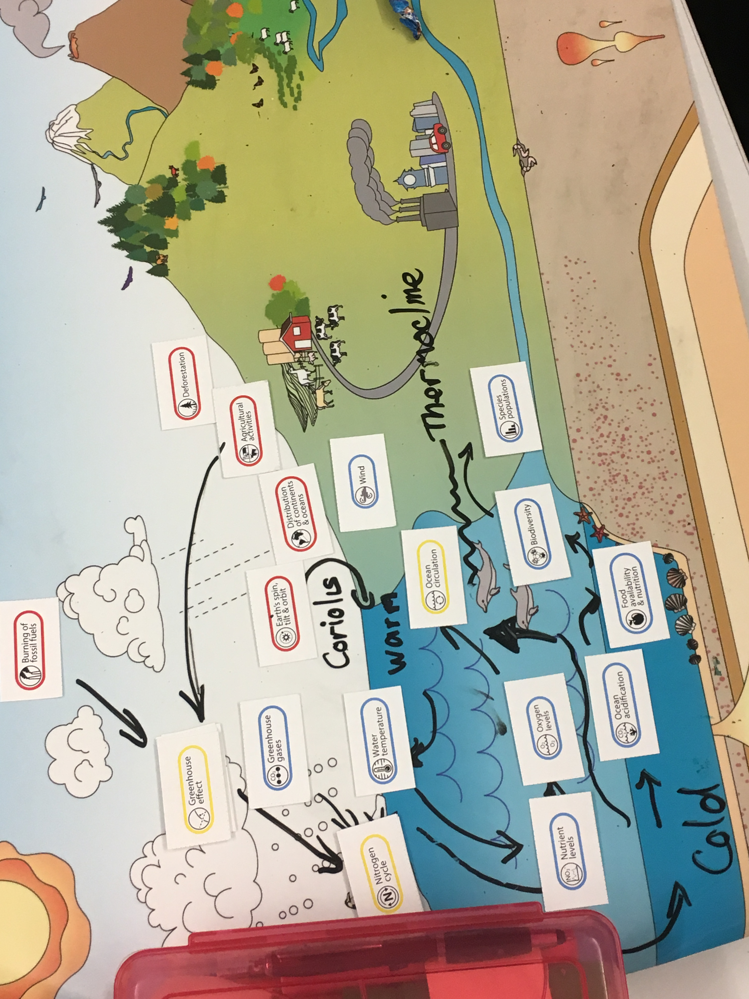
(STEP 3.A Continued) models that represent students’ understanding of the targeted Earth system connections at the middle and end of the unit.
Earth system models can be constructed in the UGC interactive or using printed copies of the UGC icons and Earth scene (as seen on the right) or another image as the background. In the UGC Interactive, you can number the arrows in your models to specify the most coherent sequence of connections students should construct to explain the phenomenon over the course of the unit. The UGC Interactive also provides an option to export your Earth system models and your model annotations into a PowerPoint file. You can delete the example models below, and copy and paste in images of example models for your unit. If you are constructing models using printed materials, write your model annotations in the Earth Systems Connections table below.
Tips for constructing Earth system models:
- Start with no more than 3-4 icons.
- Write out explanations of connections as you draw arrows.
- There might be multiple ways to accurately represent the content connections. It is helpful to keep track of alternative connections since students might construct similar models.
Example middle of unit model: Example end of unit model:
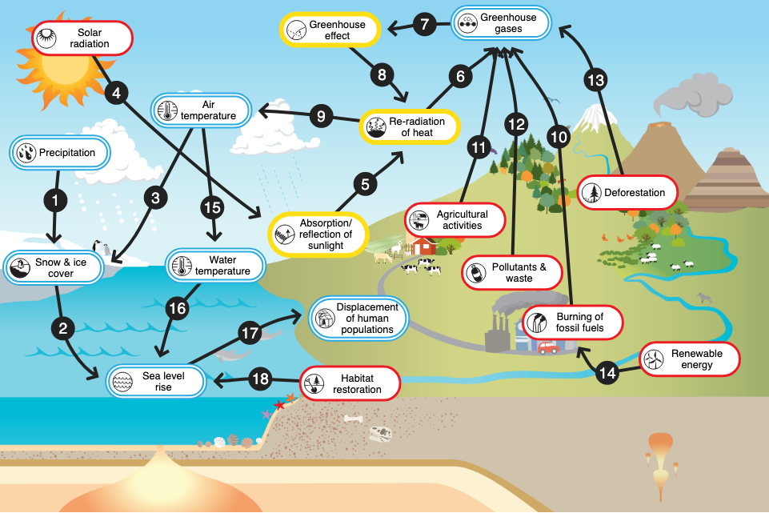
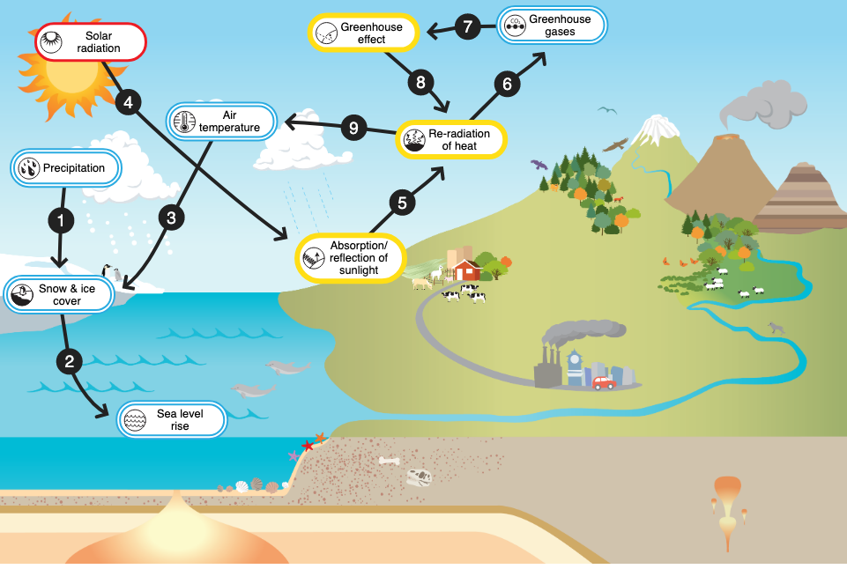

TABLE 3.A Earth System Connections:
Add more rows to the table, as needed.
Topics/icon connection | Student target explanations of system connection
- Example: Snow and ice cover => Sea level rise | Water from melting land ice (such as ice sheets and glaciers) enters the ocean and contributes to sea level rise.

STEP 3.B. Planning for student models construction

Modeling makes students’ ideas visible and provides evidence that students can coherently construct and refine their explanations of the anchoring phenomenon as the unit progresses. After you construct example Earth system models in STEP 3.A, determine how students will make sense of their learning experiences by constructing their own models. Model building could be done at various stages in the unit in small groups, individually, and as class discussions. Students should have opportunities to revise their models at least twice during a unit and to collaborate with peers to construct consensus models. If students are not able to construct the anticipated example models and Earth system connection explanations developed in section 3.A, then the unit may not be coherent from the students’ perspective and should be revised or enhanced with new resources.
During each Understanding Global Change Unit, students have opportunities to:
- Construct an initial model at the beginning of the unit that represents their understanding of the phenomenon using prior knowledge. This can be done with or without the UGC icons and Earth scene.
- Revise models individually and/or in groups of 2-4 students to share ideas. Models can also be assigned as homework and shared during class time.
- Provide and receive feedback from peers and the instructor about their models while working in pairs, small groups, or during gallery walks.
- Construct a class consensus model of the phenomenon during a teacher facilitated discussion.

Additional practices that will support the strategies above include:
- Have students construct initial models on paper and then transfer their work into the UGC interactive during the first or second model revision activity.

- Use the simple version of the UGC Infographic as a word wall to organize the topics/ icons. You may want to review suggestions about How to Use and Introduce the UGC Infographic to Students.

- Create fill-in-the-blank models. The fill-in-the-blank handouts have spaces for students to write in UGC icon names, draw arrows, and annotate model connections. These handouts can be made in the UGC Interactive.

- Use different colored pens during each model revision so students track their progress as they construct more accurate and complex explanations of the anchoring phenomenon. Alternatively, students can use the black, gray, and dashed arrows in the UGC Interactive to indicate system connections that have been added or revised. For example, students could change an arrow from a dashed line to a solid line when they can provide a more robust, evidence-based explanation following a learning experience in the unit.

- Facilitate class discussions to create checklists of topics/icons and connections that students should include in their models.

- Provide a different colored pen to each student in a work group so students can track their contributions to the group model.

- Limit the number of icons students use in their models. Teachers have noted that when students are using the interactive or provided all the UGC icons, they often include icons in their models that they cannot connect with evidence-based explanations. To ensure that students are creating models that represent their understanding of the unit focal phenomenon, provide a list of icons for students to include in their models in the interactive, or print just the relevant icons using the Icon PowerPoints if students are constructing icons using pen and paper.

- Extend student learning and exploration of global change by having students connect 1-2 additional UGC icons/ topics to their model that were not discussed in the unit. This activity could involve students independently investigating a new Earth system connection, and explaining how the unit model supports an explanation of this additional global change phenomenon.

Table 3.B Planning for Student Modeling:
Draft ideas for how and when students will engage in Earth system modeling in the table below. These ideas will be incorporated into the unit scope and sequence in STEP 4. Add more rows to the table, as needed.

Modeling activities: What will students be doing? Will students work individually, in pairs, groups, or during a facilitated class discussion? | Materials, scaffolds, and practices to support the construction of Earth system models
- Example: Constructing an initial model in groups of 3-4 students, completing a gallery walk and providing feedback to other students | Materials: Earth scene poster, pens  Practices: Each student will use a different colored pen to track their contributions to the group model


STEP 4. Select and sequence instructional resources to help students coherently build an understanding of the phenomenon
During this step, select resources for the unit and sequence learning experiences based on the progression of ideas in the explanation of the phenomenon from STEP 2, and the Earth System models from STEP 3. It is likely that as you design the scope and sequence of activities, the example Earth system models will need to be revisited and revised, as indicated by the double arrow in the diagram of the planning process (see figure on page 1).
In the Unit Planning Table below, list resources that will help students incrementally and coherently construct connections between UGC icons/concepts that explain the phenomenon. Activities, datasets videos, and other types of learning experiences could come from your existing curriculum, or other resources.
If you are looking for new resources, including activities, videos, and datasets, we recommend visiting the following websites:
- The Climate Literacy and Energy Awareness Network (cleanet.org). The National Science Foundation and NOAA funded CLEAN collection houses over 700 free, high-quality teaching and learning resources about climate and energy that have been carefully vetted by scientists and educators.
STEP 4. Select and sequence instructional resources to help students coherently build an understanding of the phenomenon, continued
- Howard Hughes Medical Institute BioInteractive (www.biointeractive.org/). BioInteractive resources are free, are developed by scientists and educators, and explore current scientific research.
- NOAA Climate.gov (climate.gov). This website provides current climate news, data, maps, and tips for teaching climate change.
The Unit Planning Table below provides a template for organizing the following information for each lesson:
- Lesson activity/resource/ dataset (website links);
- The investigative question(s) (from STEP 2.B) and the science practices (NGSS SEPs and scientific inquiry skills) students will engage in to answer the question(s);
- Key concepts students will explore and figure out (from standards identified in STEP 1 and the explanation of the phenomenon in STEP 2.B);
- The UGC topic connections students will make to explain the phenomenon (from STEP 3.A);
- Materials, instructions, scaffolds, and formative assessment ideas (including how students will construct, share, and revise Earth system models and explanations about the anchoring phenomenon (from STEP 3.A), when appropriate);
- Time needed to complete the lesson;
- Example Earth system model (not needed for every lesson, see STEP 3.B for information about when and how students could construct models).
Tips for using the template:
- The first lesson should include your plan from STEP 2.C: Introducing the phenomenon, formulating a unit driving question, and eliciting students’ ideas.

- You will likely have students construct and modify models 3-4 times over the course of the unit, so add or delete section 7 of the template, when necessary.

- You will likely need to reorder the lessons at least a few times to construct a sequence that coherently builds students’ understanding of the phenomenon and aligns with the Earth system models constructed in STEP 3.A. Copy and paste example models from STEP 3.A into the template with the appropriate lessons.

- The Activity Table (pages 17-18) is a student version of sections 1-4 in the Unit Planning Table that can be used by students to track learning throughout a unit. The content in the Activity Table can be used a reference as students construct models. The table can be completed as a class at the beginning of the unit, and filled out in small groups or individually later in the unit as they become more comfortable summarizing and synthesizing what they learn during activities.
TABLE 4. Unit Planning Table
Copy, paste, delete, and add rows as needed.
Lesson 1: Engaging with the phenomenon & constructing an initial model.

I. Activity/resource/ dataset (website link):
II. Investigative question(s) related to the anchoring phenomenon; science practices students will engage in to answer the question (such as NGSS SEPs and scientific inquiry skills):
III. Key concepts students will explore and figure out (NGSS/ standards connections):
IV. UGC topic connections students will make to explain the phenomenon:
V. Materials, Instructions, Scaffolds, & Formative Assessment Ideas
VI. Time:

Lesson 2:
I. Activity/resource/ dataset (website link):
II. Investigative question(s) related to the anchoring phenomenon; the science practices students will engage in to answer the question (such as NGSS SEPs and scientific inquiry skills):
III. Key concepts students will explore and figure out (NGSS/ standards connections):
IV. UGC topic connections students will make to explain the phenomenon:
V. Materials, Instructions, Scaffolds, & Formative Assessment Ideas
VI. Time:

Lesson 3: Model revision
I. Activity/resource/ dataset (website link):
II. Investigative question(s) related to the anchoring phenomenon; the science practices students will engage in to answer the question (such as NGSS SEPs and scientific inquiry skills):
III. Key concepts students will explore and figure out (NGSS/ standards connections):
IV. UGC topic connections students will make to explain the phenomenon:
V. Materials, Instructions, Scaffolds, & Formative Assessment Ideas
VI. Time:
VII. Lesson 3 Example Earth system model | 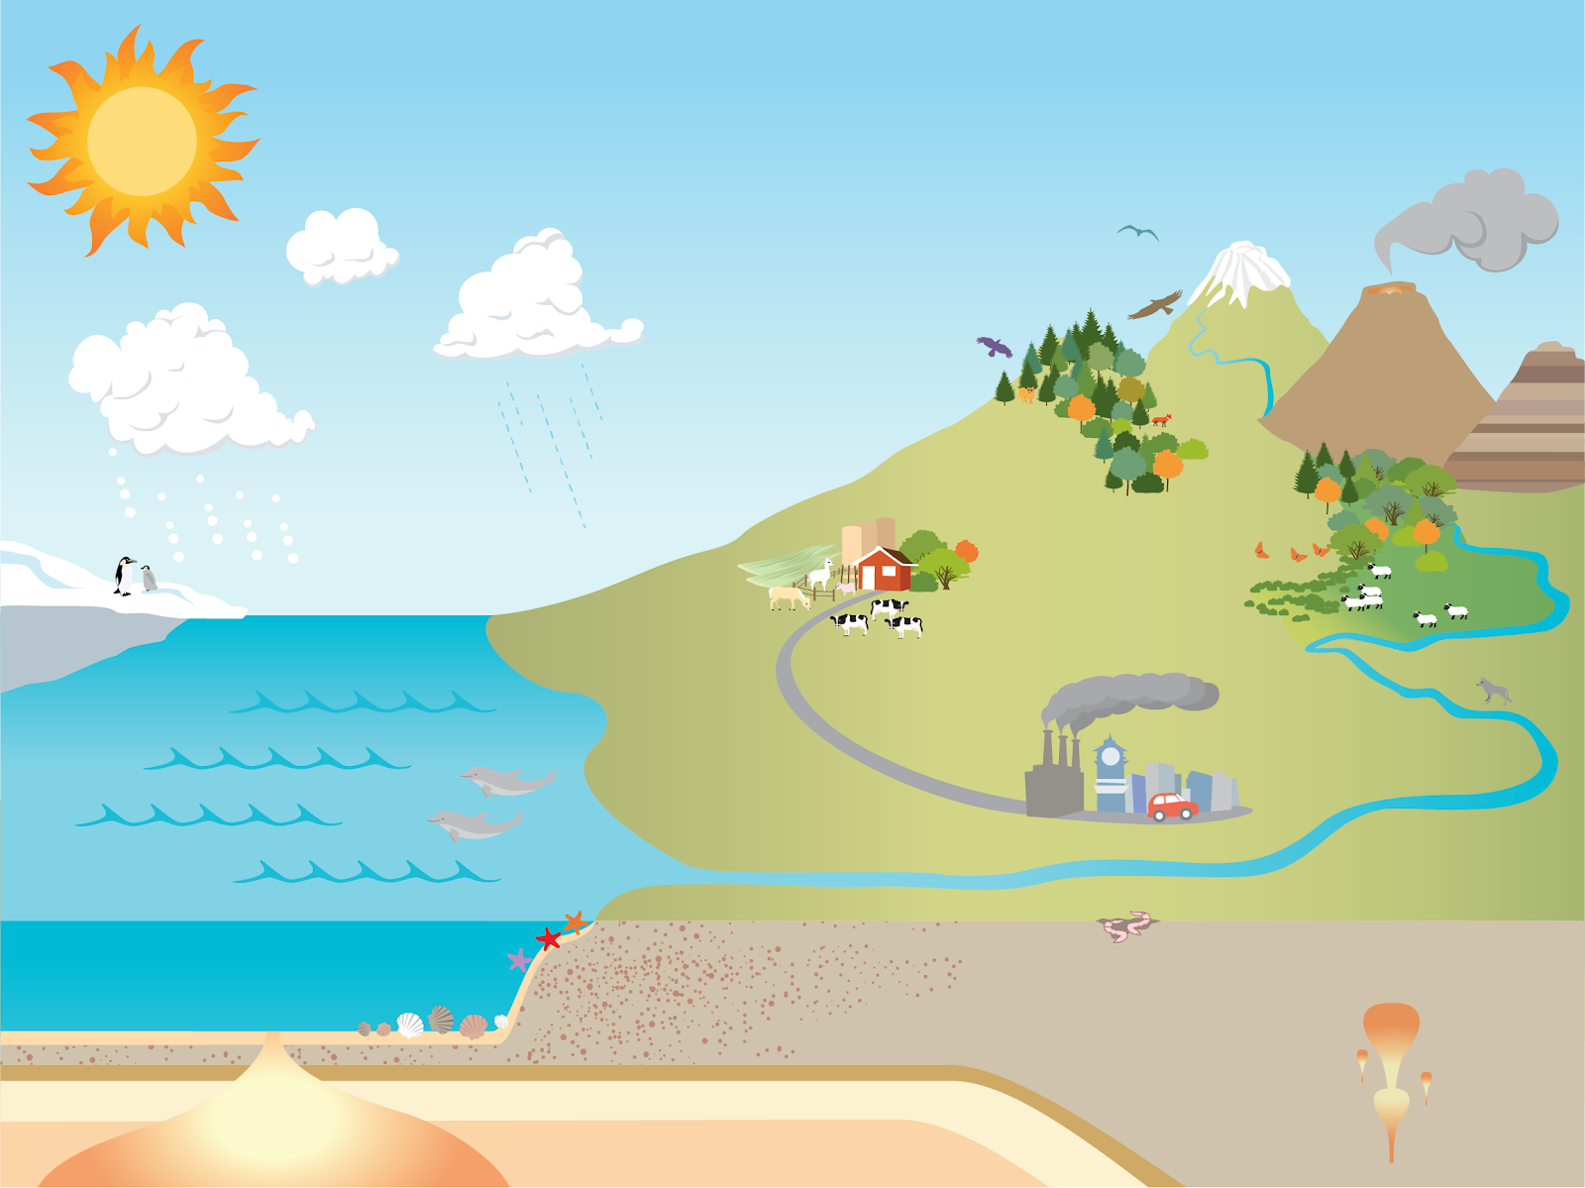

Lesson 4:
I. Activity/resource/ dataset (website link):
II. Investigative question(s) related to the anchoring phenomenon; the science practices students will engage in to answer the question (such as NGSS SEPs and scientific inquiry skills):
III. Key concepts students will explore and figure out (NGSS/ standards connections):
IV. UGC topic connections students will make to explain the phenomenon:
V. Materials, Instructions, Scaffolds, & Formative Assessment Ideas
VI. Time:

Copy and paste more lesson outlines, as needed.

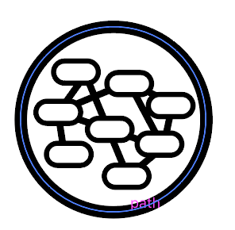
STEP 5. Apply an Earth systems perspective and connect learning to other phenomena and units
The use of the Understanding Global Change Framework and Earth system modeling tools can extend beyond a single instructional unit. These are practices that can be applied across the curriculum. Understanding of Earth system interrelationships and feedbacks from one unit can be applied to help explain other phenomena and formulate solutions to real-world problems.
Ongoing development of systems-thinking skills could occur by:
- Expanding the model of the original anchoring phenomenon to investigate closely related phenomena or processes;
- Engaging with a local manifestation of the phenomenon and/or a related Measurable Change in the Earth System;
- Using Earth system modeling to reflect and make sense of prior learning experiences;
- Allowing students to select UGC icons/ topic connections they want to explore and explain.

The example model to the right connects components of the Sea Level Rise Unit system model to phenomena related to changes in species ranges and species populations that result from reductions in snow and ice cover. Current reductions in sea and land ice cover are ultimately caused by human activities that result in global warming.
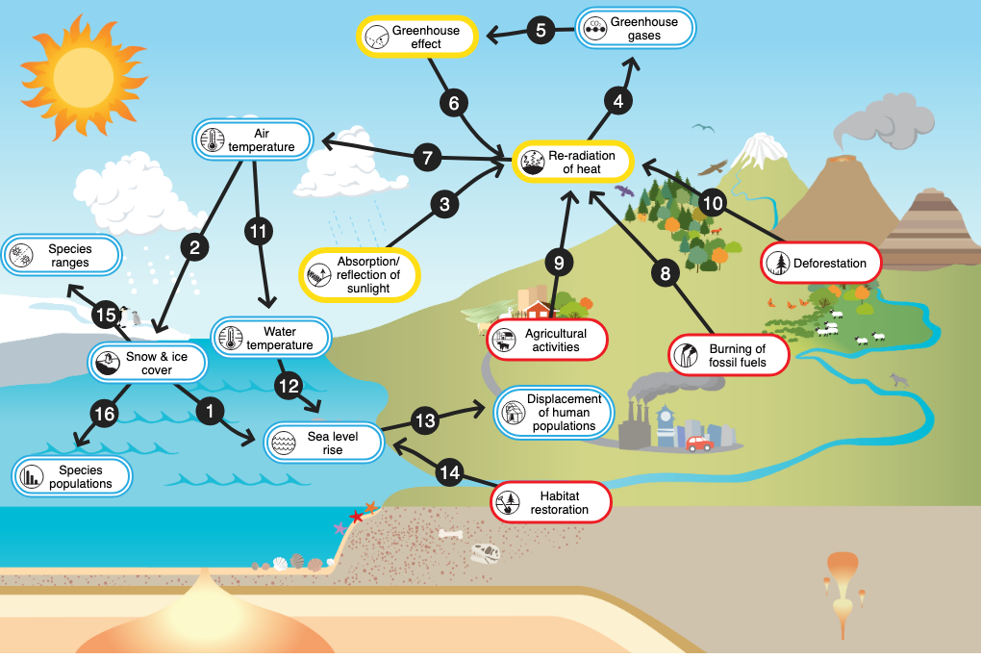
On this page, insert an image of a UGC Earth system model that connects the big ideas from this unit to UGC icons/concepts previously explored in the curriculum, or that will be investigated in another unit in your curriculum. Start by adding just 1-2 icons, and repeat STEPS 1-5 to connect Earth system concepts across your curriculum.
Topics/icon connection | Student target explanations of system connection
- Example: Snow and ice cover => Species ranges | Reductions in sea ice decreases habitat which can alter species ranges.

Student Activity Table

Activity | Observations/ Patterns | What causes those observations/ patterns? | How do these observations/ patterns help us explain/ understand the anchoring phenomenon?

Student Activity Table

Activity | Observations/ Patterns | What causes those observations/ patterns? | How do these observations/ patterns help us explain/ understand the anchoring phenomenon?

